

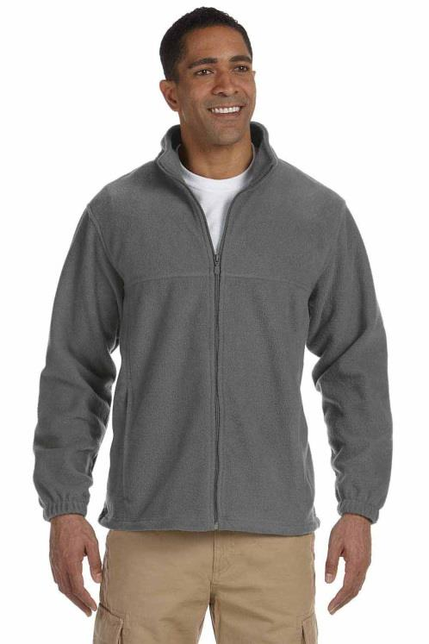

Payment Method (Circle One): Cash Check#______________

Please make check payable to Phi Lambda Sigma. There will be a collection envelope in OSPA.

Please indicate which size and quantity you would like for each color.

**Grey**

XS _________ S __________ M __________ L __________ X-Large _________ XXL(+$2.00) _________

**Black**

XS _________ S __________ M __________ L __________ X-Large _________ XXL(+$2.00) _________

Name: ______________________________________________________________________

Classification (Circle One):

P1 P2 P3 P4 Faculty

* **Full-zip fleece jackets**
* **Black or grey**
* **$35**
* **Pharmacy crest will be embroidered on left chest of jacket**