Appendix A
PRINTING THE LACARTE LOG WHEN THE CARDHOLDER HAS MORE THAN ONE ROLE (Approver, Accountant, Program Admin) IN LACARTE WORKS.
Click on Reports – Template Library

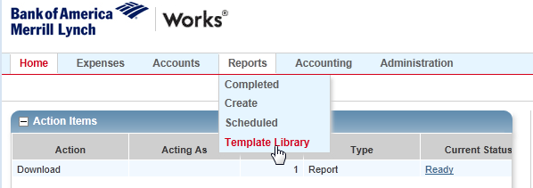
Click on Billing Cycle Purchase Log.
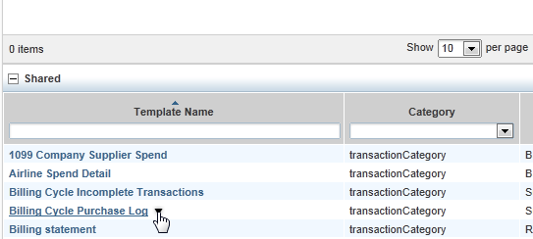
Click Modify/Run
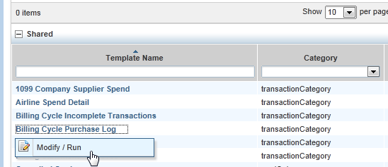
Scroll down Click on Add Filter drop down box.
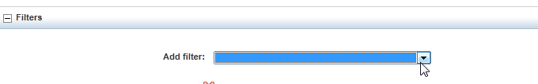
And scroll down and select CH Full Name

. 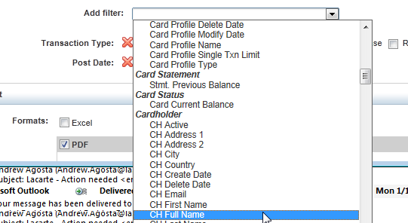
The screen below appears:
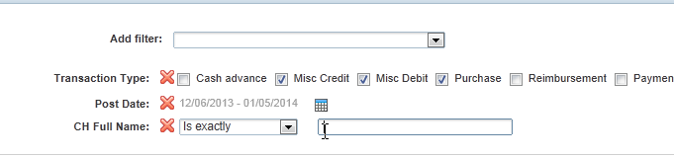
Type in your full name. Last Name first, then comma, then first name and middle initial if applicable. See the top right corner of your screen where it says Welcome to see if middle initial is applicable.
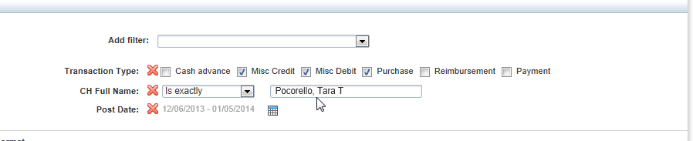
Scroll down and click Submit Report.
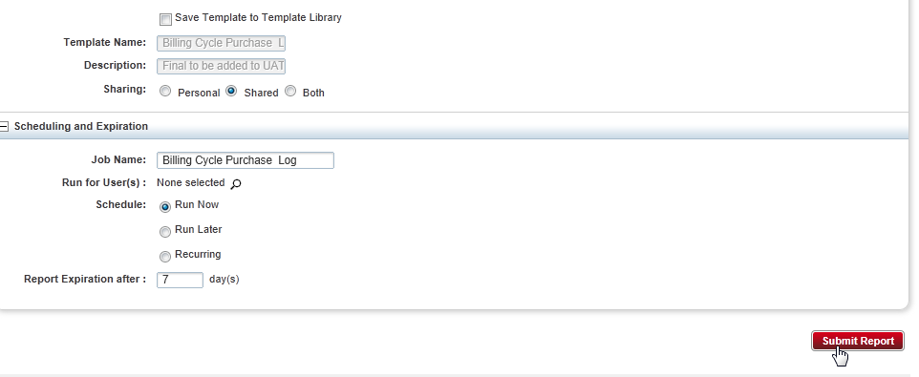
Report begins processing. Once completed click on PDF.
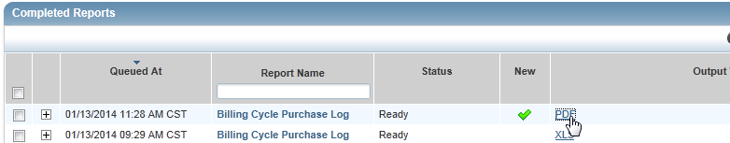
Click on Open.
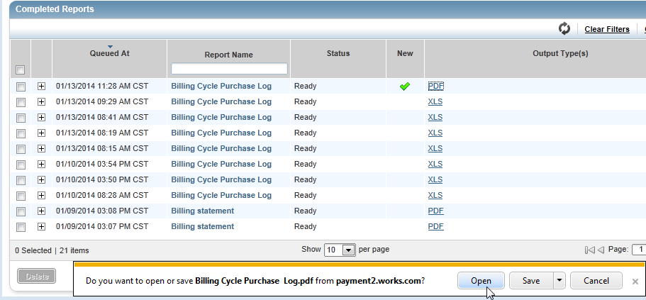

Billing Cycle Purchase Log appears in PDF form…Print the report and attach all receipts and documentation for your records and audit purposes.
