APPROVER INSTRUCTIONS

This guide provides information needed for an approver to manage transactions. Within this guide, you will learn how to:
- Review and sign off on a transaction

Review and Sign Off on a Transaction
NOTE: Approvers are usually not required to edit the account number or enter a description. The approver should review the transaction to determine that it is a reasonable, appropriate and legitimate transaction for the department. If you are required to edit the account number and subcodes, see the instructions for accountholder.
Procedure:
To review a transaction, complete the following:
- On the Home Page under Expenses>Transactions>Approver, click on the Pending link. The Pending Sign Off screen is displayed.

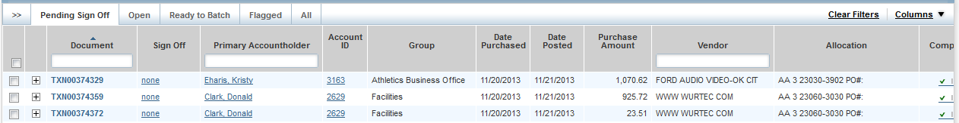

- Click the desired Document number. A menu displays.
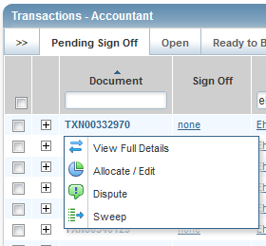
- Select View Full Details. The Transaction Details screen displays.

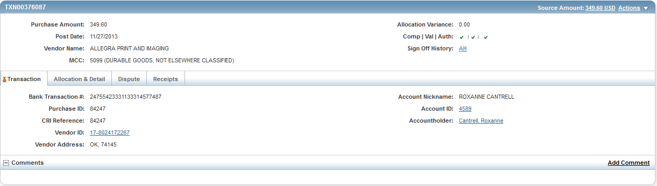

- Select the Allocation & Detail tab.
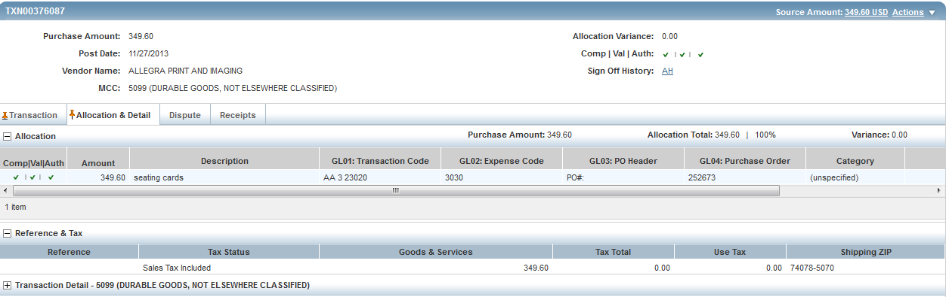

- Read the description entered into the Description field by the accountholder. To the best of your ability determine if this is a reasonable, authorized, legitimate transaction for the University, and the account number and subcode are correct.

- In the upper right corner of the Allocation & Detail tab, click on the Actions drop down menu.

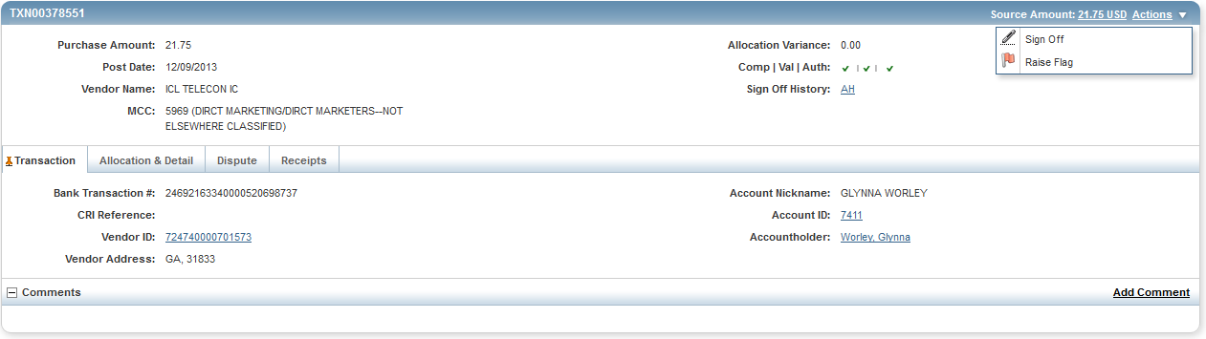

- Click Sign Off. The Confirm Sign Off screen displays.
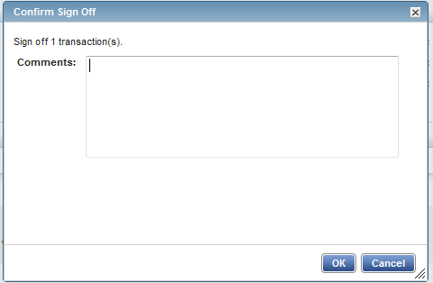

- Click OK.

- This completes the procedure.

