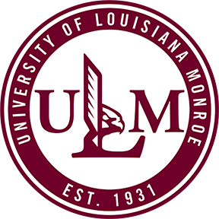
Call for Abstracts

2024 ULM Student Research Symposium

SUBMISSION DEADLINE: Wednesday, April 15, 2024, at 5:00 pm

The ULM Research Council is pleased to formally request abstracts of research and visual and performing art exhibits from ULM undergraduate and graduate students for presentation at the 23rd Annual ULM Student Research Symposium. In order to submit, the student must be enrolled during the 2023-2024 academic year. Submissions must be made to your School’s Student Research Symposium representative. A list of School representatives can be found at the ULM Student Research Symposium website at https://www.ulm.edu/symposium/representatives.html.

The heading for the abstract should include the Title, Authors, Academic College and School, and the name of the University. Multiple student authors may be listed, but the presenter’s name should be listed first. Abstracts should be typed entirely within the box below, using Times New Roman 10 pt. Font; 100 words minimum, 250 words maximum.

Please type or print only within the boundaries of the box.

Presenter: College:

Undergraduate or Graduate: School:

Student E-Mail: Mentoring Faculty:

Student Campus Phone: Mentoring Faculty E-Mail:

Hometown (City/State or Country): Mentoring Faculty Campus Phone:

Type of Presentation:
(E.g. Poster, Oral, Visual or Voice Performance, or Artistic Display)

