ULM SUMMER ART CAMP

Participant Name:

Home Address (City, State, Zip Code)

Cell Phone Number Parent Phone Number

Emergency Contact (Name, Relationship, Phone Number)

Health Insurance Carrier Policy Number
(If “N/A,” please see medical release form for info on liability)

Date of Birth Grade Just Completed

List any special services you may require due to an existing medical condition or special consideration:

Parent or legal guardian signature required if student is under 18 years of age: Guardian Signature Date

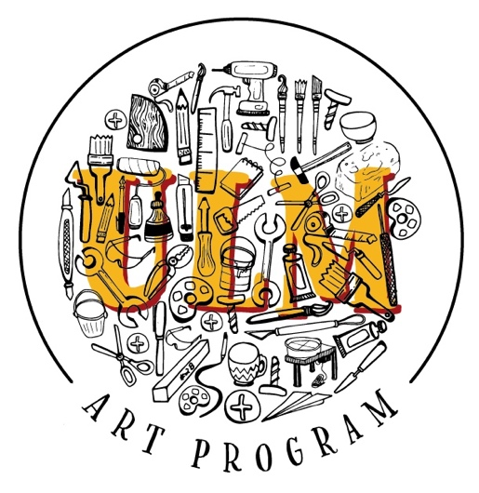

CAMP INFO
JUNE 11-14, 2024

Camp Dates: Start: June 11-14, 2024 – 10:00AM – 5:00PM

Camp Director: Brooke Foy & Megan Smith

Email Address: foy@ulm.edu

Phone: 318-342-1340 / 318-512-2131

Camp Location @ULM: Bry Hall & Stubbs Hall

Registration Fee $50.00 paid at Online Registration Portal via VAPA Website or: https://secure.touchnet.com/C21151_ustores/web/product_detail.jsp?PRODUCTID=520

Camp Check in: June 11th 9:00-10:00AM
The cost of the camp is $150 with a $50 non-refundable deposit due at registration, and the remaining $100 due at check-in paid via check to ______________.

**Campers please wear comfortable clothing that you don’t mind making art in. Bring a jacket incase studio temperatures are chilly.

ACKNOWLEDGEMENT OF RULES
By signing below, I acknowledge that as a participant in ULM Summer ART CAMP, I must follow all ULM Student Rules and Policies, and abide by all Federal, State, and Local laws. (https://www.ulm.edu/studenthandbook/studentconductrevised.pdf)
Additionally, by signing below I agree not to possess or consume alcoholic beverages while participating in this camp. I further understand that if I choose to possess or use alcohol or illegal drugs at any time during the camp, I will be sent home with a parent/ guardian and will forfeit the registration fee.
While a participant of this camp, I realize that all ULM Student Rules and Policies will be enforced by the staff on duty. I further understand that my involvement in criminal violation will result in being sent home immediately.
I agree to behave in an appropriate manner and adhere to all ULM Student Rules and Policies, and all International, Federal, State, and Local Laws.

Print Name:
Signature:
Date:
I acknowledge that my child has agreed to follow ULM rules and policies, and all International, Federal, State, and Local Laws. I agree to come get my child in the instance that he/ she/ they breaks a rule or law and that we forfeit the registration fee in this instance.

Print Name:
Signature:
Date:
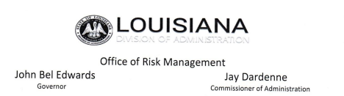ACKNOWLEDGEMENT
By signing this document, I acknowledge that I will be operating, or will be a passenger in, a state owned vehicle or vehicles rented to the State of Louisiana (or to a Department, Agency, Board, Commission, or other entity or official thereof). I acknowledge that operating, or being transported in, a vehicle is a potentially dangerous activity. I fully realize the physical risks involved, and further acknowledge that this risk, and the danger associated with this activity, is obvious to all persons. I nevertheless willingly and voluntarily elect to operate, or be transported in, said vehicle and expressly accept the risks inherent therein.
For purposes of operating said vehicle, I declare and certify that I have received training regarding the operation of motor vehicles and that I currently possess a valid driver’s license. Moreover, I certify that I am physically and mentally capable of operating, or being transported in, said vehicle, and suffer from no physical or mental condition that would prevent my safe and responsible operation of said vehicle. I affirmatively declare that the vehicle may be safely entrusted to me. Further, I certify that the State of Louisiana may rely on the representations made herein, which are true and correct to the best of my knowledge.
I hereby agree to indemnify and hold the State of Louisiana harmless from any injury or damage to myself that is sustained as a result of the fault of any third person or entity.

Print Name:

Signature:

Date:

Parent Name:

Parent Signature:

Date:

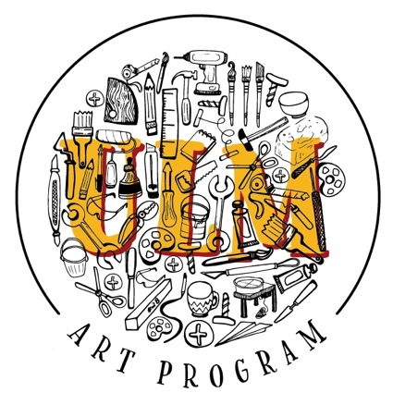
Permission to Publish
Authorization Form

Please complete this form prior to publication
I grant permission to The University of Louisiana at Monroe to record and/or publish my image or works through video, audio, photographic, electronic or printed, formats in connection with ULM-related activities. I understand that all sound, still or moving images and/or published works will not be used for commercial gain, but to support the mission of the university.
These recordings may be used in educational and promotional videos, presentations, CD-ROMs, newsletters, websites, etc. I agree that any additional reproductions may be published and distributed to the general public. I also agree that media TV, print and audio media may record my image in connection with ULM-related activities.
I understand and agree with the above statements.
Printed Name: Signature:

Please complete this section for minors under the age of 18
Student’s Printed Name/DATE:
Parent/ Guardian’s Signature/DATE:

STUDENT MEDICAL LIABILITY WAIVER

I attest that my child (student listed below) is attending this camp on their own free will and I hereby release The University of Louisiana at Monroe, its faculty, staff, or agents from any and all responsibility or negligence of any nature whatsoever. No binding special relationship exists between me and the University for injury or damage that may occur as a result of any medical care received, domestic or international, including but not limited to medical malpractice or treatment that is not in accordance with U.S. medical practice. Furthermore, I agree to hold harmlessly any faculty, staff, or agent of The University of Louisiana Monroe for any medical decisions made on my behalf and I understand that I am financially responsible for all charges for any medical treatment received by my child, whether or not paid by insurance. Initial

I understand and agree the University cannot be expected to control all of the risks articulated in this form, but may need to respond to accidents and potential emergency situations. Therefore, I hereby give my consent for any medical treatment that may be required during my child’s participation with the understanding that the cost of any such treatment will be my responsibility. Neither the University nor the sponsoring department or organization carry medical or accident insurance for the activities mentioned unless the participants are informed otherwise. As such, participants should review their personal insurance policies.

I also understand and agree that I am solely responsible for any special services necessitated by any existing medical condition or disability listed below, and that The University of Louisiana at Monroe is not responsible in any way for the provision of such services. Initial

Please check one of the boxes, if applicable:
- My child has my permission to keep their medication and will be responsible for taking that medication. Sharing medication will result in immediate dismissal from camp.
- I would prefer my child’s medication to be kept and administered by camp staff.
(Include name of medication AND dosing instruction with the medication).

List any special services you may require due to an existing medical condition or disability:
7

