University of Louisiana Monroe

Counseling Program 2023 Annual Review

Introduction

The University of Louisiana at Monroe (ULM) Counseling Program is part of the School of Allied Health within the College of Health Sciences. The program offers Master’s of Science in two 60-credit-hour concentrations: Clinical Mental Health Counseling and School Counseling. Both program concentrations are accredited by the Council for Accreditation of Counseling and Related Educational Programs (CACREP). This year, the program has begun the process of transferring to the 2024 CACREP standards for each concentration. Our last CACREP re-accreditation was in 2020, and this summary is specific to the Mid-Cycle Report in 2024.

Current Accreditation Information

ULM’s Counseling Program currently has two CACREP accredited specialty areas in Clinical Mental Health Counseling and School Counseling. Both specialty areas are accredited under the 2016 CACREP standards. They are each 60 credit programs. All of the curriculum in both specialty areas is offered in an online format.

Changes in Program Operations

The Counseling Program at ULM has undergone some changes since 2020, mainly in its size. First, we have increased the number of full-time faculty. At the time of our site visit in 2020, we had only two full-time faculty on staff and an open line not hired due to the hiring freeze due to the pandemic. In 2021, we were able to hire the third faculty line (Dr. Sarah Tucker) to get back into accreditation compliance. In 2022, we obtained two additional faculty positions and hired Dr. Cody Wehmeier and Dr. Carlo Walker, totaling five faculty members. These three faculty members did not stay for the 2023-24 academic year.
While there were varying reasons for their departure, the overarching theme for the high turnover rate in the program was due to an uncompetitive salary and that faculty had to come to campus to work. However, we have resolved these two issues by increasing the base salary to a more competitive rate and allowing faculty to work remotely.
For 2023, in addition to hiring for these existing faculty positions, we obtained two additional faculty lines, totaling seven faculty. So, for the 2023-24 academic year we hired Dr. Poppy Moon, Dr. Michelle Dobson, Dr. Tonya Elliott, Dr. Ruoxi Chen, and Dr. Janys Murphy Rising. Dr. Murphy Rising will not be returning for the Fall 2024, so we replaced her with Dr. Deborah Grant. We also have a new eighth faculty position for the Fall of 2024 in which we are currently hiring for. Below is a table of the current faculty, their core/noncore status, specialty area, and their administrative duties.

Second, we have increased the number of students for each incoming cohort since 2020. In 2020 and 2021, the program accepted 30 students into each cohort. For the Fall 2022 cohort, the program accepted 60 students, and for the Fall 2023 cohort the program accepted 75 students into the program.
The Counseling Program at ULM has also developed specialty areas in Addiction Counseling and Marriage, Couple, and Family Counseling. While these concentrations have been approved by the UCC at ULM, the Program is currently aligning them with the 2024 CACREP standards and is not yet offering them to students until closer to the next CACREP site visit.

Full-Time Faculty

Faculty | Core/Noncore | Specialty | Administrative Duties
Dr. Thomas Foster | Core | CMHC | Program Director
Dr. Poppy Moon | Core | School | School Counseling Coordinator
Dr. Tonya Elliott | Core | MCFC | MCFC Coordinator
Dr. Ruoxi Chen | Non-Core | MCFC | MCFC Coordinator
Dr. Deborah Grant | Core | Addiction/School | Addictions Coordinator, Summer Workshop Coordinator
Dr. Michelle Dobson | Core | CMHC
Dr. Yolanda Dupre | Core | CMHC, School, MCFC | Comps Coordinator
Open faculty position | Core | TBD

Revised Program Mission, Purpose, Goals, and Objectives

For the 2023-24 academic year, the Counseling Program revised its mission, purpose, goal, and objectives to reflect the 2024 CACREP standards and other improvements made to the evaluation process at ULM. The program’s commitment to diversity statement was also revised and part of this process was done with student input. Specifically, the program faculty have infused inclusion and equity into the purpose of the Counseling Program and made the program objectives directly measurable and related to the CACREP core and specialty standards. Click here to review the mission, purpose, goal, and objectives for the 2023-24 year, they are taken from the program website. These revisions were made by the program faculty and in collaboration with the students.

Revised Program Objectives, KPIs, and Skills/Disposition Assessment Procedures

This year the counseling faculty revised the program standards to comply with the 2024 CACREP standards. The program objectives are found in required core courses and evaluated using assignments in these classes (also known as Key Performance Indicators [KPI]). In accordance with CACREP, these KPIs are evaluated at least two times during a student’s time in the program; the first KPI for core and specialty areas is within content courses (e.g., Intro to Professional Counseling, Theories of Counseling, Career Counseling) and the second KPI for core and specialty areas are in fieldwork courses (i.e. Practicum, School Practicum, Internship, School Internship). We set the minimal threshold score for the content KPIs at 70%, which is the same as a passing score for the counseling classes at ULM. We set the skills and professional disposition minimal threshold score at 80% due to their overall importance for students to possess and be successful clinicians.
Scoring and storing the KPIs for knowledge and skill are done in Tevera. Rubrics for each KPI are provided and are on a 5-point Likert scale (5=Advanced; 4=Proficient; 3=Basic; 2=Developing; 1=Deficient) that measures student performance on specific core and specialty standards. Each Likert score is converted to a percentage to determine if they met the 70% or 80% threshold. (i.e., 5=100%; 4=90%; 3=80%; 2=70%; 1=60%). Individual scores are calculated by converting the Likert score to the percentage, adding each item score together, and dividing by how many items were scored thus giving an average subscore for the assessment. Any subscore under the 70% or 80% threshold (depending on the KPI) will not meet the minimal threshold.

Student Performance for 2023-24

Faculty met during the summer of 2024 to discuss each student in the program in terms of their KPI scores, clinical and professional disposition scores of the CCS-R, and overall performance. Students of concern were discussed and any formal or informal remediation plans in place were reviewed. Overall KPI scores and clinical/disposition scores of the CCS-R are provided below and can be found at the links below. The mean, minimum and maximum scores, and standard deviation are provided.

- Fall Courses KPI scores for First- and Second-Year Classes
- Fall 2023 Clinical Course CSS-R Results
- Spring Courses KPI scores for First- and Second-Year Classes
- Spring 2024 Clinical Course CSS-R Results

Fall 2023 didactic courses. First and second year fall didactic courses are divided up and listed by cohort. Results indicate that all students in the first-year fall courses scored above the 70% minimal threshold for the program objectives and scored above the 80% minimal threshold for the clinical objectives. Results indicate that all students in the second-year fall courses scored above the 70% minimal threshold for the program objectives, with the exception of one student in COUN Research in Counseling. The professor informally remediated the student with the low score.

Fall 2023 clinical courses. The CCS-R is used to assess for clinical skills and professional disposition in the Practicum, Internship, and School Internship courses. Each student is assessed using the CCS-R during the midterm and final by their faculty supervisor and site supervisor. Students also evaluate themselves using the CCS-R at the end of the semester. Last, students evaluate their site and site supervisor at the end of the semester. All the results for students in the fall clinical courses (i.e., Practicum, Internship, School Internship) all scored above the 80% minimal threshold, requiring no need for remediation. Results indicated that students gave high scores for their self-evaluations, site evaluations, and site supervisor evaluations.

Spring 2024 didactic courses. First and second year spring didactic courses are divided up and listed by cohort. Results indicate that all students in the first-year spring courses scored above the 70% minimal threshold for the program objectives. Results indicate that all students in the second-year fall courses scored at or above the 70% minimal threshold for the program objectives and no remediation was needed.

Spring 2024 clinical courses. The CCS-R is used to assess for clinical skills and professional disposition in the Practicum, Internship, and School Internship courses. Each student is assessed using the CCS-R during the midterm and final by their faculty supervisor and site supervisor. Students also evaluate themselves using the CCS-R at the end of the semester. Last, students evaluate their site and site supervisor at the end of the semester. All the results for the students in the spring clinical courses (i.e., Internship, School Internship) all scored above the 80% minimal threshold, requiring no need for remediation. Results indicated that students gave high scores for their self-evaluations, site evaluations, and site supervisor evaluations.

Trend analysis in practicum and internship. Trend analysis is a statistical and analytical technique used to evaluate and identify patterns, trends, or changes in data over time. We use trend analysis in the Practicum, Internship, and School Internship to look for changes in student clinical skills and professional disposition over the course of a semester. Faculty and site supervisors evaluate students on these clinical skills and professional disposition using the CCS-R at the midterm and end of each semester.

Results of the trend analysis for the Fall 2023 and Spring 2024 CMHC Internship and School Counseling Internship indicate that both faculty supervisors and site supervisors scored students very high for their clinical skills and professional disposition, however, there were no significant differences in scores between the midterm and final evaluation.

The Fall 2023 Practicum only contained faculty and site supervisor evaluations for the end of the semester, no midterm evaluations were conducted. This was due to human error and will be corrected in the future.

Student self-evaluation. At the end of each semester students self-evaluate themselves on their clinical skills and professional disposition using the CCS-R. Results of the Fall 2023 and Spring 2024 semesters indicate students rated themselves very high on their clinical skills and professional dispositions. Click here to review the results.

Student evaluation of site and supervisor. At the end of each semester students evaluate their site and site supervisor using a survey developed by faculty and provided in Tevera. Total scores can range from 0 to 100. Results indicate that Practicum students, Internship students, and school counseling students are very satisfied with their site and site supervisor for the fall and spring semesters this year. Click here to review the results.

Program Evaluation and Improvements 2023-24

Every year, throughout the year, the Counseling Program collects data from a variety of sources to make improvements to the program: current student survey, summer workshop survey, graduating student survey, supervisor survey, alumni survey, employer survey, and Counseling Advisory Committee (CAC). Based on the feedback given, this year the majority of the feedback that was used to make improvements came from the current student feedback, summer workshop feedback, and feedback from the CAC. Feedback from the survey and the CAC for how to improve the CMHC and School Counseling concentrations are below. The data reported on below was collected during the 2022-23 year and all revisions were made in 2023-24.

CMHC feedback. The survey for current students had themes related to increasing faculty engagement and preparing for third-year activities such as instructions for applying for graduation, procedures for taking the CPCE and NCE, and instruction for applying for provisional licensure in their respective state. Regarding faculty engagement, the faculty decided to increase engagement by having recorded lectures in all asynchronous classes; many of the classes for 23-24 also had optional live Coffee Shop Discussion Boards that were held either weekly or at set times during the semester. To address third-year activities, faculty created a recorded lecture that addressed the procedures for when and how to apply for graduation, procedures for when and how to sign up for the CPCE and NCE, and general instructions about applying for provisional licensure. This recorded lecture was placed in the course shells for Practicum, Internship, and School Internship where students are instructed to watch the video and reach out if they have questions. When we surveyed students in the 2023-24 year no mention was made of needing third-year instructions, and there were less comments made concerning faculty engagement. Click here to review the recorded lecture.

School counseling feedback. The general theme of the 2022-23 current student survey for school counseling was that the program needed to make improvements involving hiring a school counseling coordinator and more core courses that are separate from CMHC. These survey results were discussed at the CAC meeting during the spring of 2023 and the committee agreed that further improvements should be made. Since that time, the Counseling Program has hired Dr. Poppy Moon as the School Counseling Coordinator and Practicum and Internship Coordinator. This year Dr. Moon has revised all the specialty courses for School Counseling (i.e., COUN 5062 School Counseling; COUN 5063 Principles and Administration of School Counseling), revised the existing core coursework specific to School Counseling (i.e., COUN 5002 Theories of School Counseling; COUN 5049 School Assessment and Psychometrics), and has developed additional core courses with a School Counseling focus to replace the CMHC core courses taken in the past. Specifically, Dr. Moon has created COUN 6061Group Counseling in Schools to replace COUN 6067 Group Counseling and COUN 5049 School Practicum to replace COUN 5065 Practicum. These courses will now be taken by school counseling students instead of their clinical counterparts to increase school counseling identity and representation within the program. When we surveyed students in the 2023-24 year there was less feedback than before concerning making improvements to the school counseling concentration and more positive feedback about where the concentration is headed.

Summer workshop feedback. In the fall of 2023, faculty reviewed the summer workshop feedback from the summer of 2023. Two themes emerged from the feedback and are described below.

First was fatigue, students reported to feeling tired after being on the computer for three days with no breaks. They also reported that holding the summer workshop while summer classes were taking place was very difficult. They recommended implementing breaks between sessions and moving the summer workshop to a time when classes were not in session.

From this feedback, during the 2024 summer workshop scheduled breaks were integrated between the sessions. Also, there were self-care strategies implemented within the presentations, for example, students turning off their video if getting tired during a presentation, breathing exercises, and playing music chosen by the students between sessions. Students also had lunch together over Zoom. The program faculty also agreed to move summer workshop from July to May so it would not overlap with summer classes.

Second, students requested to be able to view the presentations from the workshop after the workshop was over. For the 2024 workshop, we recorded the presentations and placed them in the International Society for Counseling Canvas shell for all to view at any time.

Third, students recommended to hold different sessions simultaneously to provide variety and choice during the workshop. This year, we began the process of doing that, offering two sessions to run at the same time so students had a choice as to what to attend. This mainly ran along CMHC and School Counseling concentrations. After the 2024 summer workshop, we sent out the summer workshop survey and there was only one comment made about feeling fatigued and nothing about being overwhelmed due to also taking summer classes. Also, there was no feedback concerning needing to have multiple presentations occurring simultaneously. The program will continue to develop these strategies in the future.

Counseling Program’s Mission, Purpose, Goal, and Objectives Return to Top
______________________________________________________________________________

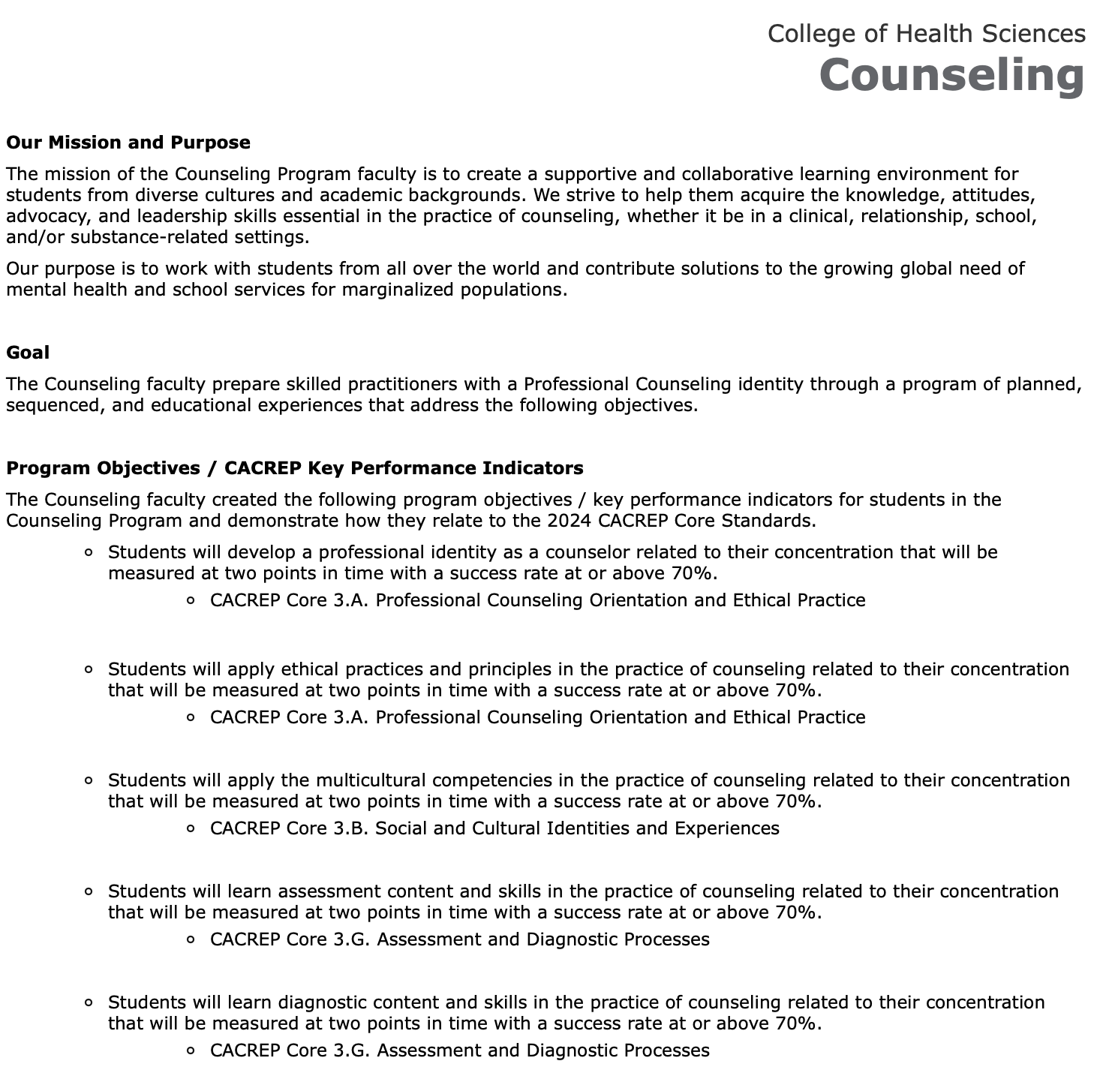

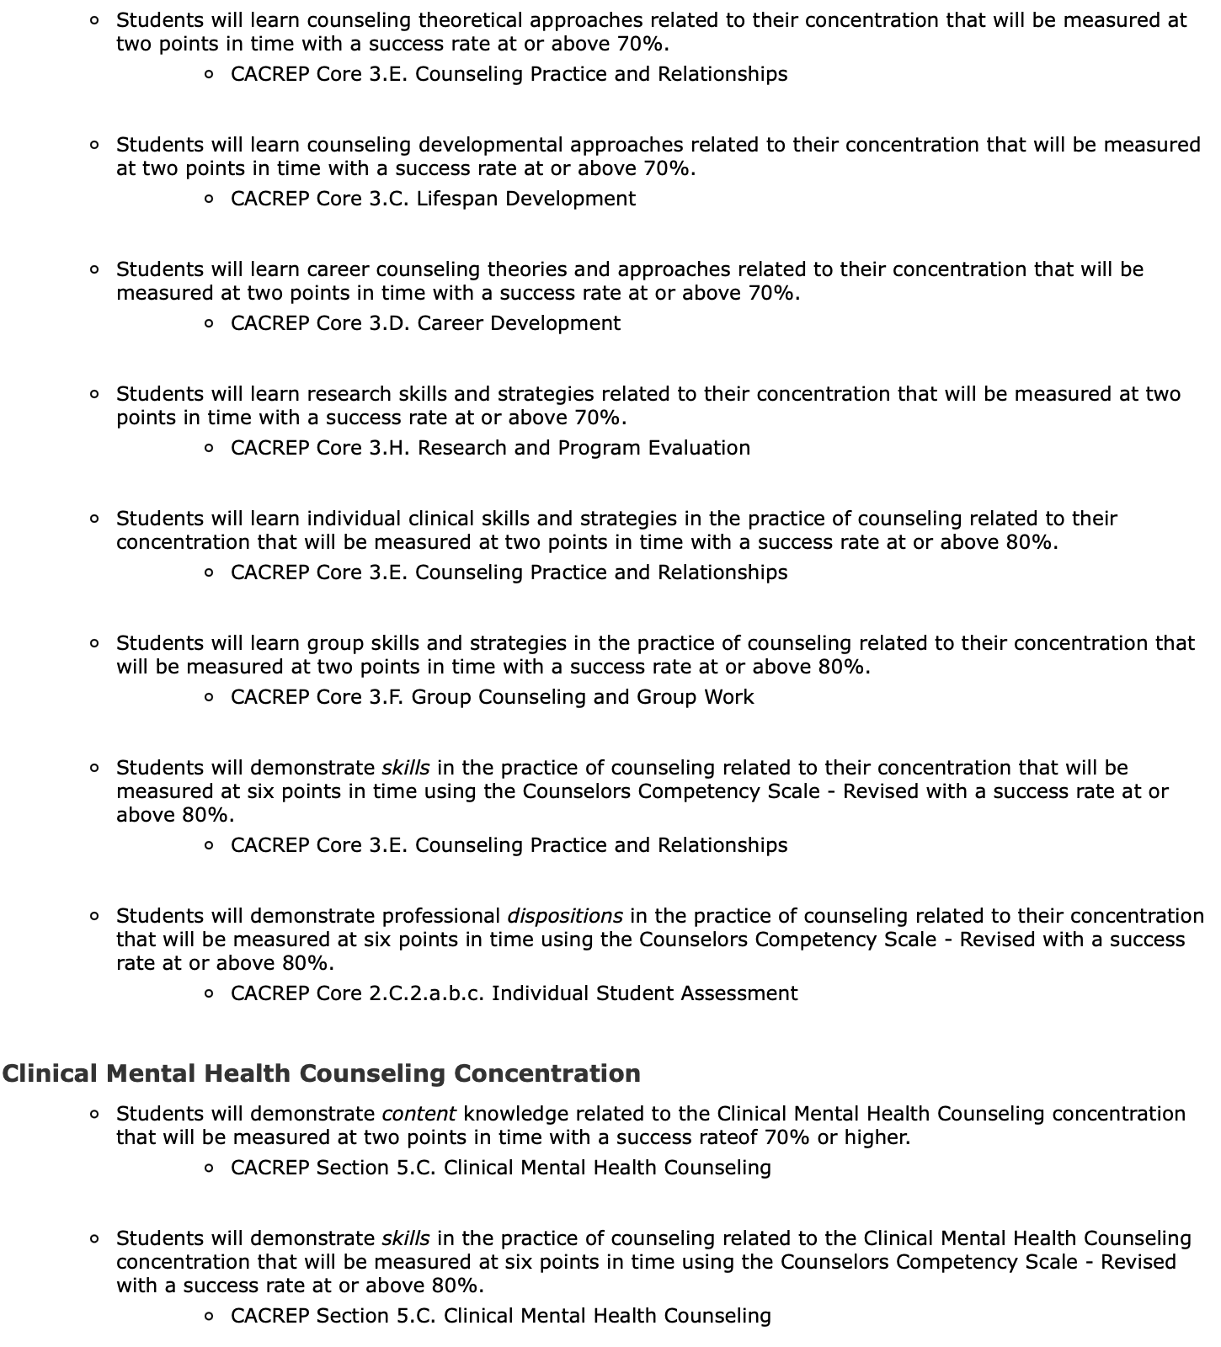
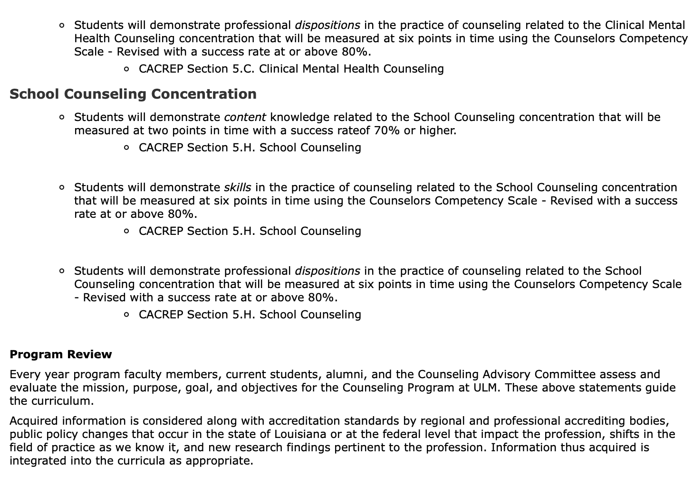
______________________________________________________________________________

Fall 2023 KPI Results Return to Top
______________________________________________________________________________

Fall 2023 Cohort First Year Course KPIs and CSS-R Results

Fall 2022 Cohort Second Year Course KPIs

Fall 2023 Clinical Practicum and Internship CSS-R Results Return to Top

Practicum Faculty Supervisor Evaluations of Students Final

Practicum Site Supervisor Evaluations of Students Final

Internship CMHC Faculty Supervisor Evaluations of Students Midterm

Internship CMHC Faculty Supervisor Evaluations of Students Final

Internship CMHC Site Supervisor Evaluations of Students Midterm

Internship CMHC Site Supervisor Evaluations of Students Final

Fall 2023 School Internship CSS-R Results Return to Top

School Counseling Faculty Evaluations of Students CCS-R Midterm

School Counseling Faculty Evaluations of Students CCS-R Final

School Counseling Site Supervisor Evaluation of Students CCS-R Midterm

School Counseling Site Supervisor Evaluation of Students CCS-R Final

Spring 2024 KPI Results Return to Top

2023 Cohort First Year Course KPIs

2022 Cohort Second Year Course KPIs

Spring 2024 Clinical Internship CSS-R Results Return to Top
______________________________________________________________________________

Internship CMHC Faculty Evaluations of Students CCS-R Midterm

Internship CMHC Faculty Evaluations of Students CCS-R Final

Internship CMHC Site Supervisor Evaluations of Students CCS-R Midterm

Internship CHMC Site Supervisor Evaluations of Students CCS-R Final

Spring 2024 School Counseling Internship CSS-R Results Return to Top

School Counseling Internship Faculty Evaluations of Students CCS-R Midterm

School Counseling Internship Faculty Evaluations of Students CCS-R Final

School Counseling Internship Site Supervisors Evaluations of Students CCS-R Midterm

School Counseling Internship Site Supervisors Evaluations of Students CCS-R Final

Student Self-Evaluations Return to Top

Fall 2023 Practicum Student Self-Evaluations CCS-R

Fall 2023 Internship CMHC Student Self-Evaluations CCS-R

Fall 2023 School Counseling Student Self-Evaluation CCS-R

Spring 2024 Internship CMHC Students' Self-Evaluation CCS-R

Spring 2024 School Counseling Internship Students' Self-Evaluation CCS-R

Student Evaluations of Site and Supervisor Return to Top

Fall 2023 Practicum Student Evaluations of Site and Supervisor

Fall 2023 Internship CMHC Student Evaluations of Sites and Supervisors

Fall 2023 School Counseling Student Evaluation of Site and Supervisor

Spring 2024 Internship CMHC Students' Evaluation of Supervisor and Site

Spring 2024 School Counseling Internship Evaluation of Supervisor and Site

