September 11, 2018 Food Truck Menus
(3 Food and 1 Dessert Option)

Poppy’s Place
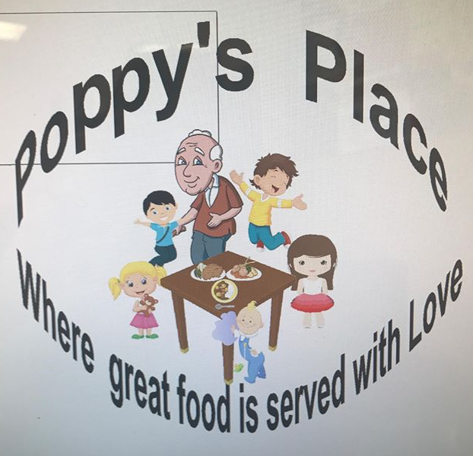
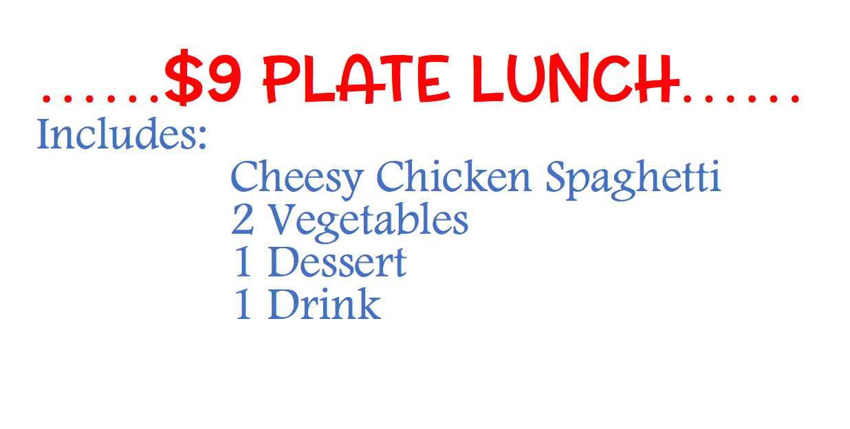
Skinny Phil’s
The Cookout
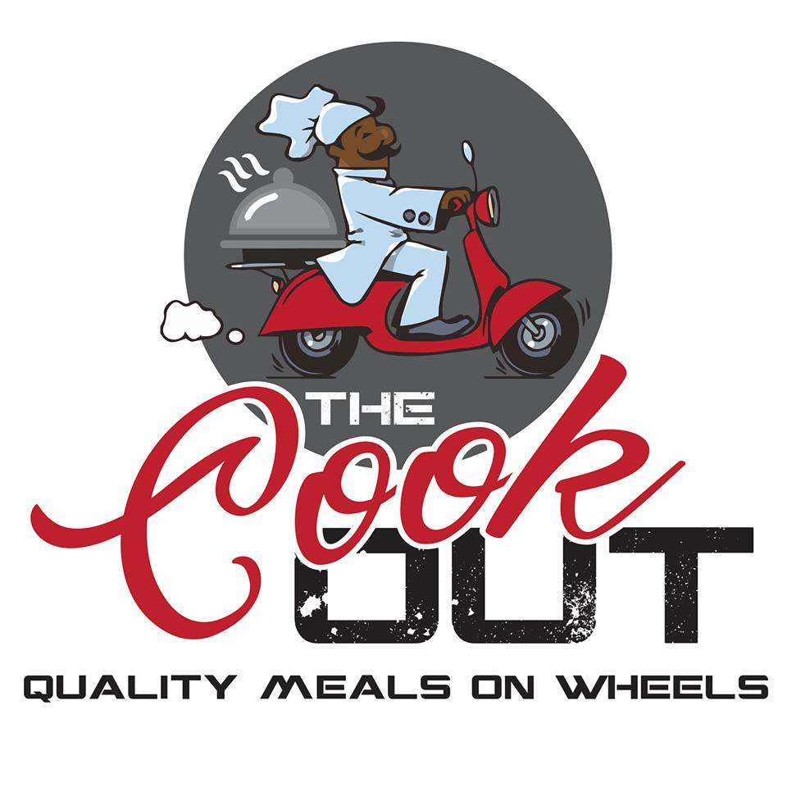
  - 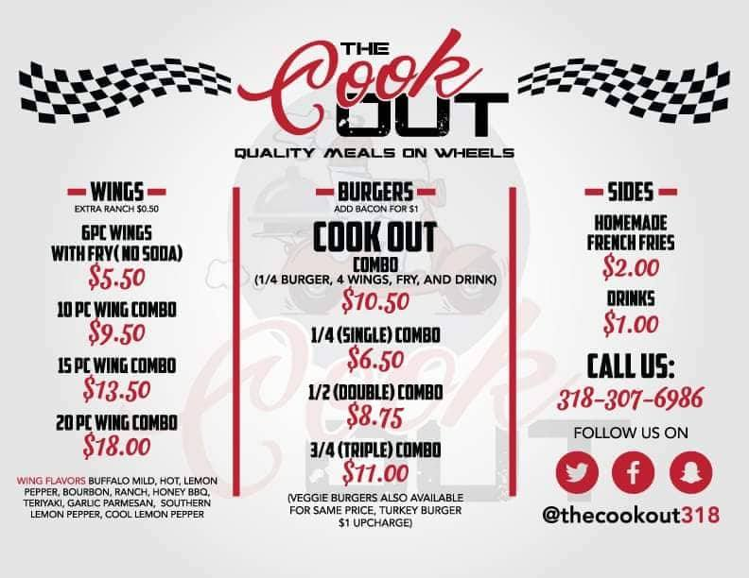
Debbie’s Snowballs
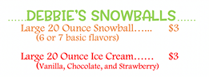

Interest Form Link to Google Doc:
https://docs.google.com/spreadsheets/d/1vue9WMiZLVHtSjaYzS1OoAvHl53EfZmTZ6TEjNJSKo4/edit?usp=sharing

