Business Continuity Plan (students not in classroom)
- Any previous Zoom links are INVALID. They were created with a classroom Zoom account. You will need to create your own Zoom link and email to students and/or post to Moodle.
- Classroom Kaltura scheduled recordings will be deleted.
- If faculty/staff are required to be at work, you can also use the classrooms to record your lecture. Contact Marcia Wells (mwells@ulm.edu, ext. 1716) at least an hour prior to the time you would like to record in the classroom. I can schedule the Kaltura recording to start and publish to the class.
- Moodle has an option to add a Kaltura Media Assignment. Students have a My Media and access to Kaltura Capture as well.

Telephone Operations
- To reach Voicemail off campus
  - Call 318-342-5991
  - When prompted, press the star * key + your 4 digit extension
  - Enter your passcode
- To forward your phone to a cell or other off campus number
  - Go into the settings by pressing the key on your phone that looks like a gear.
  - Use the square directional pad on the left of the screen to scroll to the left 2 times until “Call Forward” is highlighted in blue
  - Press the Select key at the bottom of the screen
  - The cursor will be inside a box that says ALL. Enter 9+number you wish to forward to then press the key in the middle of the directional pad that has the check mark. This will put an actual check mark in the box that says ON.
  - You must then press the button at the bottom of the screen that says SAVE.
  - If you do not save it, it will not work.

Recording lectures

Kaltura – Option 1
- Within Moodle, using the left navigation menu, scroll down to My Media. (If there is no left navigation menu showing, click on the 3 lines to the left of Moodle@ulm.edu).
- Click on the Add New button in My Media
- Select Kaltura Capture (NEW)
- This will bring up a screen to download Kaltura Capture for Mac or PC. Note: Please make sure that you download this newest version of recording software. This icon looks like this: 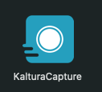
- Even if you have downloaded the software before, you need to launch it via the above instructions. If you have downloaded it, you should get a message on both Mac and PC asking if you want to Open KalturaCapture. Click Open KalturaCapture button.
- Pick your record options.
- Click the red circle to begin recording. Kaltura will countdown 3-2-1 before recording begins.
- By clicking on the pencil in the right corner of the recording screen, you can select the Draw option and use it to draw on your slides as well.
- Once you are done recording, click the Stop button, verify you want to stop the recording.
- Name your recording and click the Save and Upload button.
- You should see a message indicating successfully uploaded.
- Close KalturaCapture, or minimize it.
- Return to Moodle My Media
- You will now see your video there and it will be marked private.
- Click on the title of your video.
- It should bring up a new window, look below the video window. You should see an Actions button to the right of the screen. From the dropdown arrow, select Publish. 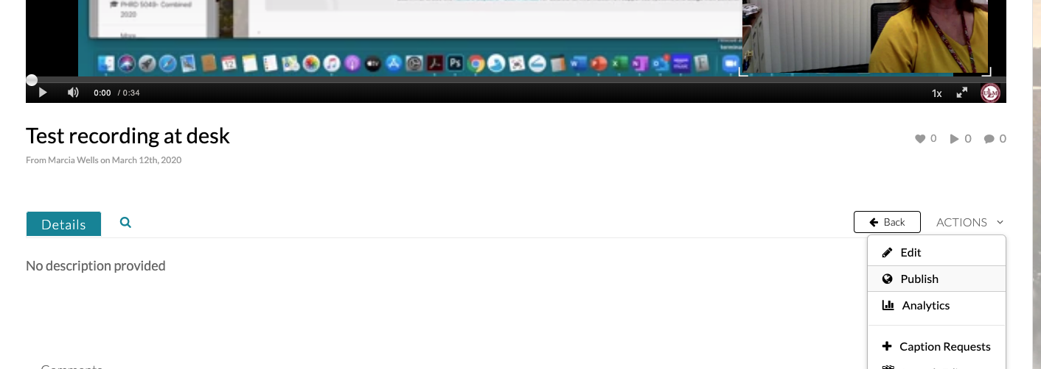
- You will see options for Private (which is currently selected), click the radio button for Published.
- This will populate your classes.
- Click the box in front of the class you want to publish the video to.
- Click Save.
- Scroll back to the Actions drop down option.
- Click on Edit.
- From this screen, click on the Downloads tab.
- Place a checkmark in the first 3 boxes.
- Click Save.
- Your video is now published and available for the students to download.

Kaltura - Option 2

IF you lecture material has NOT changed from last year, you can re-publish last year’s lecture into this year’s class. However, you would need to inform the students the video would be AT THE BOTTOM of the media gallery, as the media gallery is sorted by date recorded.

To do this:
- Locate the Media Gallery of last years class. i.e. PHRD 4029 Spring 2019.
- Locate the video you want to republish.
- Click on the video and from that screen scroll to the bottom of the video window and select Publish from the Actions drop down options.
- This time, you will see Published is already selected and there is a check in the PHRD 4029 Spring 2019 course, LEAVE THAT, but scroll to PHRD4029 Spring 2020 course and select that one as well.
- Click Save
- See above steps 21-25 to mark the video available for download.

Zoom Lecture Recording/Uploading to Moodle
- Start a New Meeting
- Select Record to COMPUTER.
- Record your lecture.
- Stop recording.
- Once the recording has been converted, it will be available for upload.
- Go to Moodle
- Click on My Media from the left menu
- Click on Add New button
- Select Media Upload
- Drag and drop or click the finder button to select the video you would like to upload.
- Once the upload bar has finished and turned green, click the Save button.
- You MUST SAVE THE FILE first, before you can select the radio button for Publish.
- Click the Published button
- Your list of classes will be loaded, check the correct class.
- Click Save.
- Scroll back to the bottom and click Go To Media, next to the Save button.
- Click the drop down Actions box and select Edit.
- Click the Downloads tab.
- Place a check mark in the first 3 boxes.
- Click Save.

Additional Resources for My Media & Kaltura Media Gallery:
https://moodle.ulm.edu/mod/page/view.php?id=1748359

https://www.ulm.edu/it/teaching-resource.html

Zoom

How to create a meeting
- If you have not downloaded the desktop software, download it now.
  - Go to ulm.zoom.us
  - Scroll to the VERY BOTTOM of the page and click on Download Client
  - On the next screen, click Download under Zoom Client for Meetings
  - Install the Zoom client and then log in to your account on the client.
- You can schedule a new meeting from the Zoom web browser or desktop client.
- On the desktop client,
  - Click Schedule, enter your meeting information.
  - Then click the meetings tab for your meeting id and send that information to your students via email and/or post in Moodle.
- For the web browser, go to ulm.zoom.us.
  - Sign in to your account
  - Click Meetings on the left menu
  - Click the Schedule a New Meeting button
  - Enter your meeting details
  - Click Save at the bottom
  - On the next window, copy and paste the Join URL or use the copy the invitation button
  - Send this information to your students via email and/or post in Moodle

Online class with Zoom
- Zoom has the capability of 100 attendees per meeting
- You will see thumbnails of all attending
- Students will need to be instructed to create a free Zoom account using his/her @warhawks.ulm.edu email address
- You would need to schedule your own meeting and send the Zoom link to your students via email/posting on Moodle
- Remind all students to mute upon joining the class
- Be sure to schedule your Zoom meeting to record to your computer
- Upload video to Moodle once completed
- Resources to assist students who are at home will be limited

Additional Resources for Zoom:
https://support.zoom.us/hc/en-us

Exams

PHAR and TOXI classes should use Moodle for administration of exams. Information regarding Respondus Lockdown Browser can be found here: https://moodle.ulm.edu/mod/page/view.php?id=1684460

Moodle How Tos: https://moodle.ulm.edu/mod/page/view.php?id=1684463

PHRD classes should continue to use ExamSoft for administering exams.
- ExamSoft testing practices will be the same as if the students were in the classroom.
- Passwords will need to be emailed to the students prior to the exam.
- They will need an internet connection to connect to ExamSoft.
- The internet will then be locked down once the exam has started.
- An internet connection is required to upload the exam.
- Students should make sure they see the green screen prior to closing their laptop/logging off.
- May want to consider sending them an email to verify their upload via ExamSoft examtaker activity screen. Require them to stay connected to ExamSoft until they see the email.
- Suggested that Backward Navigation NOT be allowed while the Business Continuity Plan is in effect.

Examsoft best practices for setting up exams can be found here, under the Assessment tab: https://moodle.ulm.edu/course/view.php?id=10298

