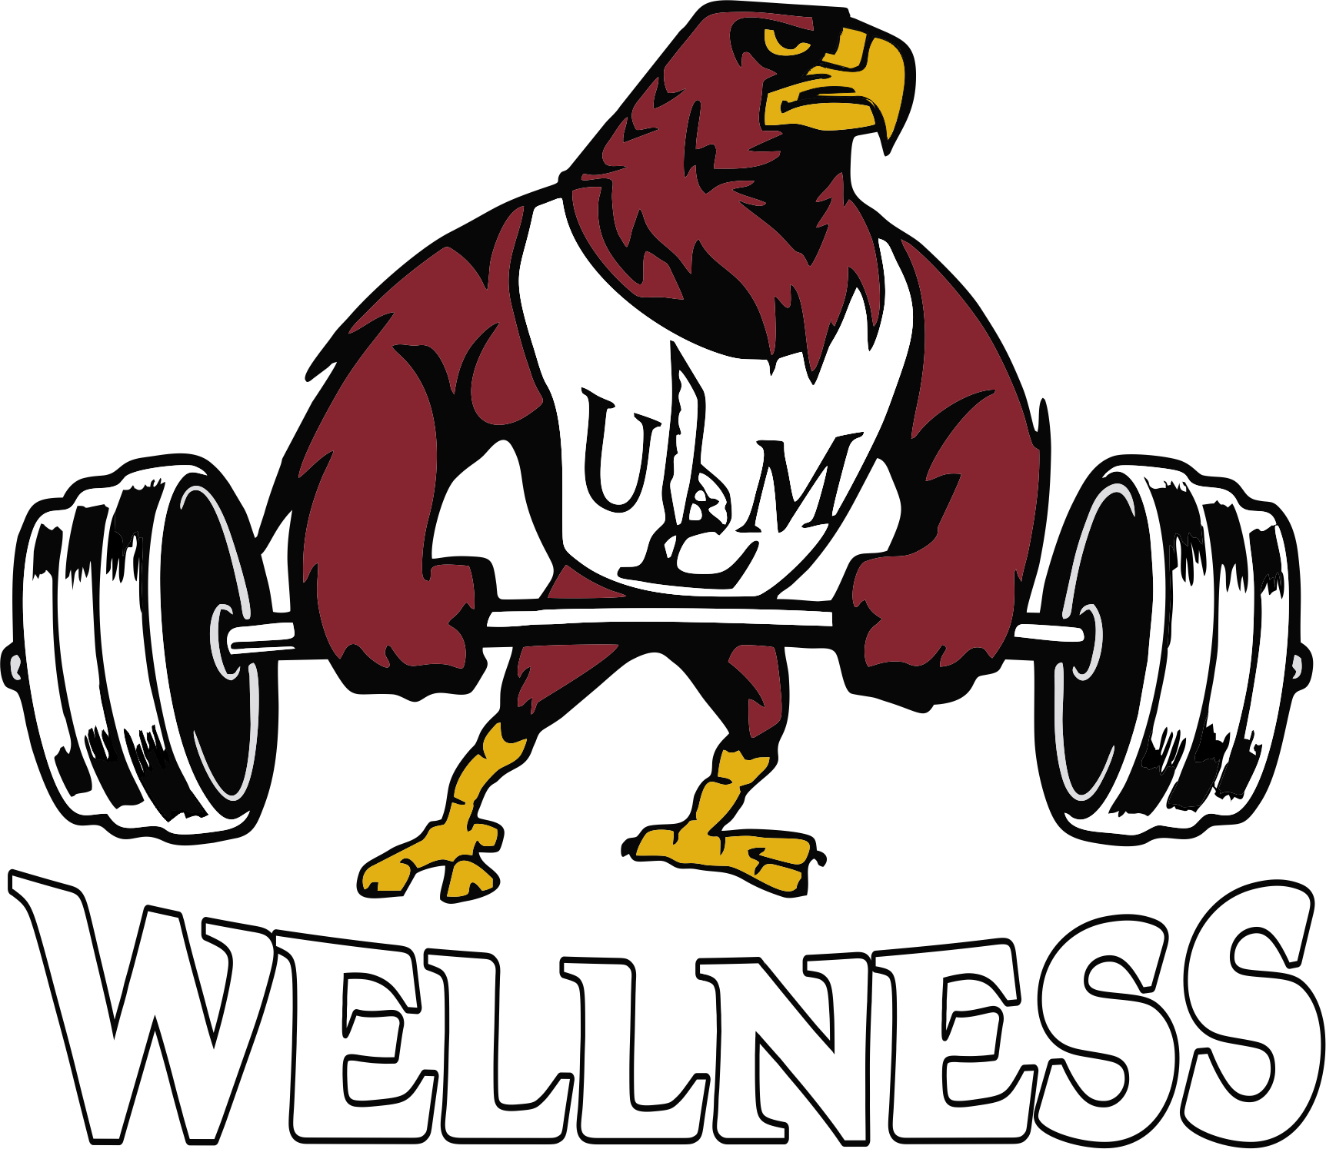
Activity Center Personal Training
Minimum purchase is 3 sessions ($75).
1 Person 1 Hour $25
2 Person 1 Hour $35
3 Person 1 Hour $45

- A complimentary fitness assessment is included.
- Hour session can be split into (2) 30-minute sessions by trainer & client.
- Sessions are non-transferable and non-refundable.
- Sessions expire 90 days from date of purchase.
- Clients must provide 24-hour notice of cancellation to avoid being charged for the session.
- Sessions must be completed during Activity Center hours in the Activity Center and surrounding area.

Please contact Mara Brown for more information
318-342-5398 | mabrown@ulm.edu

