

38th Annual

SPEECH-LANGUAGE PATHOLOGY SPRING CONFERENCE

2026
Bayou Pointe
Thursday, March 12, 2026, 8:00-4:00
Friday, March 13, 2026, 8:00-12:30
Speaker: Dr. Courtney Byrd
Topic: Evidence-Based CARE: Strengths-Based Assessment and Treatment for Stuttering

Sponsored by the
Speech-Language Pathology Program School of Allied Health
College of Health Sciences
University of Louisiana Monroe
In conjunction with the
Louisiana Speech-Language-Hearing Association

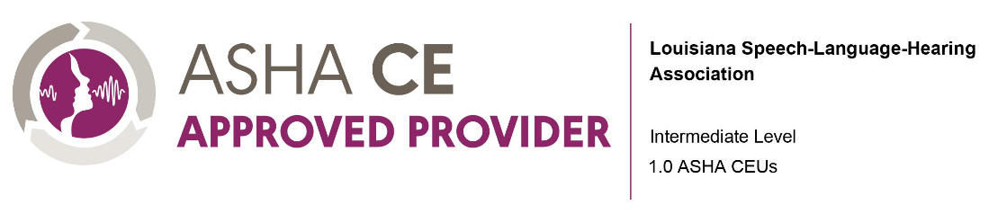

Dr. Courtney Byrd is a Professor, Associate Chair, and Graduate Advisor in the Department of Speech, Language, and Hearing Sciences. She also serves as Founding and Executive Director of the Arthur M. Blank Center for Stuttering Education and Research, which includes three core branches: the Michael and Tami Lang Stuttering Institute, the Dealey Family Foundation Stuttering Clinic, and the Dr. Jennifer and Emanuel Bodner Developmental Stuttering Lab, as well as a satellite center in Atlanta, Georgia. She has 100+ publications and has dedicated her life's work to developing the CARE Model (and the related intensive dosage “Camp Dream. Speak. Live.”) a strengths-based approach to the assessment and treatment of stuttering, the core tenets and documented impact of which are reflected in the scripts she wrote for the award winning When I talk, I stutter series.

Disclosure Statements:
Financial Disclosure: Dr. Byrd is a Professor at The University of Texas at Austin for which she receives a salary.

Non-Financial Disclosure: Dr. Byrd has professional relationships with the Arthur M. Blank Center for Stuttering Education and Research and the World Stuttering and Cluttering Organization.

Program Description: The course will focus on foundational understanding of the nature and manifestation of stuttering as well as the impact of societal stigma towards individuals who stutter. The presentation will demonstrate the rationale for, and application of each component of CARETM, a distinct whole-person, non-ableist approach to assessment and treatment.

Learning Outcomes:
After attending the session, the Learner will be able to:
- Define and provide motivating rationale for each component of the Blank Center’s CARETM
(Communication; Advocacy; Resiliency; Education) Model
- Describe the rationale of not including fluency-focused targets when implementing the Blank Center’s CARETM Model
- Identify the ways in which stuttering openly can improve communication effectiveness for individuals who stutter
- Define and describe the effective and ineffective presentations of the six communication competencies of the Blank Center’s CARETM Model
- Identify the benefits and best practices for implementation of self-disclosure of stuttering
- Identify the benefits of and best practices for implementation of self-compassion and voluntary stuttering as tools for resiliency in stuttering treatment
- Identify the benefits of learning about the tenets of stuttering, communication, and common misconceptions as it relates to treatment of stuttering
- Describe functional outcomes and related short-term goals to facilitate progress across each pillar of the Blank Center’s CARETM Model

CONFERENCE AGENDA

All conference documentation will be provided electronically.

Thursday, March 12, 2026

8:00-8:10 Blank Center: History, Mission, Vision
8:10-8:30 Theoretical tenets and rationale of the CARE Model
8:30-8:45 CARE Assessment: Development and Psychometrics
8:45-9:45 CARE Assessment: Communication Section
9:45-10:00 Break
10:00–10:45 CARE Assessment: Resiliency Section
10:45-11:30 CARE Assessment: Education Section
11:30–1:00 Lunch
1:00–2:00 CARE Assessment: Summary and Reflection
2:00-2:45 CARE Model of Treatment: Overview of Evidence
2:45–3:00 Break
3:00–4:00 CARE Treatment: Communication
Friday, March 13, 2026
8:00-9:00 CARE Treatment: Advocacy
9:00-9:30 CARE Treatment: Resiliency
9:30-9:45 Break
9:45-10:00 CARE Treatment: Resiliency (continued)
10:00-11:00 CARE Treatment: Education
11:00-11:15 Break
11:15-11:45 CARE Treatment: Participation and Caregiver Reflections
11:45-12:15 CARE Treatment: Intensive Dosage via Camp Dream. Speak. Live.
12:15-12:30 CARE Model: Present and Future Global Impact

Continuing Education:
An annual ASHA CE Registry fee is required to register ASHA CEUs and paid by the participant directly to the ASHA national office. Contact the ASHA CE staff at 800-498-2071, ext. 4219 for CE Registry fee subscription information.
The Louisiana Board of Examiners for Speech-Language Pathology and Audiology (LBESPA) accepts continuing education activities sponsored by LSHA for licensure renewal.
Our presenter holds no proprietary interest in this conference and is engaged as instructor/speaker only. FOR MORE INFORMATION CALL: (318) 342-1392 or email slp@ulm.edu
This program is offered for 1.0/10 hours ASHA CEUs (Intermediate level; Professional area

Location:
Bayou Pointe
1 Warhawk Way
Monroe, LA 71212
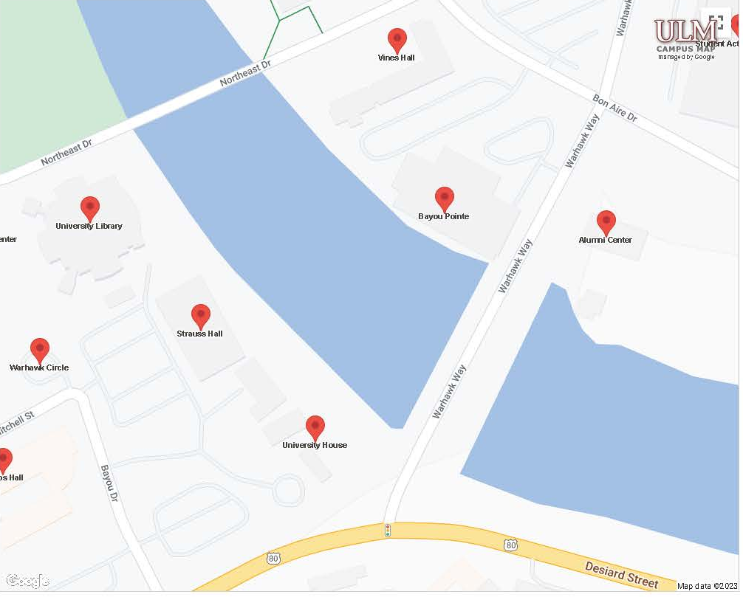
You are here!



38th Annual
SPEECH-LANGUAGE PATHOLOGY
SPRING CONFERENCE
REGISTRATION INFORMATION
Please Print, Complete and mail this Form or Register via Eventbrite
38th Annual ULM Spring Conference
Registration Deadline: Postmarked by March 8, 2026 by mail and through Eventbrite

Please check the following registration fee that applies to you:

Registration for Both Days
Registration Professionals _____$175.00 (1.0 ASHA CEUs or 10 hours, must attend full conference, no partial credit offered)

Students _____$5.00
Cancellation Policy: Written cancellation requests must be received by March 11, 2026 if mailed in or through Eventbrite.

Mail and make check or money order along with this registration form payable to:
SLP Spring Conference at ULM
Speech-Language Pathology Program,
University of Louisiana at Monroe
700 University Avenue, Monroe, LA 71209-0321

(Please use a separate form for each person registering.)
Name (Print): Daytime Phone:
Professional Title and Affiliation
Address: Email: ASHA # LA License Number: LA License Type: ULM Student CWID:
Total Amount Enclosed: (payable by check or debit/credit cards online)

*Learners will be required to complete a self-assessment at the end of this course.

Do you want these hours reported to ASHA for ASHA CEUs? Circle: YES NO
If you need specific accommodations or have complaints, concerns, or questions regarding this course please contact Mary Ann Thomas at thomas@ulm.edu or call 318-342-1392

