# 

**37th Annual**

**SPEECH-LANGUAGE PATHOLOGY SPRING CONFERENCE**

**2025**

**Bayou Pointe**

**Thursday, March 20, 2025, 8:00-4:00**

**Friday, March 21, 2025, 8:00-12:30**

*Speaker: Dr. Jan Wasowicz*

Topic: *Putting the Language Literacy Network into SLP Practice*

Sponsored by the

Speech-Language Pathology Program School of Allied Health

College of Health Sciences

University of Louisiana Monroe

In conjunction with the

Louisiana Speech-Language-Hearing Association

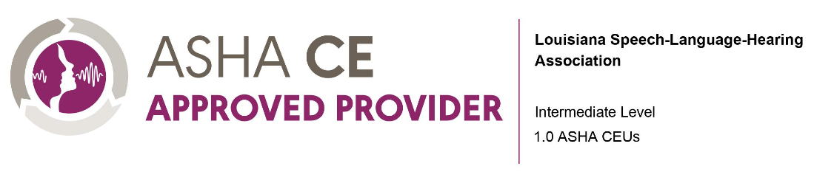

Dr. Jan Wasowicz has more than 40 years of experience as a speech-language, literacy, and learning specialist working with students in a variety of educational settings, including public schools, Head Start programs, and private practice. Dr. Wasowicz is frequently invited to speak about best practices in literacy assessment and instruction and has taught numerous undergraduate and graduate courses, holding faculty positions at Northwestern University, Elmhurst College, Rush–Presbyterian–St. Luke’s Medical Center, and Governors State University. Her credits include articles published in scholarly journals and U.S. patents for her inventions of literacy software programs including Earobics® and Spelling Performance Evaluation for Language and Literacy (SPELL-3).

Dr. Wasowicz is an author of SPELL-Links to Reading & Writing and lead moderator of the SPELLTalk multi-disciplinary professional listserv. She also currently serves as an advisory board member of The Reading League of Illinois and an external consultant for Purdue University’s inter-disciplinary initiative to strengthen teacher preparation using science-based methods.

Dr. Wasowicz is an ASHA-certified, IL-licensed, and FL-licensed speech-language pathologist and an ASHA Board Certified Specialist in Child Language and she holds a professional educator license with multiple endorsements from the State Teacher Certification Board of Illinois. She is the founder, president and CEO of SPELL-Links | Learning By Design, Inc., and she maintains a small private practice in IL via tele-practice and in FL serving students with oral and written language disorders.

**Disclosure Statements:**

**Financial Disclosure: Dr. Jan Wasowicz is receiving an honorarium for this presentation from the University of Louisiana Monroe. She is the founder, president and CEO of SPELL-Links | Learning By Design, Inc. for which she receives a salary, royalties, and has ownership interests.**

**Non-Financial Disclosure: Dr. Wasowicz has institutional relationships with The Reading League, IL (Board member), and Purdue University (external consultant). She has professional relationships with SPELL Talk (Lead moderator), Peaceniks, and ASHA.**

**Program Description: The course will focus on the language components of literacy, the roles and responsibilities of SLPs with regard to literacy assessment and instruction, specific activities for the development of language and literacy skills, and writing goals and objectives for language and literacy instruction.**

# Learning Outcomes:

After attending the session, the Learner will be able to:

1. Explain the components of reading and writing as illustrated in The Language Literacy Network.
2. Identify the similarities and differences between The Language Literacy Network and The Reading Rope and between The Language Literacy Network and the Active View of Reading.
3. Identify the roles and responsibilities of SLPs in literacy assessment and instruction
4. Describe an activity that simultaneously develops phonological, orthographic, morphological, vocabulary, syntax, decoding, spelling (encoding) and automatic written word recognition/production skills at the word and sentence levels.
5. Describe an activity that reinforces the skills listed in #3 while simultaneously developing content-area knowledge, understanding of concepts and schemas, verbal reasoning, vocabulary, syntax, connection and expression of ideas orally and in writing.
6. Explain how Open-Source AI can be used to quickly create the word lists and reading passages needed for the types of activities demonstrated in this webinar.
7. Write instructional goals and objectives that target language literacy skills.

# CONFERENCE AGENDA

# All conference documentation will be provided electronically.

# Thursday, March 20, 2025

**8:00 - 8:15 Introduction**

**8:15 – 9:45 The Language Literacy Network**

**9:45 – 10:00 Break**

**10:00–11:30 Speech-to-print, multilinguistic, and metacognitive literacy instruction**

**11:30–1:00 Lunch**

**1:00 – 2:45 SLP roles and responsibilities**

**2:45 – 3:00 Break**

**3:00 – 4:00 Sample activities: Small, simple tweaks to what you’re already doing**

**Friday, March 21, 2025**

**8:00-8:15 Introduction**

**8:15-9:30 Sample activities: Developing phonological, orthographic, morphological,**

**vocabulary, syntax, decoding, spelling (encoding), and automatic written word recognition/production skills at the word and sentence levels.**

**9:30-9:45 Break**

**9:45-11:00 Sample activities: Developing content-area knowledge, understanding of concepts**

**and schemas, verbal reasoning, vocabulary, syntax, connection, and expression of ideas orally and in writing.**

**11:00-11:15 Break**

**11:15-12:15 Writing speech-language goals and objectives**

**12:15-12:30 Closing remarks & Q&A**

## Continuing Education:

**An annual ASHA CE Registry fee is required to register ASHA CEUs and paid by the participant directly to the ASHA national office. Contact the ASHA CE staff at 800-498-2071, ext. 4219 for CE Registry fee subscription information.**

**The Louisiana Board of Examiners for Speech-Language Pathology and Audiology (LBESPA) accepts continuing education activities sponsored by LSHA for licensure renewal.**

**Our presenter holds no proprietary interest in this conference and is engaged as instructor/speaker only. FOR MORE INFORMATION CALL: (318) 342-1392 or email** [**slp@ulm.edu**](mailto:fellows@ulm.edu)

**This program is offered for 1.0 CEUs/10 PDHs (Intermediate level; Professional area)**

Location:

Bayou Pointe

1 Warhawk Way

Monroe, LA 71212

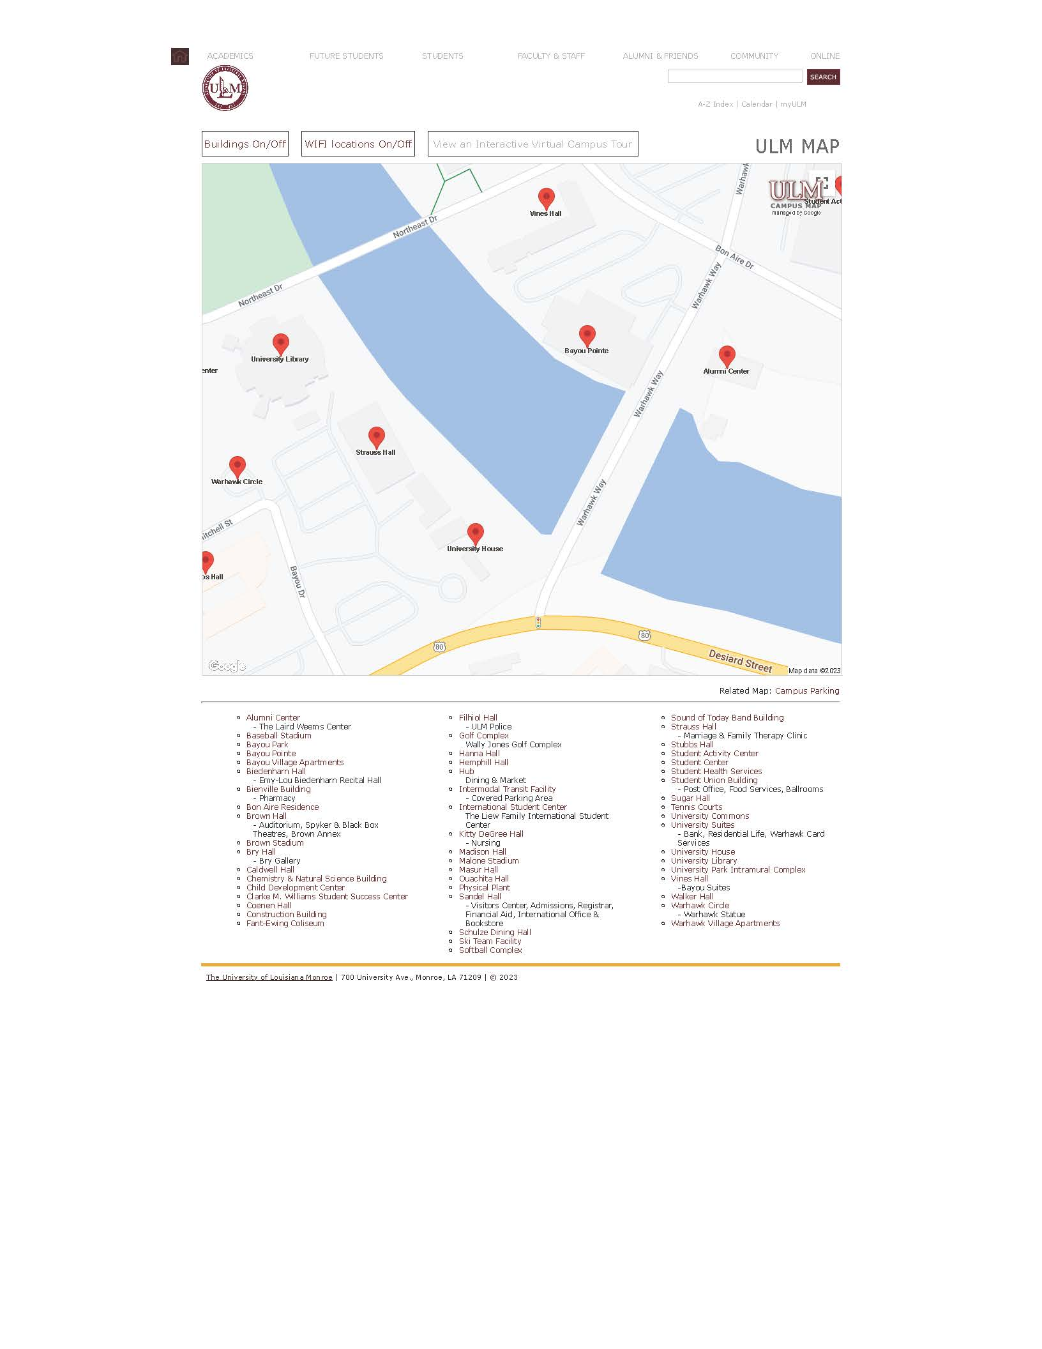

You are here!



**37th Annual**

**SPEECH-LANGUAGE PATHOLOGY**

**SPRING CONFERENCE**

**REGISTRATION INFORMATION**

***Please Print, Complete and mail this Form or Register via Eventbrite***

[***ULM 37th Annual Spring Conference***](https://www.eventbrite.com/e/37th-annual-ulm-speech-language-pathology-spring-conference-tickets-1233035956739?aff=oddtdtcreator)

**Registration Deadline: *Postmarked by March 14, 2025 by mail and through Eventbrite***

**Please check the following registration fee that applies to you:**

**Registration for Both Days**

**Registration Professionals _____$175 (Eligible for 1.0 ASHA CEUs or 10 PDH, must attend full conference, no partial credit offered)**

**Registration Students _____$80**

**Cancellation Policy: Written cancellation requests must be received by March 20, 2025 if mailed in, or refunded through Eventbrite by March 20, 2025.**

**Make check or money order along with this registration form payable to:**

**SLP Spring Conference at ULM**

**Mail to:**

**Speech-Language Pathology Program,**

**University of Louisiana Monroe**

**700 University Avenue, Monroe, LA 71209-0321**

**Privacy statement : If you have any questions regarding your privacy please refer to**[**www.LSHA.org/privacy**](https://nam04.safelinks.protection.outlook.com/?url=http%3A%2F%2Fwww.lsha.org%2Fprivacy&data=05%7C02%7Cdthomas%40ulm.edu%7Ca795091f75874e128cda08dd417dd6e5%7C90963b0cb03044fba95a9e359af4f668%7C1%7C0%7C638738730942713347%7CUnknown%7CTWFpbGZsb3d8eyJFbXB0eU1hcGkiOnRydWUsIlYiOiIwLjAuMDAwMCIsIlAiOiJXaW4zMiIsIkFOIjoiTWFpbCIsIldUIjoyfQ%3D%3D%7C0%7C%7C%7C&sdata=JED7yzjC9HSCGfPTVMjpy%2BiP7%2FTmWYAl22RyM%2B%2F%2B664%3D&reserved=0)

***(Please use a separate form for each person registering.)***

**Name (Print): ______________**  **Daytime Phone:**

**Professional Title and Affiliation ASHA #______________**

**Address: _______ Email:**

**LA License Number:___________ LA License Type: ULM Student CWID:**

**Total Amount Enclosed: (payable by check or debit/credit cards online)**

**Do you want these hours reported to ASHA for ASHA CEUs? Circle: YES NO**

**If you need specific accommodations or have complaints, concerns, or questions regarding this course please contact Donna Thomas at dthomas@ulm.edu or call 318-342-1397**

