[](https://ulm.edu/webguide/index.html)This document is part of a student’s **academic eFolio (electronic portfolio)** for an online course during the summer of 2019 at the University of Louisiana at Monroe (ULM). The images link to files located on the student’s personal ULM website account.

This student has allowed this *exemplar* to be publicly viewed. **Note: After this student graduates, these links will no longer work because the website will be de-activated. However, the student has the option to COPY and transfer the files to another website account in the future.**

3. **Your Photo.** Insert an “annotated” image of yourself that actively links to your online **about-me.pptx** online file located on your ULM website account. (25 pts)

[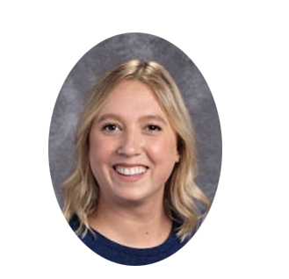](http://warhawks.ulm.edu/~guichardmt/5018/bin/about-me.pptx)4. **Your Project Proposal Cognitive Map**. Include a “cognitive map” describing your course project. (25 points)   
[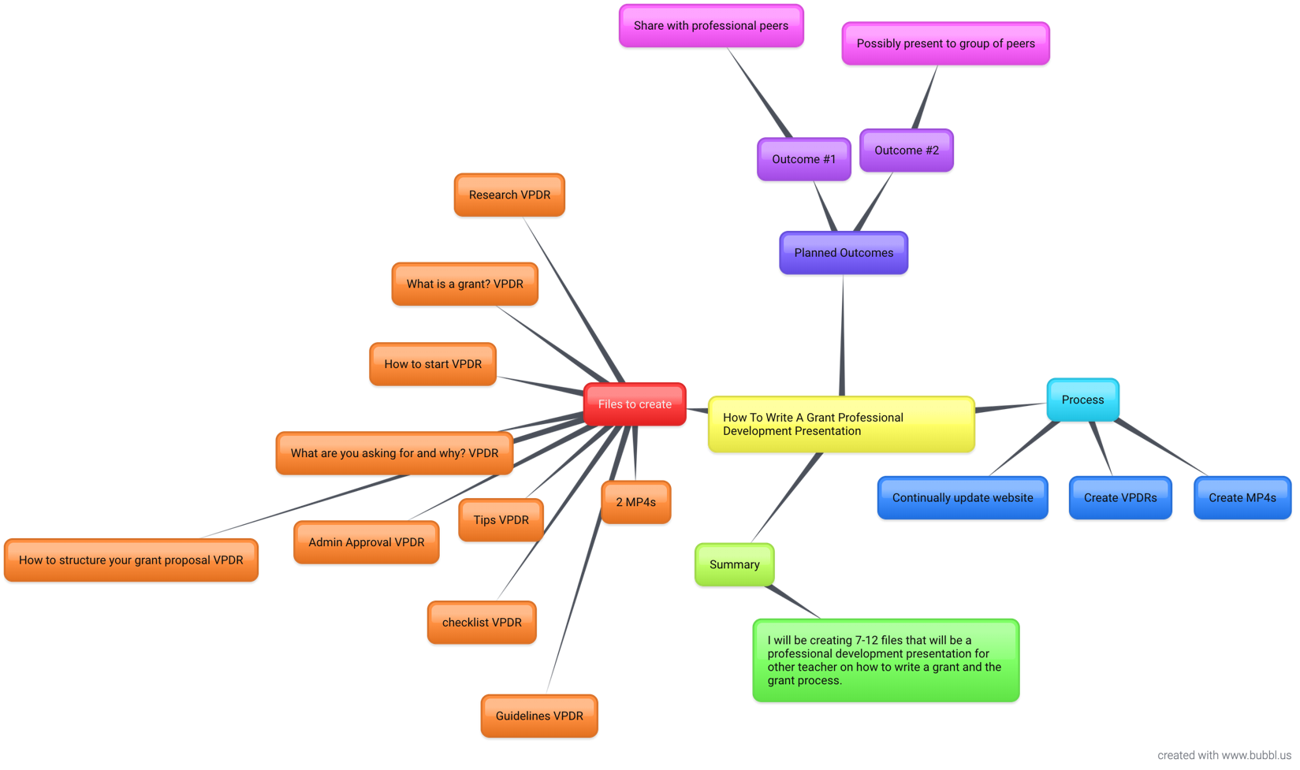](http://warhawks.ulm.edu/~guichardmt/5018/bin/project-proposal.docx)  
This is my cognitive mind map. I chose to create a “How to Write A Grant” Professional Development to share with my peers. The map helped me place my ideas down on paper. I was able to complete all of the files and more. I need to finish the projected outcomes and have my principal and administration sign off on my grant. I hope to apply for the grant on August 1.

5. **30-Second Video Summary Of Your Completed Online Course Project**. (50 points) **[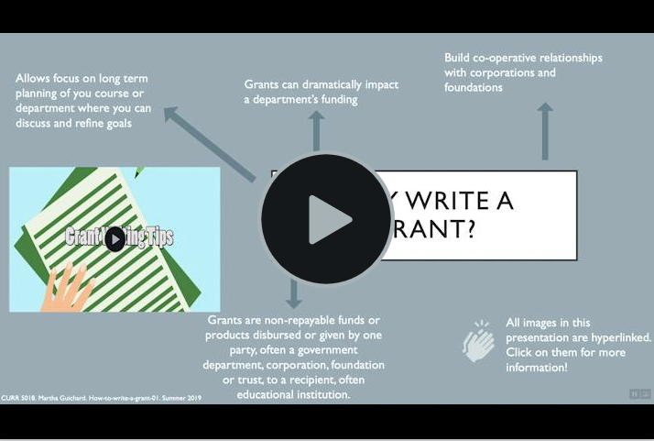](https://www.screencast.com/t/sZ56N6XFfKb)**

* 66. **Visually Link Your “Course Project Files” That You Created, Based On Your Project Proposal.**Provide actively linked images of your online course project files and provide text commentary. (200 pts.).

[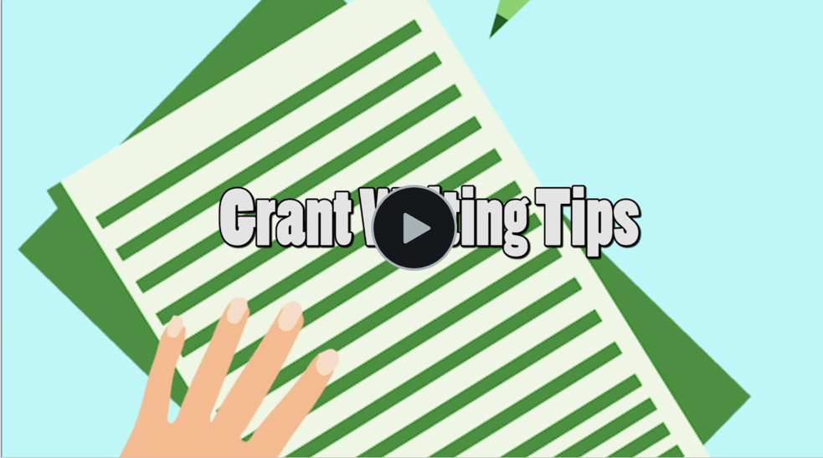](https://www.screencast.com/t/jx6abvFFhR)

This is an introduction video to show at the beginning of my professional development. I made the illustrations and animation.

[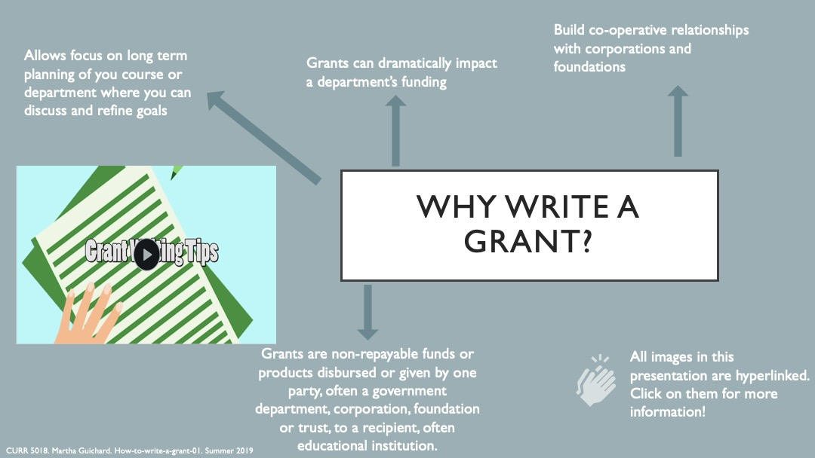](http://warhawks.ulm.edu/~guichardmt/5018/bin/project-vpdr-01.pptx)

This is my first slide of my presentation. It also has an animation that I made welcoming everyone to my presentation. By clicking on the clapping hands, you are linked to a website that I found extremely useful during this project.

[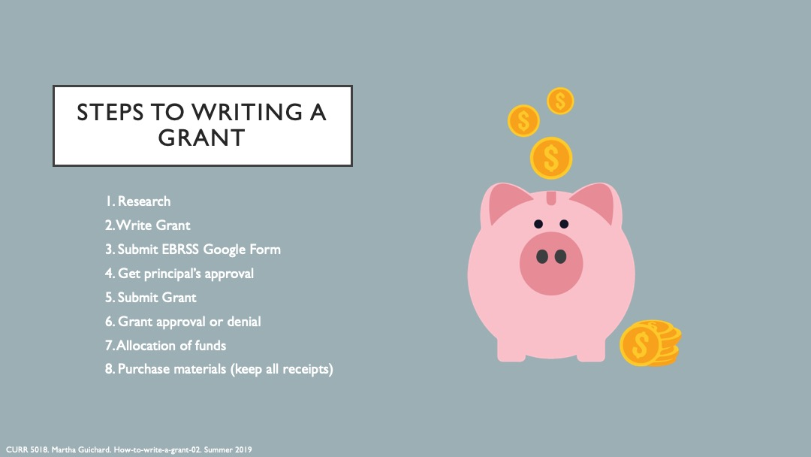](http://warhawks.ulm.edu/~guichardmt/5018/bin/project-vpdr-02.pptx)

These are the basic steps to submitting a grant. The pig is a clickable link. I wanted to show the overall process of writing and submitting a grant.

[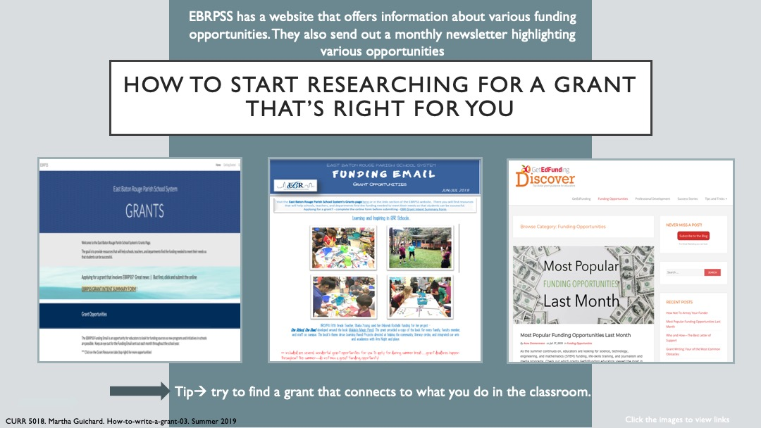](http://warhawks.ulm.edu/~guichardmt/5018/bin/project-vpdr-03.pptx)

These are East Baton Rouge Parish School System links that are very helpful. In EBRPSS, you must submit a Google Form stating that you are writing a grant. It is important to keep everyone in the loop during the grant writing process. The other pages are both very helpful websites to look at during your research in finding the right grant for you.

[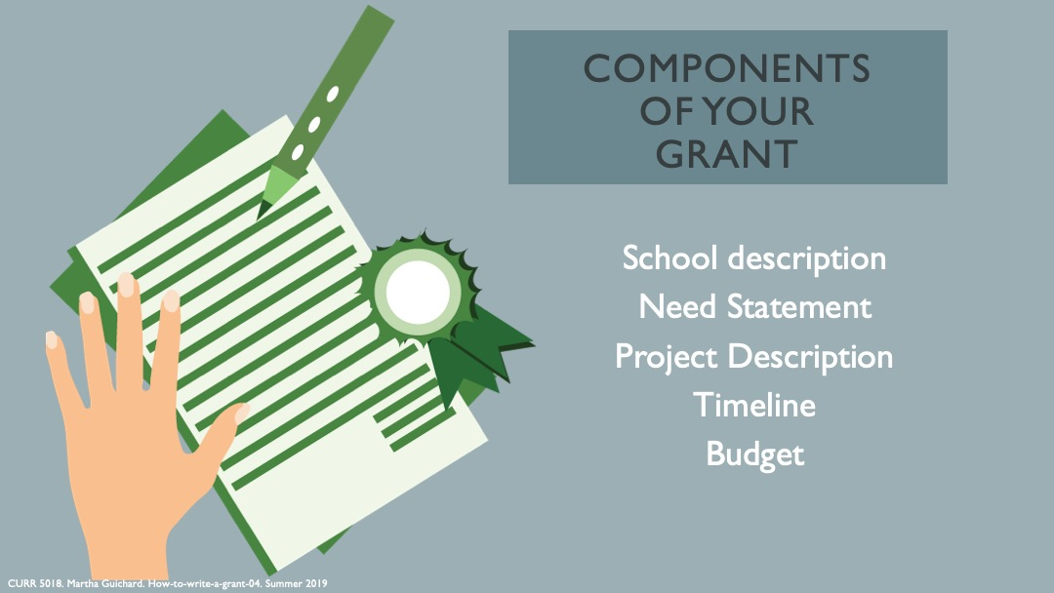](http://warhawks.ulm.edu/~guichardmt/5018/bin/project-vpdr-04.pptx)

This slide gives the different parts and components of your written grant. It helps the writer put the different sections in their grant. Again, the image leads the viewer to a very helpful website that has more in depth information.

[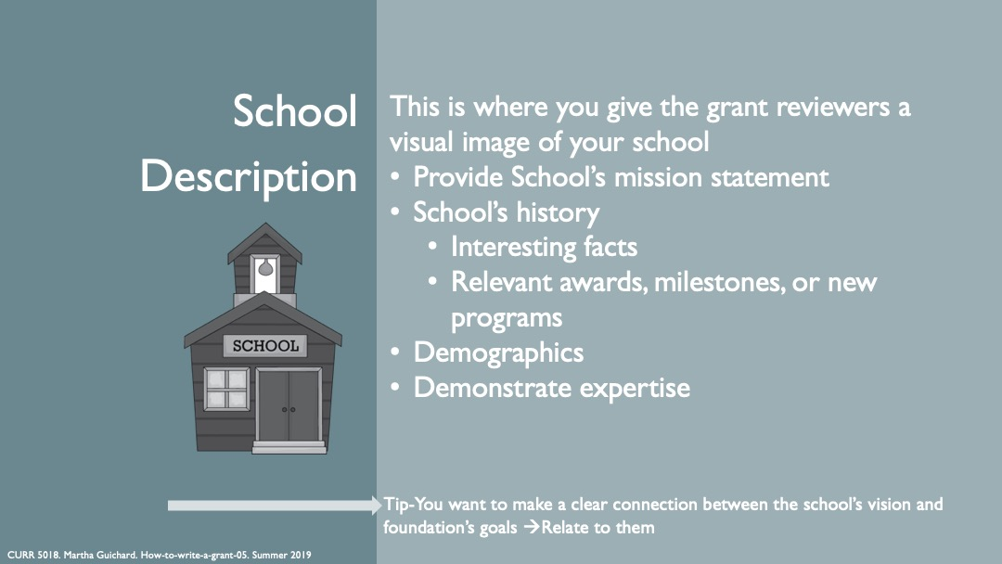](http://warhawks.ulm.edu/~guichardmt/5018/bin/project-vpdr-05.pptx)

This slide describes the school description section of the grant. It gives the writer different ideas that they can incorporate into their grant. Just a reminder- every slide has a clickable image that will link the viewer to more in depth information.

[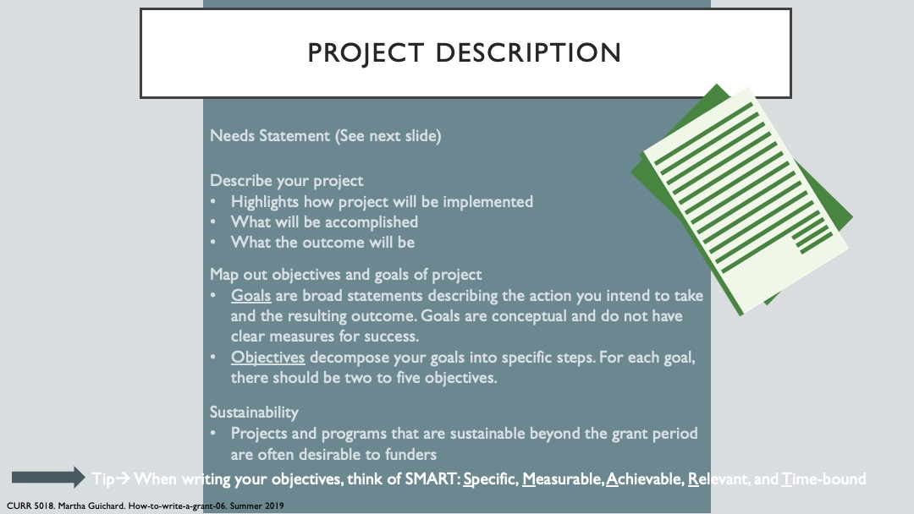](http://warhawks.ulm.edu/~guichardmt/5018/bin/project-vpdr-06.pptx)

This slide explains to the view the section of the project description. It is very important to include your objectives and goals of your grant. The grant reviewer will want to see clear and detailed goals and objectives.

[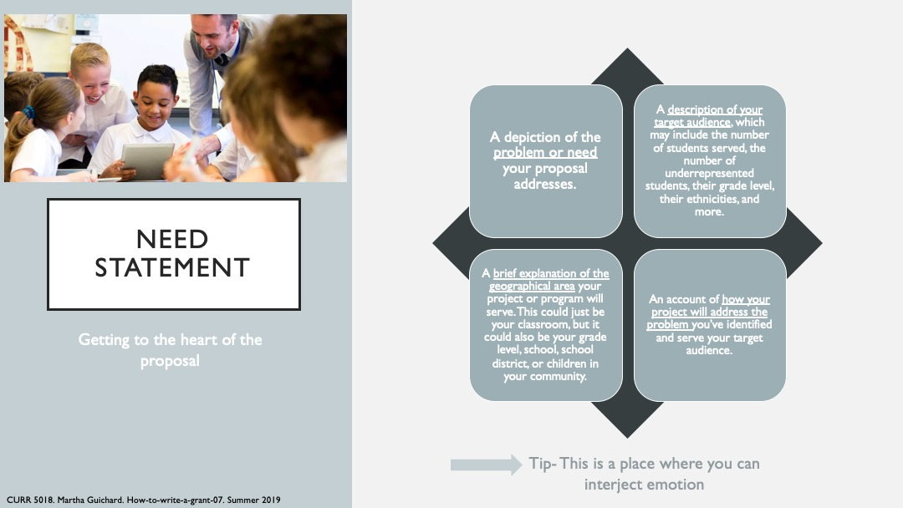](http://warhawks.ulm.edu/~guichardmt/5018/bin/project-vpdr-07.pptx)

The need statement is one of the most important parts of a grant. This is where you will pull the grant reviewers’ heart strings. You can also show the grant reviewers that the grant would really make a different in your students’ lives.

[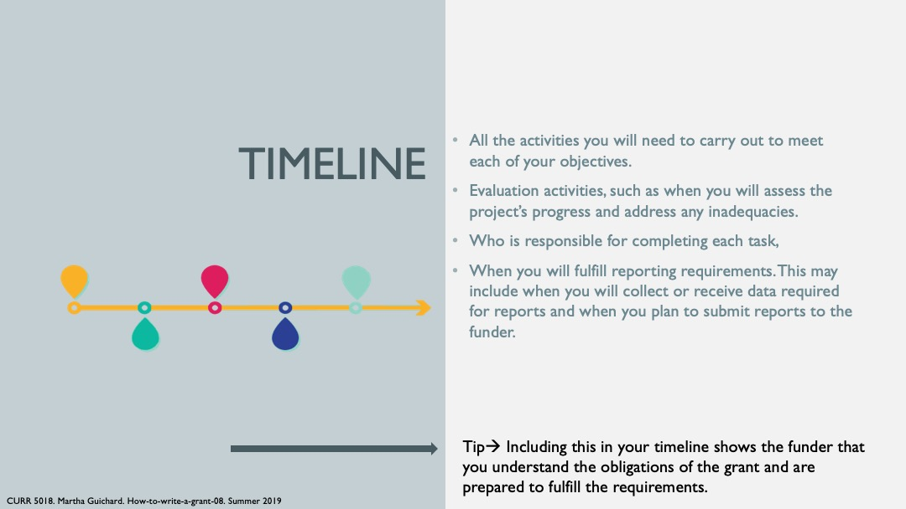](http://warhawks.ulm.edu/~guichardmt/5018/bin/project-vpdr-08.pptx)

The timeline lets the grant reviewer know how long it is going to take to meet your goals and objectives. It shows the grant reviewer that you are going to follow through with your proposal after getting the grant money. It also lets the grant reviewer know when to check in on you to make sure that you are following the requirements. After a grant, you are required to report back to the foundation about how your project is going.

[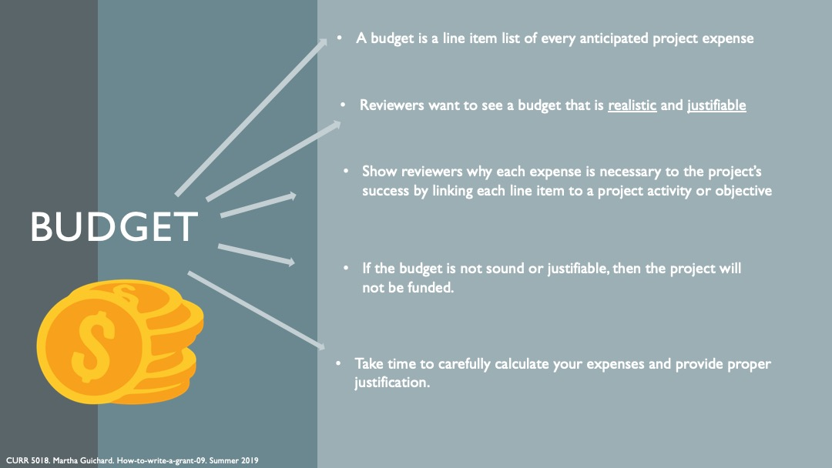](http://warhawks.ulm.edu/~guichardmt/5018/bin/project-vpdr-09.pptx)

Getting your budget calculations correct is also a very important part to the grant writing process. You must be precise down to the penny. This is also where you describe the uses of the grant in detail.

[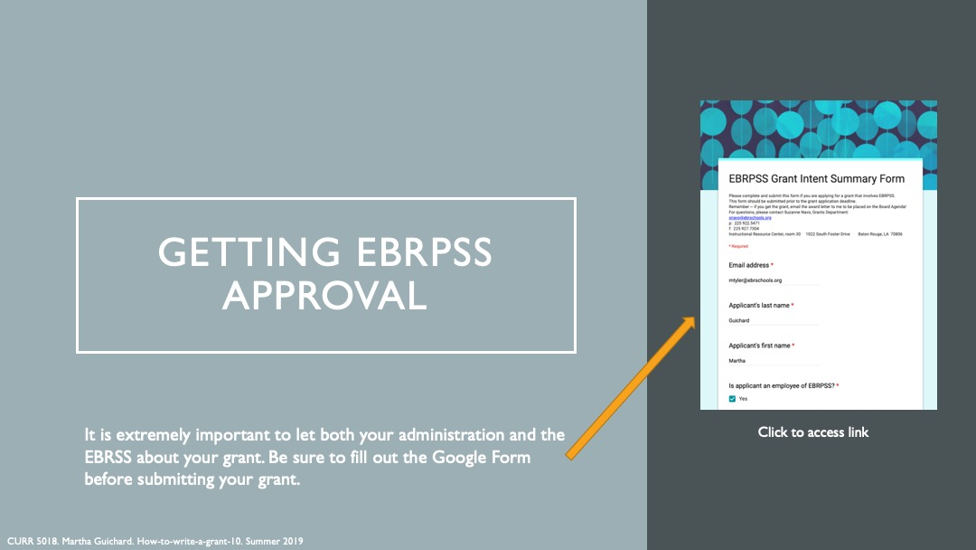](http://warhawks.ulm.edu/~guichardmt/5018/bin/project-vpdr-10.pptx)

There is a direct link to the EBRPSS Grant Intent form. You must fill this out before submitting your grant. If this form is not filled out, you may not be able to accept the grant if you get it.

[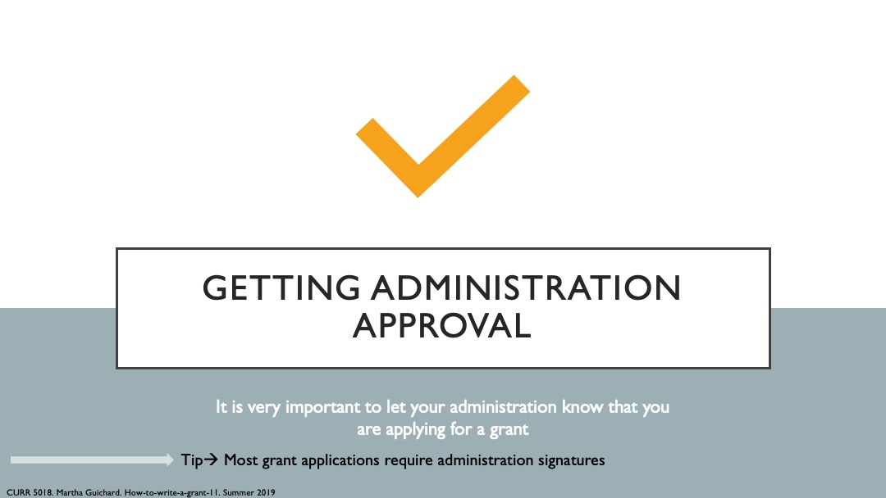](http://warhawks.ulm.edu/~guichardmt/5018/bin/project-vpdr-11.pptx)

It is also important to let your administration know that you are applying for a grant. The principal must approve any grants before submittal. Most grants require an administration signature when applying for the grant.

[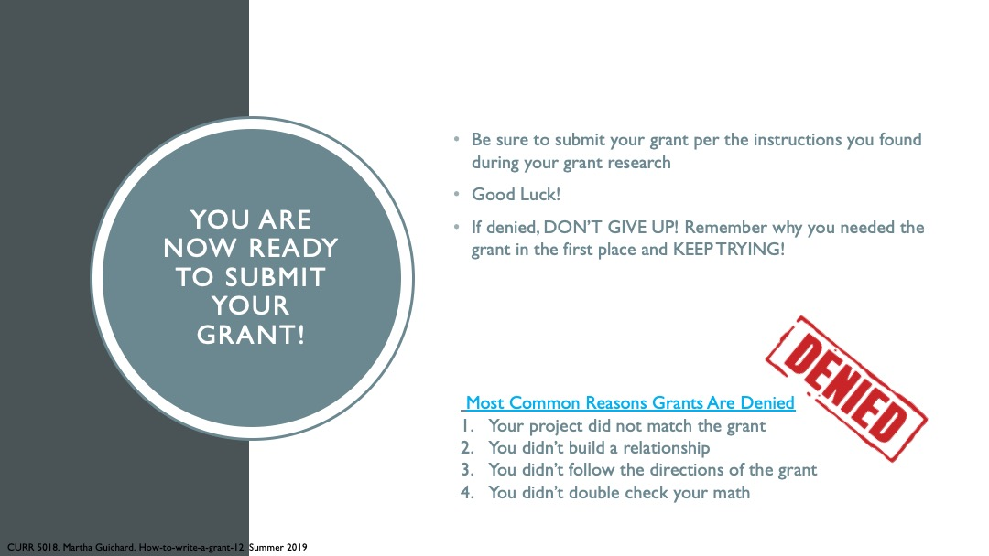](http://warhawks.ulm.edu/~guichardmt/5018/bin/project-vpdr-12.pptx)

Now it’s time to submit the grant. This slide reminds the viewer to be positive and not to get down if they do not get the grant. It takes time to get the funding that you need. Do not stop because one of your grant requests get denied. Remember to continue on your quest to get the funding your students need.

[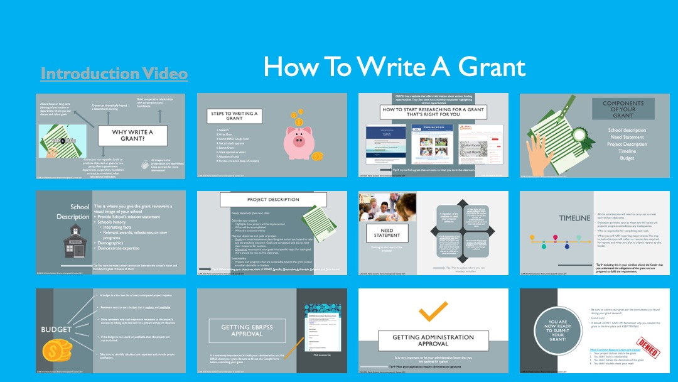](http://warhawks.ulm.edu/~guichardmt/5018/bin/project-compilation.pptx)

Compilation 7. **Visually Describe At Least 10 Professional “Visual Professional Diary Reflections”.** Provide captured images that actively link to at least 10 online visual professional diary reflections (VPDRs). (150 pts).

[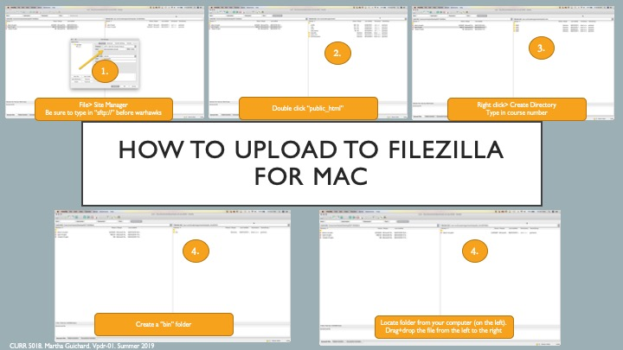](http://warhawks.ulm.edu/~guichardmt/5018/bin/vpdr-01.pptx)

This file was made to help other MAC users in the class.

[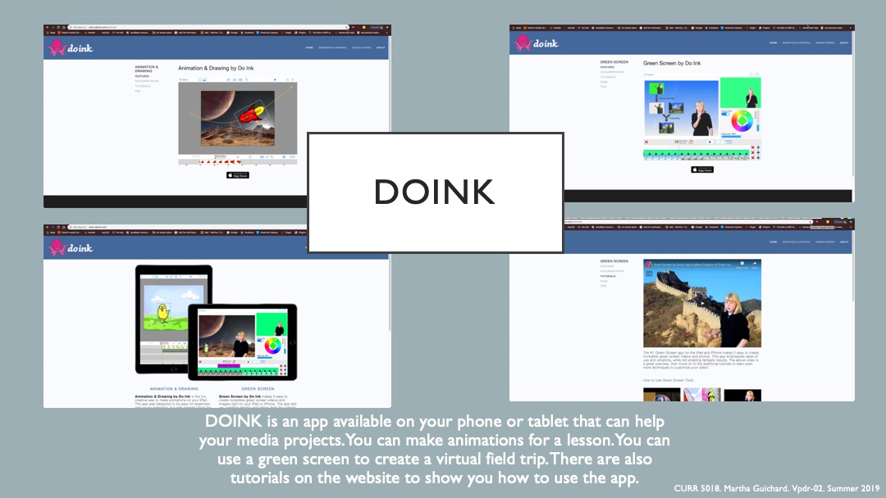](http://warhawks.ulm.edu/~guichardmt/5018/bin/vpdr-02.pptx)

This app is great for ameture green screen videos and animation. There are presets that let you plug and play with your own videos. The app can be downloaded on your phone.

[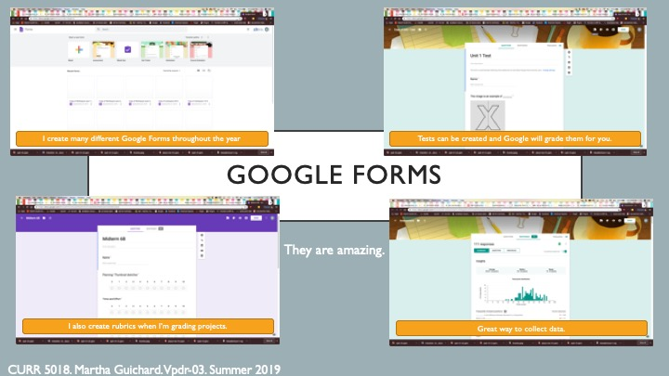](http://warhawks.ulm.edu/~guichardmt/5018/bin/vpdr-03.pptx)

This slide is about how to use Google Forms. There are many benefits of this app. You can build tests, quizzes, or simple surveys.

[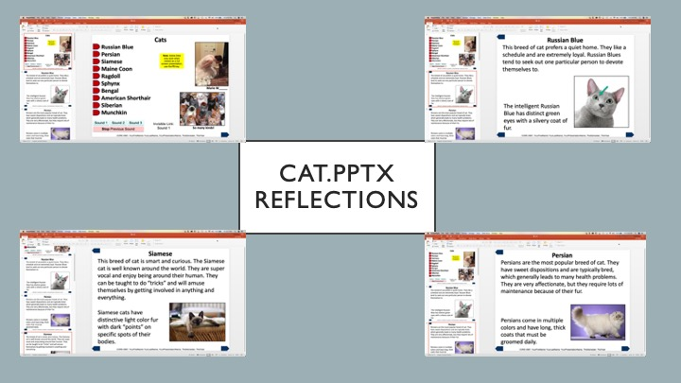](http://warhawks.ulm.edu/~guichardmt/5018/bin/vpdr-04.pptx)

This vpdr was for the assignment of examining the interactive powerpoint. There was also a snagit mp4 to go along with it.

[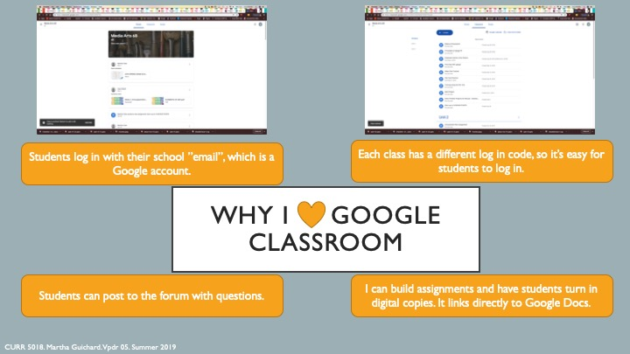](http://warhawks.ulm.edu/~guichardmt/5018/bin/vpdr-05.pptx)  
I also love Google Classroom. I use it to create assignments, post information that student’s need, and forums for students to use as well.

[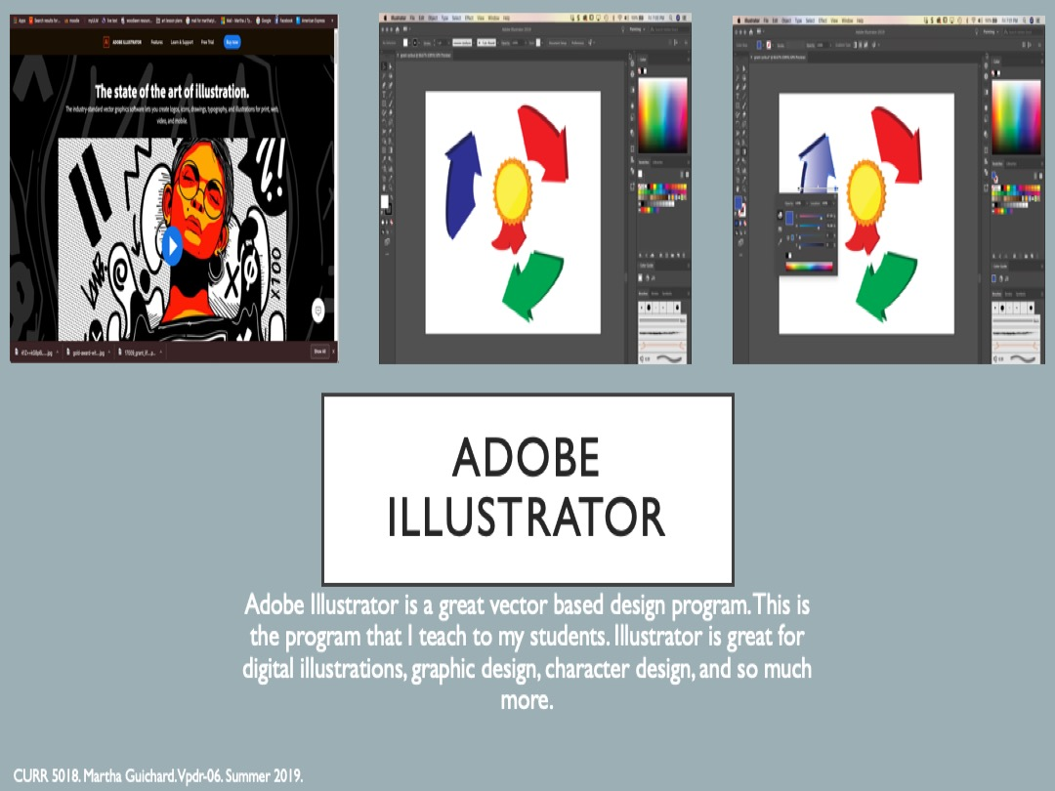](http://warhawks.ulm.edu/~guichardmt/5018/bin/vpdr-06.pptx)

Adobe Illustrator is the program that I teach my students. I basically use this program every day. It is great for building vector based illustrations.

[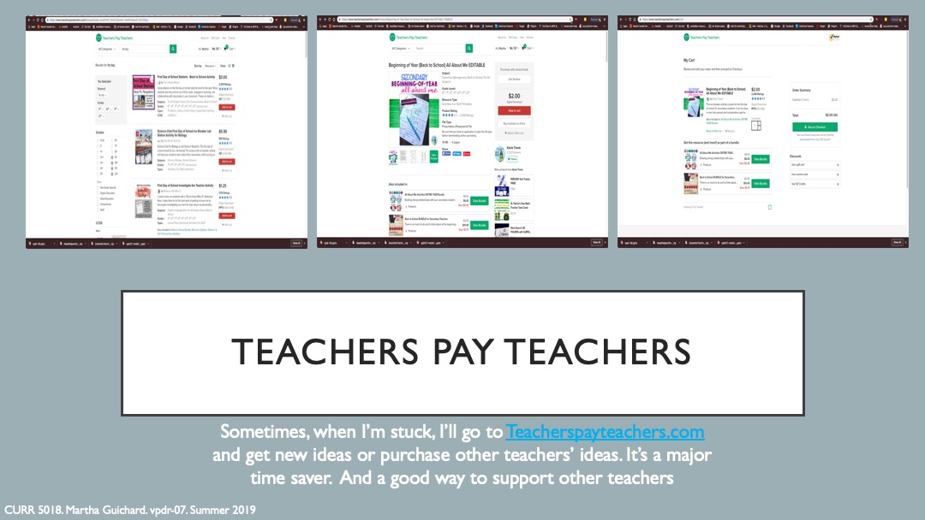](http://warhawks.ulm.edu/~guichardmt/5018/bin/vpdr-07.pptx)  
Teachers Pay Teachers is a great website to use for many different things. Personally, I like using it for any sort of substitute work. It comes with great instructions and digital files.

[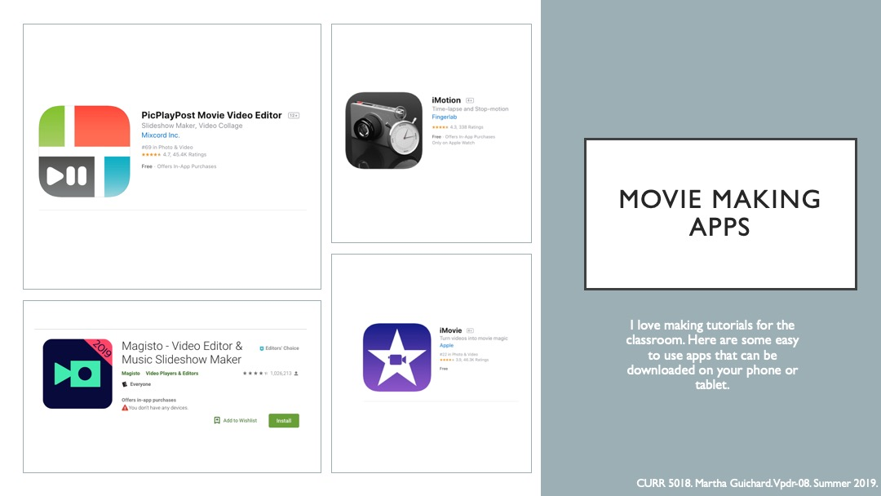](http://warhawks.ulm.edu/~guichardmt/5018/bin/vpdr-08.pptx)  
These are some great apps for both Android or Iphone. These apps are available on your phone. They are great for making videos for your students.

[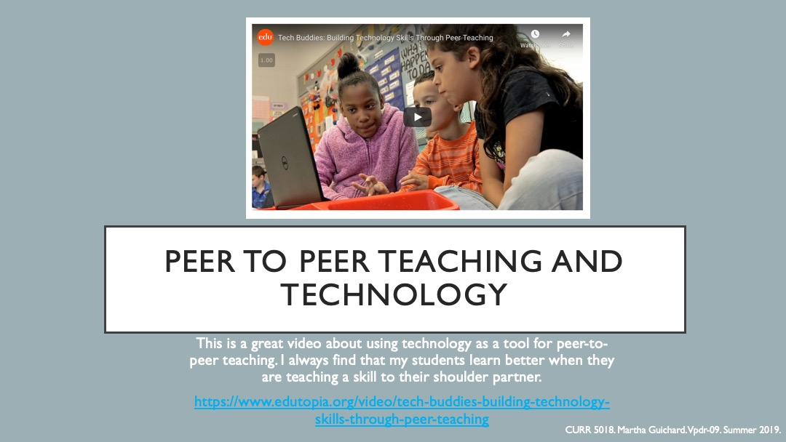](http://warhawks.ulm.edu/~guichardmt/5018/bin/vpdr-09.pptx)

I love peer to peer teaching. I find that my students learn best when they are able to teach information to other students. This article talks about incorporating technology into this strategy.

[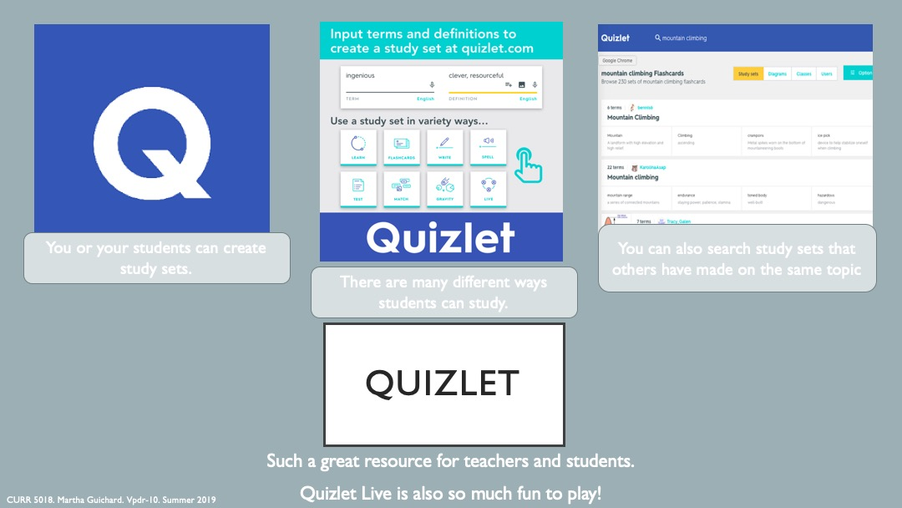](http://warhawks.ulm.edu/~guichardmt/5018/bin/vpdr-10.pptx)

Quizlet is my students’ favorite study material. We always play quizlet live before tests. I get great feedback from the student when we play.

8. **Identify An Outstanding Free Online Educational Resource** (25 points)

[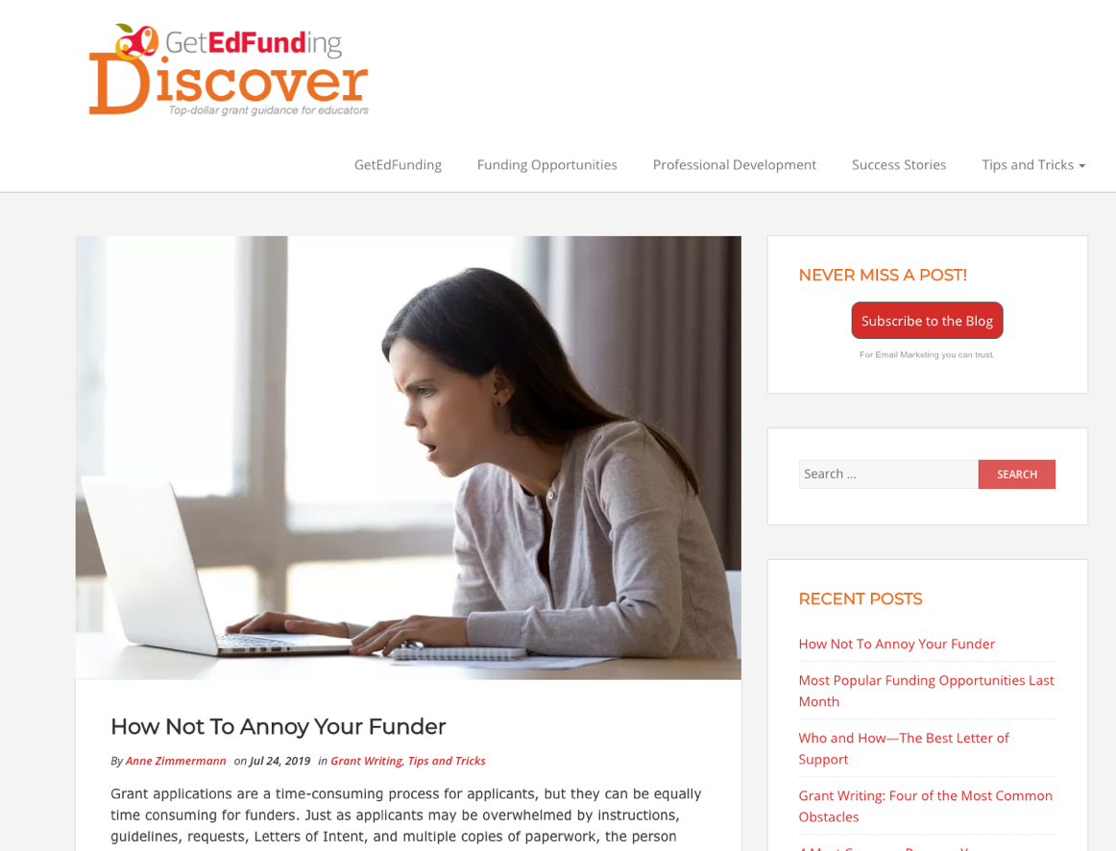](https://blog.getedfunding.com/)

I used many articles from this website for my project. It’s a very down to earth blog showing the best strategies for writing grants. It gives great insight into how to write a grant and how to really connect with the grant reviewer. This is the best resource I found for both how to write a grant and searching for grants that are right for you.