[](https://ulm.edu/webguide/index.html)This document is part of a student’s **academic eFolio (electronic portfolio)** for an online course during the summer of 2019 at the University of Louisiana at Monroe (ULM). The images link to files located on the student’s personal ULM website account.

This student has allowed this *exemplar* to be publicly viewed. **Note: After this student graduates, these links will no longer work because the website will be de-activated. However, the student has the option to COPY and transfer the files to another website account in the future.**

3. **Your Photo.** Insert an “annotated” image of yourself that actively links to your online **about-me.pptx** online file located on your ULM website account. (25 pts)

***[](http://warhawks.ulm.edu/~philippes/5018/bin/About-me.pptx)***4. **Your Project Proposal Cognitive Map**. Include a “cognitive map” describing your course project. (25 points)   
[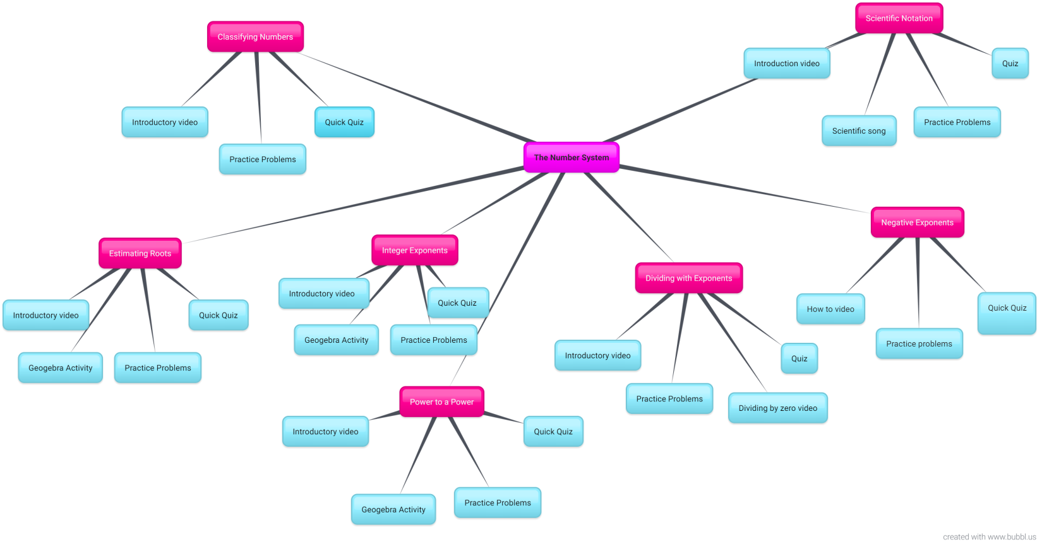](http://warhawks.ulm.edu/~philippes/5018/bin/ProjectProposalSP.docx)

The cognitive map above shows the first few lessons of the eighth grade math curriculum at my current school. We will begin with The Real Number System followed by Estimating roots, Integer Exponents, Power to a Power, Dividing with Exponents, Negative Exponents, and finally Scientific Notation. In order to learn about each topic, students will watch a Khan Academy video and then work practice problems that provide step-by-step how to-s as well as further video explanations if needed. Some topics have additional visual explanations and games for students to play on GeoGebra.

[http://warhawks.ulm.edu/~philippes/5018/bin/ProjectProposalSP**.docx**](http://warhawks.ulm.edu/~philippes/5018/bin/Project-Compilation.pptx)

My proposal was to create a series of PowerPoint presentations that will engage students in discovery learning of the Number System in Mathematics. The students that I teach struggle with the very basics of the number system and don’t comprehend why it is crucial to fully grasp the concept before we can move on to the next unit. Without the proper understanding of the Number System, it is much more difficult for students to be successful in the remainder of the eighth grade units. Creating a new and innovative way for students to grasp this information will be beneficial to all students at my current school. I created 7 VPDRs that allow students to watch videos, practice problems, engage in activities to visually understand mathematics concepts, and assess their understanding when they’re ready to show mastery of each topic.

5. **30-Second Video Summary Of Your Completed Online Course Project**. (50 points)

[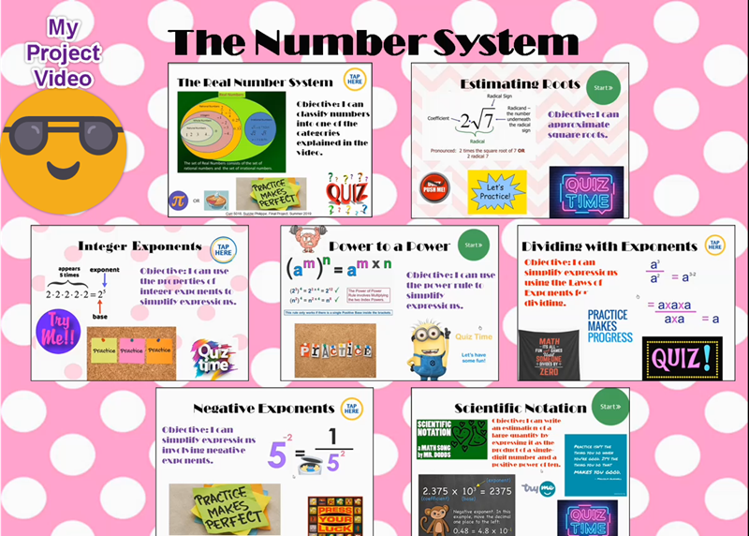](https://www.screencast.com/t/UXf7G0Z3dFr)

* 66. **Visually Link Your “Course Project Files” That You Created, Based On Your Project Proposal.**Provide actively linked images of your online course project files and provide text commentary. (200 pts.).

[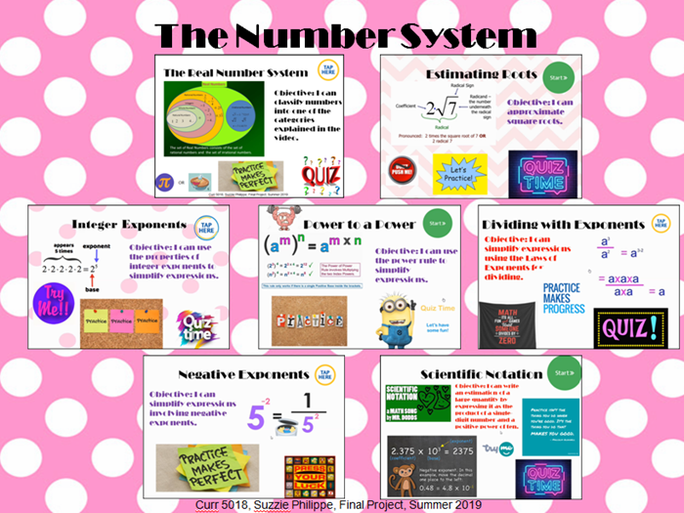](http://warhawks.ulm.edu/~philippes/5018/bin/Project-Compilation.pptx)

The image above is a compilation of the files that I made for my final project. Each one is actively linked to the online file and the images inside of each VPDR are actively linked to online activities for students to complete.

[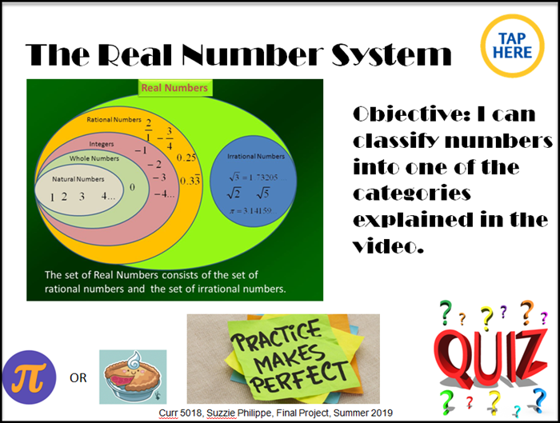](http://warhawks.ulm.edu/~philippes/5018/bin/Project1.pptx)

Students will use the file above to explore The Real Number System. It has a link to a video that I created in the top right corner to explain what order to complete the tasks in. They will view a video from Khan Academy, work practice problems, and finish with a quiz on Edulastic.

[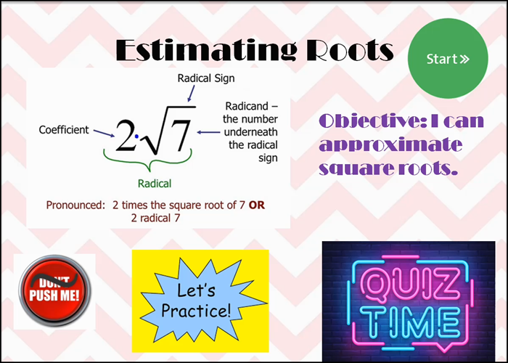](http://warhawks.ulm.edu/~philippes/5018/bin/Project2.pptx)

Students will use the file above to explore Estimating Roots. It has a link to a video in the top right corner that I created to explain what order to complete the tasks in. They will view a video from Khan Academy, work practice problems, and finish with a quiz on Edulastic. The “don’t push me” button will take them to an activity on GeoGebra for more explanations and practice.

[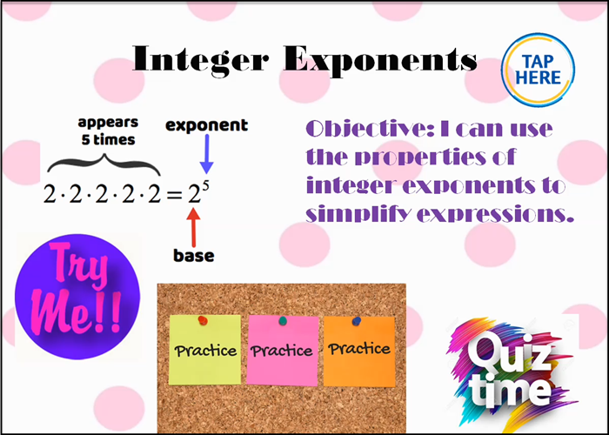](http://warhawks.ulm.edu/~philippes/5018/bin/Project3.pptx)

Students will use the file above to learn about Integer Exponents. It has a link to a video in the top right corner that I created to explain what order to complete the tasks in. They will view a video from Khan Academy, work practice problems, and finish with a quiz on Edulastic. The “try me” button will take them to an activity on GeoGebra for more explanations and practice.

[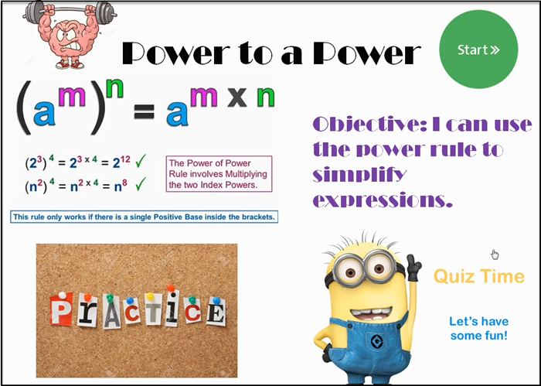](http://warhawks.ulm.edu/~philippes/5018/bin/Project4.pptx)

Students will use the file above to learn about Power to a Power rules for integer exponents. It has a link to a video in the top right corner that I created to explain what order to complete the tasks in. They will view a video from Khan Academy, work practice problems, and finish with a quiz on Edulastic. The brain working out link will take them to an activity on GeoGebra for more explanations and practice.

[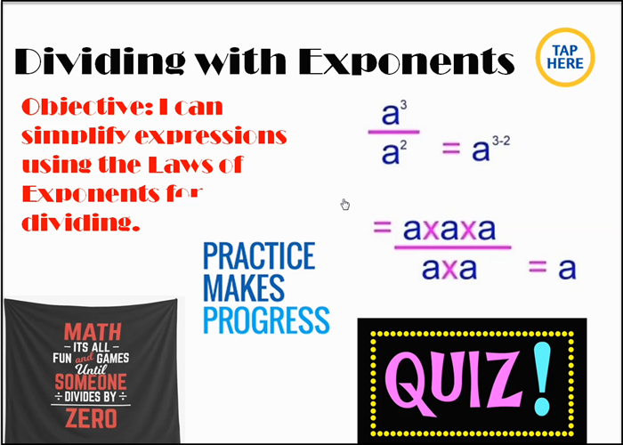](http://warhawks.ulm.edu/~philippes/5018/bin/Project5.pptx)

Students will use the file above to explore dividing with exponents. It has a link to a video in the top right corner that I created to explain what order to complete the tasks in. They will view a video from Khan Academy, work practice problems, and finish with a quiz on Edulastic. The “Dividing by Zero” will take them to a video that explains why it is impossible to divide by zero.

[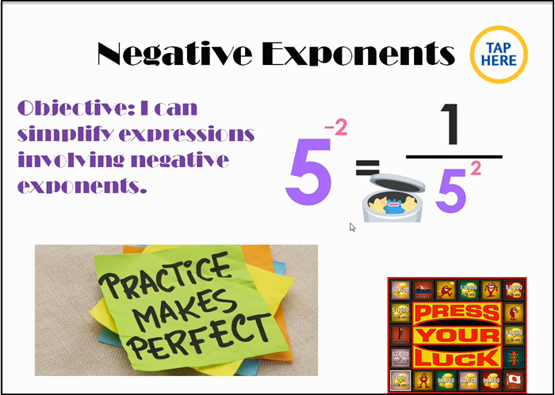](http://warhawks.ulm.edu/~philippes/5018/bin/Project6.pptx)

Students will use the file above to learn how to use Negative Exponents. It has a link to a video in the top right corner that I created to explain what order to complete the tasks in. They will view a video from Khan Academy, work practice problems, and finish with a quiz on Edulastic.

[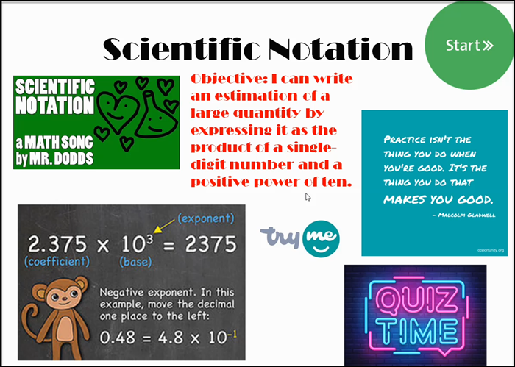](http://warhawks.ulm.edu/~philippes/5018/bin/Project7.pptx)

Students will use the file above as in introduction to scientific notation. It has a link to a video in the top right corner that I created to explain what order to complete the tasks in. They will view a watch a video of a song about scientific notation, then watch a how-to video from Khan Academy, work practice problems, and finish with a quiz on Edulastic. The “try me” button will take them to an activity on GeoGebra for more explanations and practice.

7. **Visually Describe At Least 10 Professional “Visual Professional Diary Reflections”.** Provide captured images that actively link to at least 10 online visual professional diary reflections (VPDRs). (150 pts).   
  
[](http://warhawks.ulm.edu/~philippes/5018/bin/vpdr-01.pptx)

The image above is my About Me VPDR. It shows a picture of me and my family as well as my sweet puppy Oliver. It shows that I am a math teacher, Saints fan, and player of the Nintendo Switch.

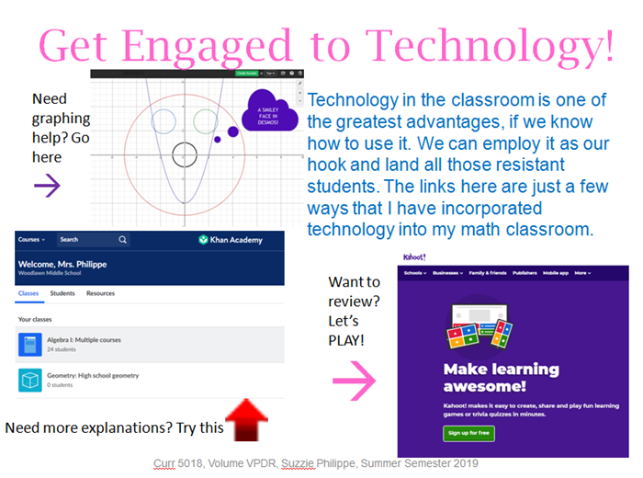

The image above showcases a few of the great resources that are available to teachers. I use these regularly in my classroom and they are so beneficial to me and my students. Our students require technology these days to stay engaged.

[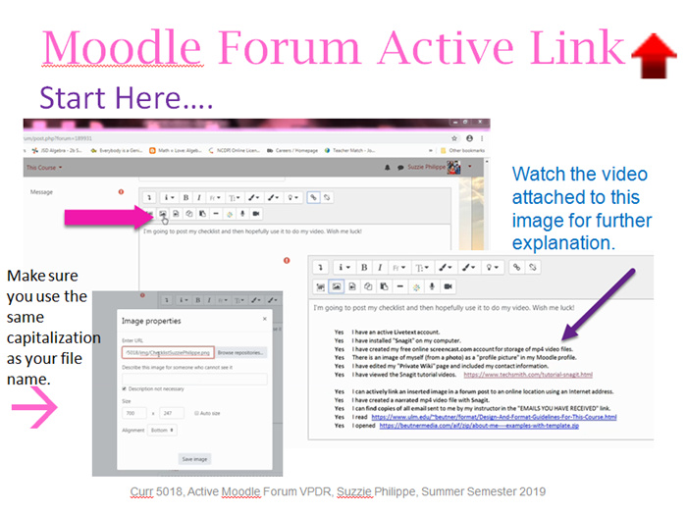](http://warhawks.ulm.edu/~philippes/5018/bin/vpdr-03.pptx)

The VPDR above shows how to actively link an image in a Moodle post. It was a very useful technique to learn. It also includes a how-to video that I made describing the process.

[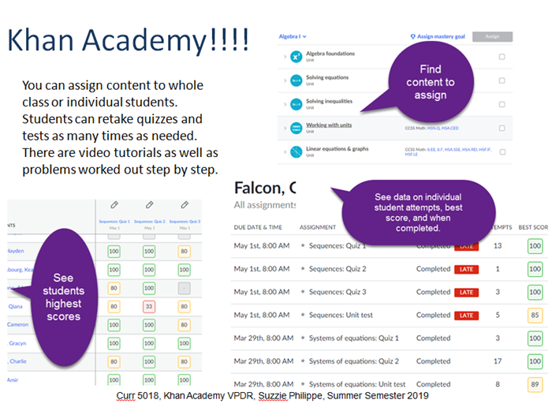](http://warhawks.ulm.edu/~philippes/5018/bin/vpdr-04.pptx)

The VPDR shown above is on Khan Academy. It is probably one of the most useful websites for students in any mathematics course. I use it daily with my homeroom students. It tracks progress from beginning to end and shows which topics the student has mastered and what they still need assistance with.

[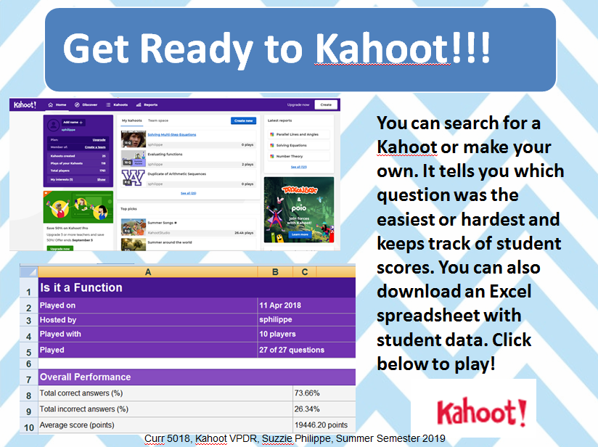](http://warhawks.ulm.edu/~philippes/5018/bin/vpdr-05.pptx)

Kahoot is a huge hit with students of all ages. It will get any student engaged in Mathematics. My students get very competitive when we play. It keeps track of which questions were most missed as well as individual statistics.

[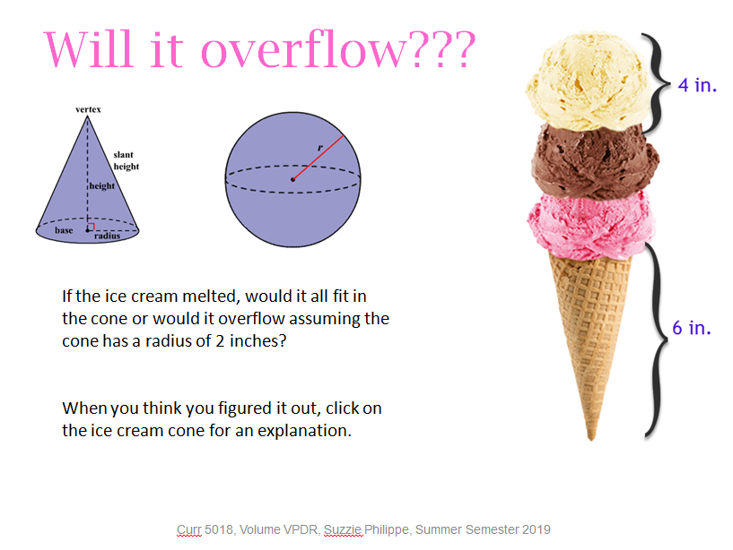](http://warhawks.ulm.edu/~philippes/5018/bin/vpdr-06.pptx)

This VPDR was made specifically for my Geometry students. It is an interactive way for students to discover the formulas for different 3-D shapes and figure out if the cone will overflow. These types of VPDRs would be very beneficial to my students because it allows them the autonomy to explore the topics at their own pace.

[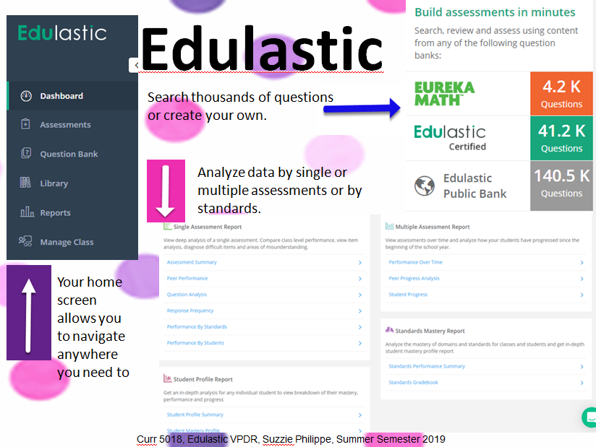](http://warhawks.ulm.edu/~philippes/5018/bin/vpdr-07.pptx)

Edulastic is a wonderful resource for all teachers. It has thousands of questions for every subject and allows teachers to monitor student success. You can create your own assessments, create your own questions, or use questions made by other teachers, districts, or textbook manufacturers.

[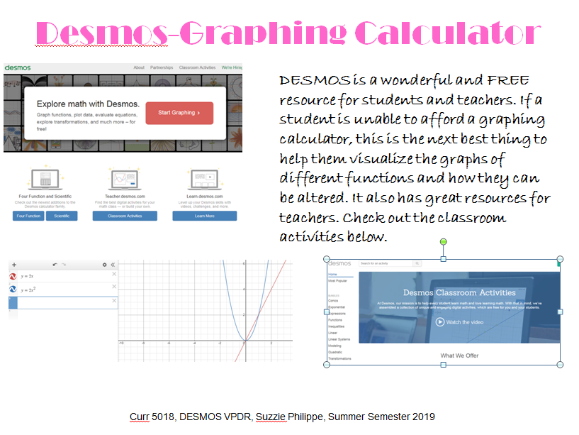](http://warhawks.ulm.edu/~philippes/5018/bin/vpdr-08.pptx)

Desmos is a free resource for everyone. It is amazing for students who can’t afford to purchase a handheld graphing calculator. There are also resources for teachers with lesson plans and activities.

[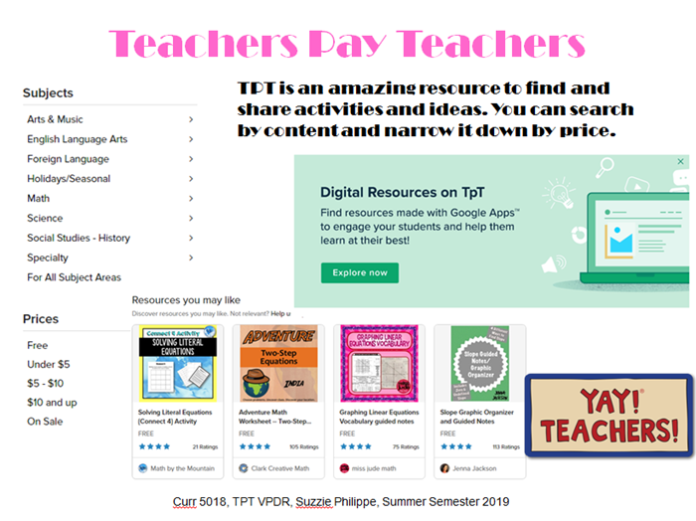](http://warhawks.ulm.edu/~philippes/5018/bin/vpdr-09.pptx)

Teachers Pay Teachers is a great website if you need some fresh ideas. You can purchase something another teacher has made or find free resources. Sometimes it’s just a great place for inspiration.

[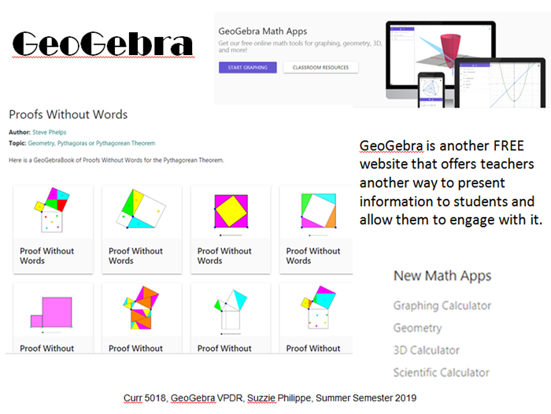](http://warhawks.ulm.edu/~philippes/5018/bin/vpdr-10.pptx)

GeoGebra is a free resource that provides visual interactive activities for students to engage with. I am looking forward to using this resource more often in my classroom this year. There are great resources for teachers and students.

[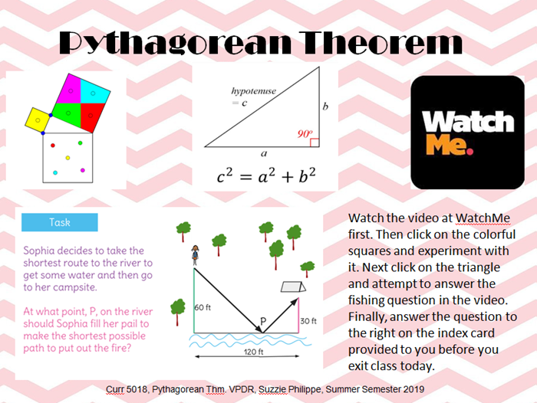](http://warhawks.ulm.edu/~philippes/5018/bin/vpdr-11.pptx)

I can’t wait to use this with my students this year. It has a link to a GeoGebra activity, two videos from Khan Academy, and an exit ticket.

8. **Identify An Outstanding Free Online Educational Resource** (25 points)

[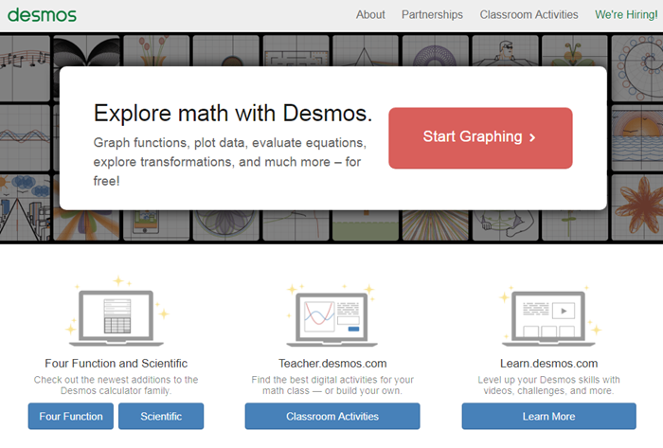](https://www.desmos.com)

This website is an amazing free resource for teachers and students. If students can’t afford to pay the hundred dollars for a handheld graphing calculator, this is an excellent substitute. It will help students to visually see how functions can be manipulated and in what ways. There are also predesigned lesson plans and activities for teachers to use.