[](https://ulm.edu/webguide/index.html)This document is part of a student’s **academic eFolio (electronic portfolio)** for an online course during the summer of 2019 at the University of Louisiana at Monroe (ULM). The images link to files located on the student’s personal ULM website account.

This student has allowed this *exemplar* to be publicly viewed. **Note: After this student graduates, these links will no longer work because the website will be de-activated. However, the student has the option to COPY and transfer the files to another website account in the future.**

3. **Your Photo.** Insert an “annotated” image of yourself that actively links to your online **about-me.pptx** online file located on your ULM website account. (25 pts)

In this original picture a woman was in full view behind me. Snagit allowed me to crop her out to make for a better picture.

Tortoises, Sea Turtles, and all turtle alike are my favorite animals.

***[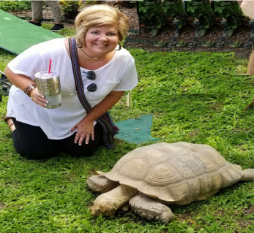](http://warhawks.ulm.edu/~nugenta/5018/bin/about-me.pptx)***

Picture was taken at a Turtle/Tortoise Sanctuary.

4. **Your Project Proposal Cognitive Map**. Include a “cognitive map” describing your course project. (25 points)   
[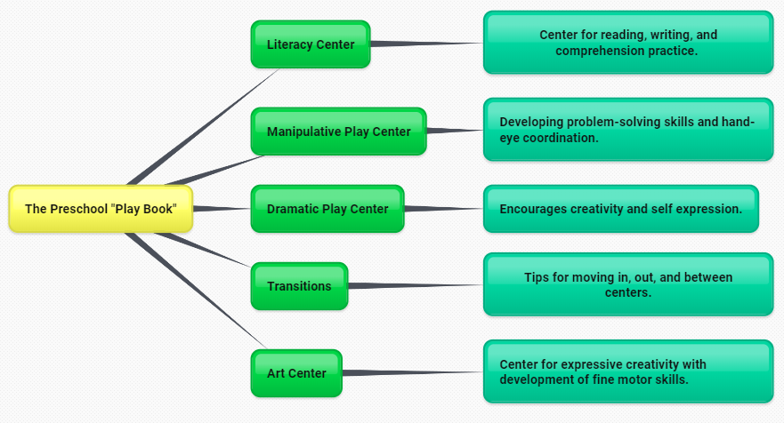](http://warhawks.ulm.edu/~nugenta/5018/bin/project-proposal.docx)

My project proposal pitches a “play book” of tips for implementing simple adaptations that teachers can use during center time for our preschool students with disabilities. Because play time is an important part of the educational school day, this “play book” provides helpful modifications to five major areas used in classrooms across the nation. It will be implemented as a curriculum aid to allow teachers to modify their current lesson plans to better assist children with fine and gross motor, cognitive, social/emotional, and language concerns. By creating a Kiosk Power Point with an interactive menu and a slide for instructions, teachers can navigate between the different areas listed in the cognitive map above. Each slide will also include picture(s) illustrating ideas for each topic as well as videos to assist teachers in navigating topics in each slide.

5. **30-Second Video Summary Of Your Completed Online Course Project**. (50 points)

[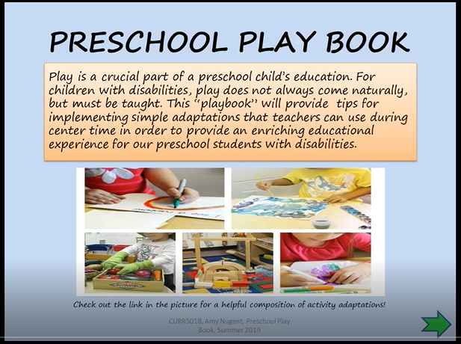](https://www.screencast.com/users/AmyNugent/folders/Default/media/0163d309-71c0-46a5-be68-cb3c37559dc7)

Teachers can modify any center in order to provide an enriching educational experience for all children.

Each file is equipped with active links to helpful articles and fun videos.

Centers included: Literacy, Manipulatives, Dramatic Play, Art Centers, and Center time Transitions.

* 66. **Visually Link Your “Course Project Files” That You Created, Based On Your Project Proposal.**Provide actively linked images of your online course project files and provide text commentary. (200 pts.).

[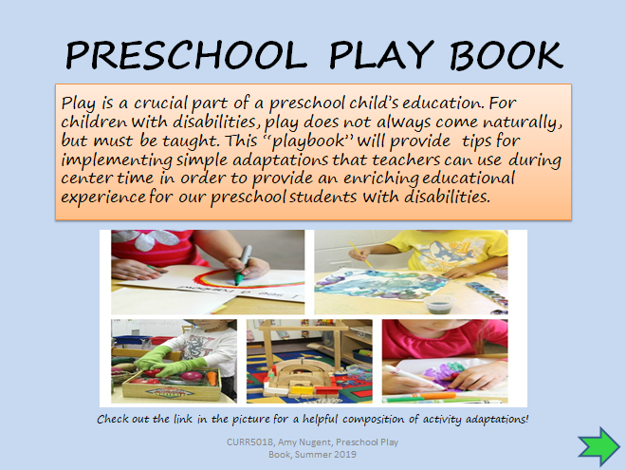](http://warhawks.ulm.edu/~nugenta/5018/bin/project-play-book.pptx)

The Preschool Play Book was designed to help teachers with implementing adaptations that can be used during center time. The Play Book highlights universal center themes and provides tips, web links, and videos to modify materials, strategies, and layouts of individual activities.

[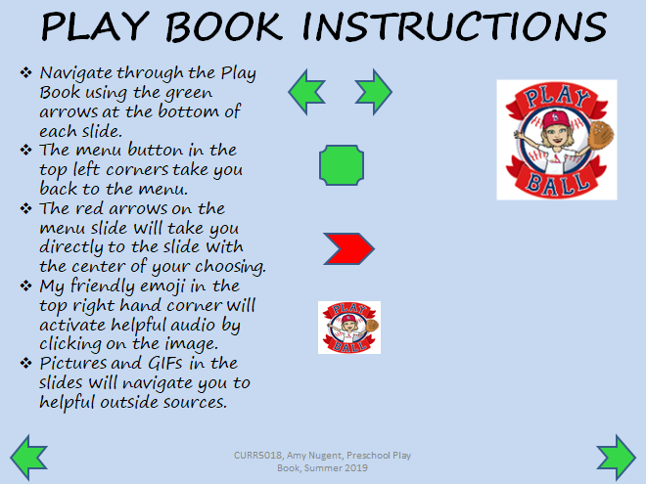](http://warhawks.ulm.edu/~nugenta/5018/bin/project-instructions.pptx)

The instructions slide provides viewers with detailed directions for navigating the Play Book. This slide also informs viewers of the embedded links and audio within each topic slide.

[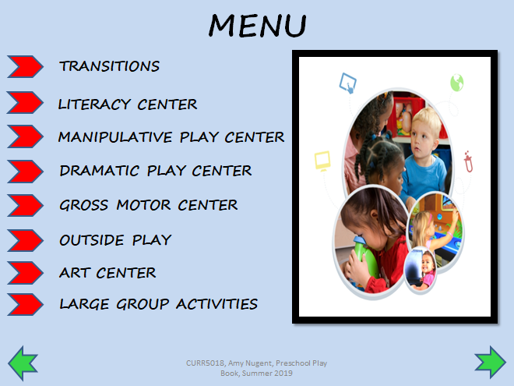](http://warhawks.ulm.edu/~nugenta/5018/bin/project-menu.pptx)

The menu slide of the Play Book is assembled as a Kiosk format. The red tabs allow for movement directly from the menu to the individual slides. The green arrows allow for movement forward and backward through the Kiosk in order.

[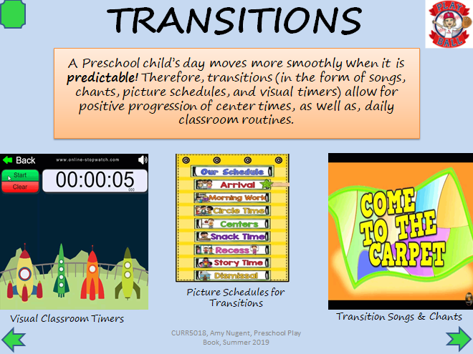](http://warhawks.ulm.edu/~nugenta/5018/bin/project-transitions.pptx)

Transitions are a vital part of the daily routine. They provide children with a sense of security, and allow them to prepare for changes that are to come.

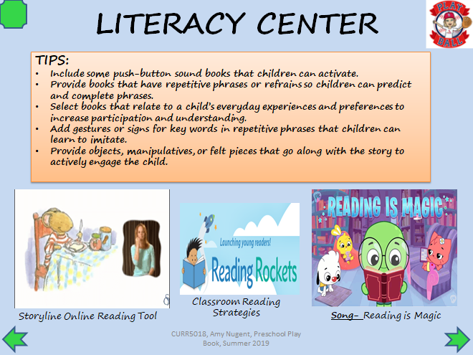

Literacy includes reading, listening, comprehension, fluency, and vocabulary. Literacy centers allow teachers the ability to weave these skills together in a fun way.

[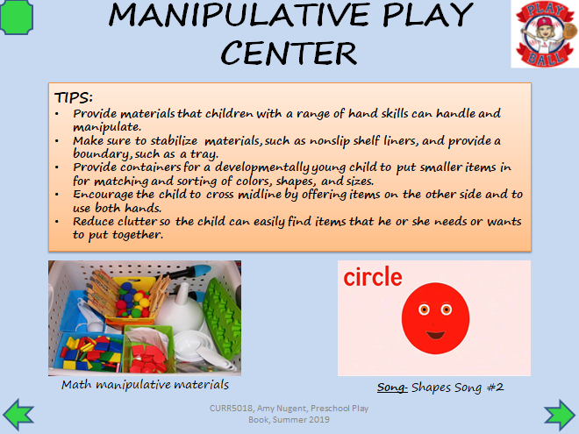](http://warhawks.ulm.edu/~nugenta/5018/bin/project-manipulative.pptx)

Manipulative centers provide activities for children to problem solve and learn basic math concepts. By using manipulatives, motor skills and hand-eye coordination are improved.

[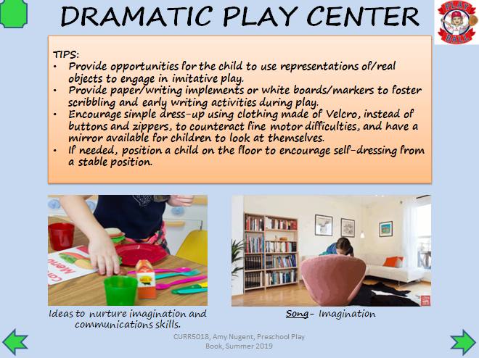](http://warhawks.ulm.edu/~nugenta/5018/bin/project-dramatic.pptx)

Dramatic play is a wonder way to engage young children in role play. The tips listed in this file give suggestions for techniques to use for children with fine and gross motor concerns.

[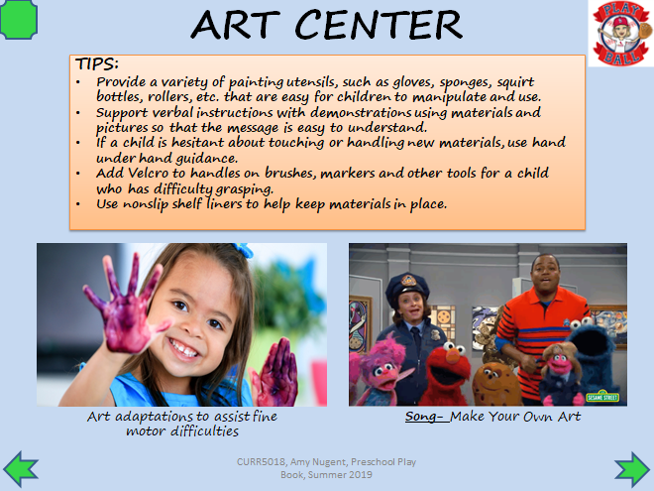](http://warhawks.ulm.edu/~nugenta/5018/bin/project-art.pptx)

Art provides an avenue for children to express their feelings, ideas, and be creative. The tips provided will aid all children, as well as, those with fine motor, visual motor, and sensory concerns.

7. **Visually Describe At Least 10 Professional “Visual Professional Diary Reflections”.** Provide captured images that actively link to at least 10 online visual professional diary reflections (VPDRs). (150 pts).

[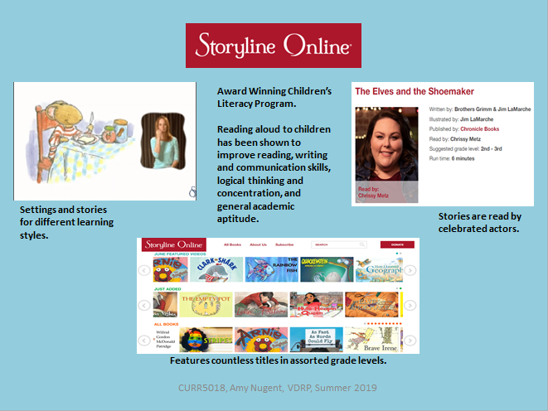](http://warhawks.ulm.edu/~nugenta/5018/bin/vpdr-01.pptx)

Storyline Online is an online storybook experience where children’s books are read by celebrated actors. In the image above, showcasing Chester the mouse, the story is being read aloud and in American Sign Language. The Storyline library is full of beloved classics, as well as, newly released titles.

[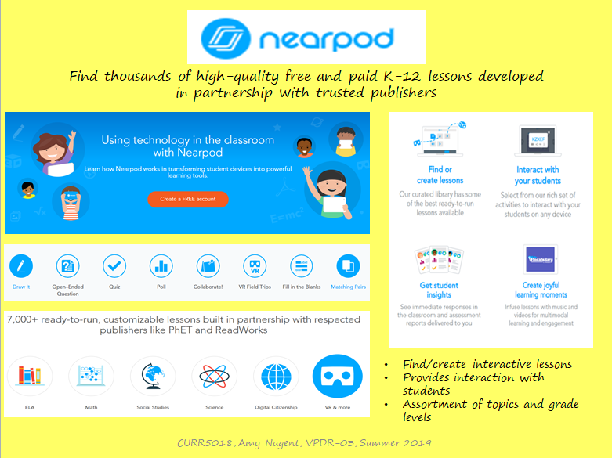](http://warhawks.ulm.edu/~nugenta/5018/bin/vpdr-03.pptx)

Nearpod is a platform for teachers, created to make teaching with technology simple and efficient. It contains a library of readily available lessons to add to your current curriculum that can be used over a multitude of devices. This site also gives educators the avenue to create their own online lessons.

[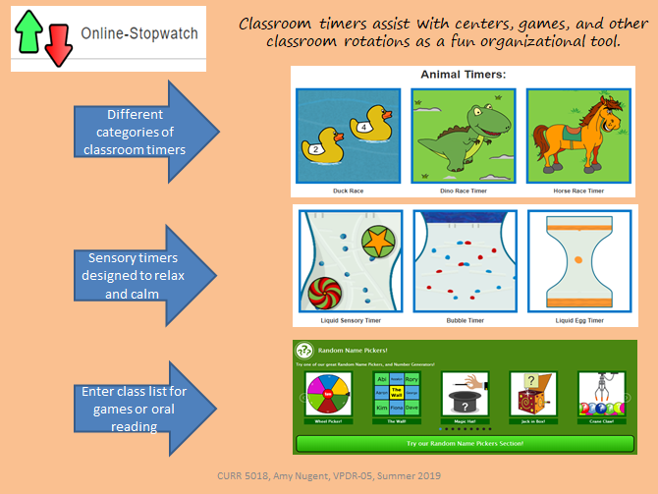](http://warhawks.ulm.edu/~nugenta/5018/bin/vpdr-05.pptx)

Online-Stopwatch is an easy to use website that provides classroom timers and countdowns. Timers are assorted by theme and also include a section for “cool down” and raffle style interactives for “popcorn” reading and classroom participation activities.

[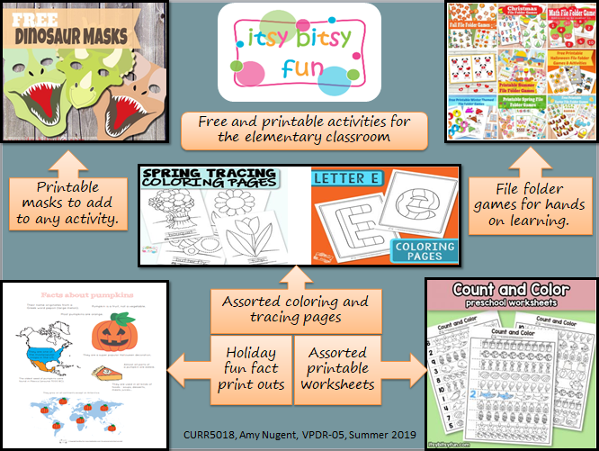](http://warhawks.ulm.edu/~nugenta/5018/bin/vpdr-06.pptx)

Itsy Bitsy Fun is a marketplace packed full of free printable activities for teachers to use in their classrooms. This site is geared towards Pre-K and Kindergarten learners. There are many printable options that cover math, ELA, holidays/seasons, and even file folder games for even more hands-on learning.

[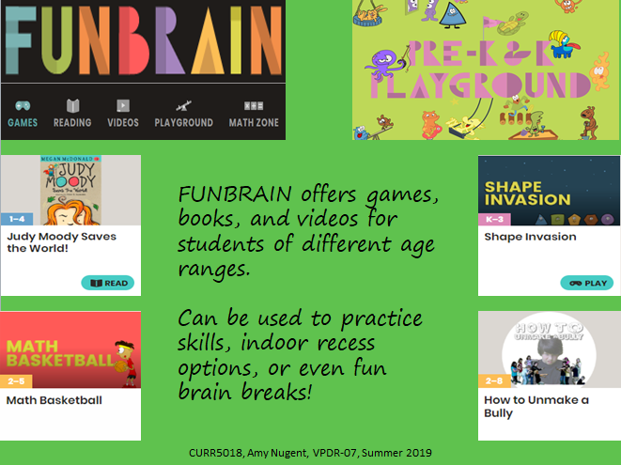](http://warhawks.ulm.edu/~nugenta/5018/bin/vpdr-07.pptx)

Launched in 1992, FunBrian was created for students Pre-K through 8th grade. It spotlights games in math, ELA, science, spelling, and history. It is also the site that *Diary of a Wimpy Kid* was first published.

[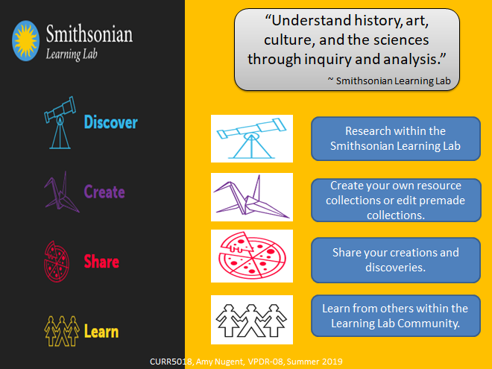](http://warhawks.ulm.edu/~nugenta/5018/bin/vpdr-08.pptx)

The Smithsonian Learning Lab is an interactive website where students can research, and store digitized museum collections, videos, and blog posts. It includes resources from Smithsonian’s 19 museums, nine research centers, and the national zoo.

[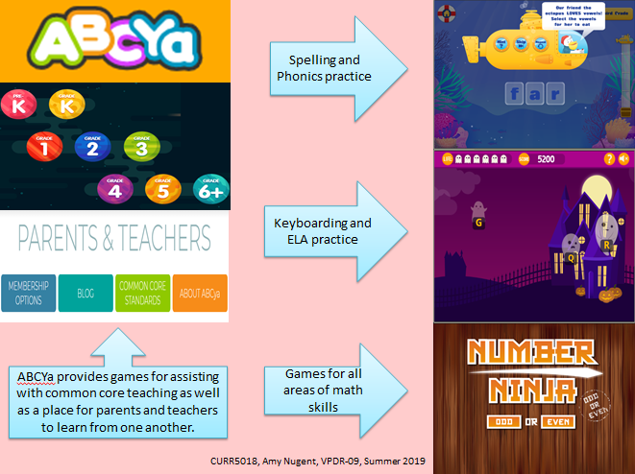](http://warhawks.ulm.edu/~nugenta/5018/bin/vpdr-09.pptx)

ABCYa provides educational games that are organized into grade levels Pre-k through 6th grade and up. Topics include spelling and phonics, ELA and keyboarding, and math in assorted areas. This site also includes games that align with common core standards.

[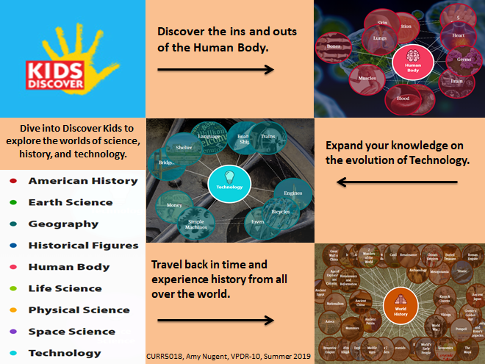](http://warhawks.ulm.edu/~nugenta/5018/bin/vpdr-10.pptx)

Discover Kids focuses on Science, History, and Technology. It provides a read-a-loud support for children with literacy challenges. This site navigates through each topic in an interactive concept map.

[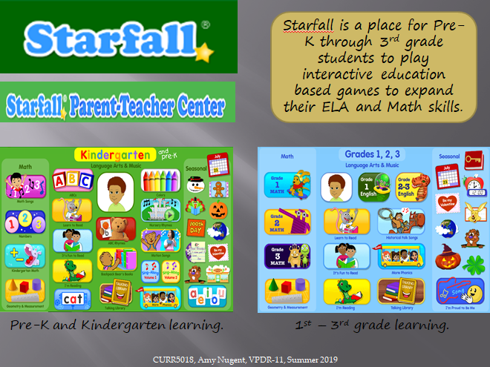](http://warhawks.ulm.edu/~nugenta/5018/bin/vpdr-11.pptx)

Starfall is a children’s website that teaches basic math, reading, English, and writing skills to students attending the Pre-k through the 3rd grade. Starfall has a free app that complements the ELA and math contents areas from the website.

[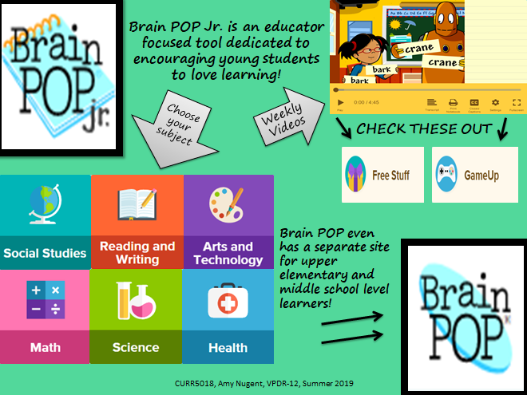](http://warhawks.ulm.edu/~nugenta/5018/bin/vpdr-12.pptx)

BrainPOP & BrainPOPjr are educator focused tools. There is a free library of animated teaching tools as well as subscription options for even more activities and curriculum based content. Between these brother sites the activities cater to students from Pre-K through upper middle school.

8. **Identify An Outstanding Free Online Educational Resource** (25 points)

[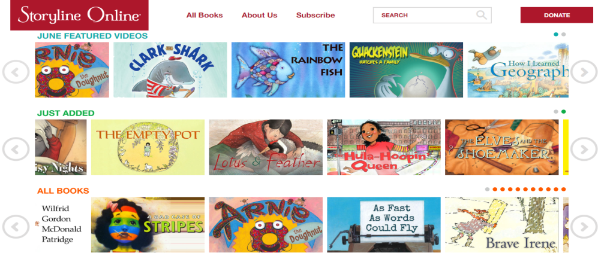](https://www.storylineonline.net/)

Storyline Online is one of my favorite websites. It is a large online library of children’s books read by celebrated actors. It was founded by the Screen Actors Guild Foundation to enrich comprehension, writing, and communication skills, as well as, inspire a lifelong love of reading. This is a free program that is available 24 hours a day, and it used by parents, children’s hospitals, and educators world-wide. Each book also includes supplemental curriculum developed by accredited educators. I personally use Storyline Online with my students with learning disabilities, as well as, my own grandson who loves the moving illustrations and music.