
This document is part of a student’s academic eFolio (electronic portfolio) for an online course during the summer of 2019 at the University of Louisiana at Monroe (ULM). The images link to files located on the student’s personal ULM website account.
This student has allowed this exemplar to be publicly viewed. Note: After this student graduates, these links will no longer work because the website will be de-activated. However, the student has the option to COPY and transfer the files to another website account in the future
3. Your Photo. Insert an “annotated” image of yourself that actively links to your online about-me.pptx online file locate
Kerri Kannady

4. Your Project Proposal Cognitive Map. Include a “cognitive map” describing your course project. (25 points)
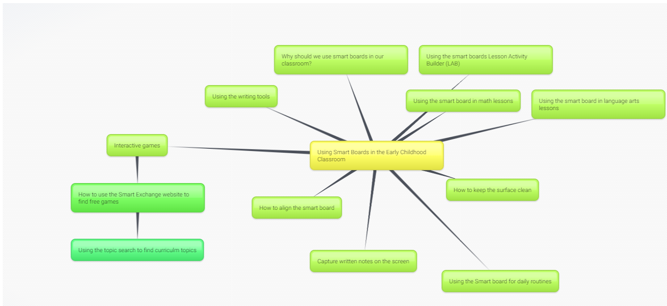
My project proposal cognitive map is a basic orientation for teachers to learn about Smart Boards in early learning classrooms. I felt a “quick guide” would be helpful and could be shared easily with teachers that have not used Smart Boards before. Topics that are covered include basic operations of the Smart Board, how to care for Smart Boards, and tips for using Smart Boards in the classroom. The lesson activity builder is explained with useful websites for finding games and activities. This is a topic that I really wanted and needed more information to effectively use the Smart Board in my classroom. It is my hope that it is useful information for someone like me.
5. 30-Second Video Summary Of Your Completed Online Course Project. (50 points)
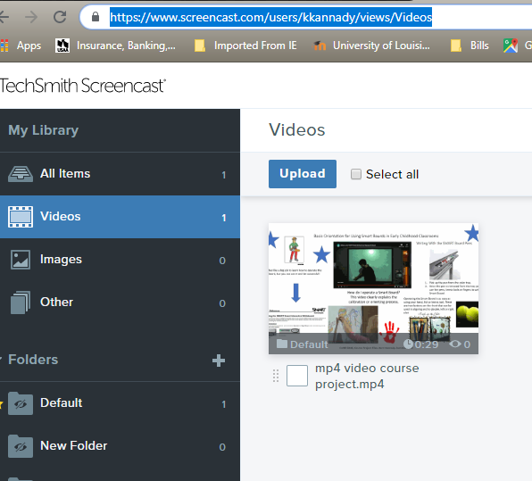

- 66. Visually Link Your “Course Project Files” That You Created, Based On Your Project Proposal.
Provide actively linked images of your online course project files and provide text commentary. (200 pts.).

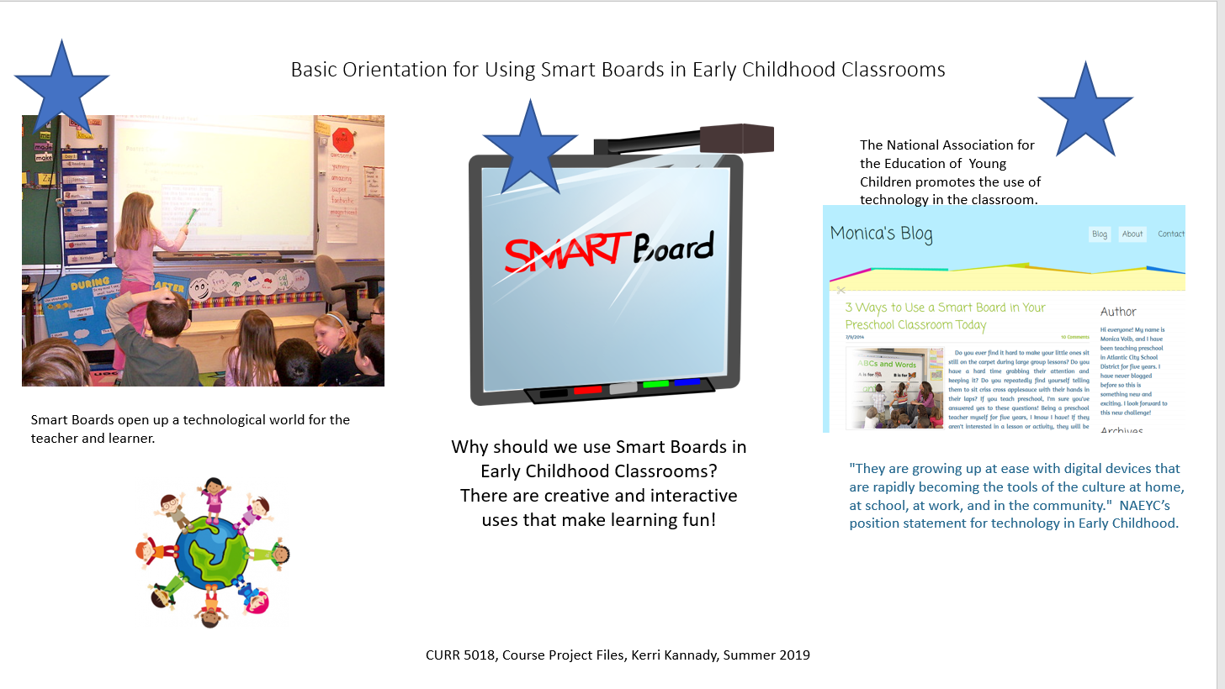
The interactive white board or Smart Board is a tool that enhances the early childhood classroom. For the age group we teach we must catch their attention. Young children are creative and visuals peak their interest. Instead of just showing a picture of a tree, show a panoramic video of a forest, while zooming in on tree parts, on the Smart Board.

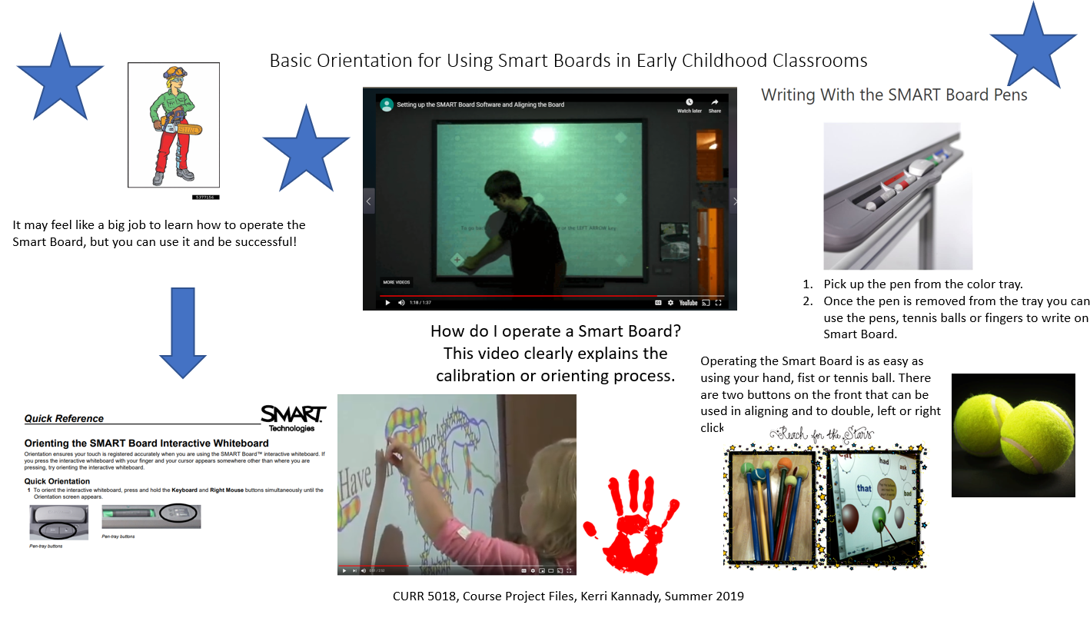
I found several resources to help educators understand how to operate a Smart Board computer system. It is helpful to understand what the two buttons on the front will do and how to use them.

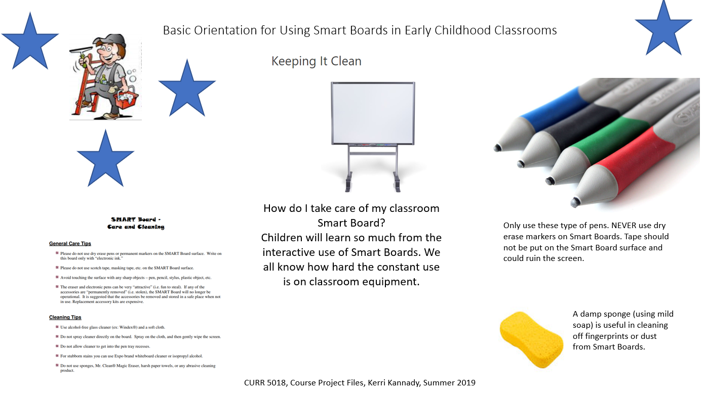

In an early childhood classroom, accidents happen. There are times when the children can be pretty rough with materials. It is important to know just how to clean up if needed.

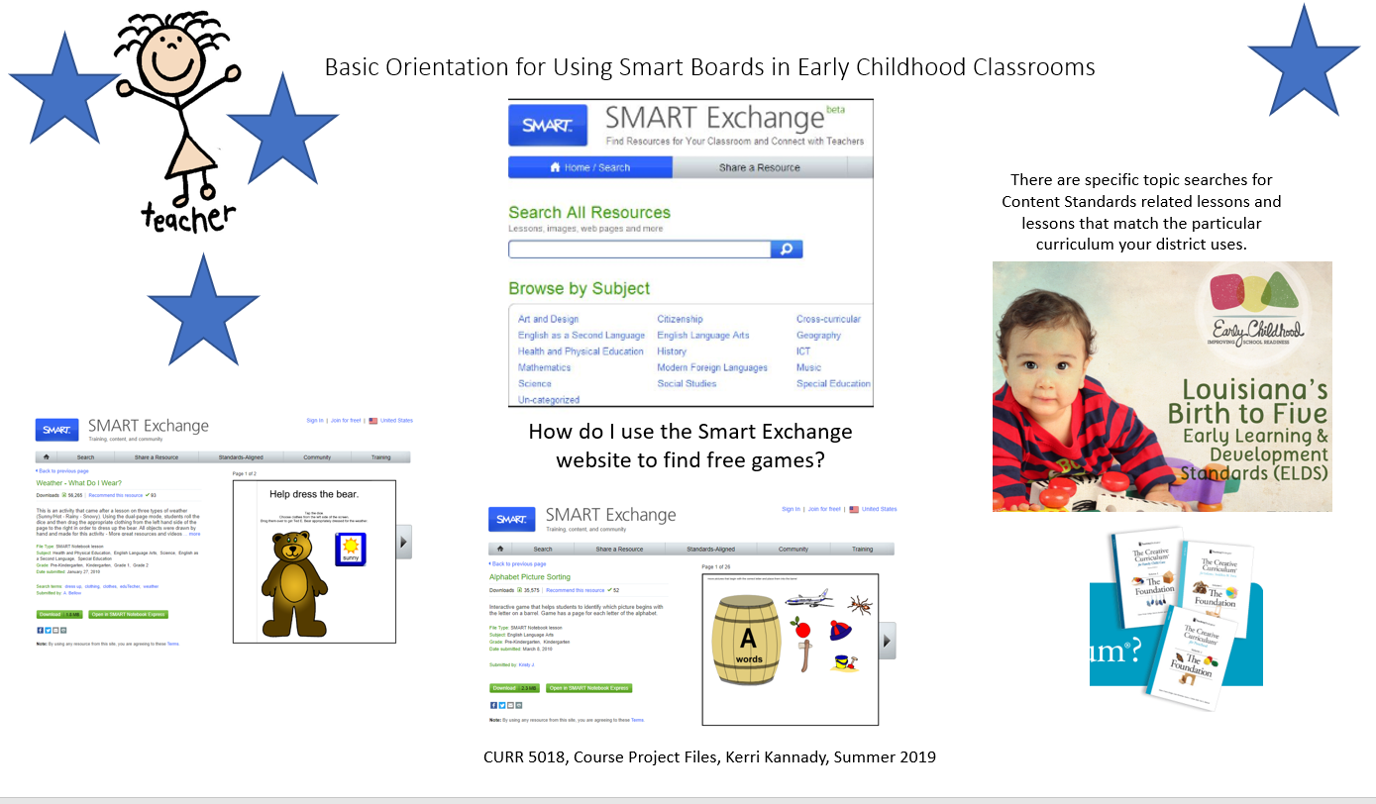

The Smart Exchange website has free interactive games to use to enhance lessons. It is easy to search for Content Standards related topics and lessons.

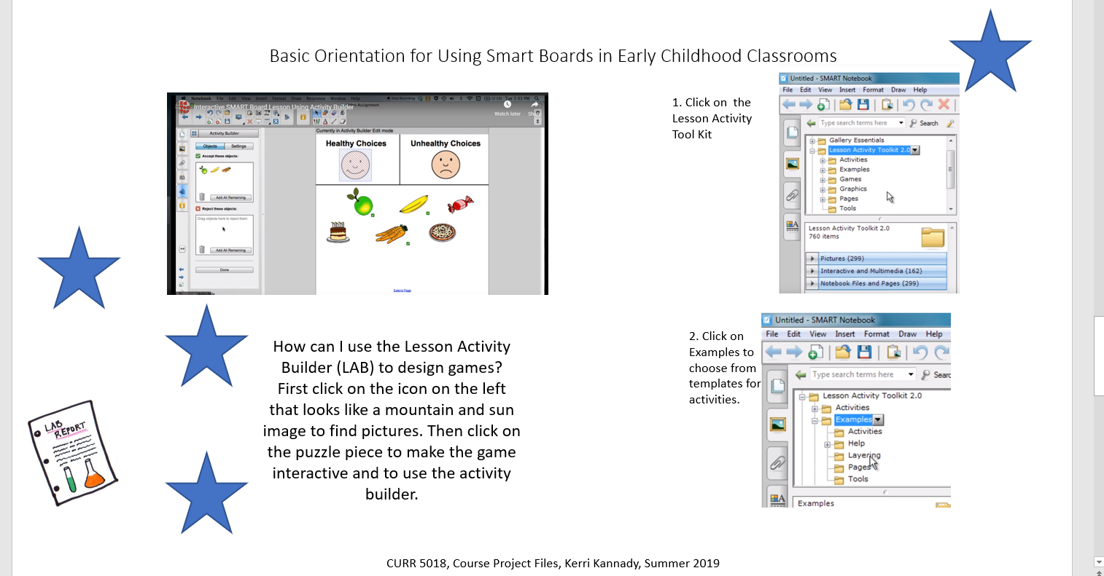

The Lesson Activity Builder or LAB is a tool that enables teachers to design their own interactive games. There are examples and templates that are useful and helpful.

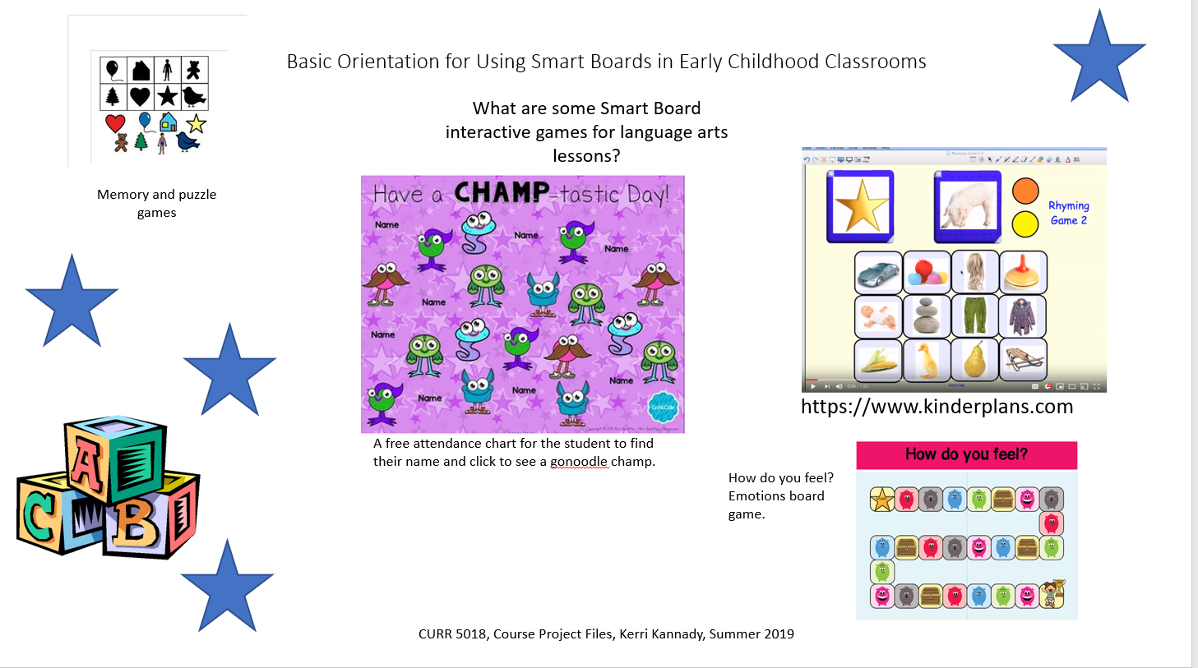
The language arts concepts I found were rhyming, name identification, labeling feelings, puzzles and matching. There were so many free Smart Board games that were accessible through TeachersPayTeachers.
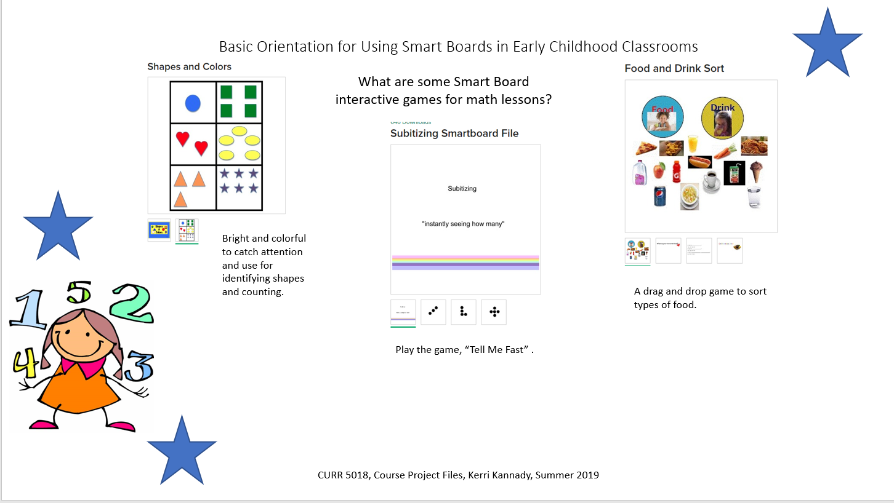
The math concepts that I found were shapes and colors, counting, sorting, and subitizing. These were also found on the TeachersPayTeachers website and were all free to download.

7. Visually Describe At Least 10 Professional “Visual Professional Diary Reflections”. Provide captured images that actively link to at least 10 online visual professional diary reflections (VPDRs). (150 pts).
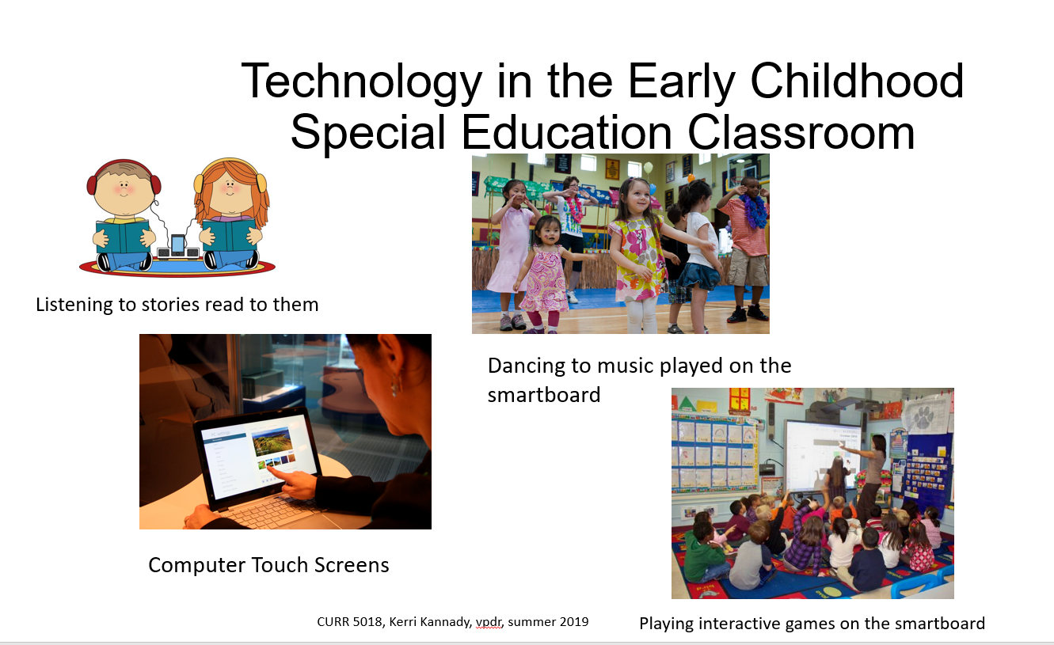
I began with a broad topic for my first vpdr. This is pretty much how I use technology in my classroom at this time.
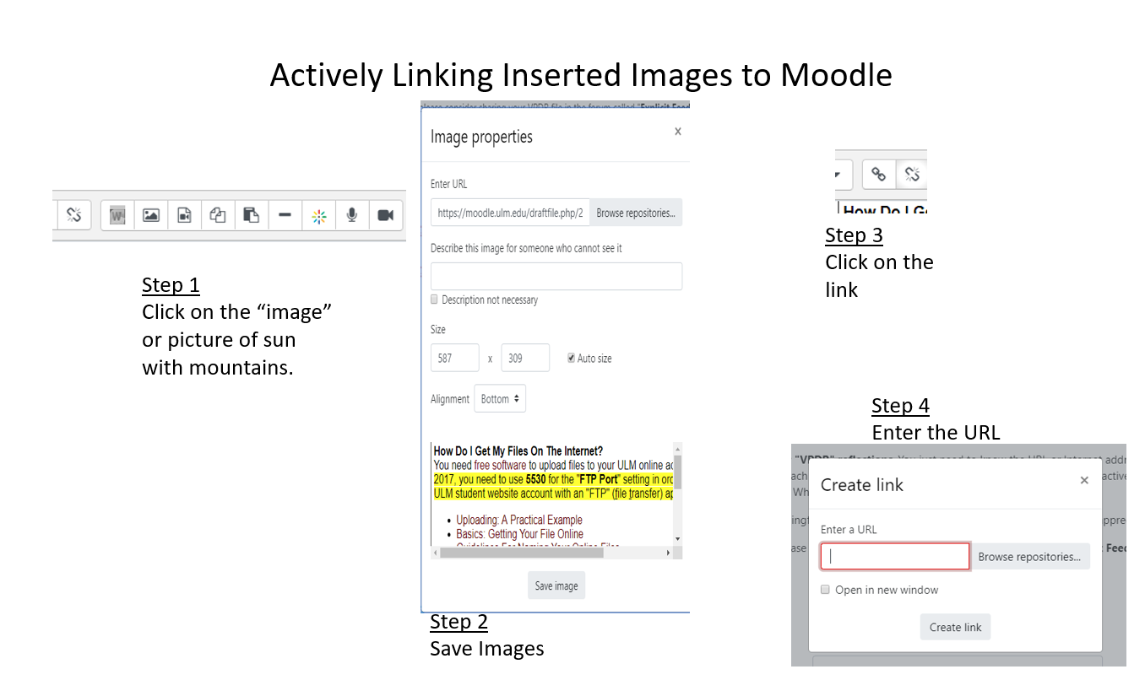

Learning and understanding the steps to “actively link” an image in moodle was difficult for me due to not fully understanding the url process. Now I understand, am able to use it, and have located the “link” and “hyperlink” buttons on my computer.
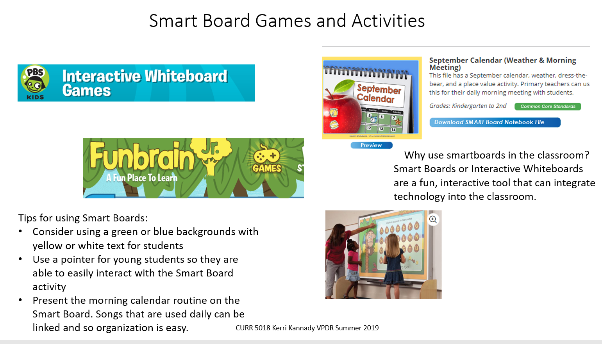
In 2010 I taught for a Department of Defense School in Netzaberg, Germany. It was my first exposure to Smart Boards. I was only there two years in the classroom, but the next DODs school in South Carolina also had Smart Boards and I substituted there many times. I have a Smart Board in my classroom now and am ready to use it more in my daily classroom lessons and routines.
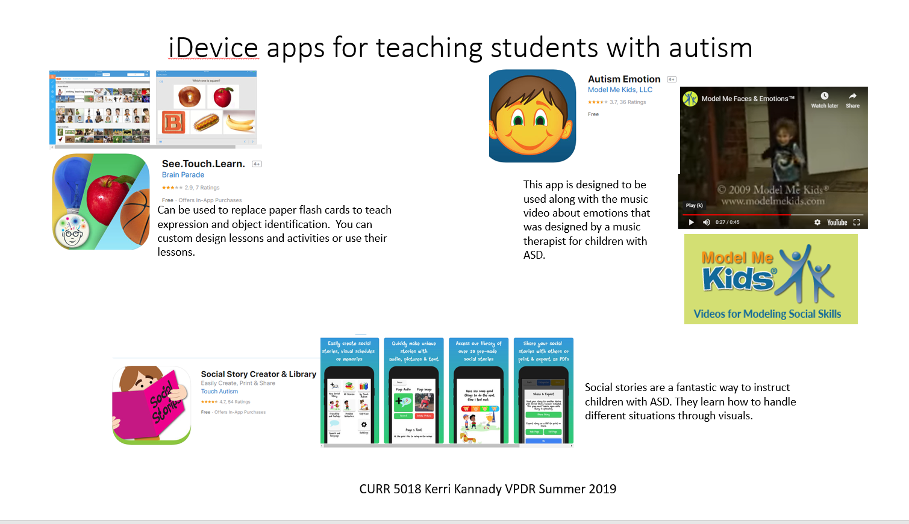
These are apps that can be used with students who are autistic or sensory processing issues. It can be a resource for parents to be used at home.
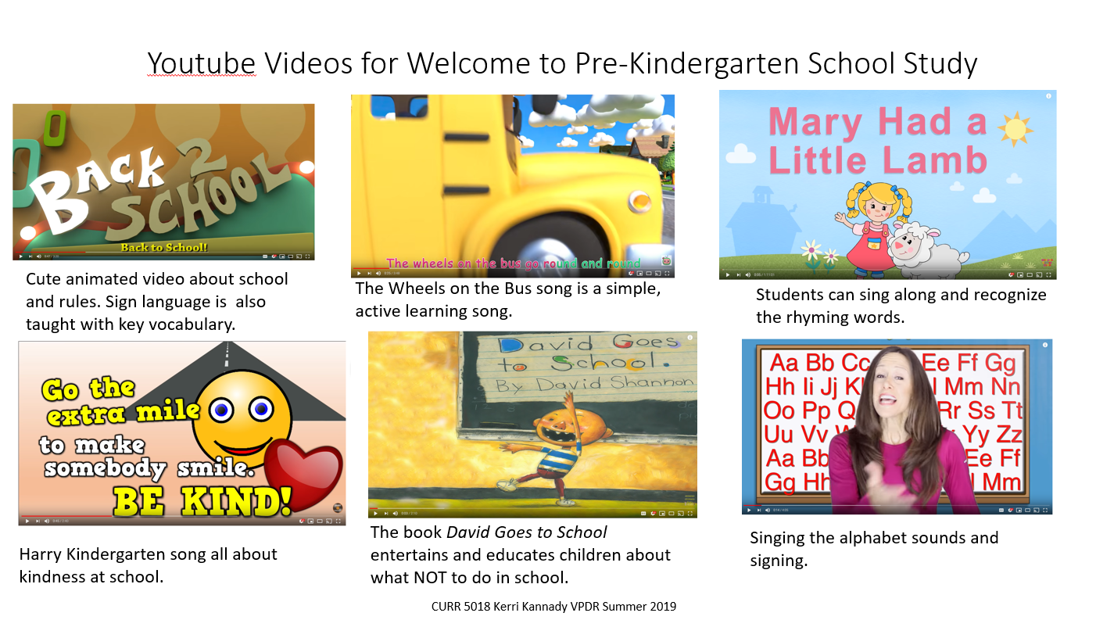
This is a beginning of the school year collection of songs and videos. The concepts discussed are rules, kindness, school behaviors, learning the alphabet, and rhyming words.
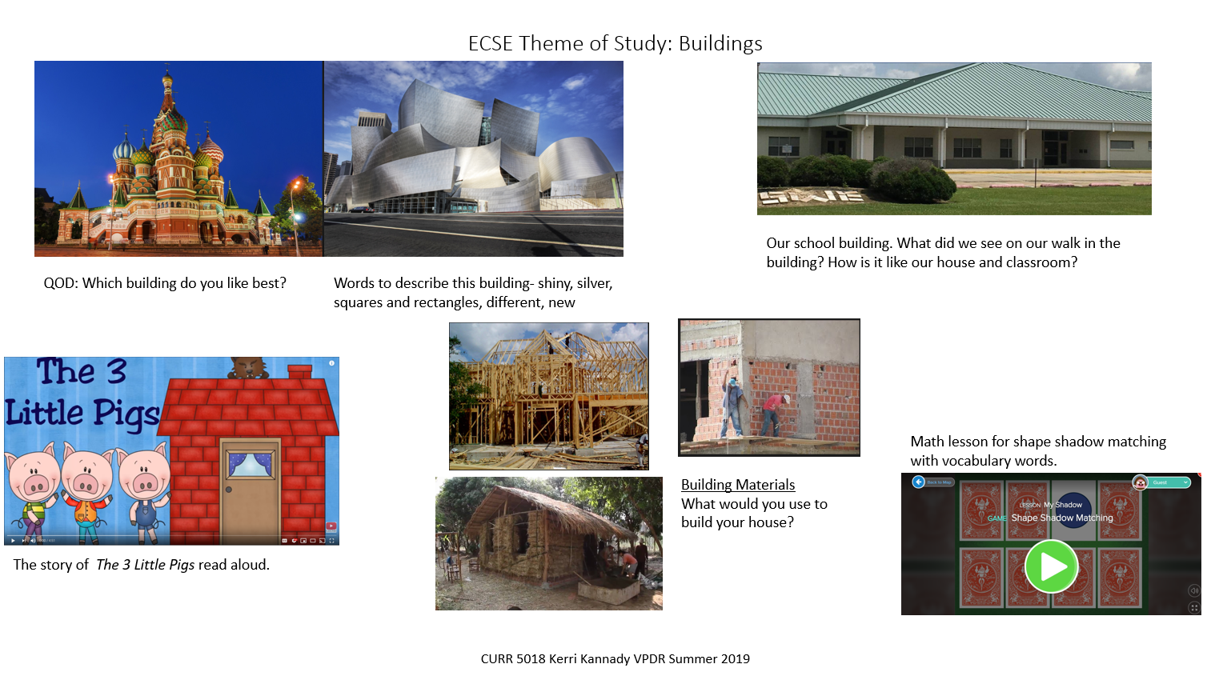
This is a collection of songs, stories, and games for the buildings study. Concepts that are discussed are question of the day, describing words, building materials, shapes and retelling.
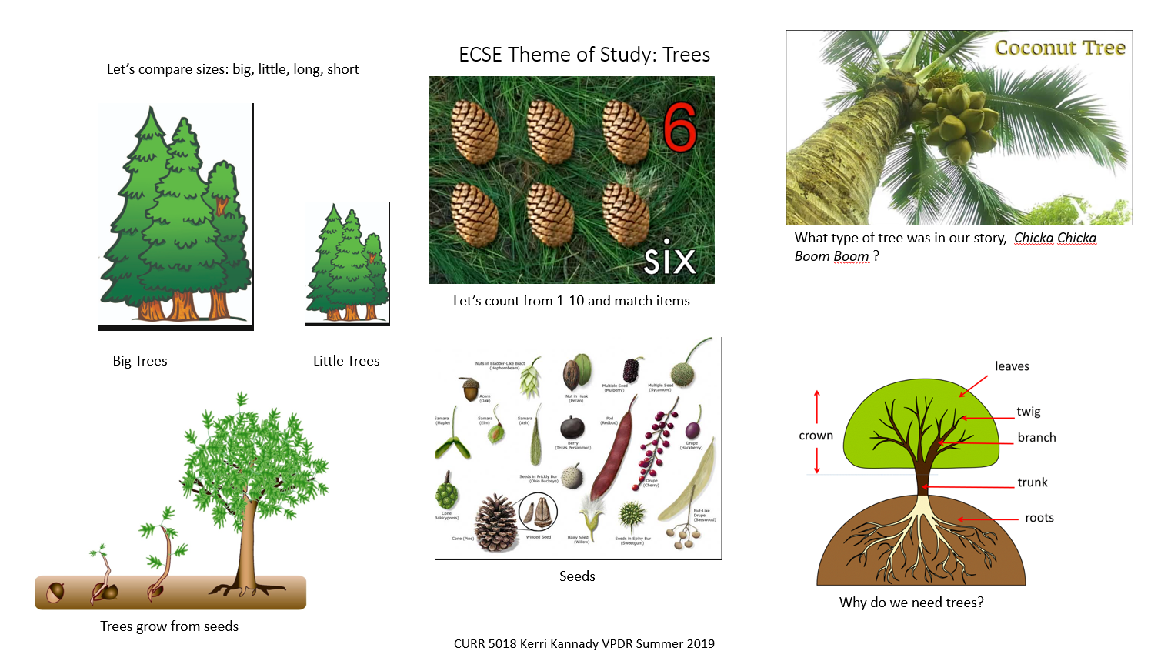
This is a collection of songs, games, and stories for the trees study. Concepts that are discussed are comparing sizes, how trees grow, counting and number identification and information parts of a tree and seeds.
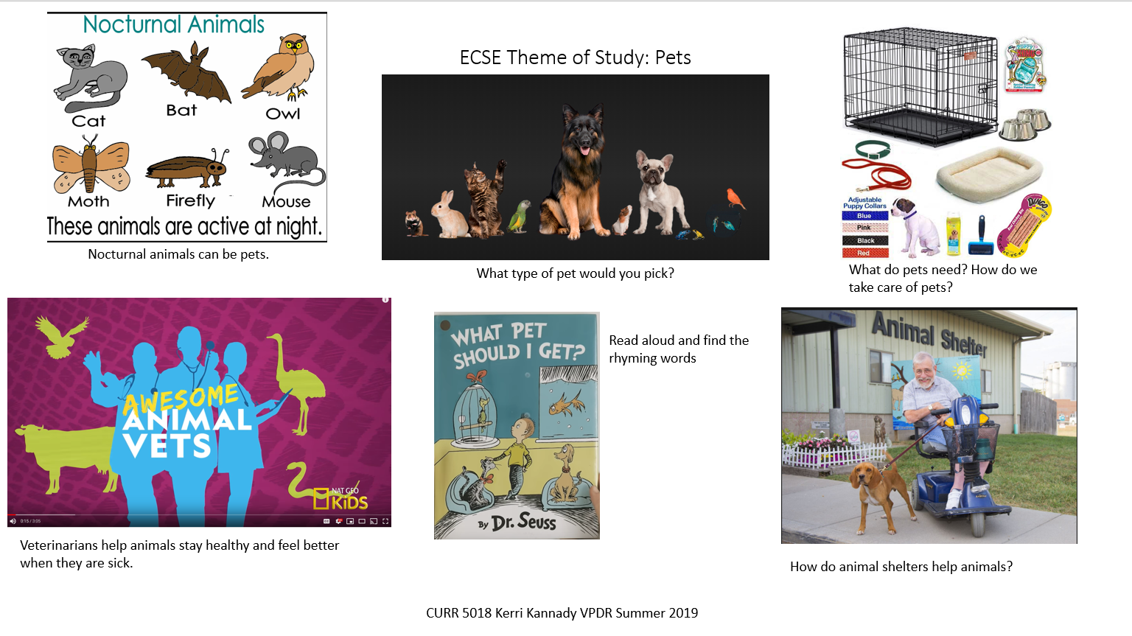
This is a collection of songs, stories, videos and information for the pets study. Concepts that are discussed are nocturnal animals, what a veterinarian does, how shelters help animals, and rhyming words.
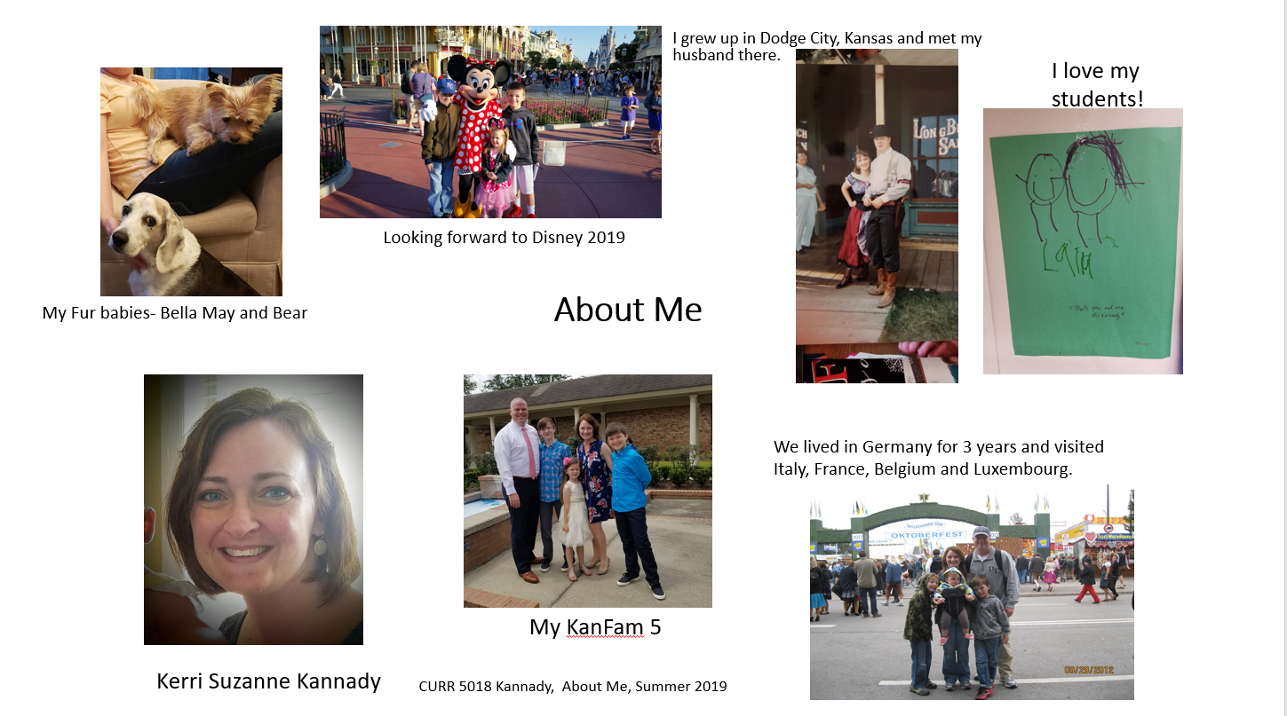
My about me vpdr gives you a glimpse of my life. I am a wife, mom of three children, full time ECSE teacher, and dog-mom. I have lived in many different places and enjoy spending time with my family! I try to find the good in every day.
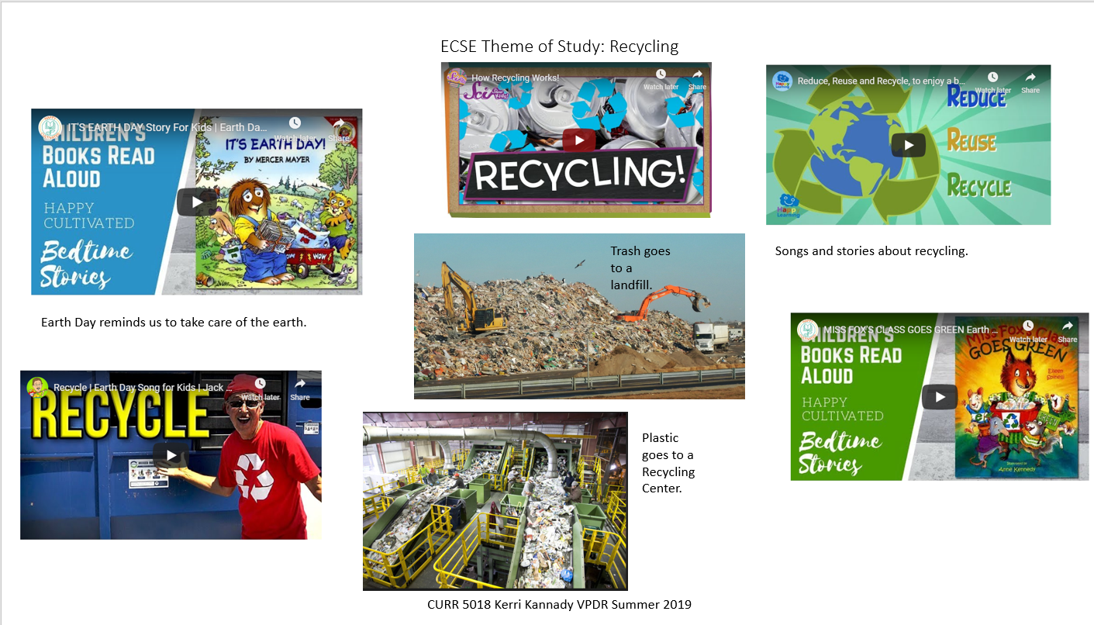

This is a collection of songs, stories and videos for the recycling study. Concepts that are discussed are places our trash and recycling goes, ways to reduce, reuse and recycle, and sorting items to recycle.

8. Identify An Outstanding Free Online Educational Resource (25 points)
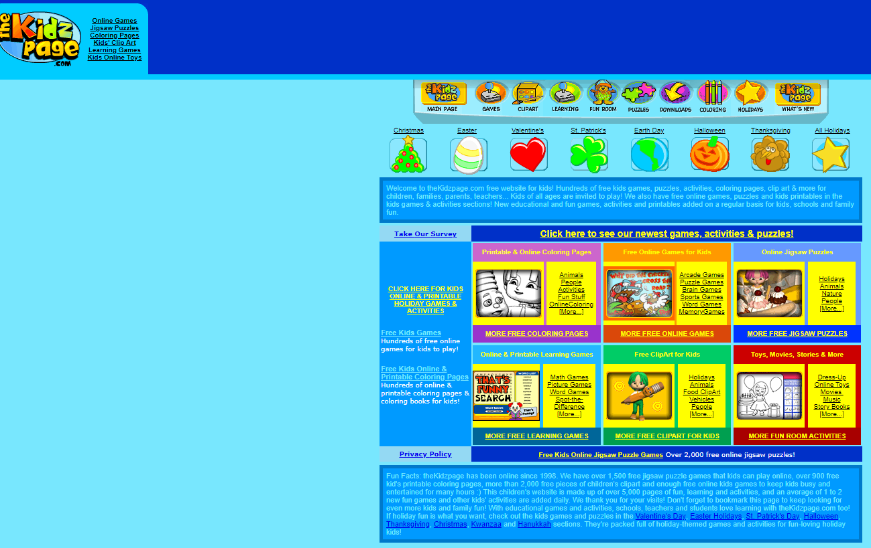
The games and activities are very age appropriate for a Pre Kindergarten classroom. There are some great puzzles, dress-up and decorate scenes, and clipart for students to use. In our curriculum we make books and it would be a useful site to get images from to use.

