[](https://ulm.edu/webguide/index.html)This document is part of a student’s **academic eFolio (electronic portfolio)** for an online course during the summer of 2019 at the University of Louisiana at Monroe (ULM). The images link to files located on the student’s personal ULM website account.

This student has allowed this *exemplar* to be publicly viewed. **Note: After this student graduates, these links will no longer work because the website will be de-activated. However, the student has the option to COPY and transfer the files to another website account in the future.**

3. **Your Photo.** Insert an “annotated” image of yourself that actively links to your online **about-me.pptx** online file located on your ULM website account. (25 pts)

***[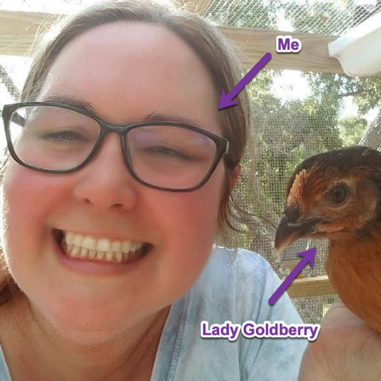](http://warhawks.ulm.edu/~hamiltonec/5018/bin/about-me.pptx)***4. **Your Project Proposal Cognitive Map**. Include a “cognitive map” describing your course project. (25 points)   
[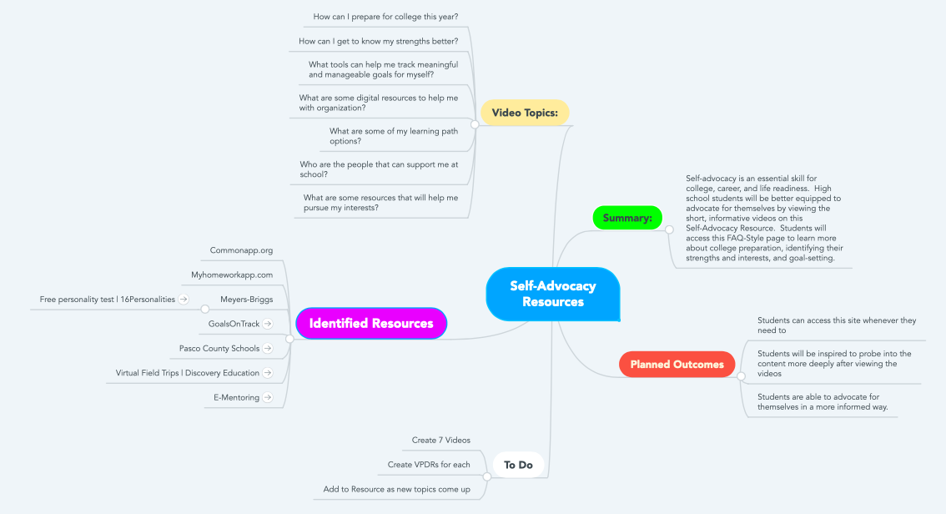](http://warhawks.ulm.edu/~hamiltonec/5018/bin/curr5018-elizabeth-hamilton-selfadvocacyresources.docx)

These resources will include short videos on topics that will help students take charge of their learning and follow their strengths and interests to more rewarding college and career paths. Each video will provide a resource that students can use to get themselves closer to autonomous learning. The student will also be challenged to probe deeper into the topic through independent research.

Students often wonder how they can start preparing for college as early as 9th grade. One video will explore a valuable site for college preparation and will also set the “why” behind most of the other videos in the Self-Advocacy resource. The first step to becoming an autonomous learner is knowing what you want to accomplish. Therefore, It is important that students know what resources can help them better understand their strengths and interests. The proposed videos will explore digital resources that will aid the students to a better understanding of themselves, their wants, and their needs through taking online quizzes based on educational psychological research. When students have a solid understanding of who they are and what they want from their education, they will need to form a community of support around them. In these videos, they will also get to know the people at their school and learn about resources and tools that can help them get the support they need.

5. **30-Second Video Summary Of Your Completed Online Course Project**. (50 points)

[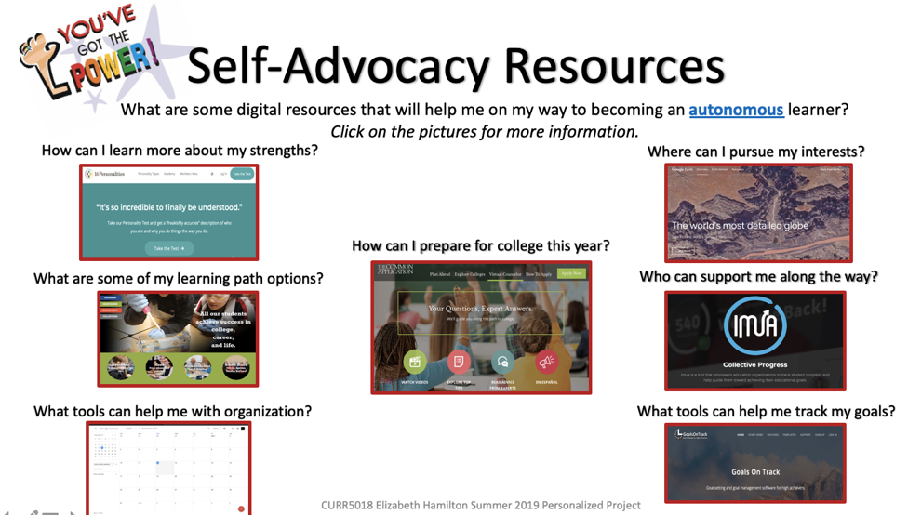](https://www.screencast.com/t/brjwyBfM1)

66. **Visually Link Your “Course Project Files” That You Created, Based On Your Project Proposal.**Provide actively linked images of your online course project files and provide text commentary. (200 pts.).

[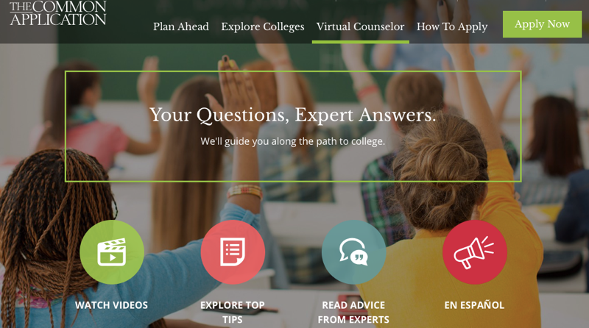](https://www.screencast.com/t/JQTHn19sZs)

**How can I prepare for college this year?**

The Common Application is a “one-stop shop” for college preparation. Students can research, plan for and apply to college all in one place. This video helps students understand that college preparation does not have to be overwhelming when they set meaningful and manageable goals each year of high school.

[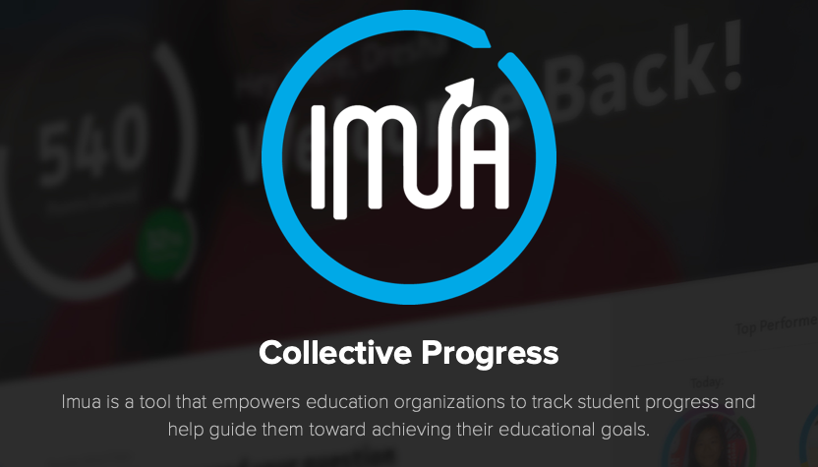](https://www.screencast.com/t/94zNYUxE9CHt)

**Who can help me along the way?**

IMUA is a wealth of resources for setting up an “E-Mentorship” so students can connect with professionals and leaders in their areas of strength and interest. This video encourages students to be solution-focused when advocating for mentorships.

[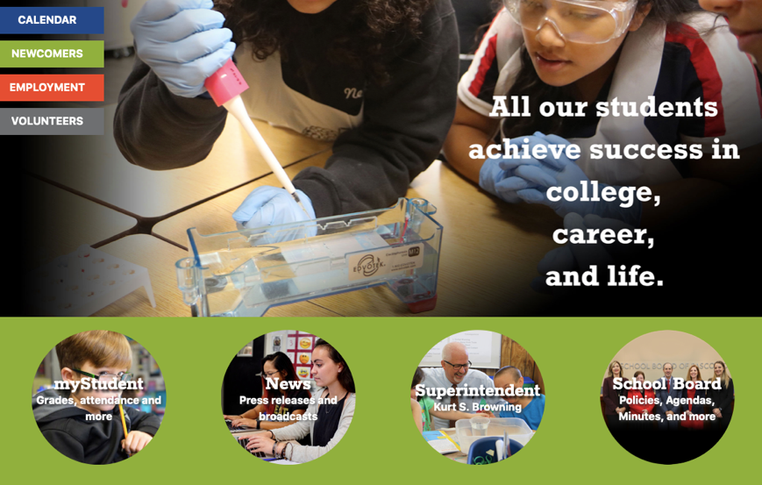](https://www.screencast.com/t/caQ2PhJC)

**What are my learning path options?**

Students can find resources on learning path options available in their own school system. This video will help them navigate the Pasco County Schools website to find more information on program choices that will best fit their learning profile needs.

**[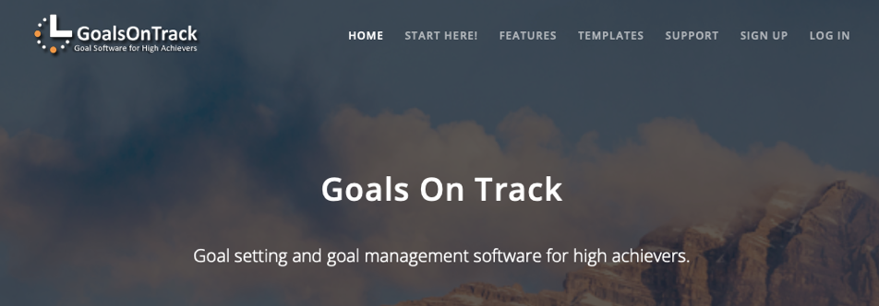](https://www.screencast.com/t/EfAk8fny)**

**What tools can help me with my goals?**

The autonomous learner sets personal goals and works to achieve them. This video explores one comprehensive goal-setting tool. “Goals On Track” offers comprehensive SMART goal tracking and progress monitoring; it is not free, but it is worth looking into.

[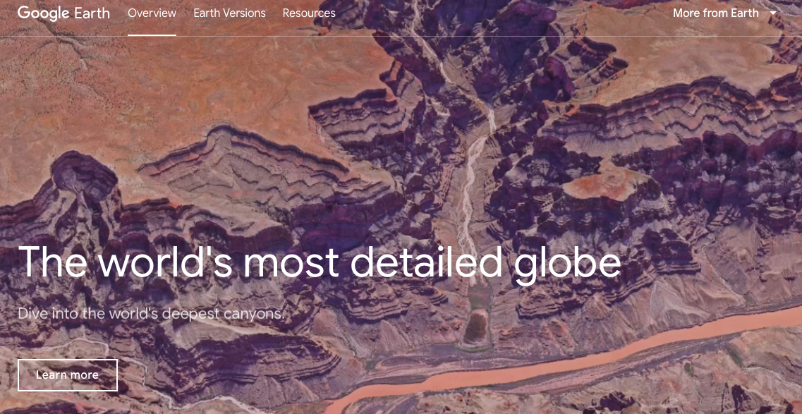](https://www.screencast.com/t/c2Pzd3jymy)

**Where can I pursue my interests?**

Google Earth allows students to see the world from their computer. Students can learn more about farm systems across the United States, visit Ford’s Theatre for an immersive look at Lincoln’s Legacy, and more. It can take them anywhere their interests take them. This video encourages students to pursue their interests independently.

[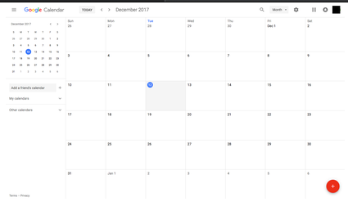](https://www.screencast.com/t/qly10zTj)

**What tools can help me with organization?**

Google Calendar is a cross-platform app helps students stay organized throughout their day. They can collect all of their assignments, projects, and due dates in one place. They can even share their calendar with their parents so they can support their success, as well. This video asks students to collect all of their daily assignments into one place for ease of access and communication.

[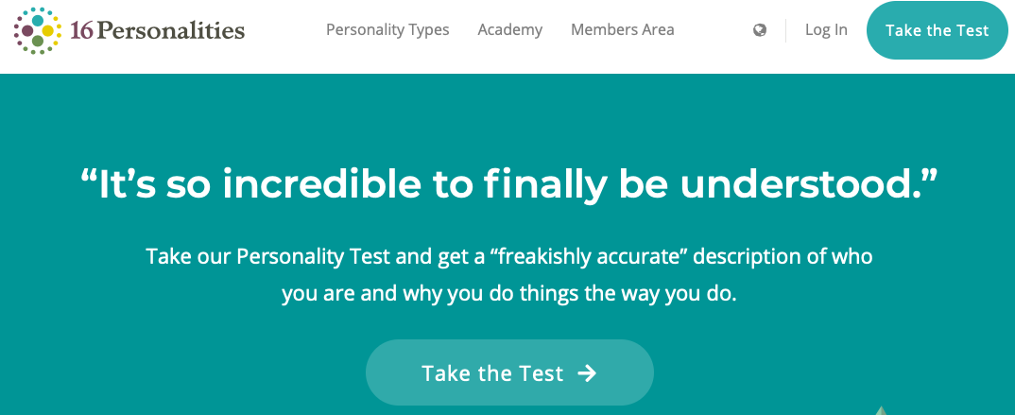](https://www.screencast.com/t/QE1sim1AX5)

**How can I learn more about my strengths?**

Students can get to know themselves better by taking personality tests. They will be better equipped to express their learning needs and can tailor their environments to fit what works best for them. This video encourages them to be honest with themselves and consider their perceived flaws as potential strengths.

8. **Identify An Outstanding Free Online Educational Resource** (25 points)

[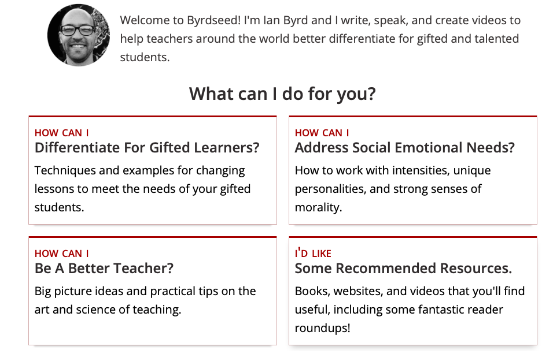](https://www.byrdseed.com/about/)

Byrdseed.com is a wealth of information for teachers looking for ways to enrich and engage their gifted learners. There are easy to find resources that are relevant and ready to implement. His blog is always informative and provides excellent resources. I also subscribe to his “Puzzlements” mailer. Every Friday he sends 3-5 links of interesting web content (very short videos, articles, images, etc..) meant to be shown to students to inspire curiosity, deeper questioning, and further research.