
This document is part of a student’s academic eFolio (electronic portfolio) for an online course during the summer of 2019 at the University of Louisiana at Monroe (ULM). The images link to files located on the student’s personal ULM website account.
This student has allowed this exemplar to be publicly viewed. Note: After this student graduates, these links will no longer work because the website will be de-activated. However, the student has the option to COPY and transfer the files to another website account in the future.

3. Your Photo. Insert an “annotated” image of yourself that actively links to your online about-me.pptx online file located on your ULM website account. (25 pts)
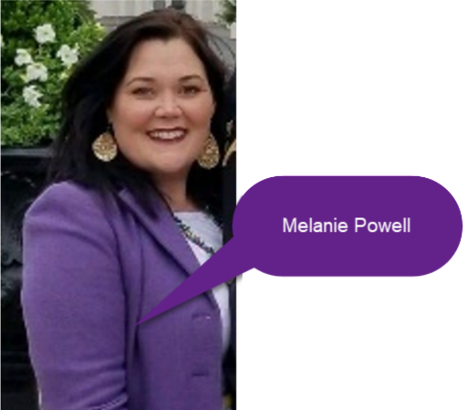

4. Your Project Proposal Cognitive Map. Include a “cognitive map” describing your course project. (25 points)
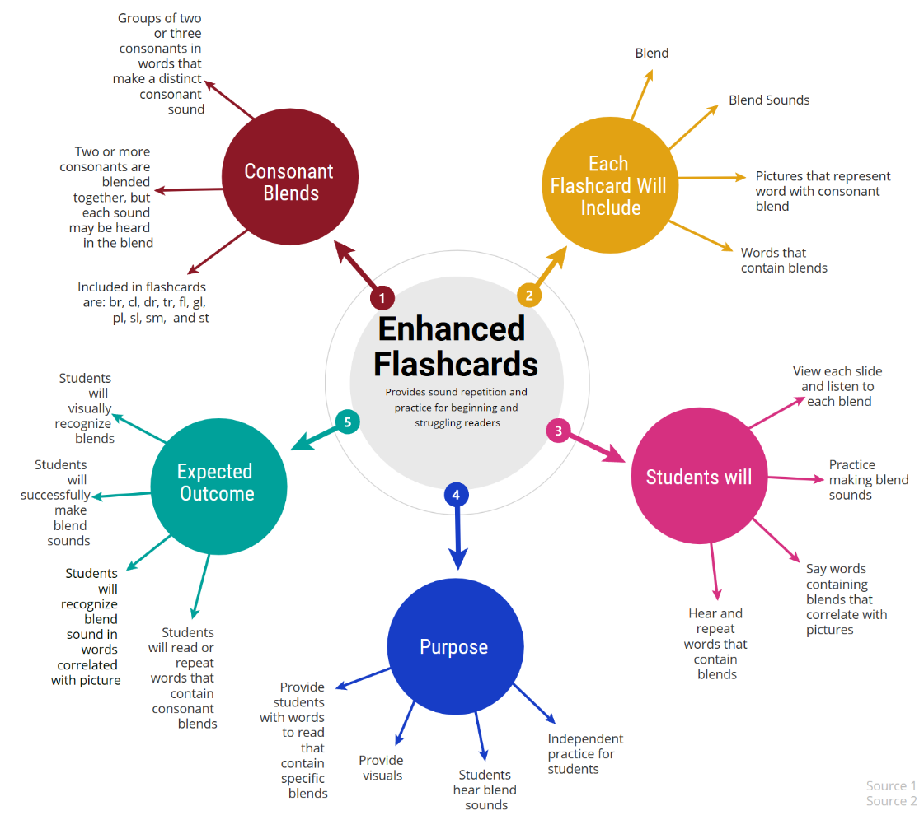
The above cognitive map describes my end of course project and links directly to the project proposal. Enhanced flashcards that target initial consonant blends that will accompany my intervention program were my project of choice. The purpose of the enhanced flashcards is to provide students will additional practice hearing and reading words with targeted initial consonant blends. The students will be provided the opportunity to practice the blends by seeing the targeted blend, hearing the blend sound, reading words that have the targeted initial blend, hearing the words read to them, as well as having some selected photographs that contain the same targeted blend. The goal is that the additional practice will help students recognize and successfully read words with the blends.

- 5. 30-Second Video Summary of Your Completed Online Course Project. (50 points)
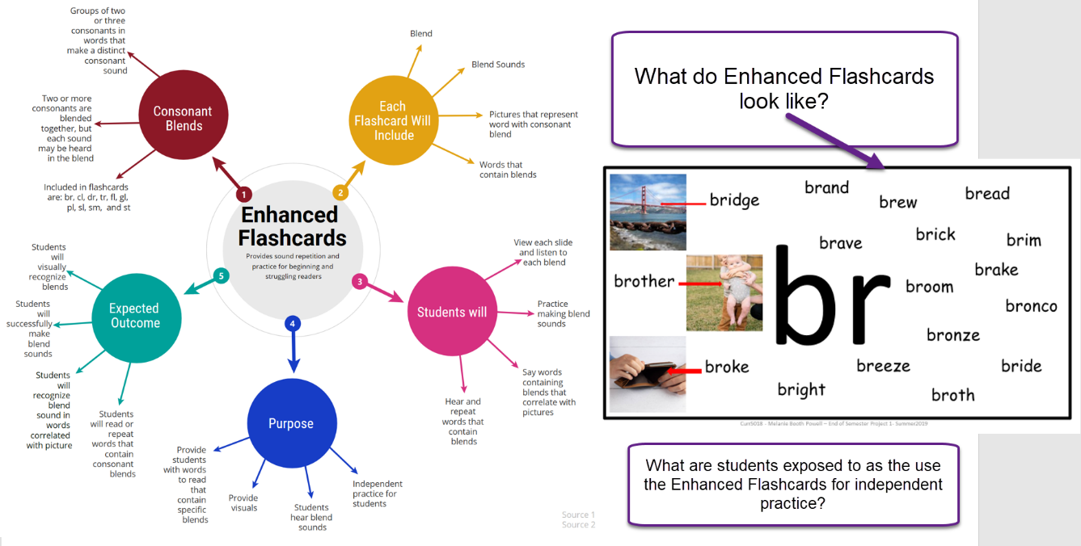
- 66. Visually Link Your “Course Project Files” That You Created, Based On Your Project Proposal.
Provide actively linked images of your online course project files and provide text commentary. (200 pts.).

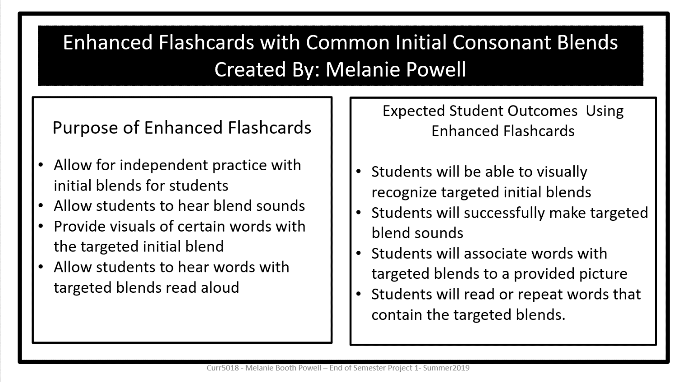
Vpdr-p01 is an overview of what Enhanced Flashcards are. It provides information on the purpose of the enhanced flashcards as well as what the expected student outcomes are.
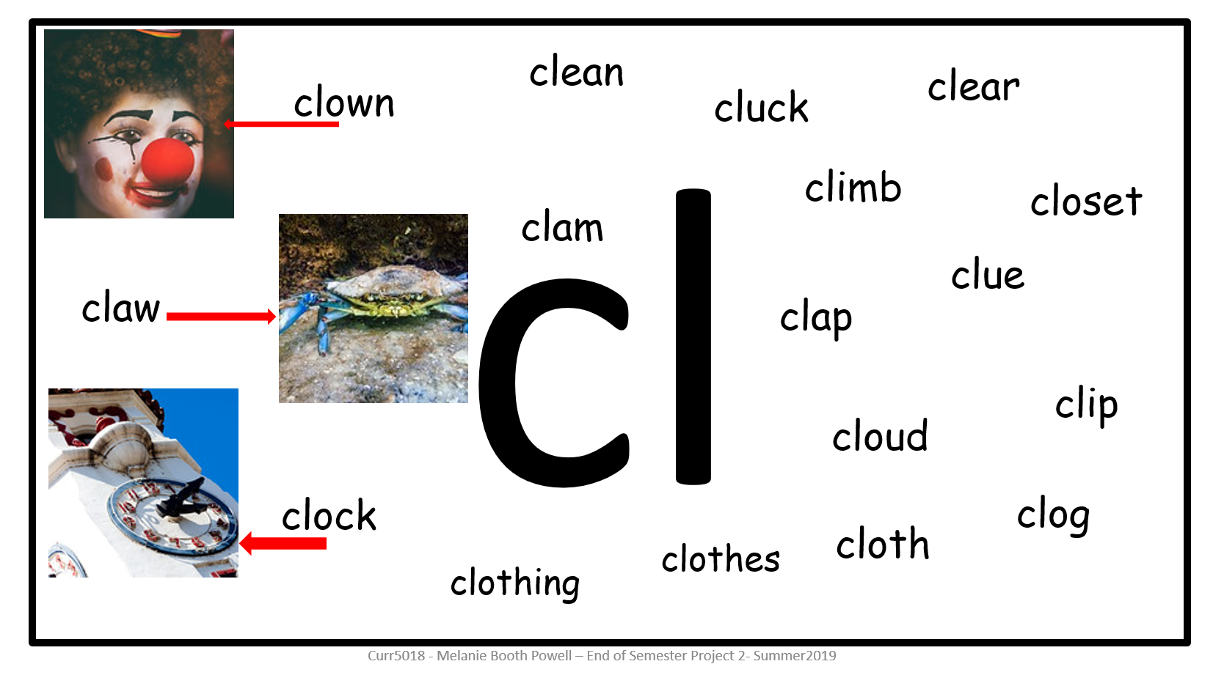
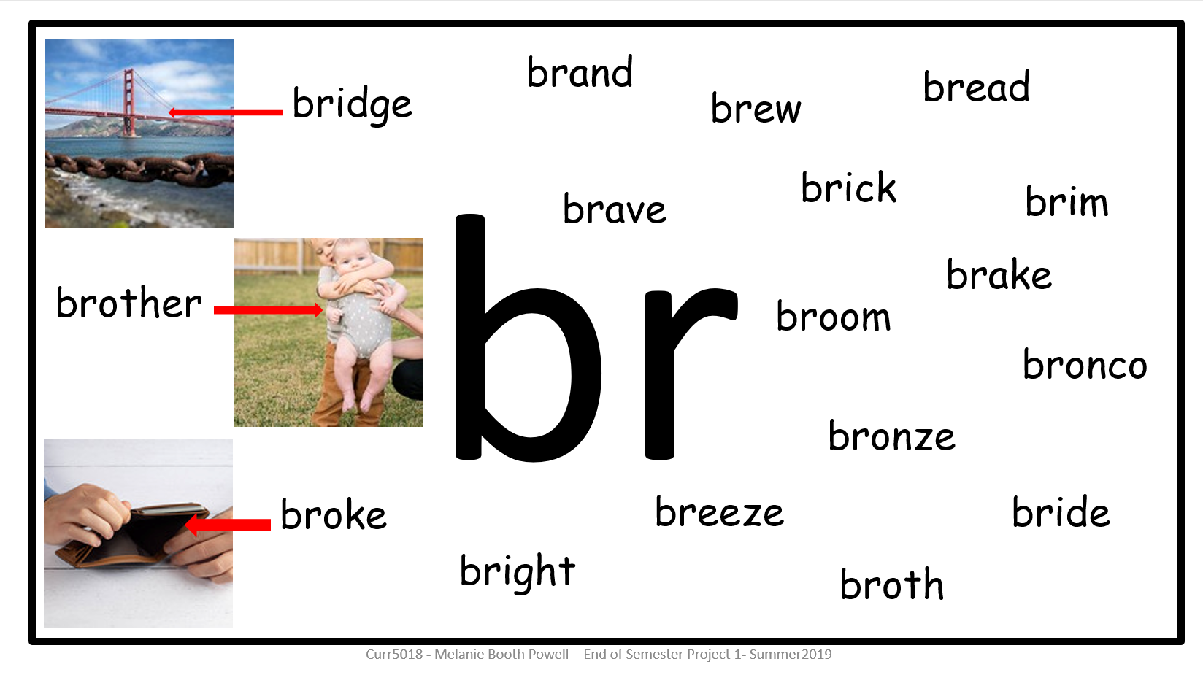
Vpdr-p1 is an enhanced flashcard that targets the initial consonant blend “br”. It allows student to click on the blend to hear the sound being made, mouse over the words that begin with the blend to hear them read, and associate pictures with a few vocabulary words with the targeted blend.
Vpdr-p2 is an enhanced flashcard that targets the initial consonant blend “cl”. It allows student to click on the blend to hear the sound being made, mouse over the words that begin with the blend to hear them read, and associate pictures with a few vocabulary words with the targeted blend.
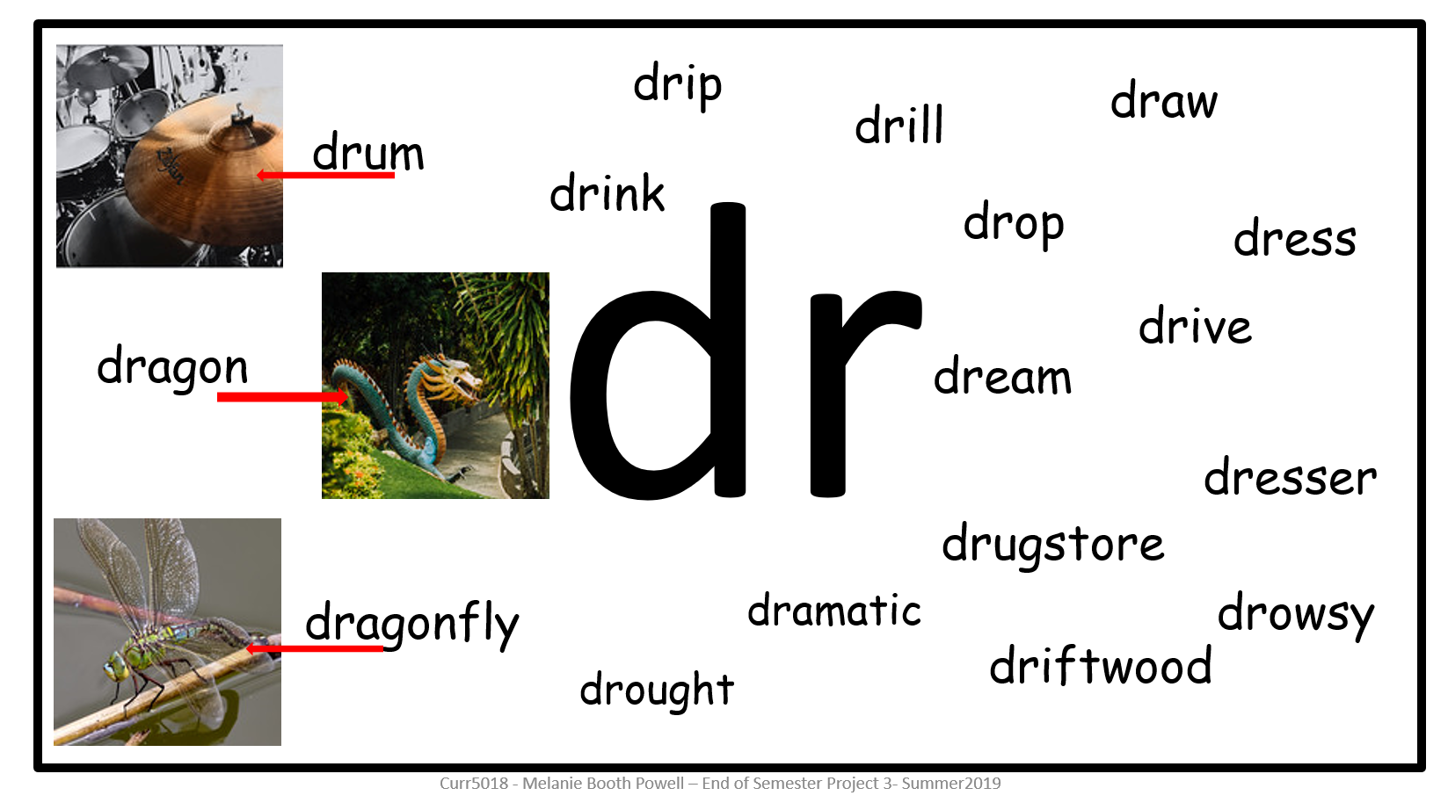
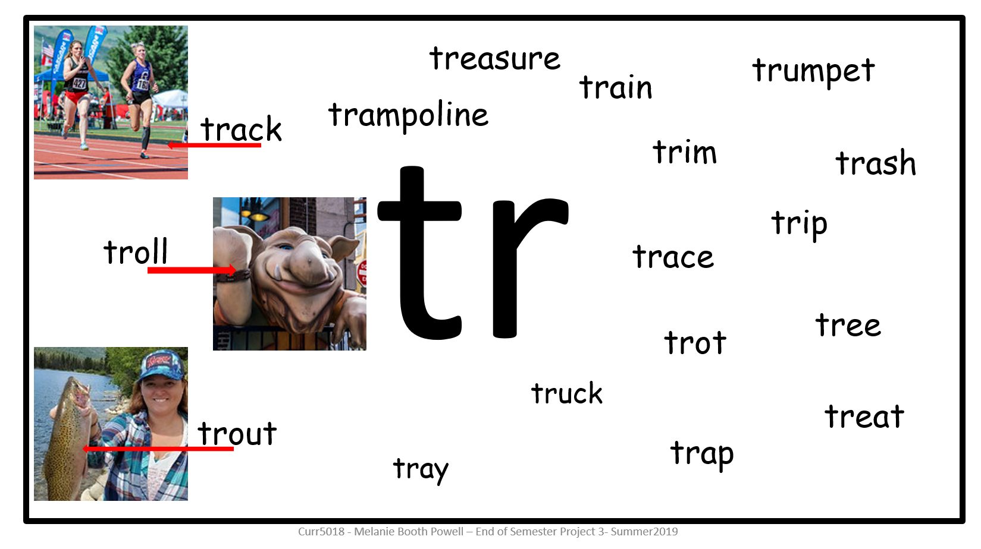
Vpdr-p3 is an enhanced flashcard that targets the initial consonant blend “dr”. It allows student to click on the blend to hear the sound being made, mouse over the words that begin with the blend to hear them read, and associate pictures with a few vocabulary words with the targeted blend.
Vpdr-p4 is an enhanced flashcard that targets the initial consonant blend “tr”. It allows student to click on the blend to hear the sound being made, mouse over the words that begin with the blend to hear them read, and associate pictures with a few vocabulary words with the targeted blend.

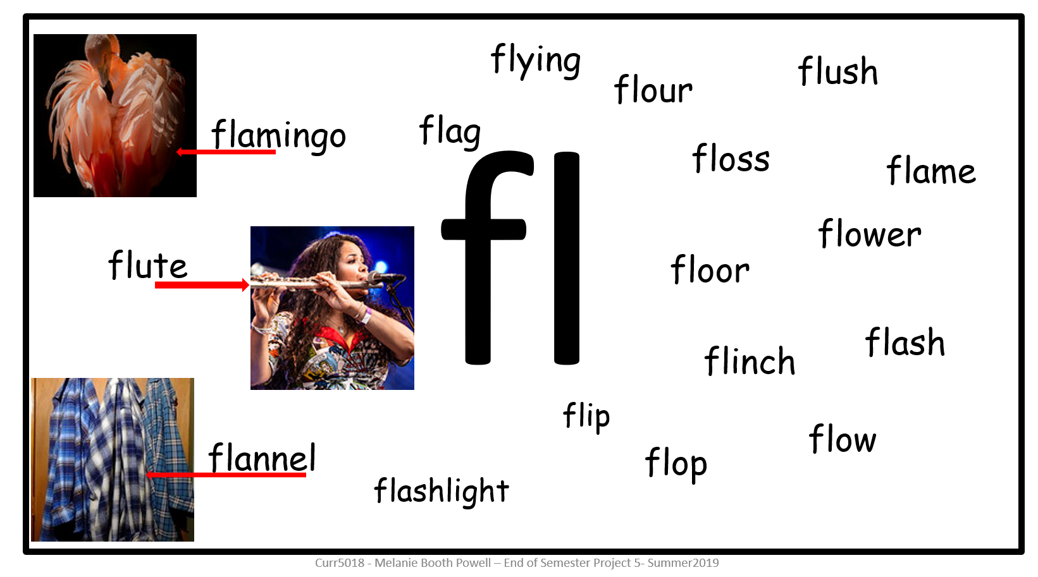
Vpdr-p5 is an enhanced flashcard that targets the initial consonant blend “fl”. It allows student to click on the blend to hear the sound being made, mouse over the words that begin with the blend to hear them read, and associate pictures with a few vocabulary words with the targeted blend.
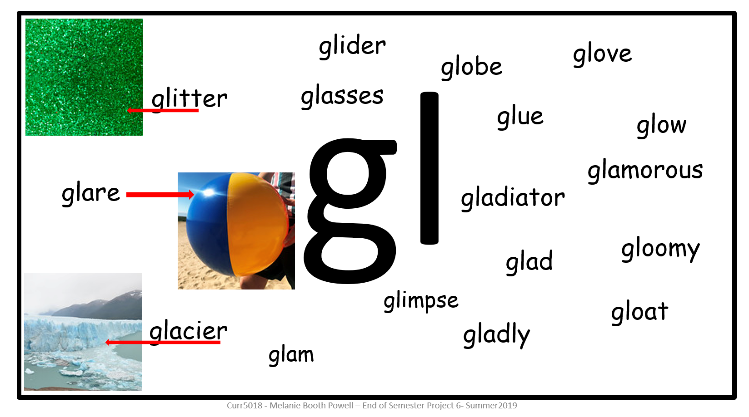
Vpdr-p6 is an enhanced flashcard that targets the initial consonant blend “gl”. It allows student to click on the blend to hear the sound being made, mouse over the words that begin with the blend to hear them read, and associate pictures with a few vocabulary words with the targeted blend.
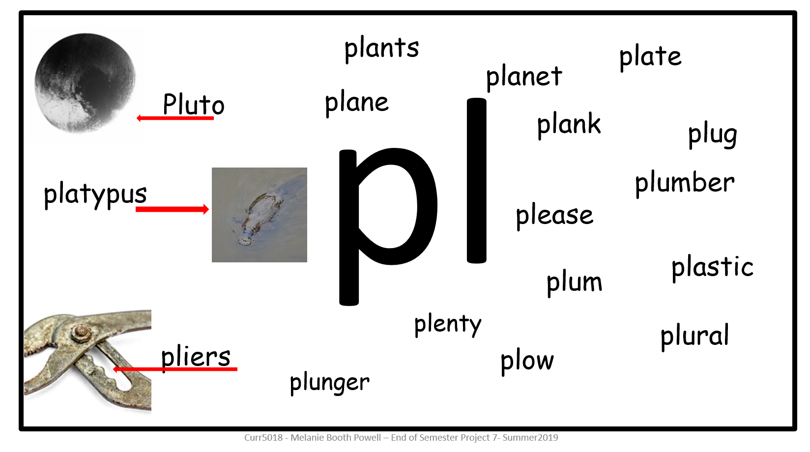
Vpdr-p7 is an enhanced flashcard that targets the initial consonant blend “pl”. It allows student to click on the blend to hear the sound being made, mouse over the words that begin with the blend to hear them read, and associate pictures with a few vocabulary words with the targeted blend.
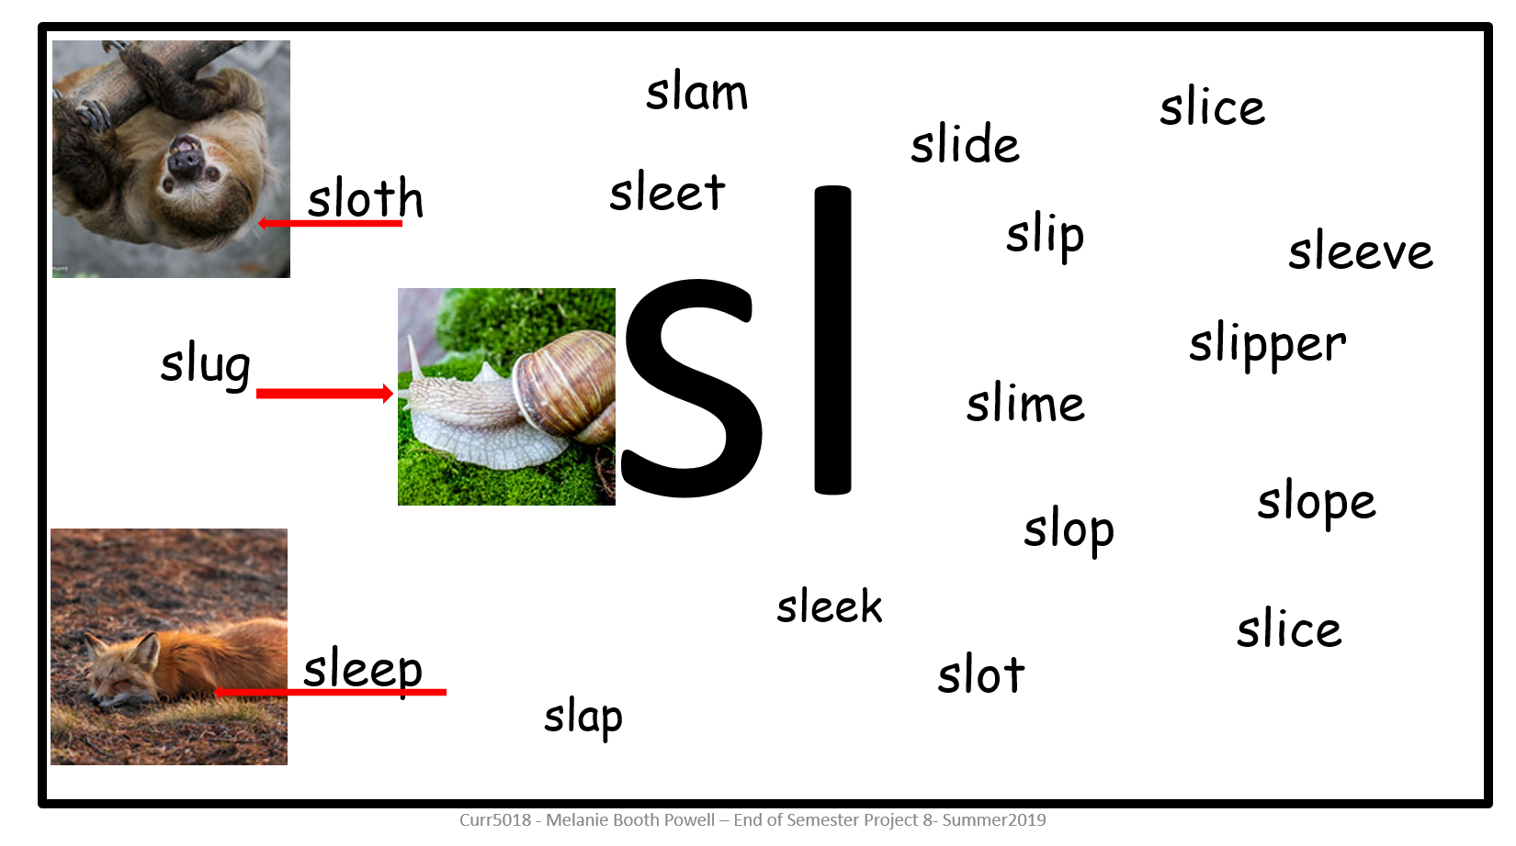
Vpdr-p8 is an enhanced flashcard that targets the initial consonant blend “sl”. It allows student to click on the blend to hear the sound being made, mouse over the words that begin with the blend to hear them read, and associate pictures with a few vocabulary words with the targeted blend.

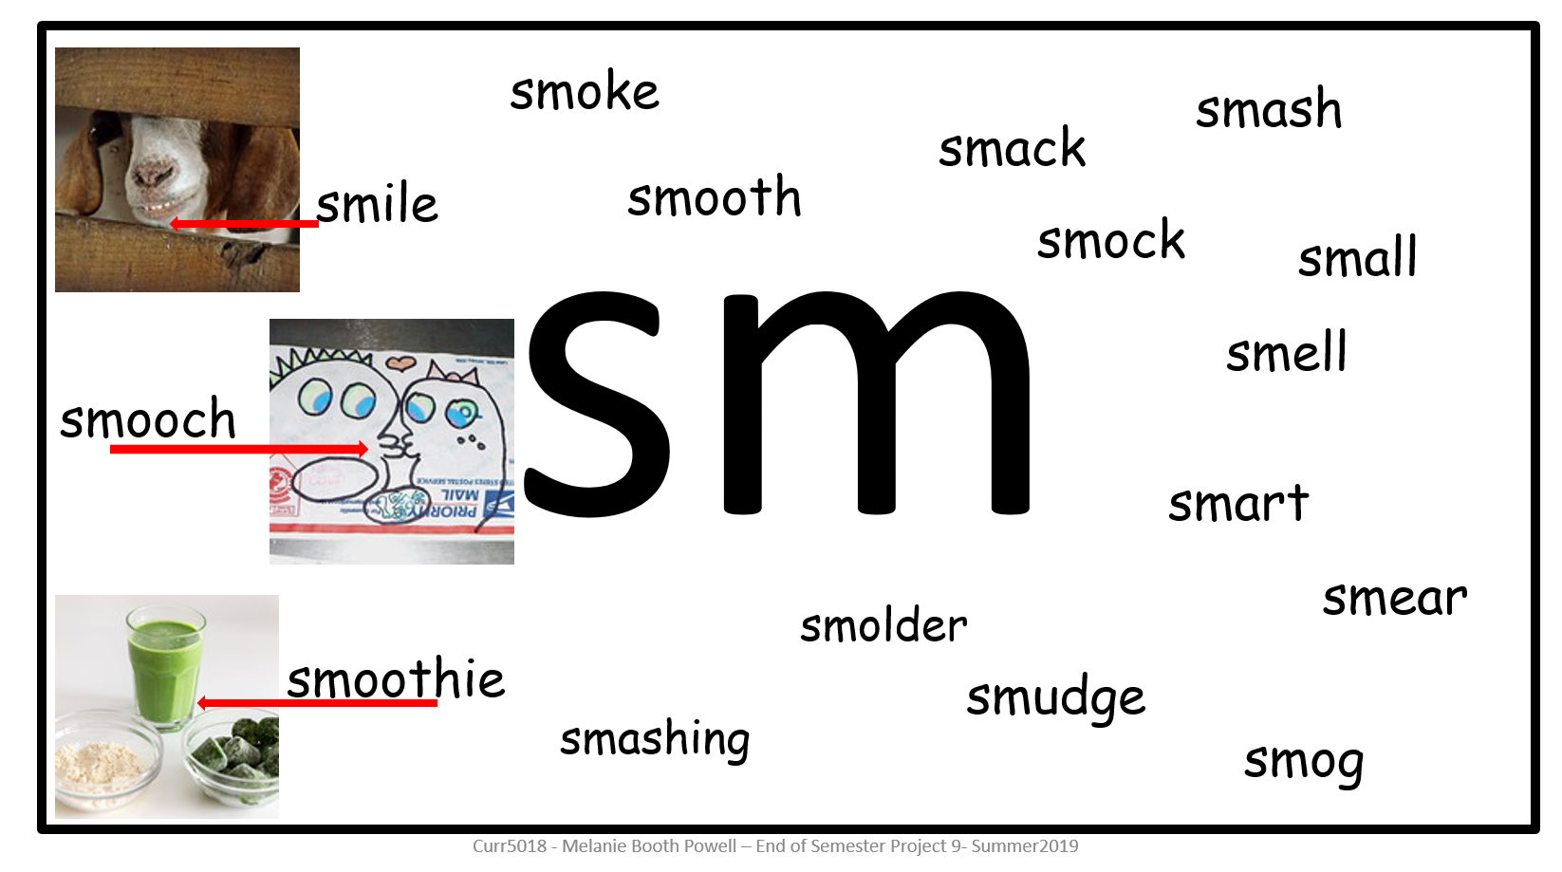
Vpdr-p9 is an enhanced flashcard that targets the initial consonant blend “sm”. It allows student to click on the blend to hear the sound being made, mouse over the words that begin with the blend to hear them read, and associate pictures with a few vocabulary words with the targeted blend.
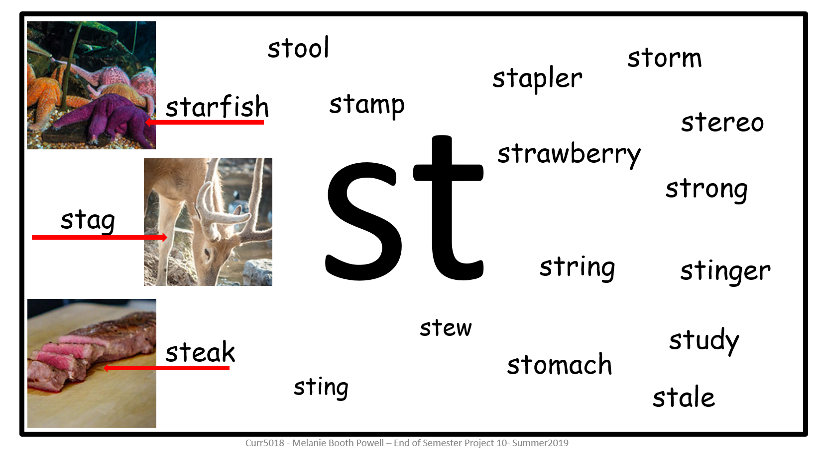
Vpdr-p10 is an enhanced flashcard that targets the initial consonant blend “st”. It allows student to click on the blend to hear the sound being made, mouse over the words that begin with the blend to hear them read, and associate pictures with a few vocabulary words with the targeted blend.

7. Visually Describe at Least 10 Professional “Visual Professional Diary Reflections”. Provide captured images that actively link to at least 10 online visual professional diary reflections (VPDRs). (150 pts).
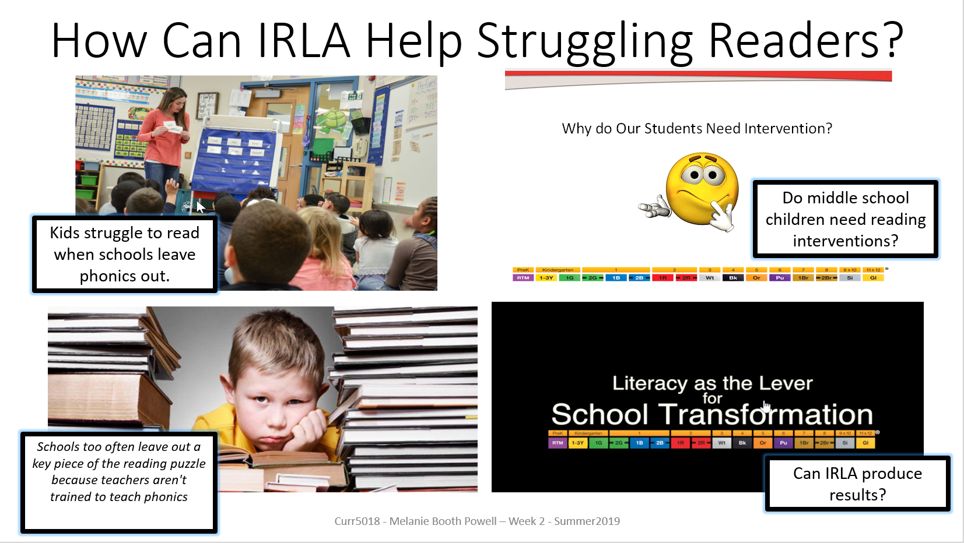

This interactive slide provides information about “IRLA” Foundational tool kits that are used in literacy intervention. There is an embedded PowerPoint that gives hints and tip on implementing an intervention program and why there is a need for one.
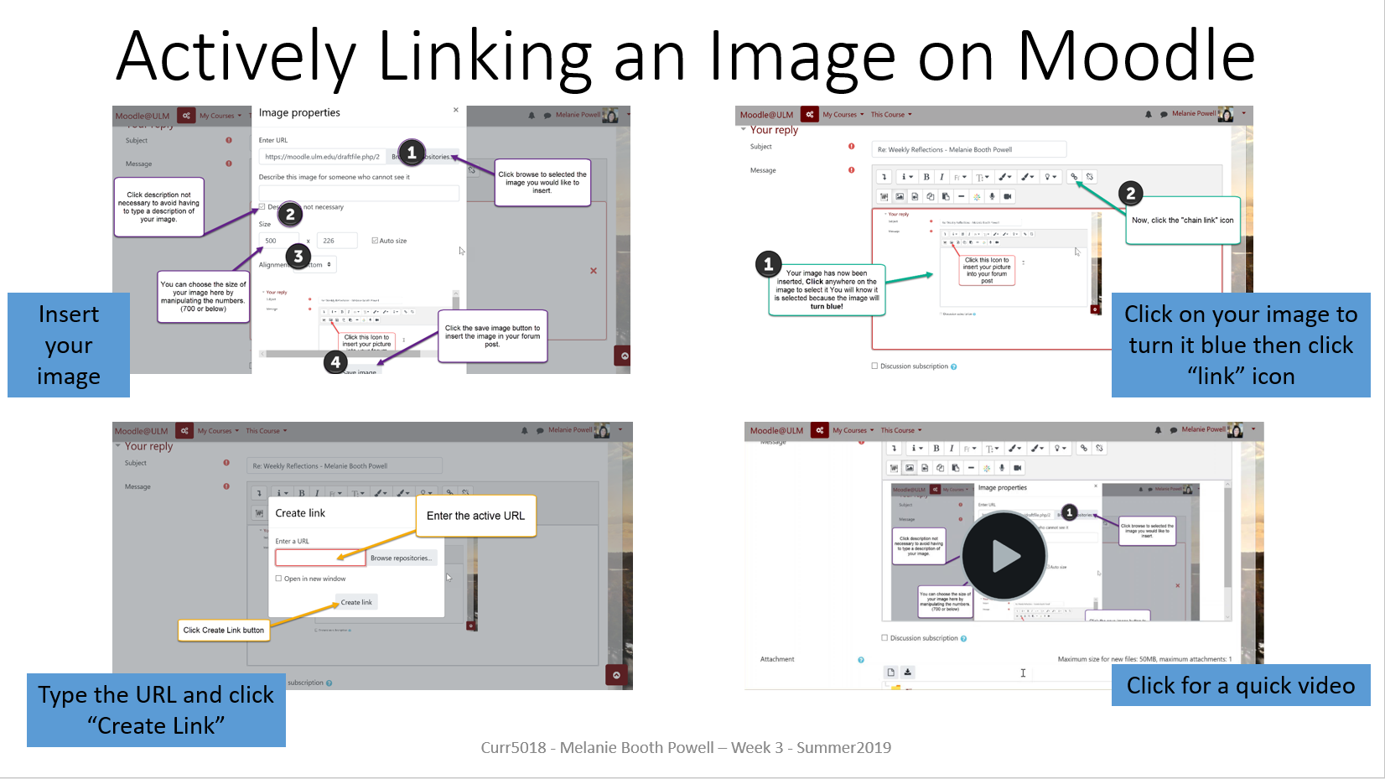

Vpdr-03 shows the steps necessary to actively link an image in Moodle when posting an image in a forum. The video highlights the steps as a tutorial that will effectively explain how to link an image.

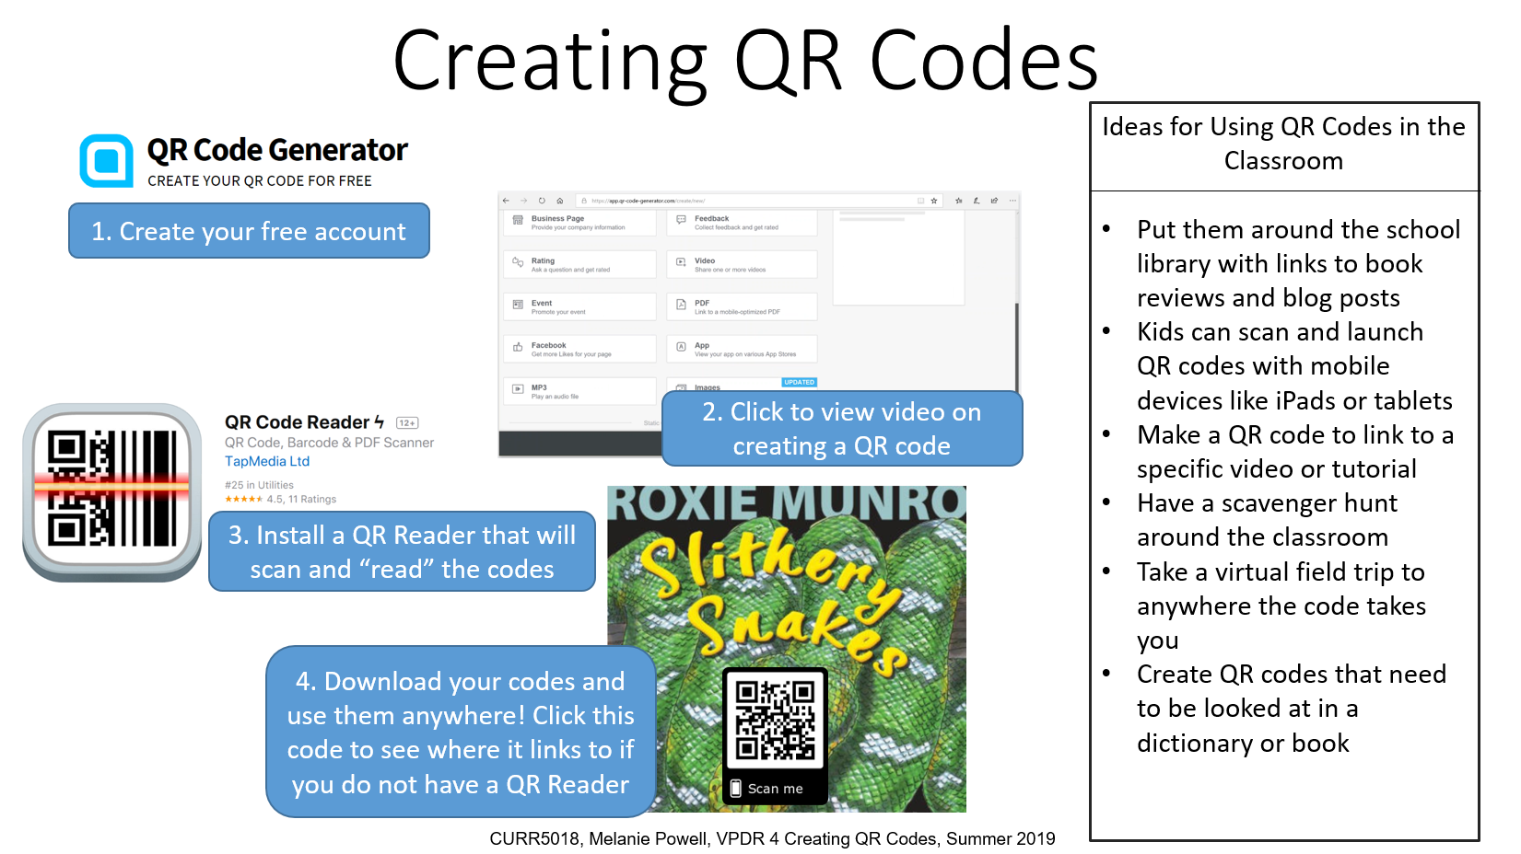
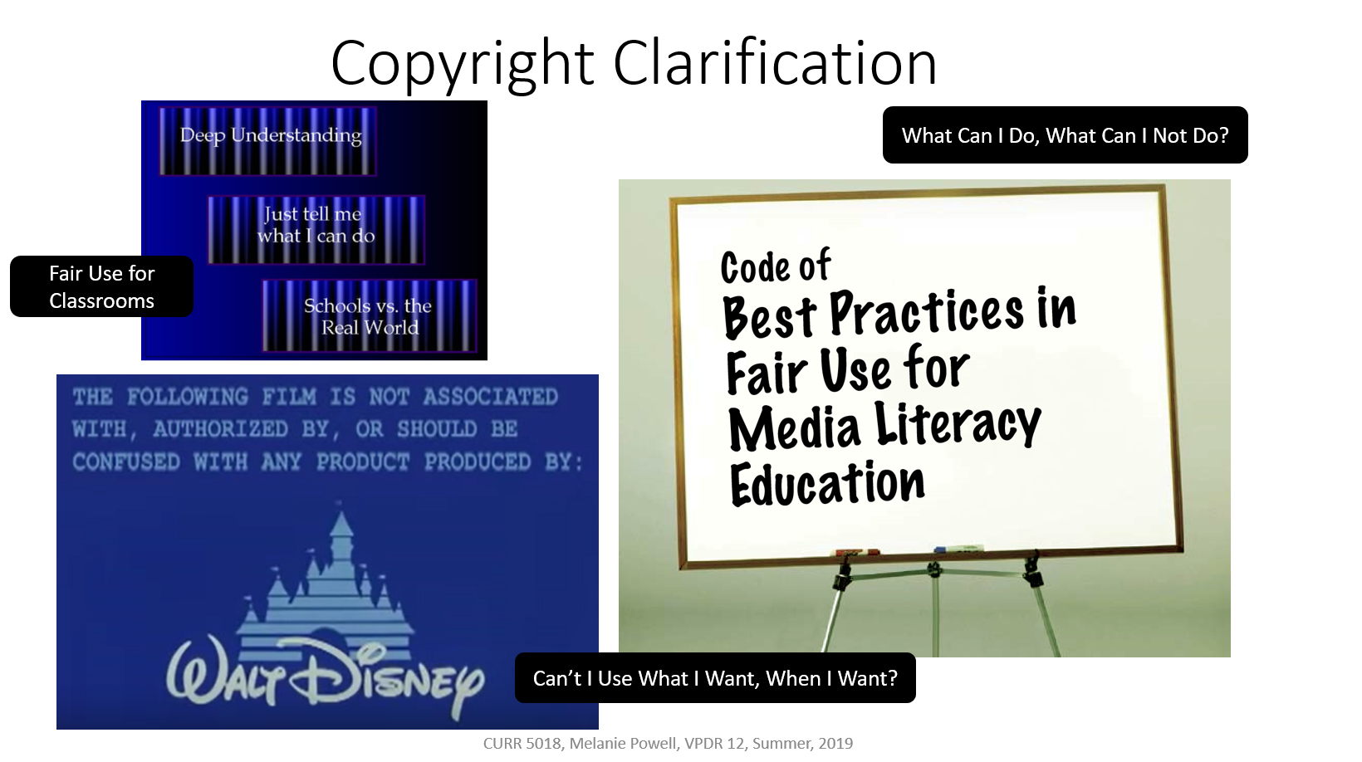
Vpdr-04 provides resources for creating QR codes and ideas on how to use them in the classroom. You will find a video that outlines the steps to create a QR code using the provided resource and demonstrates how easily it can be done.

Vpdr-12 calls attention to copyright issues when using graphics in the classroom. There is a video included that explains more in depth what can and what should not be used freely.

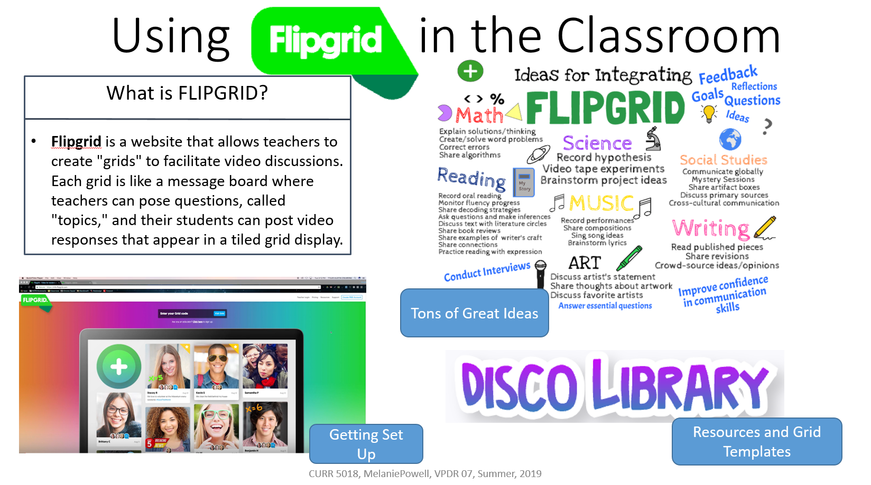
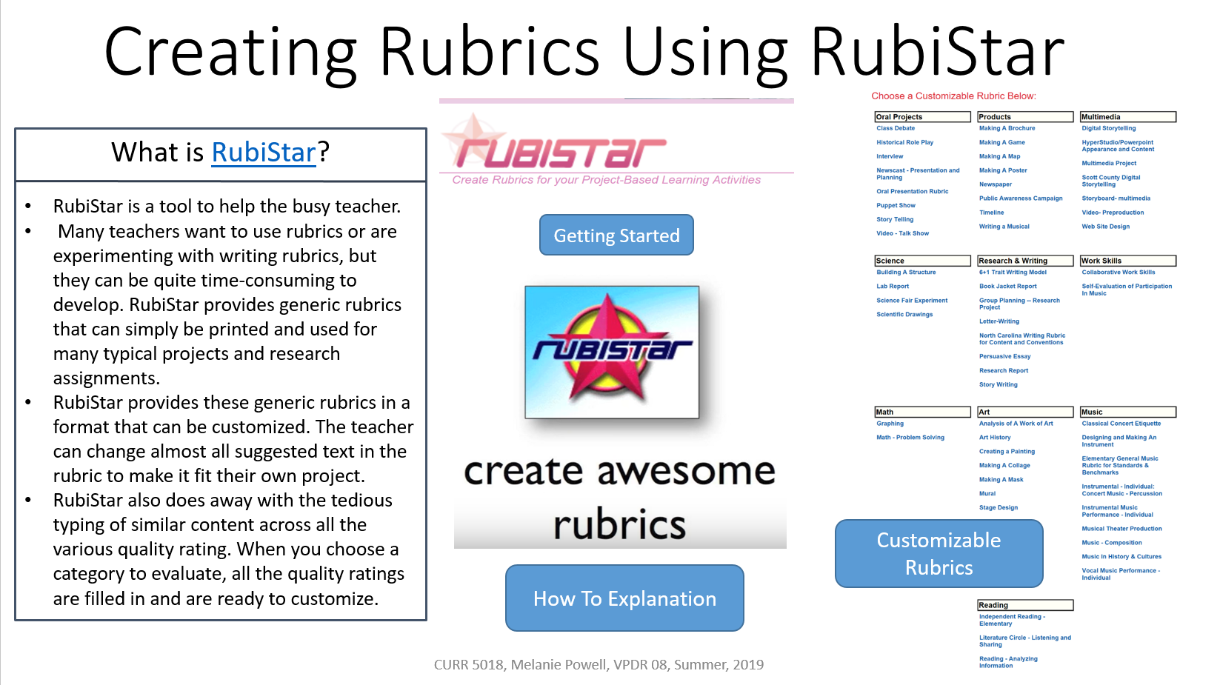
Vpdr-07 provides an explanation of an excellent available resource, FLIPGRID. FLIPGRID allows teachers to create grids that are used to facilitate video discussions. You will find a video that explains the resource further along with available templates and resources that will make using FLIPGRID easy for a busy teacher.
Vpdr-08 provides information about an extremely useful and time saving resource. RubiStar allows teacher to easily and quickly create usable rubrics to effectively grade student assignments.
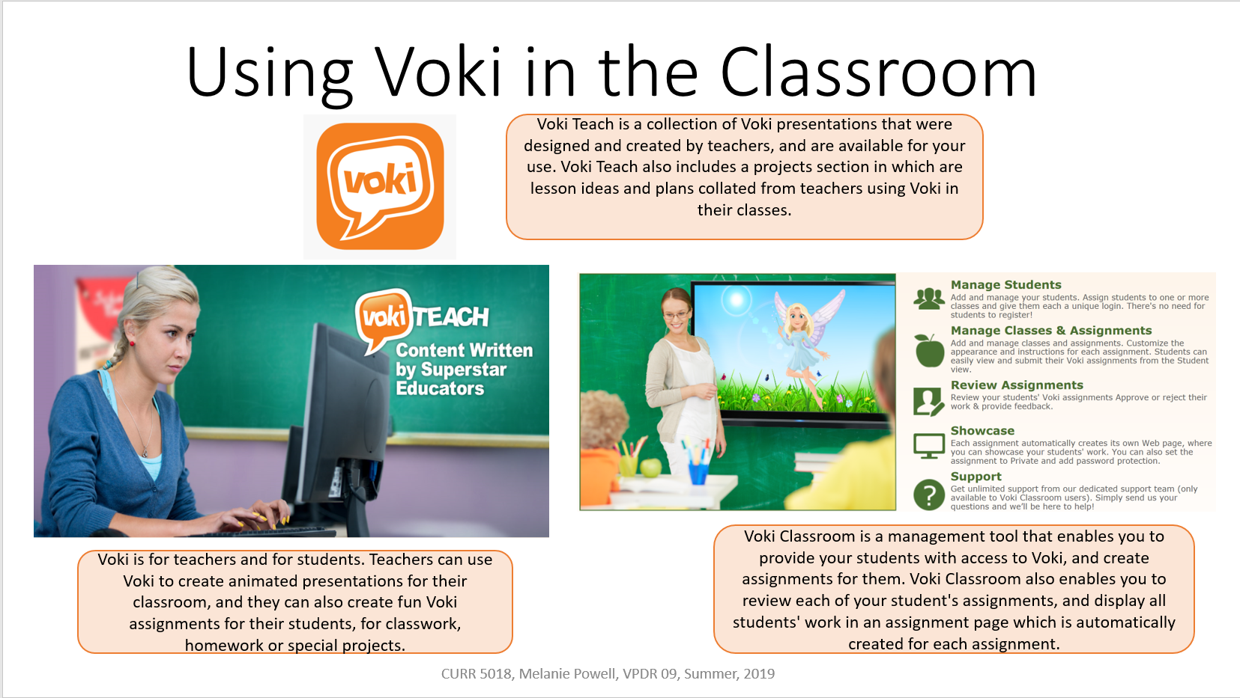
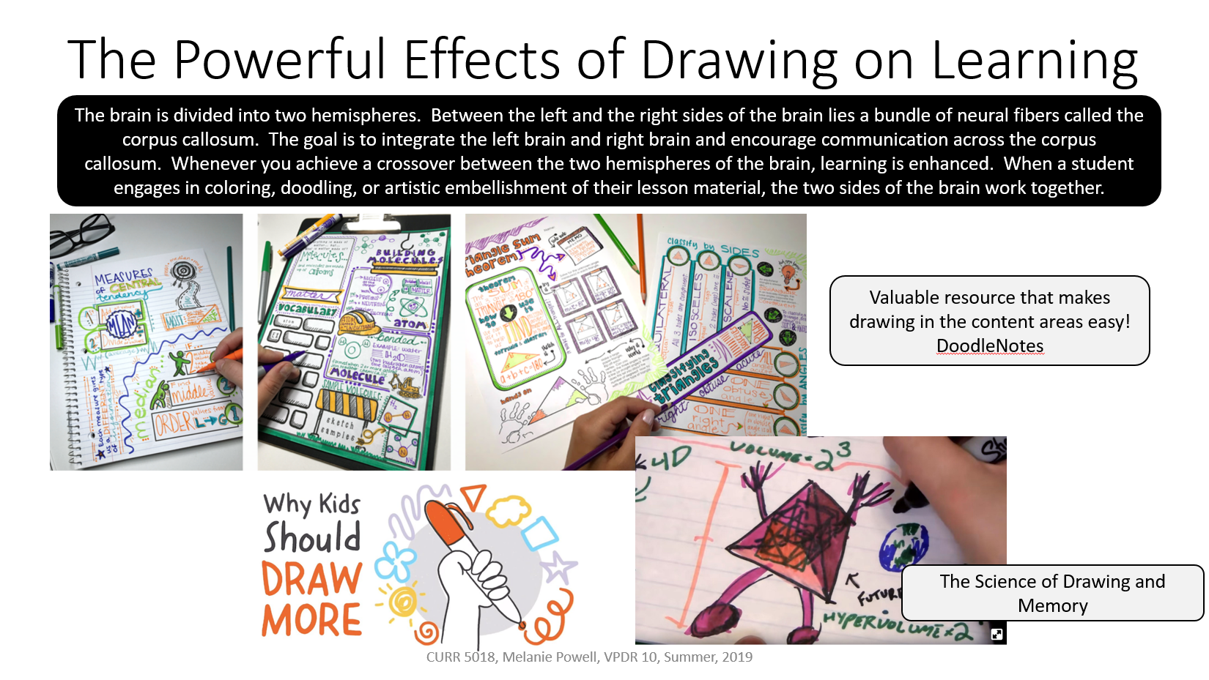
Vpdr-09 provides information about Voki and links to resource that explain how and why this would be useful in a classroom setting. Voki provides a selection of presentations that are free to use by teachers. The project section of the website provides lesson plans and projects that incorporate the Voki presentations.
Vpdr-10 provides teachers with research that shows the powerful impact that drawing can have on learning. There is a link that will hook teachers up with DoodleNotes and the DoodleNote club that makes incorporating drawing into instruction easy and enjoyable.

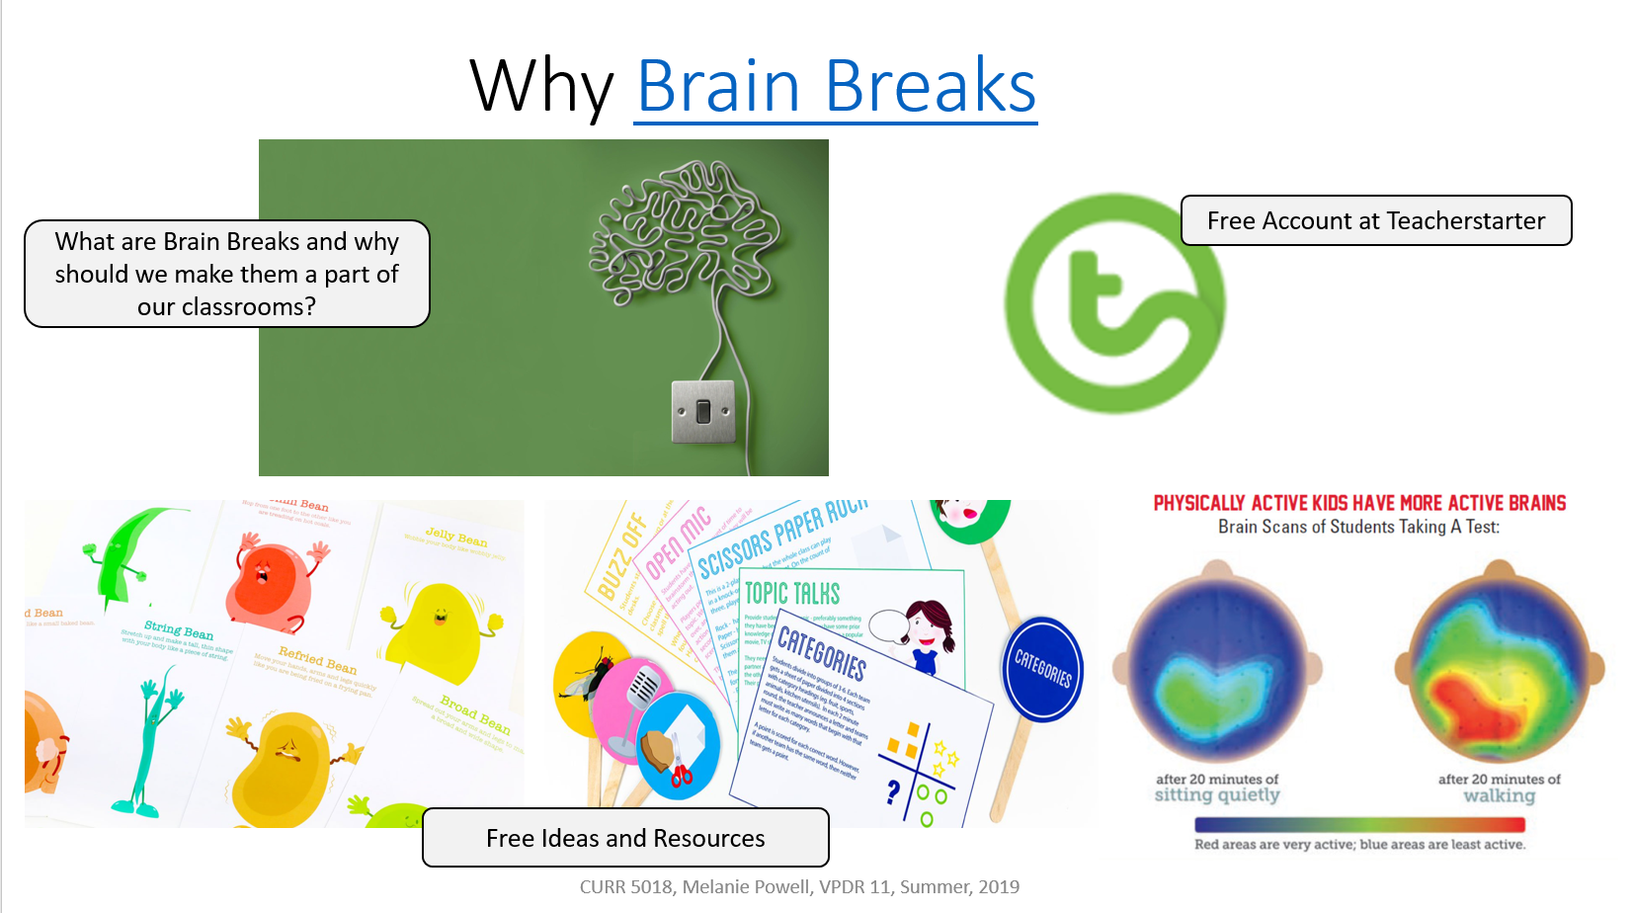
Vpdr-11 provides teacher with research explaining the proven benefits of using “brain breaks”. The links take teachers to a plethora of ideas as well as free printable resources they can be utilized for implementing the use of brain breaks in their classrooms.
8. Identify An Outstanding Free Online Educational Resource (25 points)
I believe one of the most beneficial, underutilized websites available to educators in the state is the Louisiana Department of Education. There are so many free, valuable resources available by just navigating a quick search or a few quick clicks. There are updates, resources, ideas, and data readily available. I like to read the most recent notes updated from the conferences, this allows me to keep up with the most current information and conversations that are being had.



