[](https://ulm.edu/webguide/index.html)This document is part of a student’s **academic eFolio (electronic portfolio)** for an online course during the summer of 2019 at the University of Louisiana at Monroe (ULM). The images link to files located on the student’s personal ULM website account.

This student has allowed this *exemplar* to be publicly viewed. **Note: After this student graduates, these links will no longer work because the website will be de-activated. However, the student has the option to COPY and transfer the files to another website account in the future.**

3. **Your Photo.** Insert an “annotated” image of yourself that actively links to your online **about-me.pptx** online file located on your ULM website account. (25 pts)

***[](http://warhawks.ulm.edu/~cardinas/5018/bin/about-me.pptx)***

Click here to learn more about me.

4. **Your Project Proposal Cognitive Map**. Include a “cognitive map” describing your course project. (25 points)   
](http://warhawks.ulm.edu/~cardinas/5018/bin/project-proposal.docx)

This project proposal map shows an outline for my class project that I completed. The entire project is about Google Extensions. Many people do not understand what an extension is or how to use extensions. This project answers common questions that people have such as What is an extension, How do you find and add extensions, how do you manage extensions, what is the difference between an app and an extensions, and why should you use extensions in your classroom. A list of useful extensions in the classroom with tutorials for each extension is included as an interactive powerpoint within the project. This tool will be used to help other educators use extensions.

5. **30-Second Video Summary Of Your Completed Online Course Project**. (50 points)

[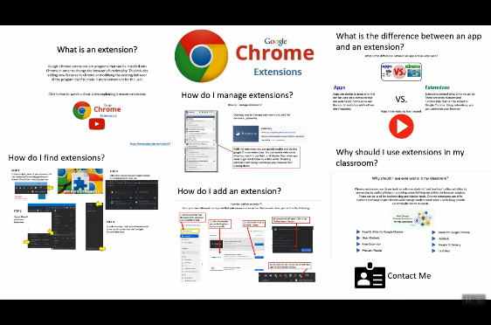](https://www.screencast.com/t/gcOw2AXcwv)

* 66. **Visually Link Your “Course Project Files” That You Created, Based On Your Project Proposal.**Provide actively linked images of your online course project files and provide text commentary. (200 pts.).

[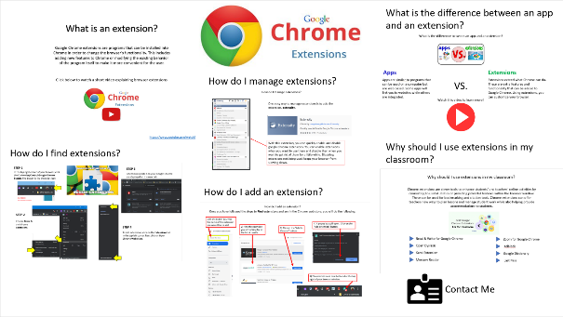](http://warhawks.ulm.edu/~cardinas/5018/bin/Project-Compilation.pptx)

This is the compilation of all of my project files. On this slide, all questions are presented to the reader. When they click on each VPDR with a question, a new file will be opened where information will be given to answer each question.

[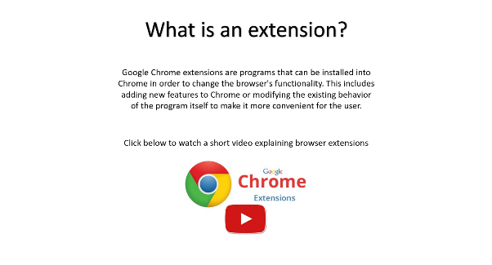](http://warhawks.ulm.edu/~cardinas/5018/bin/WhatIs.pptx)

The first questions is “What is an extension?” Included on this slide is a short description to tell the reader what an extension is. There is also an active link to a video which allows the reader to see what an extension is.

[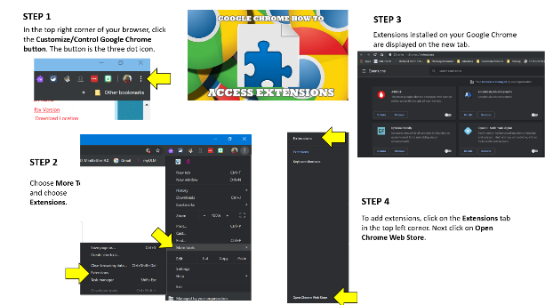](http://warhawks.ulm.edu/~cardinas/5018/bin/extensions1.pptx)

The second question answered is “How do I access extensions”. On this VPDR there are step by step instructions of where to go to find extensions in your google chrome browser.

](http://warhawks.ulm.edu/~cardinas/5018/bin/add.pptx)

The next question answered is “How do I add an extension?” I have included step by step directions for the reader. By following the steps they will be able to add any extension to their web browser.

](http://warhawks.ulm.edu/~cardinas/5018/bin/manage.pptx)

This VPDR helps the reader manage extensions in order to keep from slowing down their browser. I chose to show the extension “Extensity” which allows you to toggle extensions on and off as needed.

](http://warhawks.ulm.edu/~cardinas/5018/bin/Difference.pptx)

The difference between apps and extensions is explained in this VPDR. There is a description of both an app and an extension. There is also a linke to a video which explains the difference as well as shows the difference between the two.

](http://warhawks.ulm.edu/~cardinas/5018/bin/Why.pptx)

An interactive powerpoint is included for my last VPDR. In this interactive powerpoint I included 8 beneficial extensions that are great to use in a classroom. Each of these extensions includes a slide with information, links, and videos.

[](http://warhawks.ulm.edu/~cardinas/5018/bin/About_Me.pptx)

Contact Me

At the bottom of my Project compilation I included an icon that will link to my “About Me” VPDR when clicked. My about me VPDR with contact information is as follows:

On my about me page I included information with my degree and a few of my work responsibiltiies. I also included a link to my email so that the reader can simply click on my email address and a new email will be created addressed to me in their default email engine.

7. **Visually Describe At Least 10 Professional “Visual Professional Diary Reflections”.** Provide captured images that actively link to at least 10 online visual professional diary reflections (VPDRs). (150 pts).

[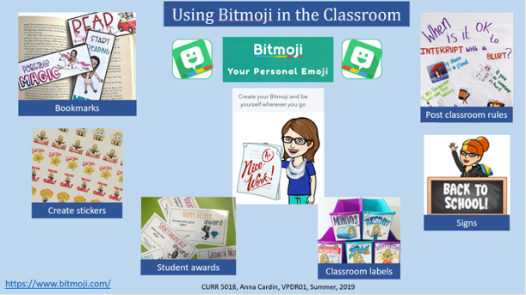](http://warhawks.ulm.edu/~cardinas/5018/bin/VPDR-01.pptx)

Bitmoji is a fun way to add personalization to your classroom. You create an avatar that looks like you. You can then print it out to use in the classroom as rewards, stickers, bookmarks, and more. You can also add it to digital work that your students turn in to you digitally.

[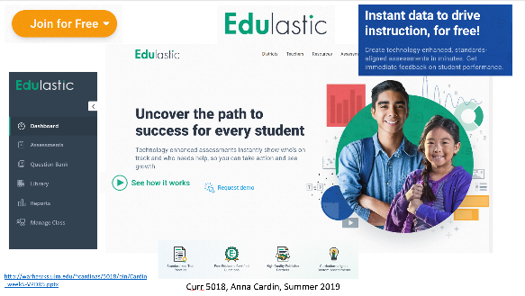](http://warhawks.ulm.edu/~cardinas/5018/bin/VPDR-05.pptx)

Edulastic is a free website that allows you to personalize assessments for your students. It allows you to track your students progress in order to direct your instruction.

](http://warhawks.ulm.edu/~cardinas/5018/bin/VPDR-04.pptx)

Seesaw is a free resource that allows you to create and assign activities to each individual student. Students can create portfolios. It also allows teachers to share student work with parents easily.

](http://warhawks.ulm.edu/~cardinas/5018/bin/VPDR-09.pptx)

This VPDR shows a free online classroom management tool. This free tool allows you to monitor sound level, give instructions, show a timer, choose names randomly and more.

[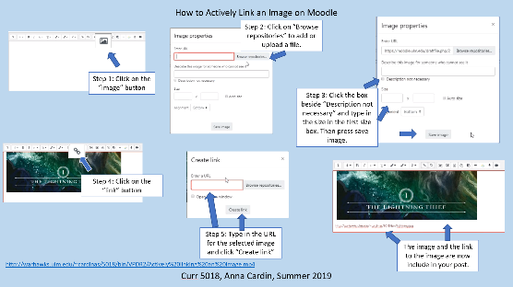](http://warhawks.ulm.edu/~cardinas/5018/bin/VPDR-02.pptx)

This VPDR shows step by step instruction on how to actively link an image in Moodle. Annotated images are used to demonstrate each step.

[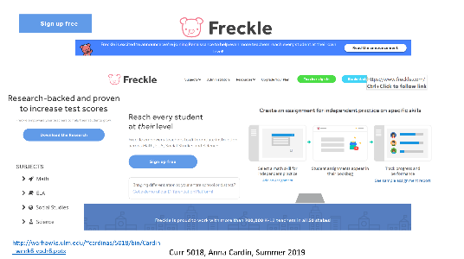](http://warhawks.ulm.edu/~cardinas/5018/bin/VPDR-06.pptx)

Freckle is a free website that allows you to assign Math, ELA, Social Studies and Science assignments to a classroom full of students. The upgraded version allows you to print reports and assign multiple assignments at a time.

](http://warhawks.ulm.edu/~cardinas/5018/bin/VPDR-10.pptx)

This VPDR shows the free resource “Epic!” All educators have free access to thousands of books, learning videos, and quizzes. There are many books that read aloud to the students while showing the pictures. This is a great resource for all teachers.

](http://warhawks.ulm.edu/~cardinas/5018/bin/VPDR-07.pptx)

Classkick is a free resource that allows you to track your students progress. Students work at their own pace while the teacher is able to monitor and provide help when needed. Teachers are able to add their own content as well.

[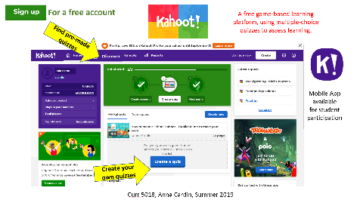](http://warhawks.ulm.edu/~cardinas/5018/bin/VPDR-03.pptx)

Kahoot is a fun learning website. This is a great competitive way to practice and review content. Students access the interactive website on their own device and answer multiple choice questions while competing with their peers.

](http://warhawks.ulm.edu/~cardinas/5018/bin/VPDR-08.pptx)

Plickers is a quick assessment tool to check for understanding. Students are given cards with images. Each image has one letter on each side of the image including letters A-D. To answer a question, the student holds their image up with their answer (A, B, C, or D) at the top of their image. The teacher uses the camera on a smartphone or tablet to scan all cards and is able to quickly see what each student answered. The teacher can then look at a spreadsheet of students and their answers.

8. **Identify An Outstanding Free Online Educational Resource** (25 points)

](https://www.wssd.k12.pa.us/ProgressMonitoring.aspx)

The West Shore School District is an outstanding educational resource. As a Special Education teacher, I am always searching for progress monitoring tools. This resource has printable Oral Reading Fluency passages and Reading Comprehension passages for grades 1st through 8th grade. It also includes Number calculation and Written Expression progress monitoring assessments. There are many more printable resources included throughout the website.