[](https://ulm.edu/webguide/index.html)This document is part of a student’s **academic eFolio (electronic portfolio)** for an online course during the summer of 2019 at the University of Louisiana at Monroe (ULM). The images link to files located on the student’s personal ULM website account.

This student has allowed this *exemplar* to be publicly viewed. **Note: After this student graduates, these links will no longer work because the website will be de-activated. However, the student has the option to COPY and transfer the files to another website account in the future.**

**[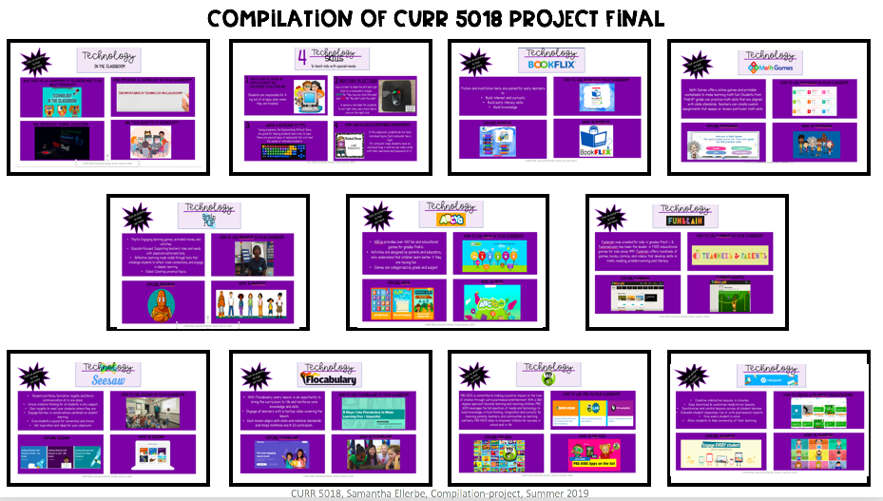](http://warhawks.ulm.edu/~ellerbesa/5018/bin/compilation-5018-course-project.pptx)**

**[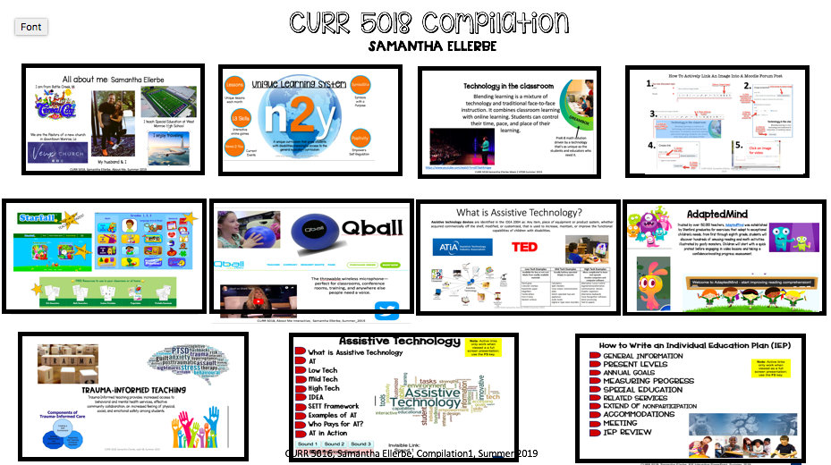](http://warhawks.ulm.edu/~ellerbesa/5018/bin/compilation-5018-course-files.pptx)**

**MobiRise Website**

[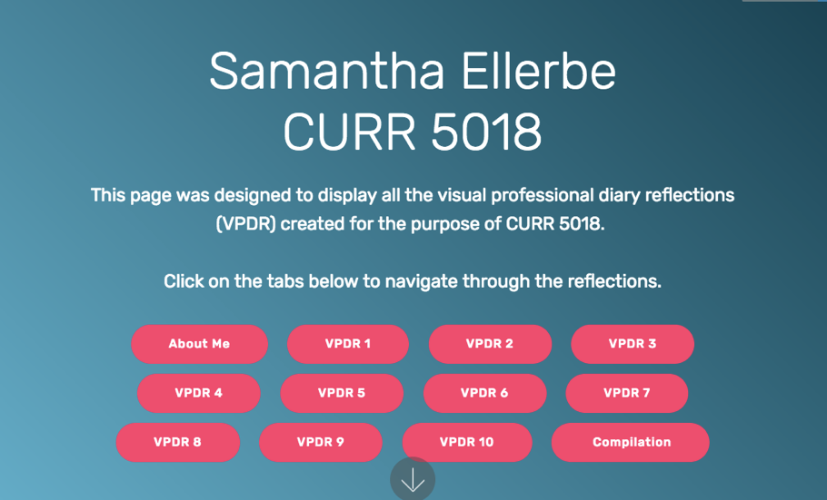](http://warhawks.ulm.edu/~ellerbesa/5018/project.html)  
3. **Your Photo.** Insert an “annotated” image of yourself that actively links to your online **about-me.pptx** online file located on your ULM website account. (25 pts)

***[](http://warhawks.ulm.edu/~ellerbesa/5018/bin/about-me.pptx)***

[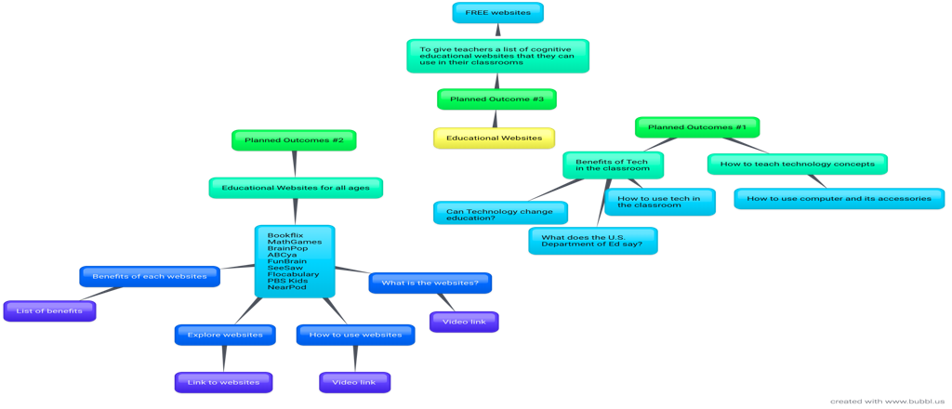](http://warhawks.ulm.edu/~ellerbesa/5018/bin/project-proposal.docx)

4. **Your Project Proposal Cognitive Map**. Include a “cognitive map” describing your course project. (25 points)   
My Project Proposal is to create a series of PowerPoint presentations (VPDRs) to provide to other teachers in my school district. The VPDRs can be provided during professional developments, PLC meetings, or at any time during the school year. The VPDR series will consist of online websites or resources that are beneficial to student learning. These online websites can be used during whole group, small group, or independent learning to support state standards. The VPDR are the top ten resources I use in my classroom with my students who have disabilities. These are great interactive resources that engaged students in learning. They can be used in any classroom with any student.

5. 30-Second Video Summary Of Your Completed Online Course Project. (50 points)

[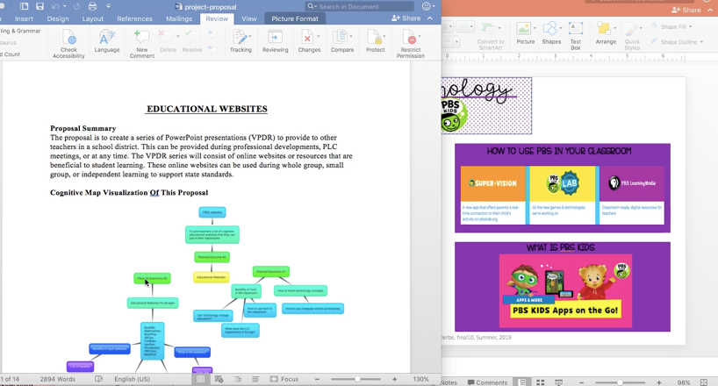](https://www.screencast.com/users/SamEllerbe)

* 66. **Visually Link Your “Course Project Files” That You Created, Based On Your Project Proposal.**

**Project File 1:**

[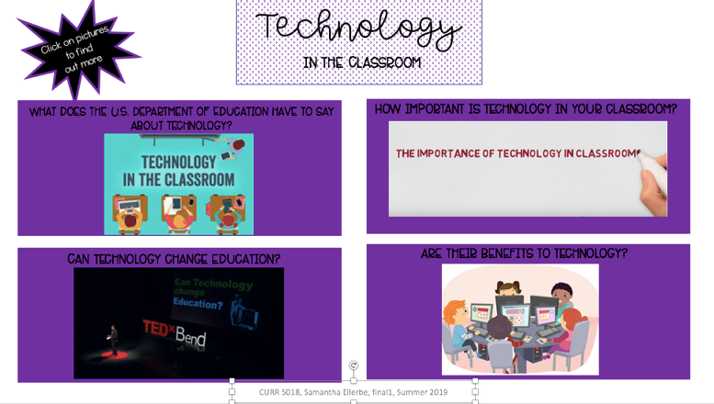](http://warhawks.ulm.edu/~ellerbe/5018/bin/project-file-01.pptx)

This VPDR is an introduction to technology in the classroom. It explains the importance of using technology in the classroom. It has videos and articles linked so that teachers can explore the importance of digital learning, student engagement and motivation, and how technology has the power to transform teaching. It is important for teachers to understand how technology can be incorporated into their classrooms and the benefits of it.

**Project File 2:**

[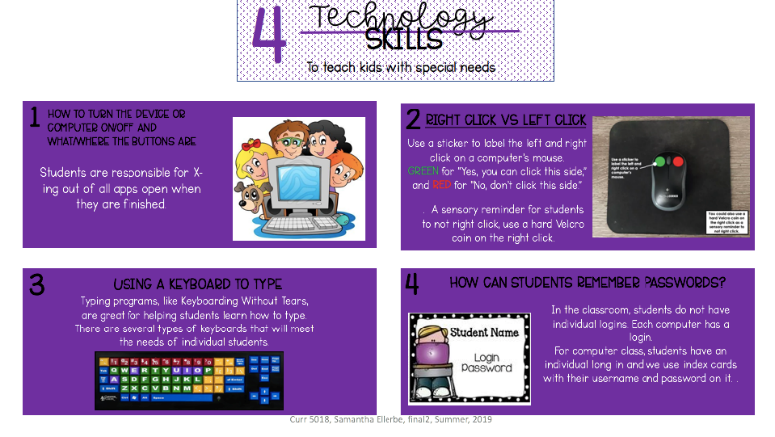](http://warhawks.ulm.edu/~ellerbesa/5018/bin/project-file-02.pptx)

In a special education classroom, or even early childhood classroom, students need introductions on computers and their accessories. This VPDR has two amazing links of videos that teachers and students can watch together to introduce simple operations of the computer. The VPDR also has two resource links that teachers can explore to gain more information and ideas. It explores how to turn on/off computers, how to use a mouse, how to store and use student logins/passwords, and assistive technology resources.

**Project File 3:**

[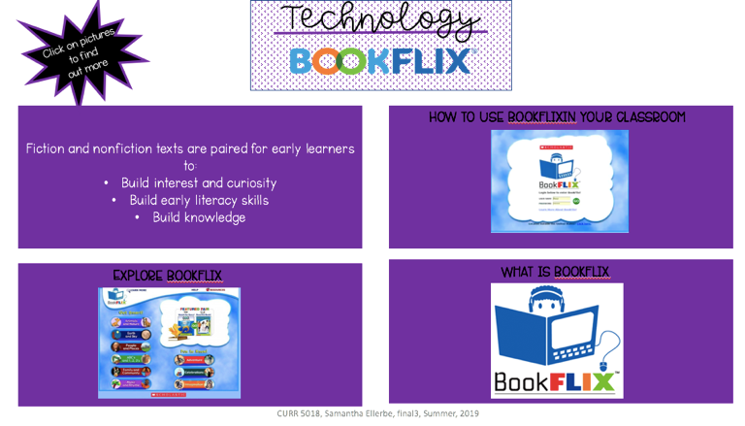](http://warhawks.ulm.edu/~ellerbesa/5018/bin/project-file-03.pptx)

This VPDR explores the website of Bookflix. Bookflix is a website that has fiction and nonfiction books that can help learners to build interest and curiosity, literacy skills, and knowledge. It has step-to-step demonstrations for teachers and students on how to use Bookflix. The VPDR resources explore different genres of books and features that Bookflix has to offer.

**Project File 4:**

[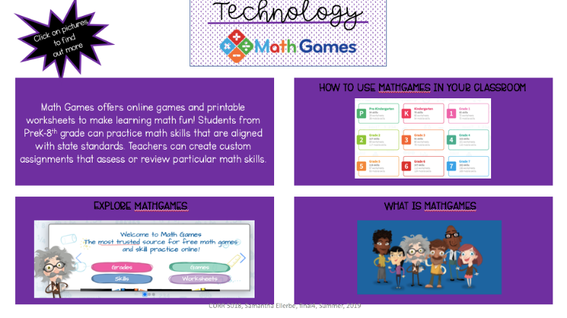](http://warhawks.ulm.edu/~ellerbesa/5018/bin/project-file-04.pptx)

This VPDR explores the website: MathGames. MathGames is a website that offers online games and printable worksheets to make math learning more fun and engaging. Mathgames are aligned with state standards and can benefits students in PreK-8th grade. The resources linked to the VPDR directs teachers to the state standards connected to the math skills, math activities for each grade level, and a video that provides a tutorial for teachers to to better understand what MathGames is and how to incorporate it into their classrooms.

**Project File 5:**

[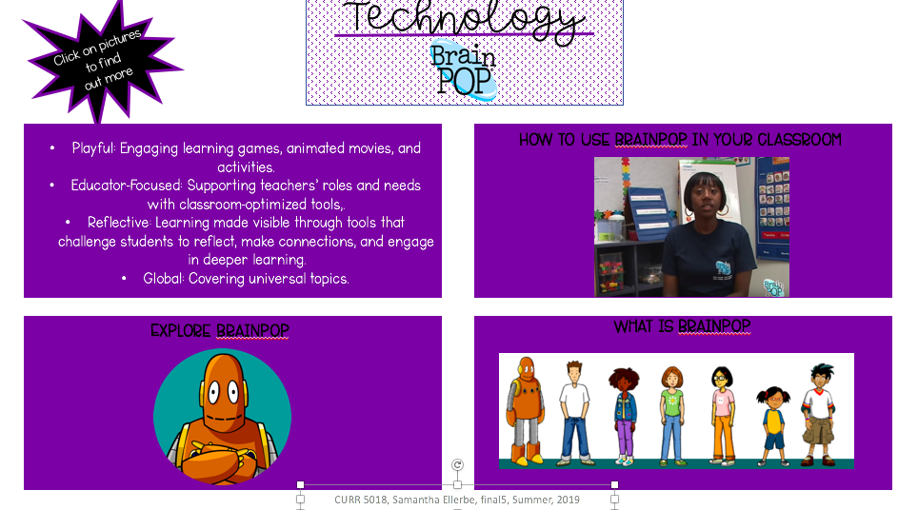](http://warhawks.ulm.edu/~ellerbesa/5018/bin/project-file-05.pptx)

This VPDR explores BrainPop. BrainPop offers engaging learning games, animated movies, and activities. BrainPop makes learning more visible through tools that challenge students to reflect, make connections, and engage in deeper learning. I use BrainPop with my students to support different content. The resources linked to this VPDR provide real-life teacher examples of classroom use, a 101 tutorial of BrainPop, and a change to explore the website on their own.

**Project File 6:**

[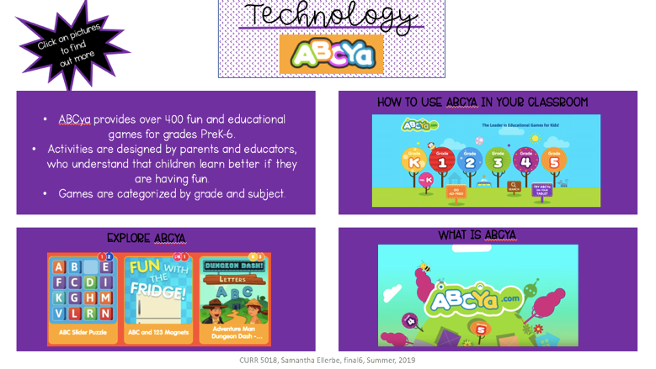](http://warhawks.ulm.edu/~ellerbesa/5018/bin/project-file-06.pptx)

This VPDR explores ABCya. ABCya is a website that I use daily with my students. ABCya provides my students with over 400 fun and educational games. The resources linked provide teachers a short video on how to use and incorporate ABCya into their classrooms and a change to explore the variety of games and activities. ABCya is a great resource to make learning more fun and engaging.

**Project File 7:**

[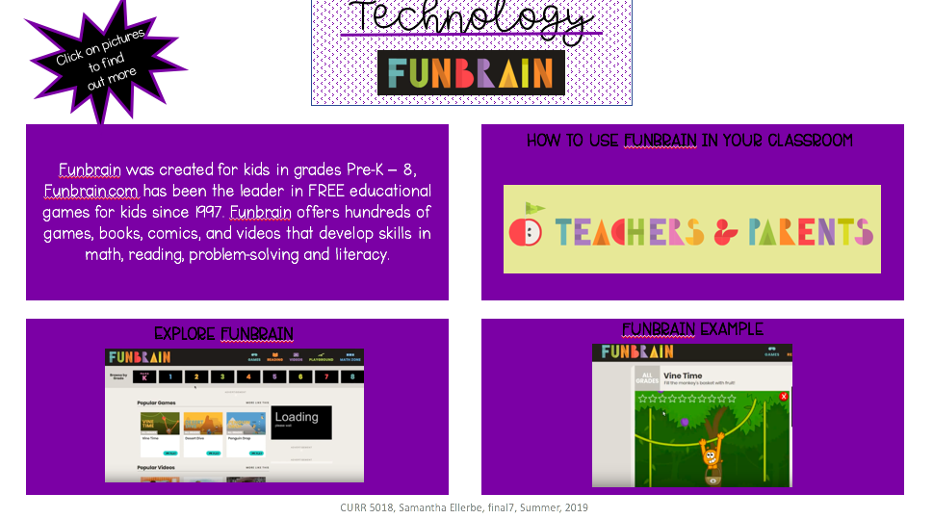](http://warhawks.ulm.edu/~ellerbesa/5018/bin/project-file-07.pptx)

This VPDR explores FunBrain. FunBrain offers hundreds of online games, books, comics, and videos to help students in PreK-8th grade to develop skills in math and ELA. The links demonstrate what FunBrain is all about, the games, the content area, and much more. It provides a short synopsis of what FunBrain is all about and how to use it with students. The VPDR also has a video of a student exploring FunBrain and playing games on the website.

**Project File 8:**

[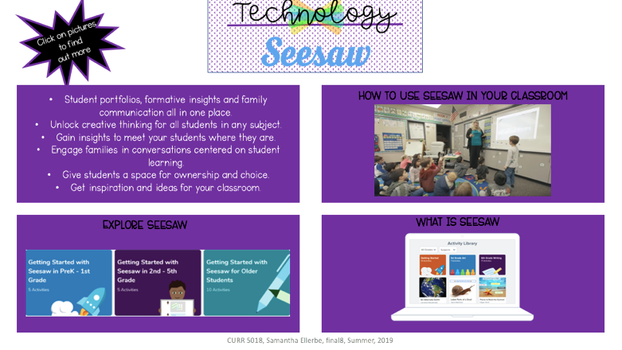](http://warhawks.ulm.edu/~ellerbesa/5018/bin/project-file-08.pptx)

This VPDR explores SeeSaw. SeeSaw is the best platform for empowering students to demonstrate and share their learning. I use SeeSaw to engage families in conversations about their child’s learning and to give my students a place for ownership and choices in their learning. The VPDR provides a real-life teacher using Seesaw in her own classroom. It also provides a short demonstration and tour of SeeSaw and how teachers can use the app.

**Project File 9:**

[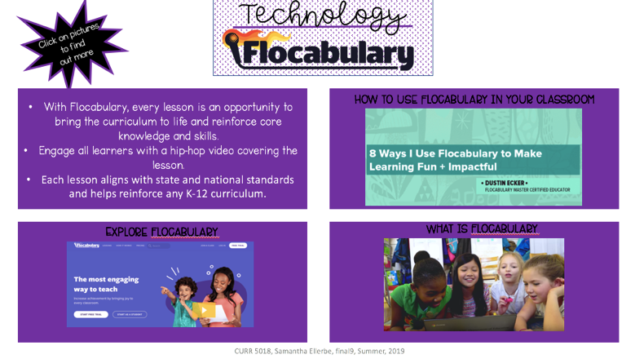](http://warhawks.ulm.edu/~ellerbesa/5018/bin/project-file-09.pptx)

This VPDR explores Flocabulary. Flocabulary is a fun and engaging program that uses educational hip-ho music for students to learn and increase achievement in all content areas. My students love music and I thought I would share this website with other teachers. The VPDR provides resources of articles and videos on Flocabulary. It provides 8 ways that a teacher uses Flocabulary to make learning more fun and impactful in his own classroom. The VPDR also links a short video on what exactly Flocabulary is and explores the website.

**Project File 10:**

[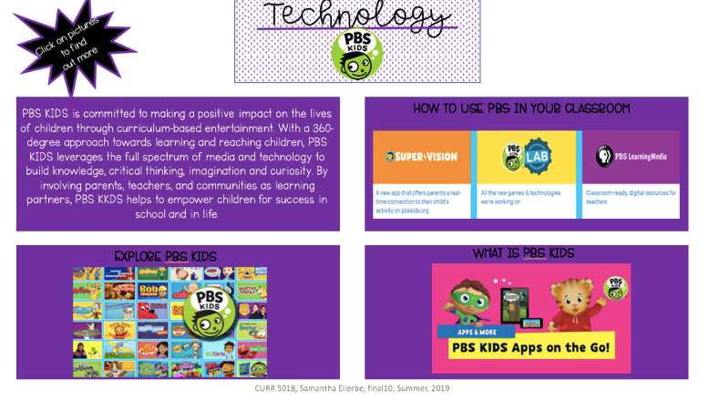](http://warhawks.ulm.edu/~ellerbesa/5018/bin/project-file-10.pptx)

This VPDR explores PBSkids. I personally use PBS kids with my students to build knowledge, critical thinking skills, and imagination in the classroom. Teachers and students can use PBS Kids on a computer and IPad. The VPDR explores both options. There is also a screencast video linked to demonstrate how to use the interactive website and explores different things the website has to offer.

**Project File 11:**

[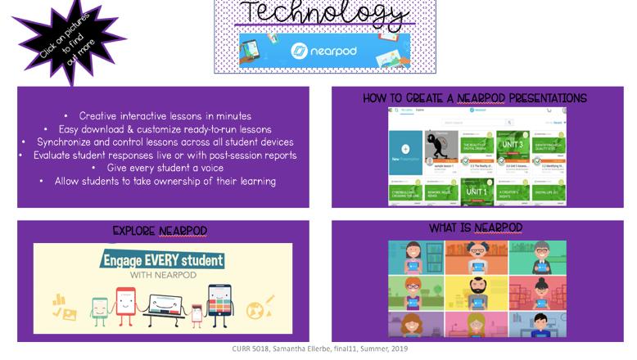](http://warhawks.ulm.edu/~ellerbesa/5018/bin/project-file-11.pptx)

**Project File 11:** This VPDR explores NearPod. Teachers can bring engagement into their classrooms and create interactive lessons or customize ready-to-go lessons when using NearPod. Teacher. In the VPDR, there are videos that introduce Nearpod and explain what it is. They also describe how to create lessons and how to upload PowerPoint presentations.

**Project File Compilation:**

[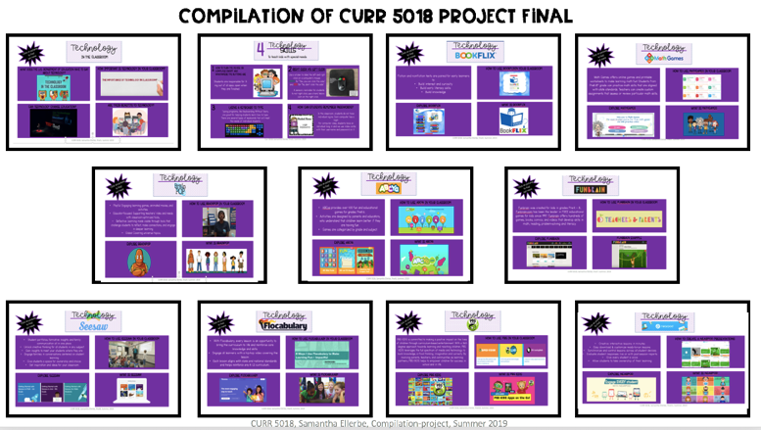](http://warhawks.ulm.edu/~ellerbesa/5018/bin/compilation-5018-course-project.pptx)

This VPDR is a compilation of my 11 project files. It has active links that will take you directly to the VPDR of each educational website. This is a handout I would print and give to teachers so they have a one-page resource of all the educational websites that can be used in their classroom.

7.

**VPDR 1:**   
[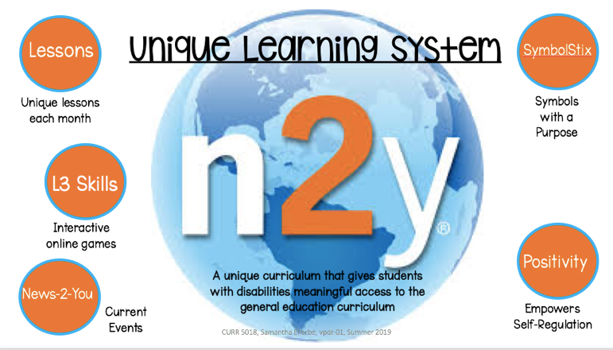](http://warhawks.ulm.edu/~ellerbesa/5018/bin/vpdr-01.pptx)

I use Unique Learning System Curriculum in my own classroom. Unique was designed specifically for students with disabilities. To access the general education curriculum. It is based off of state standards. It has symbol-supported tools and materials that I with my students. Unique is our main curriculum for math, ELA, social studies, and science. We also use News-2-You for current events happening around the world.

**VPDR 2:**   
[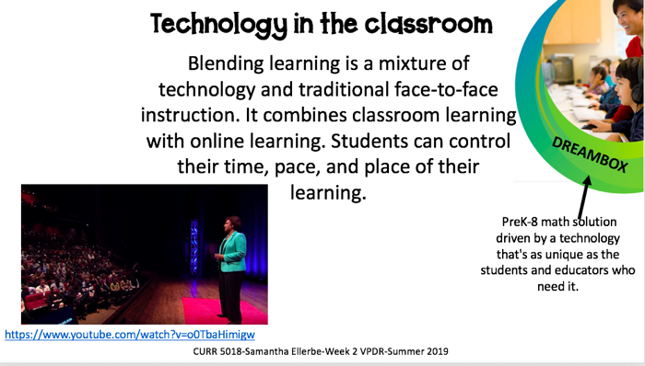](http://warhawks.ulm.edu/~ellerbesa/5018/bin/vpdr-02.pptx)

I created this VPDR as a basic knowledge for educators on the importance of technology in the classroom. I have linked a TED talk by Jessie Wooley-Wilson on blended learning impacts students. Jessie Wilson is the president of LeapFrog and Blackboard and is the CEO of DreamBox. This VPDR includes a resources of the website, DreamBox. DreamBox is an online K-8 math program.

**VPDR 3:**

[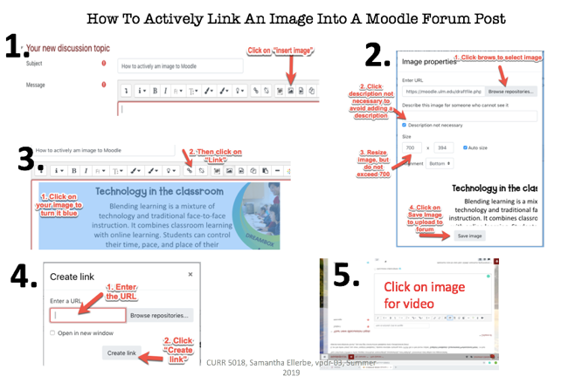](http://warhawks.ulm.edu/~ellerbesa/5018/bin/vpdr-03.pptx)

This VPDR is a step-by-step tutorial of how to actively link an image into a Moodle Forum. It shows students who use Moodle how to link their images. In step five, students can watch my screencast video for a better understanding.

**VPDR 4**:

[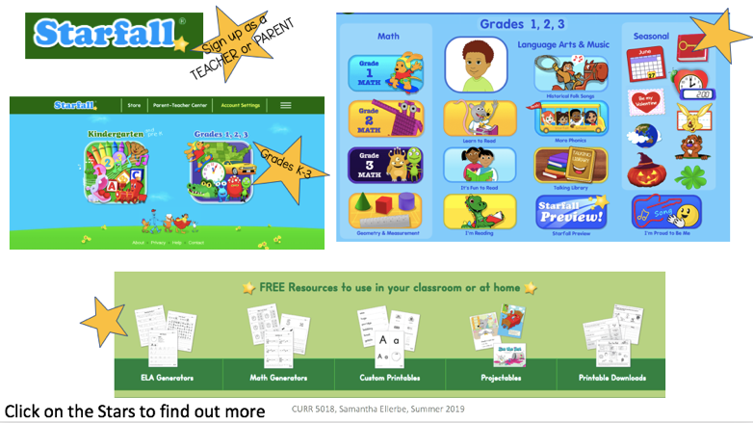](http://warhawks.ulm.edu/~ellerbesa/5018/bin/vpdr-04.pptx)

Starfall is very important website in my own classroom. I created this VPDR to share with others the benefit of Starfall. Starfall is a great resource for PreK-3rd grade. It specializes in math and language arts. Starfall is aligned with common core state standards, so teachers use this resources as an added bonus for their lessons. There are linked images that will help teachers explore the various options of starfall.

**VPDR 5**:

[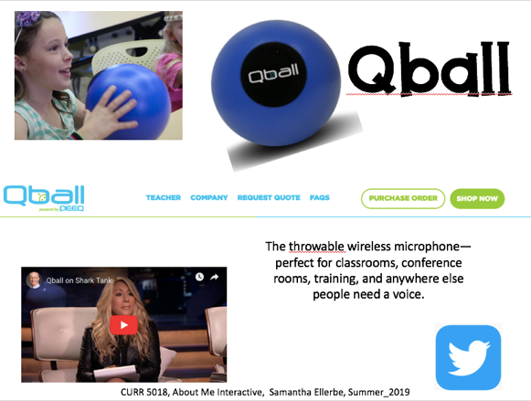](http://warhawks.ulm.edu/~ellerbesa/5018/bin/vpdr-05.pptx)

I first learned about Qball in an Assistive Technology professional development. Qball is a wireless microphone that is throwable, just like a ball. Qball is a great tool to use in the classrooms for students who need a voice. The VPDR has active links that explores Qball. It has videos, articles, and more that will give demonstrations, ideas, and how to use Qball in the classroom.

**VPDR 6**:

[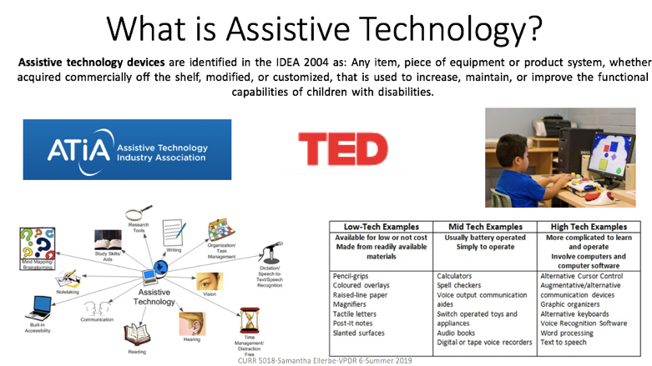](http://warhawks.ulm.edu/~ellerbesa/5018/bin/vpdr-06.pptx)

I am a special education teacher. My students cannot always access curriculum and materials on their own. They may need help with assistive technology. Assistive technology are pieces of equipment that is used to increase, maintain, or improve the functional capabilities of individuals with disabilities. There are low, medium, and high types of assistive technology devices. I have linked resources of the different types and how to use them.

**VPDR 7**:

[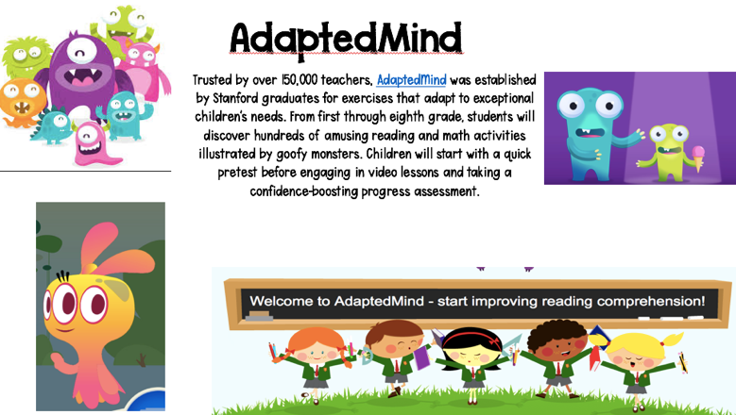](http://warhawks.ulm.edu/~ellerbesa/5018/bin/vpdr-07.pptx)

I found the AdaptedMind website very interesting. As we are creating VPDR to help fellow classmates and teachers to become better educators through technology, AdaptedMind was created by college students to improve the way children learn. AdaptedMind is a learning experience to help with student’s strengths and weaknesses through a curriculum that adapts to their needs. This VPDR explores the AdaptedMind website and provides links to videos on the resources.

**VPDR 8**:

[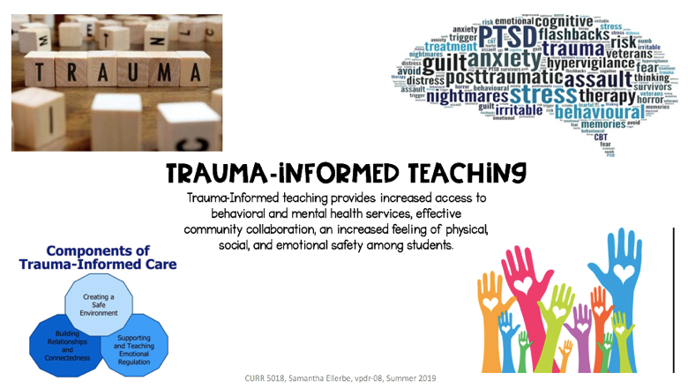](http://warhawks.ulm.edu/~ellerbesa/5018/bin/vpdr-08.pptx)

Trauma is an epidemic in our schools and communities. Nearly 35 million children in the U.S. have experienced trauma. This VPDR is to educate educators on trauma-informed teaching by building and cultivating more equitable, trauma informed classrooms and social/emotional learning environments. The images are actively linked to articles, videos, and other resources to inform teachers about trauma-informed practices.

**VPDR 9:**

[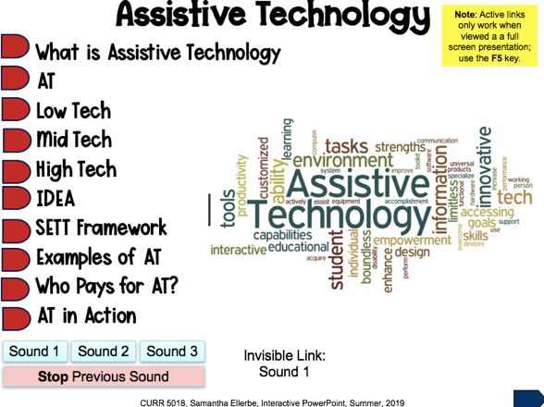](http://warhawks.ulm.edu/~ellerbesa/5018/bin/interactive-powerpoint.pptx)

In this interactive PowerPoint, I explain all about assistive technology. My special education students. Each slide gives different information concerning assistive technology. This interactive PowerPoint explains what assistive technology is, the different types of assistive technology, examples, and so much more. Each slide has links that provide additional resources.

**VPDR 10:**

[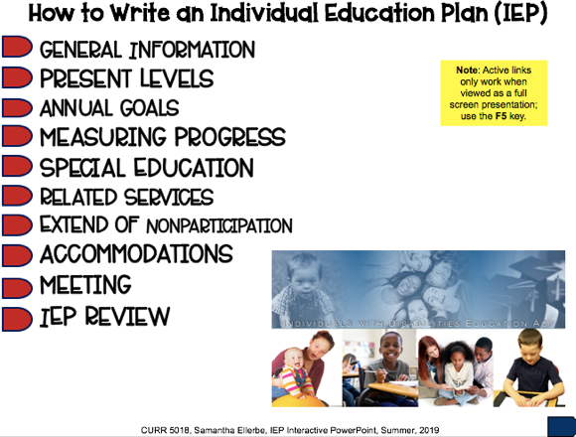](http://warhawks.ulm.edu/~ellerbesa/5018/bin/iepinteractive-powerpoint.pptx)

As a special education teacher, each one of my students has an Individual Education Plan (IEP). If you work with a child with special needs, then you may be familiar with IEPs. I created this interactive PowerPoint to help other special educator teachers, specifically first year teachers, to help them be familiar with the different components of the IEP. Each slide has links that provide videos, articles, or online resources to help teachers have a better understanding of the IEP.

8. **Identify An Outstanding Free Online Educational Resource** (25 points)

[](https://do2learn.com/)

Do2Learn is a free online educational website that has a variety of resources to help students improve their social skills, behavior, and academics. Resources for students include: songs, games, communication cards, arts, crafts, and more. Resources for teachers include: behavior management plans, literacy tools, and much more. I think this resource is beneficial to any teaching working in special education. I recommend this website if you are a teacher working with students with autism or other disabilities that affect learning, social skills, communication, and self-regulation.