[](https://ulm.edu/webguide/index.html)This document is part of a student’s **academic eFolio (electronic portfolio)** for an online course during the summer of 2019 at the University of Louisiana at Monroe (ULM). The images link to files located on the student’s personal ULM website account.

This student has allowed this *exemplar* to be publicly viewed. **Note: After this student graduates, these links will no longer work because the website will be de-activated. However, the student has the option to COPY and transfer the files to another website account in the future.**

3. **Your Photo.** Insert an “annotated” image of yourself that actively links to your online **about-me.ppt** online file located on your ULM website account. (25 pts)

[[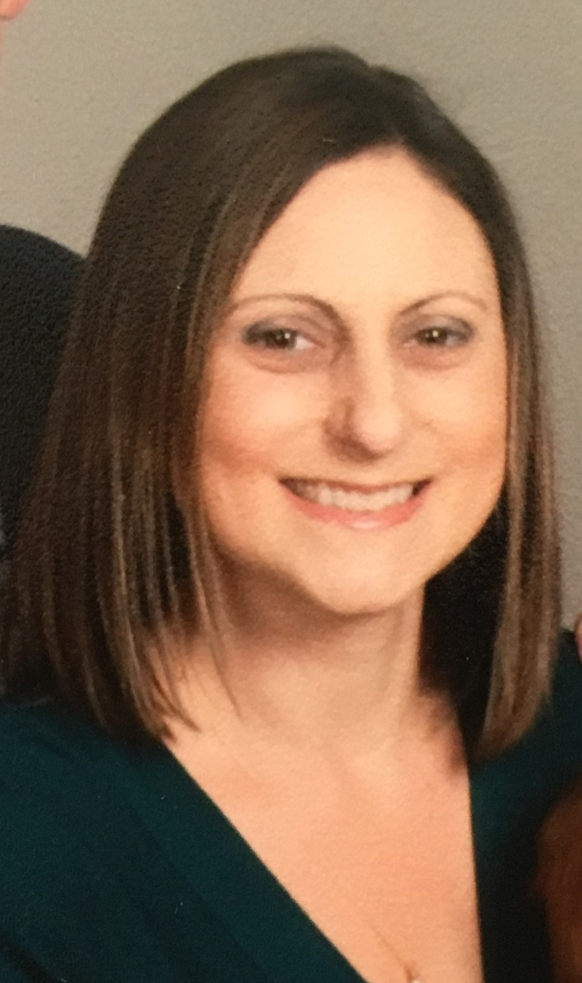](http://warhawks.ulm.edu/~booths/5018/bin/about-me.pp)](http://warhawks.ulm.edu/~booths/5018/bin/about-me.ppt)



***Click here***4. **Your Project Proposal Cognitive Map**. [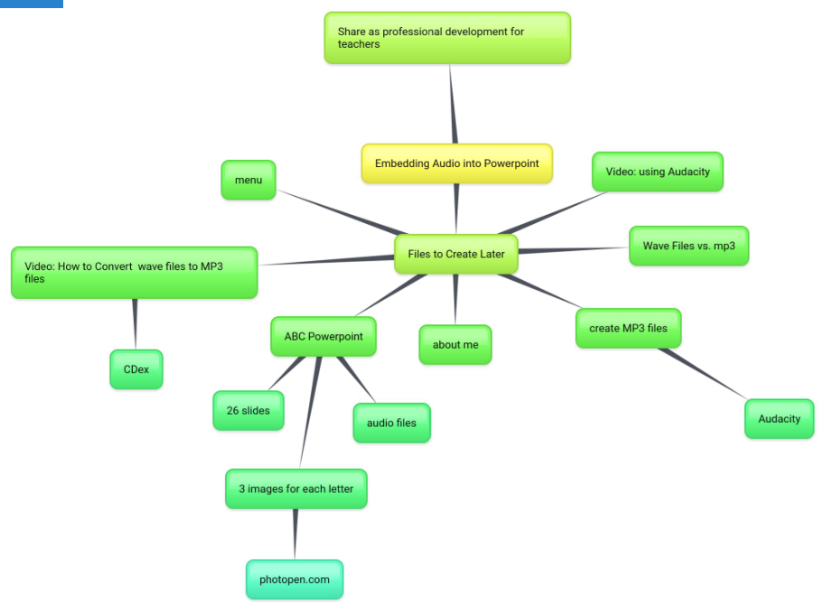](http://warhawks.ulm.edu/~booths/5018/bin/project-proposal.docx)  
This cognitive map describes the many different parts of the project. There are files that show how to convert WAV files to MP3 files, the difference is WAV files and mp3 files, how to use Audacity to create MP3 files, and the idea of how the ABC PowerPoint will be set up.

The main goal of the project proposal is to show how adding audio files to PowerPoint can be done. It also had step by step instructions and multiple video tutorials so teachers from my school could apply this to their own classrooms.

5. **30-Second Video Summary Of Your Completed Online Course Project**. (50 points)

[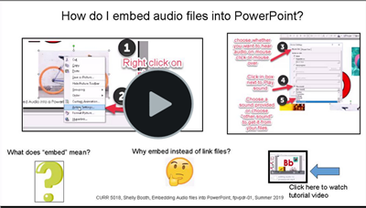](https://www.screencast.com/users/booths1106/folders/Default/media/f70cc8fd-bac4-4635-989a-67826a921bdd)

* 66. **Visually Link Your “Course Project Files” That You Created, Based On Your Project Proposal.**Provide actively linked images of your online course project files and provide text commentary. (200 pts.).

[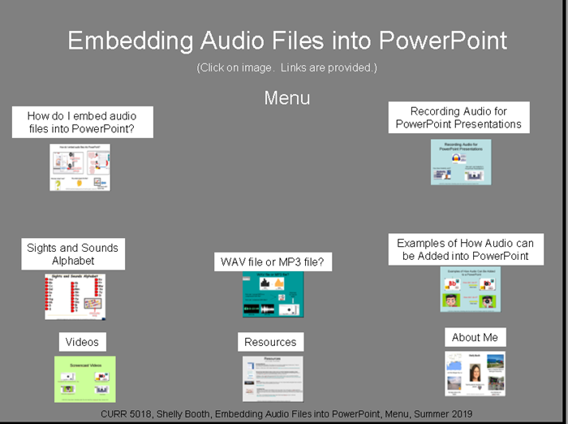](http://warhawks.ulm.edu/~booths/5018/bin/Menu.ppt)

This project shows how to embed audio files into PowerPoint. Course project menu has active links to each of the files created.

[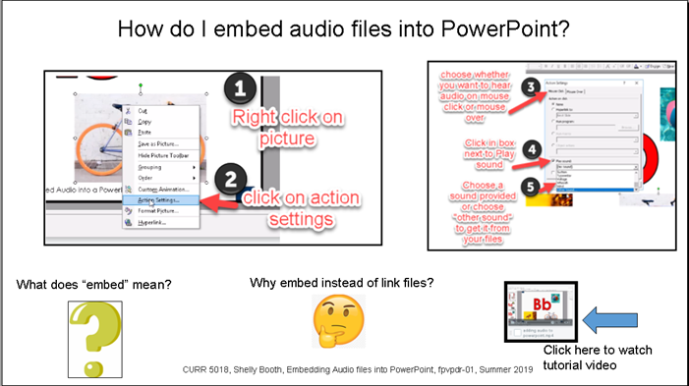](http://warhawks.ulm.edu/~booths/5018/bin/fpvpdr-01.ppt)

This file discusses what “embed” means and why you would need to embed files. Pictures have active links to the websites included. Also, a video tutorial on the process is included.

[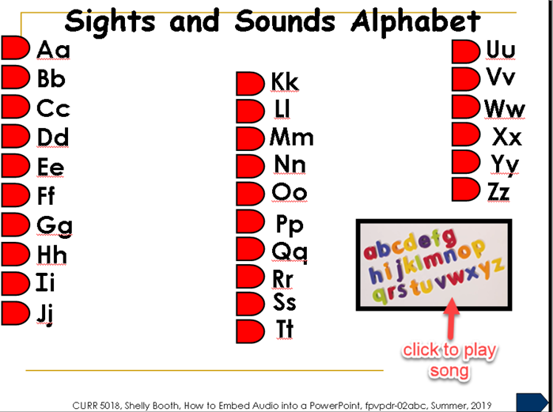](http://warhawks.ulm.edu/~booths/5018/bin/fpvpdr-02abc.ppt)

Sights and Sounds Alphabet is a kiosk mode presentation that includes original recordings created through Audacity and embedded into the file. Each picture contains an audio file. An alphabet song video is linked to the picture above. This project will be used in the special education classroom to reinforce letters and sounds.

[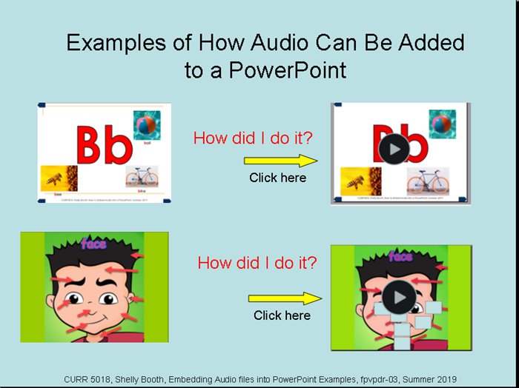](http://warhawks.ulm.edu/~booths/5018/bin/fpvpdr-03.ppt)

This VPDR is example presentations using the skill of embedding audio files into PowerPoint. The first one is an example of sound on the click. The second one is an example of sound as a mouse over. Also, the second example shows how audio files can be hidden.

[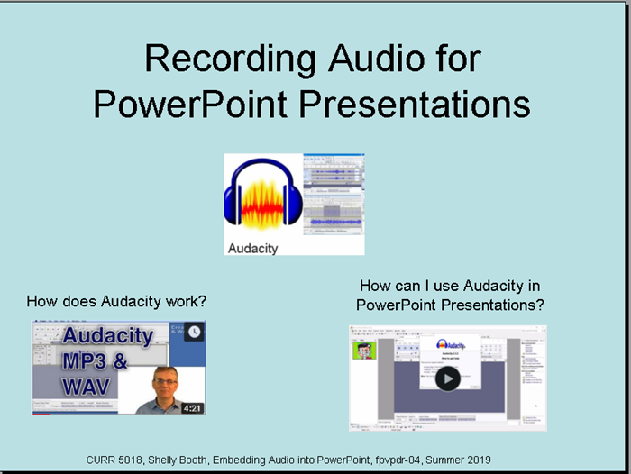](http://warhawks.ulm.edu/~booths/5018/bin/fpvpdr-04.ppt)

This VPDR shows how to actually record original audio to add to your presentations. Audacity is free software used in this slide. A Youtube video shows how Audacity works. There is also a video tutorial on how to use Audacity to make recordings.

[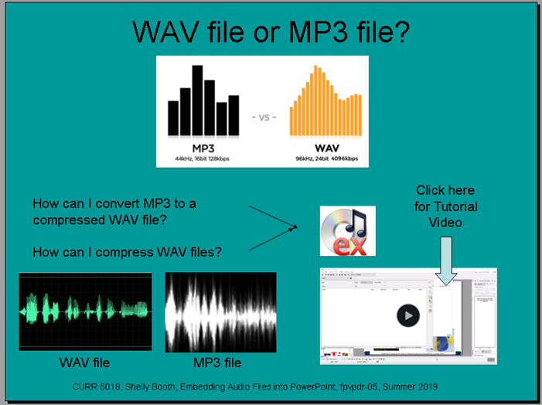](http://warhawks.ulm.edu/~booths/5018/bin/fpvpdr-05.ppt)

This VPDR explains the difference between WAV files and MP3 files. It also includes information of CDex, which is software that was used to convert MP3 files to WAV files in order to be recognized in PowerPoint. A video tutorial is also included.

7. **Visually Describe At Least 10 Professional “Visual Professional Diary Reflections”.** Provide captured images that actively link to at least 10 online visual professional diary reflections (VPDRs). (150 pts).

* [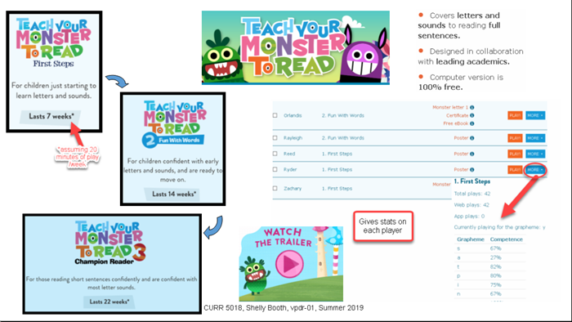](http://warhawks.ulm.edu/~booths/5018/bin/vpdr-01.ppt)

This VPDR focused on a handy website that helps children learn to read while having fun building a spaceship. Teachers can also monitor their students’ progress by using the teacher page. A link to the trailer for the game was included.

[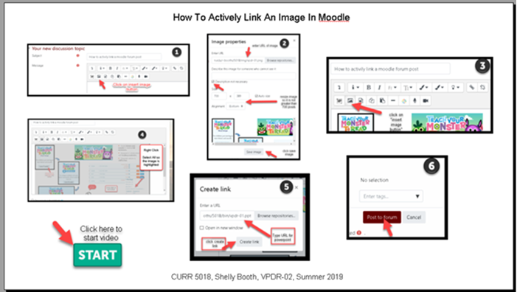](http://warhawks.ulm.edu/~booths/5018/bin/Vpdr-02.ppt)

This VPDR is a step by step progression of how to actively link an image in Moodle. It also contains a video tutorial to narrate the steps.

[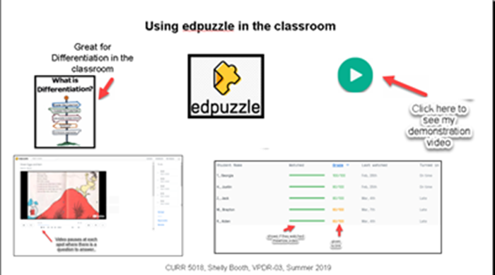](http://warhawks.ulm.edu/~booths/5018/bin/vpdr-03.ppt)

This VPDR explains a free website called edpuzzle. It allows the teacher to assign a video, create original questions, or use questions already there to monitor a child’s comprehension on a subject.

[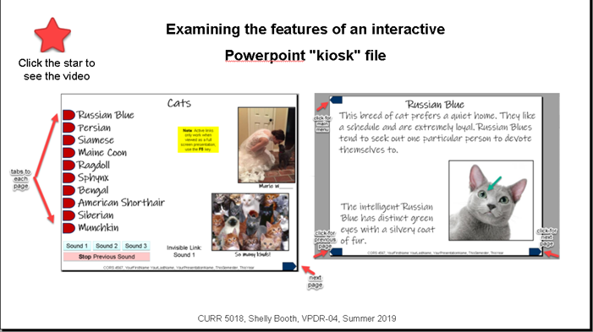](http://warhawks.ulm.edu/~booths/5018/bin/vpdr-04.ppt)

This VPDR examines a PowerPoint presentation in Kiosk mode. Websites giving information on kiosk mode for PowerPoint are linked to the pictures. There is a video linked to the star discussing the different part of the presentation.

[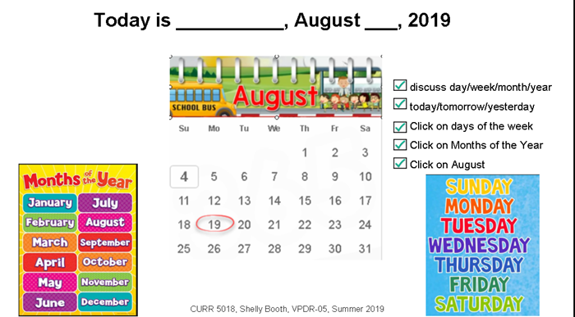](http://warhawks.ulm.edu/~booths/5018/bin/vpdr-05.ppt)

This slide was created for a morning routine in a special education classroom. There is a checklist with the order of the routine and videos are linked to each of the pictures.

[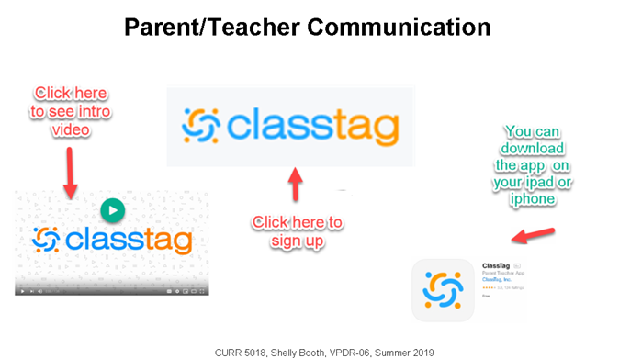](http://warhawks.ulm.edu/~booths/5018/bin/vpdr-06.ppt)

Classtag is a parent/teacher communication app that allows easy access to include parents in their child’s education. Videos or pictures can be posted for the parents to see, or the teacher can simply send out reminders using the app.

[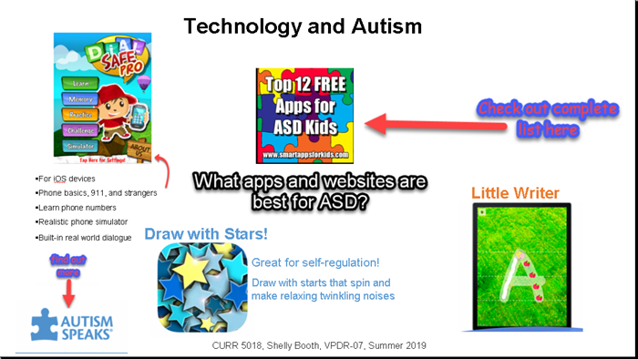](http://warhawks.ulm.edu/~booths/5018/bin/vpdr-07.ppt)

Technology is important in the special education classroom. This slide shows some great apps for not just children with Autism, but for any child. Some apps can be used for educational purposes, others may just be used for self-regulation when a child is suffering from sensory overload.

[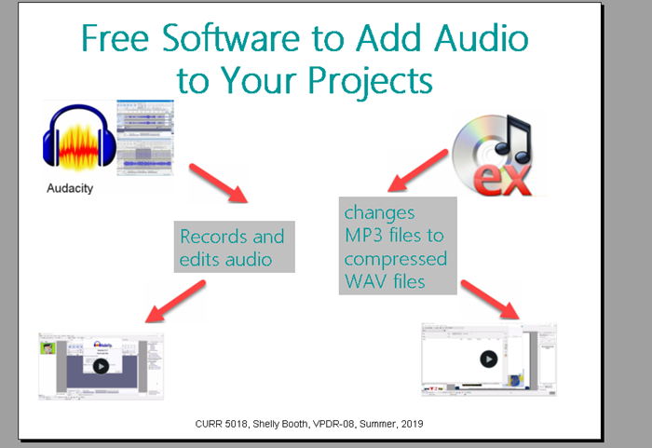](http://warhawks.ulm.edu/~booths/5018/bin/vpdr-08.ppt)

Audacity and CDex are two applications that make adding audio files to PowerPoint a breeze. Each contains a video showing how to use the program.

[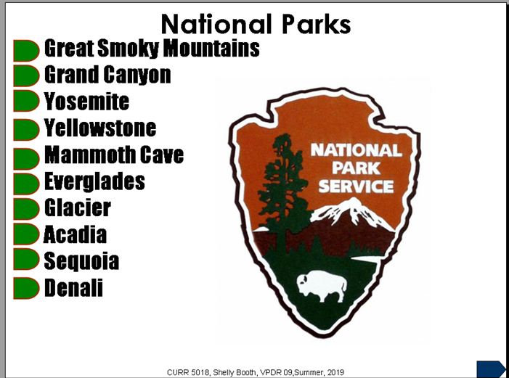](http://warhawks.ulm.edu/~booths/5018/bin/vpdr-09.ppt)

This VPDR is an example of a second grade social studies lesson that gives information of some well-known national parks. Each tab is linked to the following corresponding slide.

8. **Identify An Outstanding Free Online Educational Resource** (25 points)

[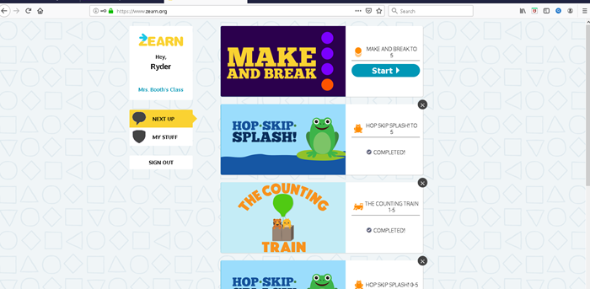](https://www.zearn.org/)

Zearn is a free online math program that provides Common Core aligned math lessons, personalized to individual learners, and based on Eureka Math / Engage New York. Lessons focus on three critical components: deep understanding, fluency, and problem-solving. It provides the teacher with the progress the student shows by working through lessons and recording their data.