
This document is part of a student’s academic eFolio (electronic portfolio) for an online course during the summer of 2019 at the University of Louisiana at Monroe (ULM). The images link to files located on the student’s personal ULM website account.
This student has allowed this exemplar to be publicly viewed. Note: After this student graduates, these links will no longer work because the website will be de-activated. However, the student has the option to COPY and transfer the files to another website account in the future.

3. Your Photo. Insert an “annotated” image of yourself that actively links to your online about-me.pptx online file located on your ULM website account. (25 pts)


4. Your Project Proposal Cognitive Map. Include a “cognitive map” describing your course project. (25 points)
Over the course of several sessions, gifted students in the secondary setting will learn the general details of designing their own personal website using Mobirise. Mobrise is a free application for website design and can be easily implemented by Mac users. Students will learn the features of this program, learn basics if digital web design, learn to upload personal files, and add interesting effects such as video.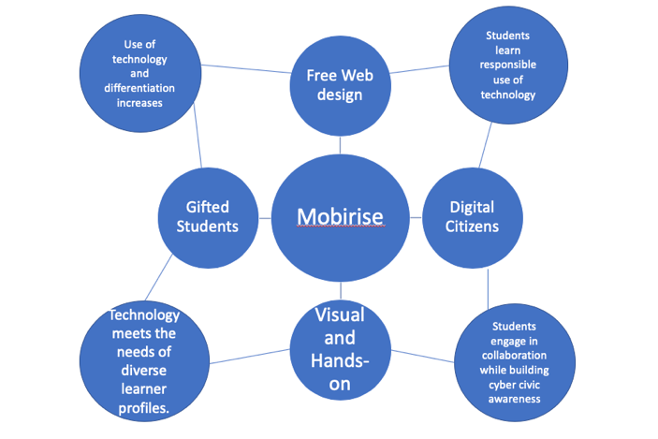

5. 30-Second Video Summary Of Your Completed Online Course Project. (50 points)

- 66. Visually Link Your “Course Project Files” That You Created, Based On Your Project Proposal.
Provide actively linked images of your online course project files and provide text commentary. (200 pts.).

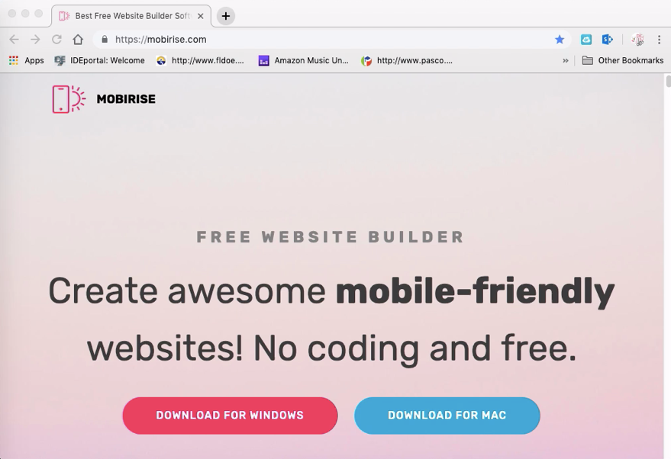
Students begin by understanding the importance of learning to design a website. They’ll delve into discussions about how this skills could open up new possibilities and how it is already being used. Students will also begin the process by downloading this application.

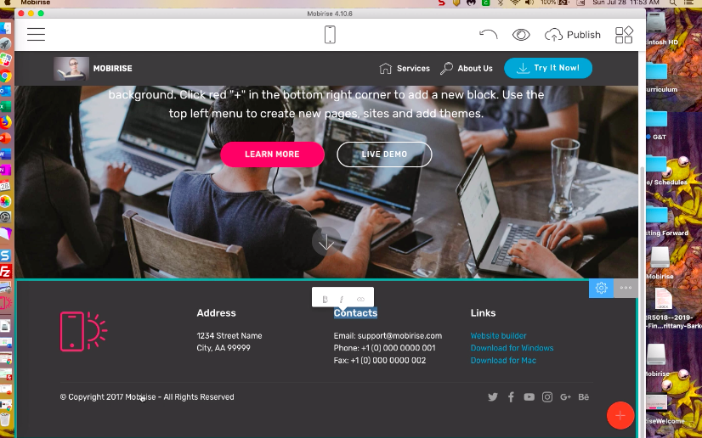
Students will engage in the second session of this workshop by exploring the features of Mobirise. Students will have time to explore these features and are encouraged to look through the themes and creative layouts of other website designs.

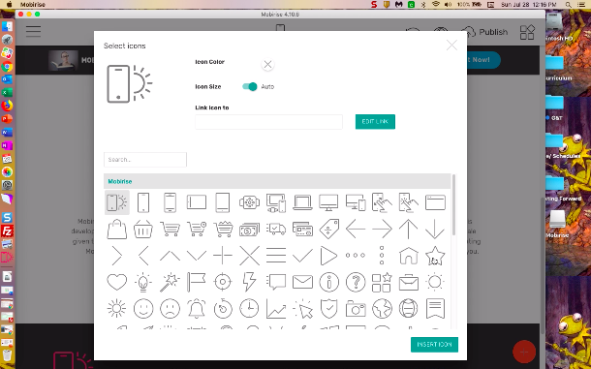
In the first of two design videos, students will begin to learn about placement of blocks, text options and changing icons. Students are encouraged to look around the internet for other creative design applications.

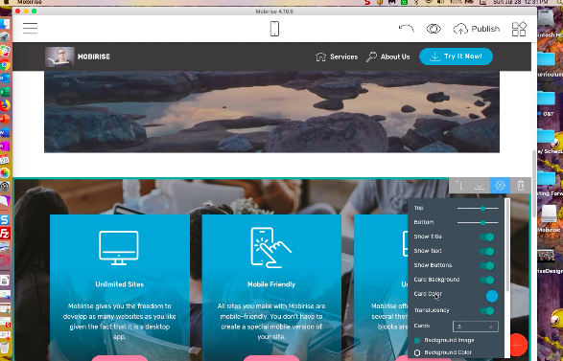

The second session of the Design process involves students learning how to upload a file to their personal websites. There are two ways described in this process, though there are a few others available. During this session, students will also discuss the importance of citing sources.

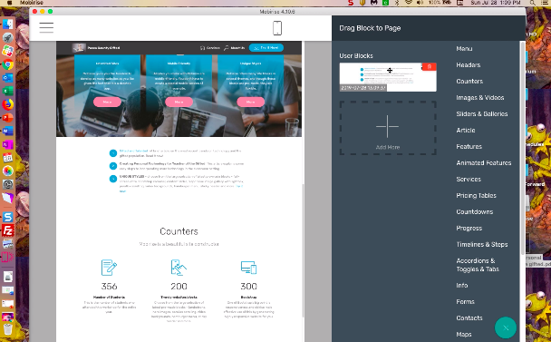

Adding a video to your personal website is the next step in this workshop. Students have the option of looking for appropriate content on either YouTube or Vimeo and adding these to their personal website. Some student may have YouTube account already and may wish to upload their own videos.

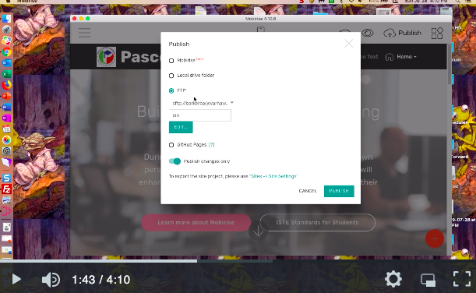
The final stage in this workshop for gifted learners is to publish their websites. Because this workshop isn’t meant to focus using applications for transferring files over to the internet just yet, this clip just shows how to use the Mobirise test option.

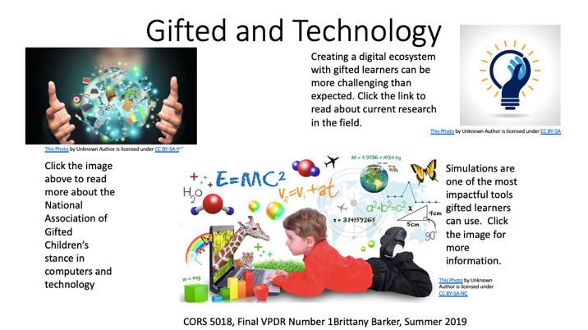

For gifted students, the opportunity to work towards overcoming challenges and reaching towards goals specifically designed for enrichment on an individual basis is best practice. In this workshop, gifted students are provided with the opportunity to build a skill that has endless possibilities and provided for differentiation in the learning environment.

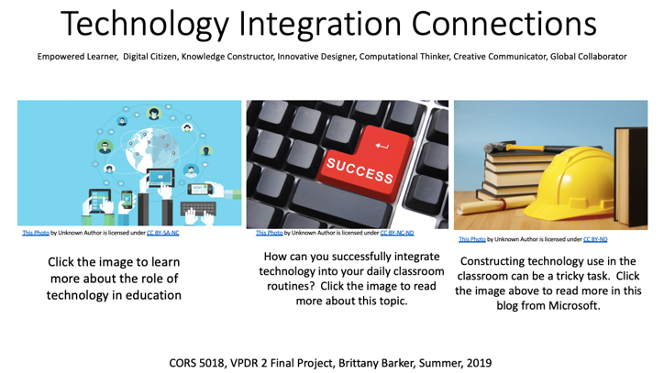

There are a great many ideas about how to integrate technology into the classroom which is dependent upon school resources and time. Part of this workshop entails management of these aspects as well as allowing students the autonomy to experiment in their design process.

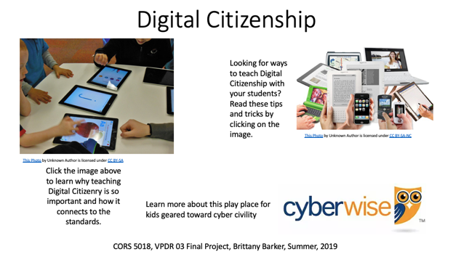

Students are tasked with more and more responsibility with global communication than ever before. It is up to the community to make sure students learn and maintain integrity when engaging with peers and adults online. Developing their own website provided students with ownership over this aspect.
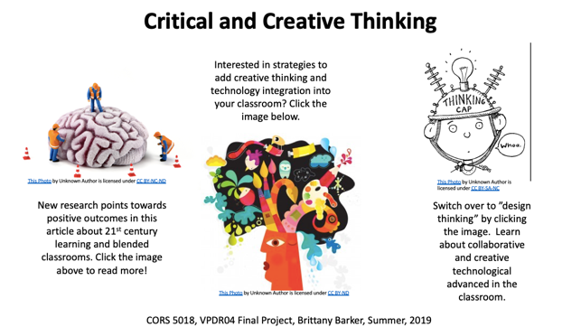

Critical and creative thinking and problem-solving are life-long skills that translate to all areas of life. Competitive employers search for people who can think quickly on their feet and who generate new and innovative ideas. Learning to web design offers students the ability to build these skills at an early age.

7. Visually Describe At Least 10 Professional “Visual Professional Diary Reflections”. Provide captured images that actively link to at least 10 online visual professional diary reflections (VPDRs). (150 pts).
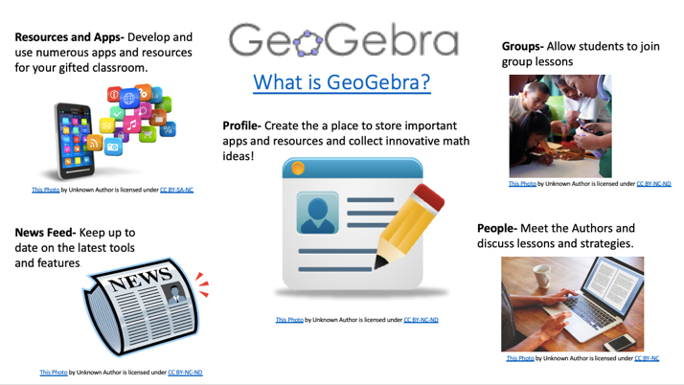
GeoGebra is a great website for engaging students in simulation, gaming, tutorials and brief lessons. It is also used globally in all areas of the world. Diverse perspectives on engaging in math are offered here.
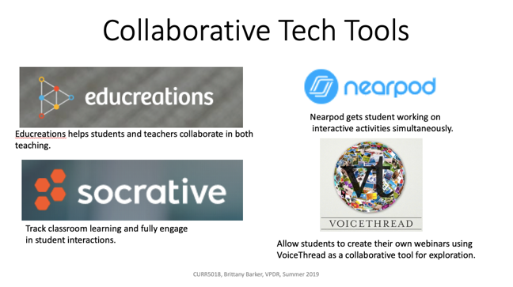
Teachers are always looking for new technology to offer their students engaging and challenging content. The few mentioned in this VPDR are great for beginners. NearPod is especially great for integrating collaborative discussions through the use of instant polls.
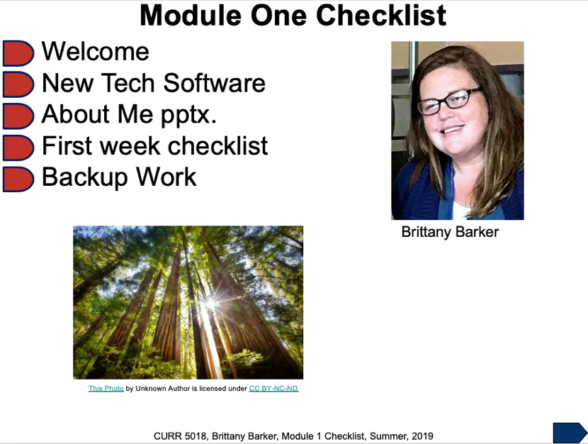

This was one of the first VPDRs created and really provoked the thought of using PowerPoint in a new and unique way. The introduction slide was always just a place where the presentation began, not a “check point”. This format will definitely come in handy in future teachings.

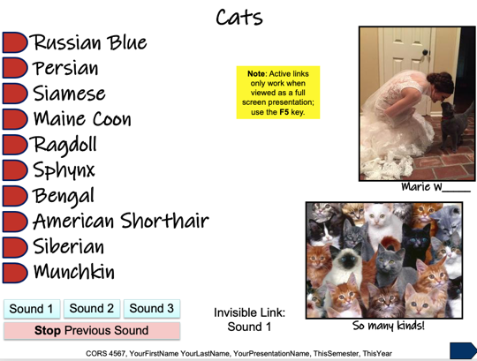
This VPDR was a great way to experience SnagIt and ScreenCast together. There’s certainly a challenge in the art of recording your own voice and making sure you don’t go on for too long.

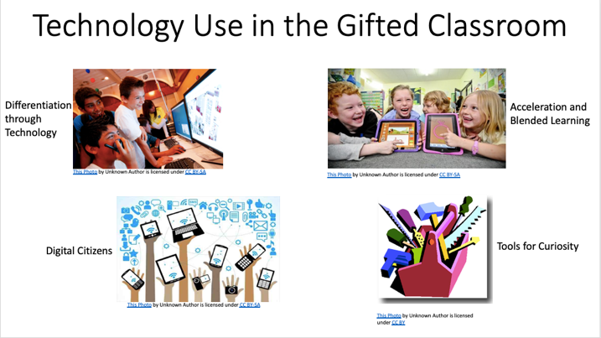
This VPDR was specifically geared towards gifted learners and some of their specific need for differentiation. Gifted students often have unquenchable thirsts for knowledge. What a better way to enhance that than by teaching them how to use technology responsibly.

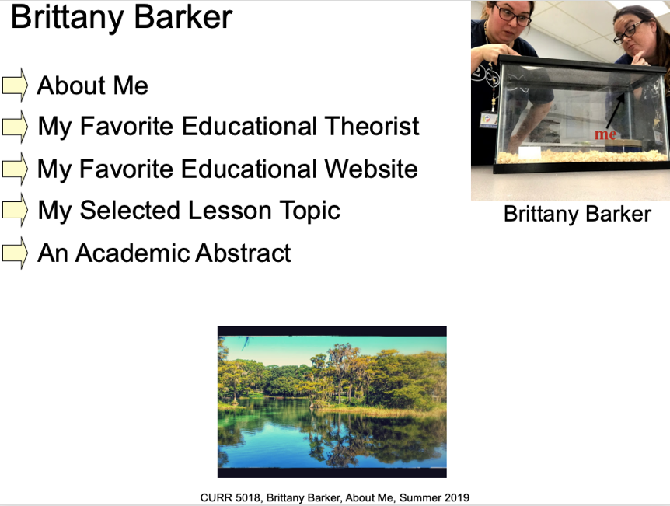
My first venture into making VPDRs was an adventure. I’d never used this format for presenting information and it has grown on me. I used personal photos I’d taken off my phone as well. I think students would have fun modifying their own versions at the beginning of the school year.

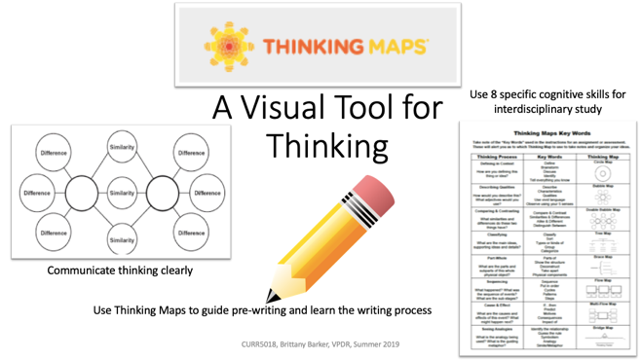
Thinking Maps, Inc. are extremely useful and practical in their application. I encourage anyone I know to learn more about these fabulous visual guidelines for thinking. They can be introduced at the beginning of the year and used all throughout all content areas until the end of the year.

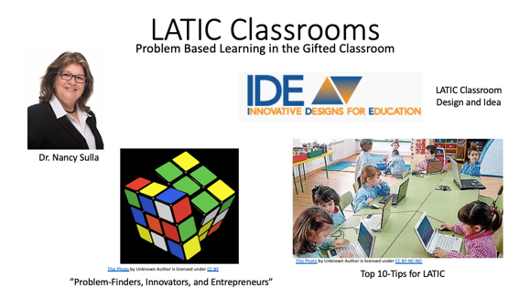
LATIC, or Learner-Active, Technology-Infused Classroom, is a structure that has come to my county in some of the schools. Students are assigned a computer and use it for daily problem solving throughout their course work.

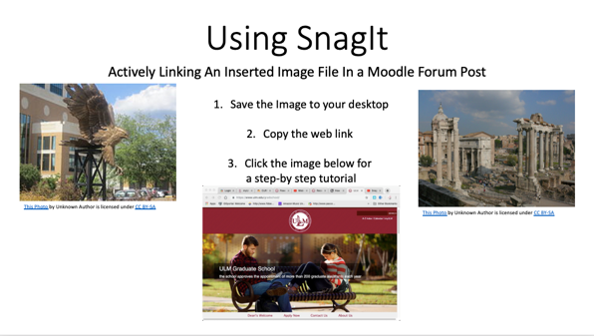
SnagIt has proven to be a pretty handy tool throughout this course. It makes taking screen shots to a whole other level in precision and clarity. It also creates simple videos. These can easily be shared through several options like Dropbox or the Cloud.
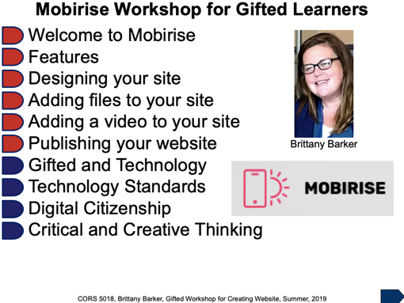

This VPDR is the culminating visual menu for my Final Project of this course. I created 6 different video files and 4 VPDRs to compile a Gifted Workshop on using Mobirise to create a personal website. I have learned a lot through this process to say the least.

8. Identify An Outstanding Free Online Educational Resource (25 points)
GeoGebra is a great website for teaching math using simulations, gaming, tutorials, and brief online lessons. It offers a variety of interactive visuals for all grade levels but also is used globally. This site hosts many authors who routinely contribute to the content of this site. These authors are mainly classroom instructors so you know that what is being added has been tried in the classroom. GeoGebra would make for a great companion with any curriculum as it addresses the standards, is easily managed, and can be used as a collaborative or independent tool for both remediation and enrichment. Another helpful feature is the “Newsfeed” section that gives updates to the content regularly so user can find the most recent additions.

