[](https://ulm.edu/webguide/index.html)This document is part of a student’s **academic eFolio (electronic portfolio)** for an online course during the summer of 2019 at the University of Louisiana at Monroe (ULM). The images link to files located on the student’s personal ULM website account.

This student has allowed this *exemplar* to be publicly viewed. **Note: After this student graduates, these links will no longer work because the website will be de-activated. However, the student has the option to COPY and transfer the files to another website account in the future.**

3. **Your Photo.** Insert an “annotated” image of yourself that actively links to your online **about-me.pptx** online file located on your ULM website account. (25 pts)

[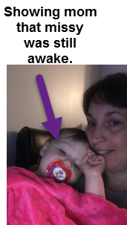](http://warhawks.ulm.edu/~soileauc/5018/bin/about-me.pptx)

4. **Your Project Proposal Cognitive Map**. Include a “cognitive map” describing your course project. (25 points)

[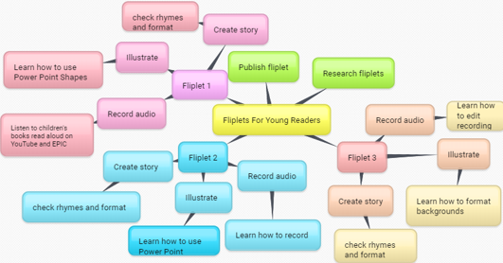](http://warhawks.ulm.edu/~soileauc/5018/bin/project-proposal.docx)  
This project proposal explains what is needed to create “fliplets”. My project involves creating three PowerPoint presentations. Each presentation contains over 15 pages of rhyming couplets and their accompanying illustrations. Separate files contain the audio files of the stories. The project proposal introduces the benefits of reading aloud for the reader and the listener. It goes on to briefly explain listening centers in literacy classrooms. The project proposal also contains a link for an online fliplet. If the fliplet stories I created are accepted, they will be converted and used on ULM’s “*aceadventures”* website as a digital picture book.

5. **30-Second Video Summary Of Your Completed Online Course Project**. (50 points)

[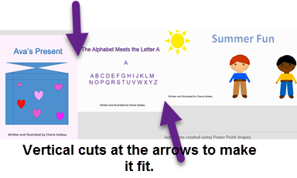](https://www.screencast.com/t/AbDLARAoe)

* 66. **Visually Link Your “Course Project Files” That You Created, Based On Your Project Proposal.**Provide actively linked images of your online course project files and provide text commentary. (200 pts.).

[](http://warhawks.ulm.edu/~soileauc/5018/bin/fliplet1-narration.wav) [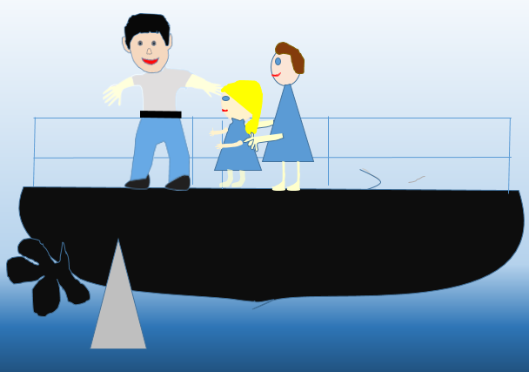](http://warhawks.ulm.edu/~soileauc/5018/bin/fliplet1-Ava.docx)

I was inspired for this fliplet story by my grand-daughter’s recent birthday. Her name is Ava and it was her birthday, but the story is fictional. The script and the illustrations are each considered as one file; therefore, “Ava’s Present” PowerPoint is worth 2 files. This was my first attempt at writing and illustrating a story. Learning to illustrate was a challenge. The narration is worth a separate file. Click on the headphones to hear the audio recording.

[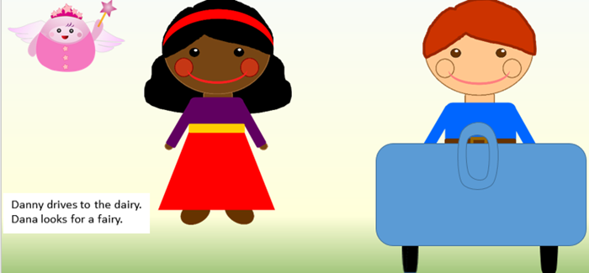](http://warhawks.ulm.edu/~soileauc/5018/bin/fliplet2.pptx)[](http://warhawks.ulm.edu/~soileauc/5018/bin/fliplet2-narration.wav)

Fliplet 2 was inspired by the teaching reading to beginners. Beginning literacy involves phonemic awareness and phonics. Beginning readers also must learn the alphabet. I spent many hours on Starfall.com this summer. For this fliplet story, I chose to focus on the different phonemes for “a”. I had never really considered how difficult it is for a beginning reader to know which phoneme is the correct one when they are faced with an unknown word. I did buy the people and borrow the fairy, but the car was designed using PowerPoint shapes. Fliplet two with the audio file is also worth 3 files.

[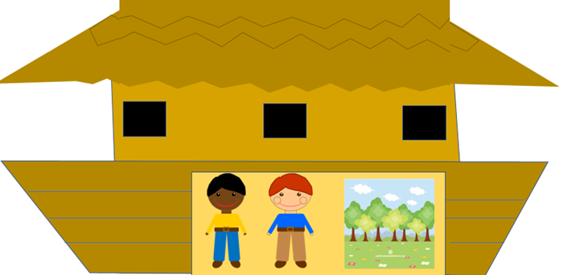](http://warhawks.ulm.edu/~soileauc/5018/bin/fliplet3.pptx)[](http://warhawks.ulm.edu/~soileauc/5018/bin/fliplet3-narration.wav)

.

In “Summer Fun”, Danny and Liam visit the Noah’s Ark Museum. Inside the ark, they find a park. I had started to create a story about the most common children’s bible stories, but I realized it would not be acceptable in most schools. At the same time, I was thinking about creating another alphabet story using animals for the letters of the alphabet. I combined the two ideas for this story. The above illustration shows the boys inside the ark near the park. The boys do see some animal exhibits. The ones in the story were chosen for their rhymes. I bought the people on teacherspayteachers.com and copied the park clipart, but the ark was created using PowerPoint shapes.

* 7. **Visually Describe At Least 10 Professional “Visual Professional Diary Reflections”.** Provide captured images that actively link to at least 10 online visual professional diary reflections (VPDRs). (150 pts).
* The number of the vpdr’s are not in the order of when they were created. At the beginning of the semester, I had some technical difficulties. I had some vpdr’s saved as examples. When I became comfortable with making vpdr’s, I deleted the examples. I wanted to start at 1, so I started over with 1 on the new vpdr’s.
* [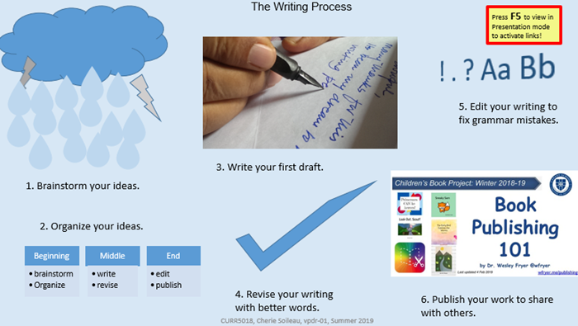](http://warhawks.ulm.edu/~soileauc/5018/bin/vpdr-01.pptx)

VPDR-01 gives resources related to the stages of the writing process. The presentation has articles from writing centers at universities. It also has a blog post. Understood.org is one of the references used. The last resource is readingrockets.org, which has many resources for all areas of literacy for educators as well as parents.

[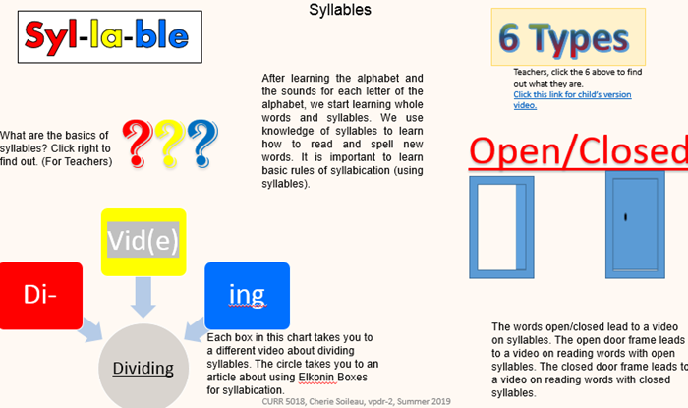](http://warhawks.ulm.edu/~soileauc/5018/bin/vpdr-02.pptx)

The second VPDR is an overall picture of syllables. It gives a reason to want to know about syllables. Some of the videos explain syllables and the types of syllables. The door frames each lead to a video about the corresponding categories of syllables: open or closed. For beginning readers, Elkonin Boxes can be used to teach syllabication. Each of the items of the diagram lead to a different video about syllabication.

[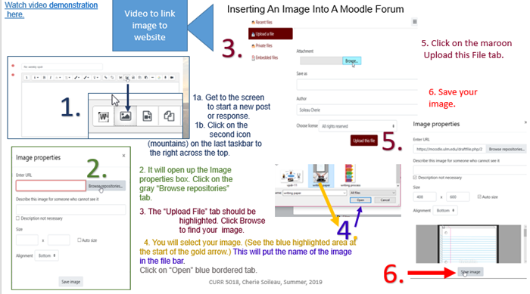](http://warhawks.ulm.edu/~soileauc/5018/bin/vpdr-03.pptx)

VPDR-03 is a tutorial presentation and video on inserting an image into a Moodle Forum. I used Snag-It to capture the photos and large stepped numbers. I also used PowerPoint arrows to annotate for clarity.

[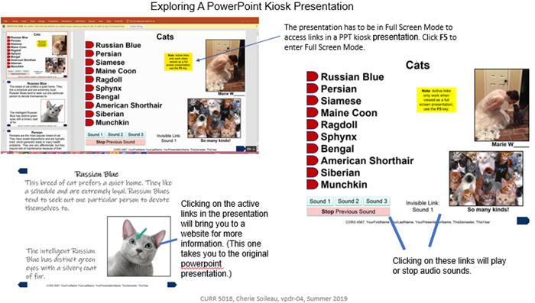](http://warhawks.ulm.edu/~soileauc/5018/bin/vpdr-04.pptx)

The fourth vpdr was an exploration of a PowerPoint Kiosk Presentation. It was also a lesson with using Snag-It and screencast.com for videoing on-screen navigating, recording audio to explain the navigations, and having the file saved in screencast.com for online access.

[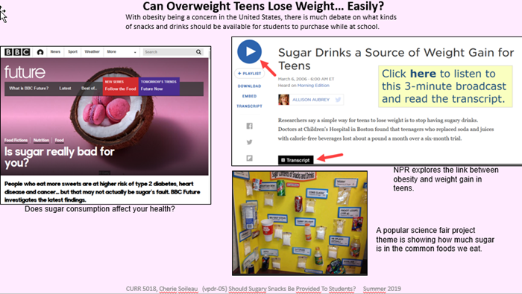](http://warhawks.ulm.edu/~soileauc/5018/bin/vpdr-05.pptx)

VPDR-05 is totally unrelated to the other vpdr’s. This was my training vpdr. It was posted in the Explicit Feedback Forum and was modified as an instructional tool. It was the first one completed as part of the you choose your topic. This vpdr explores the effects of sugar on the body. It has articles from the NPR and BBC news sites.

[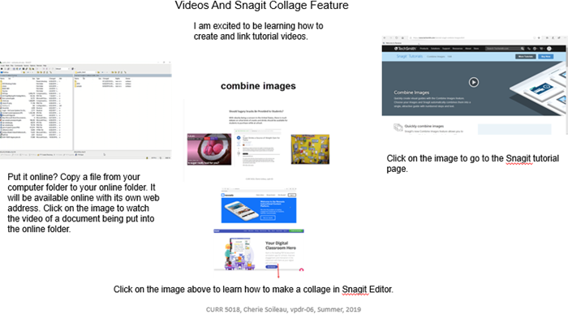](http://warhawks.ulm.edu/~soileauc/5018/bin/vpdr-06.pptx)

In vpdr-06, there are tutorial videos and a link to the Snag-it tutorial page. I did not learn how to copy my working folder into the online folder until the final. I was dragging and dropping to transfer files back and forth from the local to the remote locations. The first video is a demonstration showing me how to drag and drop. The next presentation came from a question another student had about a collage feature in Snag-it. I also included the tutorial page for us to learn new functions of Snag-It.

[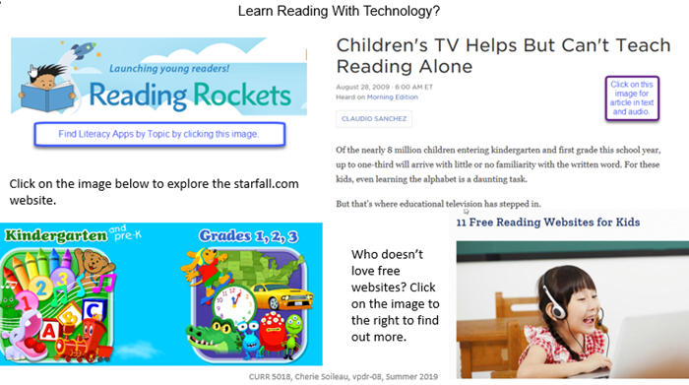](http://warhawks.ulm.edu/~soileauc/5018/bin/vpdr-08.pptx)

Technology is being used more and more in the classrooms as evidenced by vpdr-08. Children are using media to assist them with learning to read. It starts with educational television programs and videos teaching the children the letters of the alphabet. Readingrockets.org is a treasure trove of resources for teachers. What teacher does not like free websites for the classroom. It also contains a link to starfall.com.

[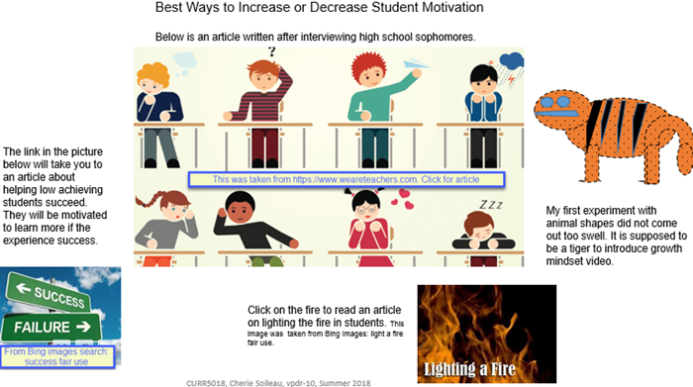](http://warhawks.ulm.edu/~soileauc/5018/bin/vpdr-10.pptx)

Student motivation is gaining attention as a major concern for today’s teachers. Students do not learn as much when they are not motivated to learn. Vpdr-10 explores some ways to light the fire and prevent a teacher from de-motivating students. It also has evidence of me learning to use PowerPoint shapes.

[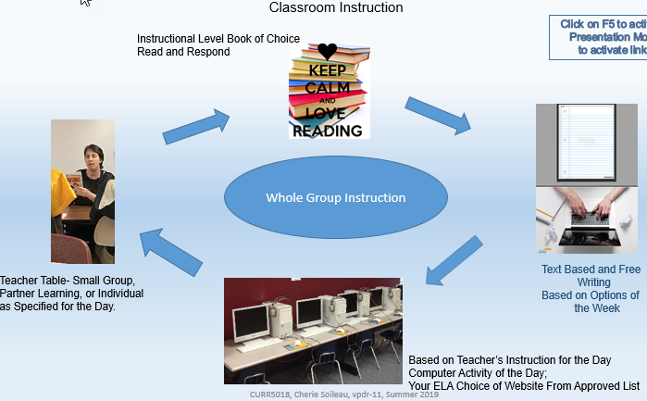](http://warhawks.ulm.edu/~soileauc/5018/bin/vpdr-11.pptx)

Instructional formatting is important. This will be the first full year of teaching in middle school that I am not teaching Read180. This year, I am mandated to use the state’s curriculum. At the same time, I will still teach struggling students. I will do my best to incorporate the Read180 model into the state’s curriculum for instruction this year. In vpdr-11, I show the different centers of learning in my literacy classroom.

[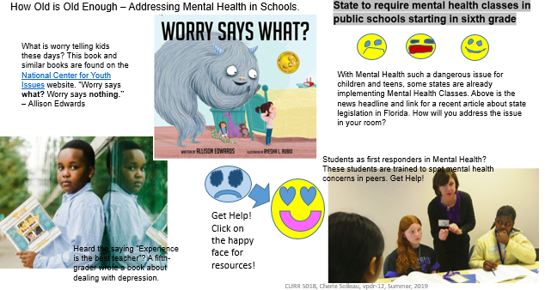](http://warhawks.ulm.edu/~soileauc/5018/bin/vpdr-12.pptx)

Mental health concerns and issues are becoming prevalent in today’s society. No class is immune to the struggle. Vpdr-12 gives teachers resources to assist students with overcoming anxiety and worry in the classroom. *Worry Says What by* Allison Edwards may not be fully understood by very young children, but it plants the seed to be aware of what thoughts are going through your mind. It shows them how to defeat the monster of worry.

8. **Identify An Outstanding Free Online Educational Resource (**25 points)

[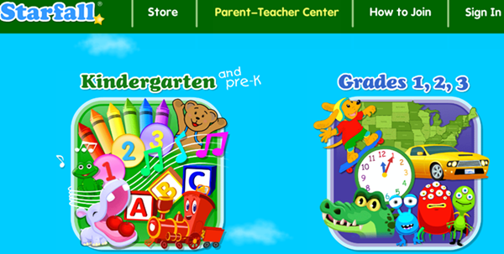](http://www.starfall.com/)

Besides being free, Starfall.com has both language and number literacy activities. The activities begin with basic letters and numbers and progress through some third-grade skills. It is simple but entertaining. It also makes use of music as a learning tool. It is interactive and can be used with a group or in an independent listening center. It can also be used on various devices ranging from smartphones to computers.