[](https://ulm.edu/webguide/index.html)This document is part of a student’s **academic eFolio (electronic portfolio)** for an online course during the summer of 2019 at the University of Louisiana at Monroe (ULM). The images link to files located on the student’s personal ULM website account.

This student has allowed this *exemplar* to be publicly viewed. **Note: After this student graduates, these links will no longer work because the website will be de-activated. However, the student has the option to COPY and transfer the files to another website account in the future.**

3. **Your Photo.** Insert an “annotated” image of yourself that actively links to your online **about-me.pptx** online file located on your ULM website account. (25 pts)

***[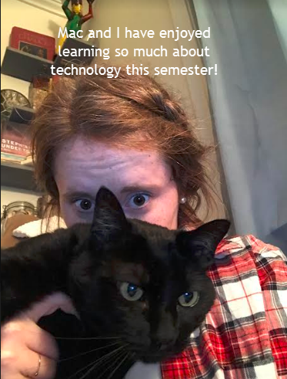](http://warhawks.ulm.edu/~millerky/5018/bin/about-me.pptx)***4. **Your Project Proposal Cognitive Map**. Include a “cognitive map” describing your course project. (25 points)

Click this image to learn more about me and my love of cats!

**http://warhawks.ulm.edu/~millerky/5018/bin/project-proposal.docx**  
[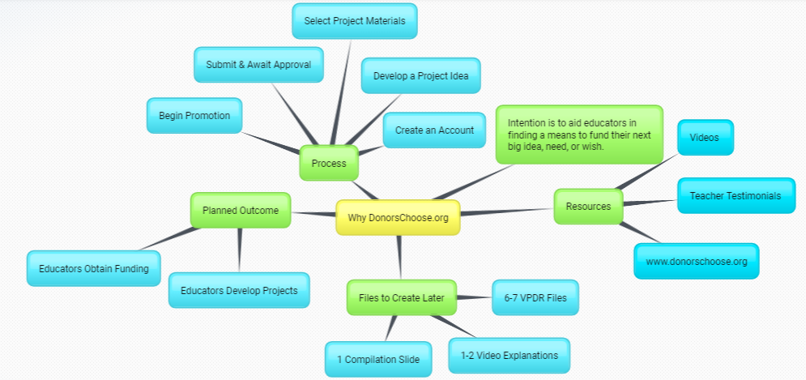](http://warhawks.ulm.edu/~millerky/5018/bin/project-proposal.docx)  
The cognitive map above acts as a walk through description of my final course project. Within the map you see the overarching focus, “Why DonorsChoose.org” in a yellow box with subpoints branching out. The subcategories include: process, intention, resources, files, and planned outcome. In the completed files there are VPDRs that go more in depth into the processes mentioned as well as the resources. Created within some of those VPDRs are original videos going over various portions of the DonorsChoose website and funding process. Additionally, in the final project there exists a compilation slide to keep everything nicely organized. By participating in reading/listening to my final project the intention and outcomes become even more clear – this project intends to provide educators with the materials needed to confidently and successfully post a project to DonorsChoose.org.

5. **30-Second Video Summary Of Your Completed Online Course Project**. (50 points)   
[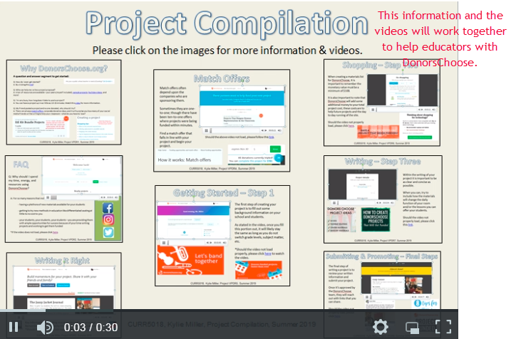](https://www.screencast.com/users/millerky/folders/Snagit/media/fbc9e5a5-d2f5-4dc9-85ad-55081c70d2c7)

Each of these VPDRs plays a role in teaching others how to become part of the DonorsChoose community.

* 66. **Visually Link Your “Course Project Files” That You Created, Based On Your Project Proposal.**Provide actively linked images of your online course project files and provide text commentary. (200 pts.).

*Note, on my proposal you’ll notice I stated that there would be 6-7 VPDRs and 1-2 videos. Instead I’ve chosen to create a hybrid of sorts. Of my 8 files, 7 of them includes a video explanation, as well as VPDR content. You’ll also on my project compilation that some of the Snagit images were taken before my linked images had been put into place so instead the actual videos are there. During this stage of my project I was experimenting with putting videos directly into the VPDRs as sometimes my school doesn’t allow us to use the Wifi and I wanted to see how well the videos played when placed in Powerpoint. If it is not okay that those images are not the final versions, please let me know and I will correct that issue immediately.



[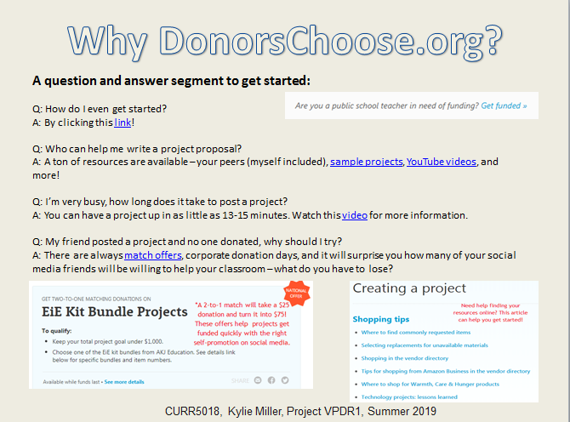](http://warhawks.ulm.edu/~millerky/5018/bin/ProjectVPDR1.pptx)

The content highlighted on this particular file covers introductory level FAQs for the donation platform for education, DonorsChoose. On this VPDR there can be found information on how to get started quickly with a high chance of success by sharing tips, tricks, Youtube videos, and additional outside materials.

[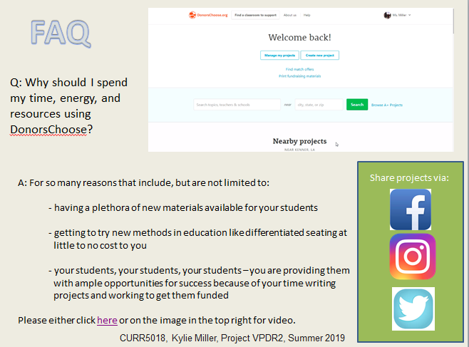](http://warhawks.ulm.edu/~millerky/5018/bin/ProjectVPDR2.pptx)

The second VPDR is where we transition into including videos. From this point on each slide will include a video. This method allows for me to achieve the goal of telling the story of why other educators should try this website to obtain materials. Specifically on this VPDR the question of “Why should I spend my time, energy, and resources using DonorsChoose” with the response coming in both written and video formatting. The video includes a walk-through of a past funded project, and the slide concludes with applications that can be used to promote funding.

[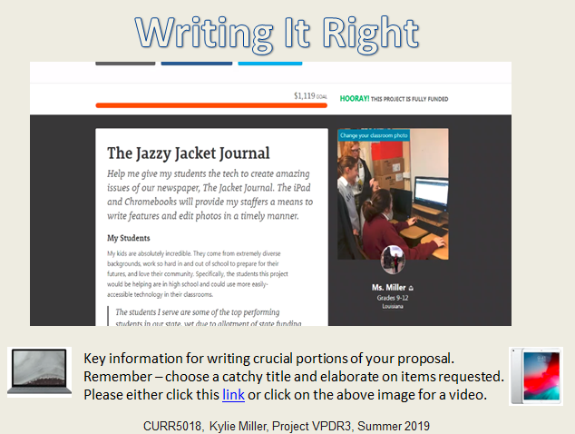](http://warhawks.ulm.edu/~millerky/5018/bin/ProjectVPDR3.pptx)

“Writing It Right” focuses in on how to effectively craft portions of a project proposal so that they are attractive to potential donors. A few topics that are specifically addressed are project titles and the materials section. As is the case with each VPDR, there are additional resources located upon the slide other than the video that will help educators familiarize themselves with the website.

[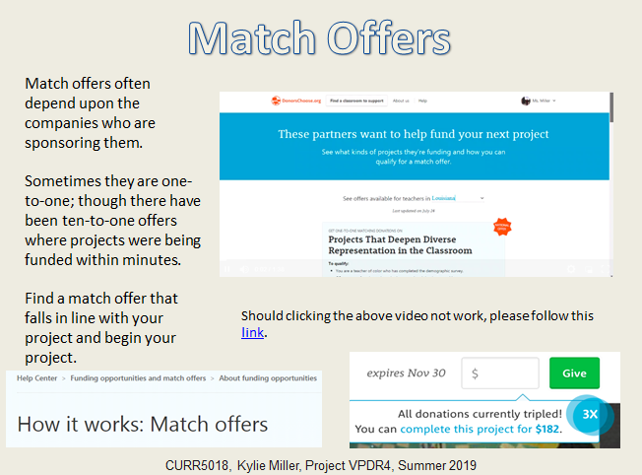](http://warhawks.ulm.edu/~millerky/5018/bin/ProjectVPDR4.pptx)

Perhaps one of the most important features of DonorsChoose is that they have partnerships with many big name companies, which means a higher chance for projects to get funded. These companies often sponsor “match offers” in which money donated to projects is doubled, tripled, or more. This is important to address, as knowing this information could allow a new teacher to become fully funded even more quickly if their timing was right with one of these special offers. To further explain the match offers, there is a video that works in conjunction with the information on the left side of the slide.

[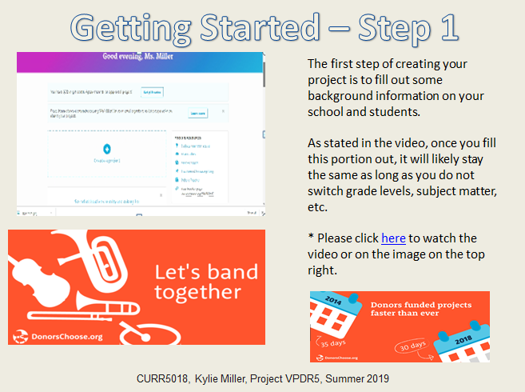](http://warhawks.ulm.edu/~millerky/5018/bin/ProjectVPDR5.pptx)

With quite a bit of introductory information under their belts, new project writers can begin their projects in earnest. The first step is to complete background information upon the school/teacher/students that will benefit from this project. It’s nice to note that unless a teacher changes grade levels, content, etc. this information will be automatically filled in starting with the second project.

[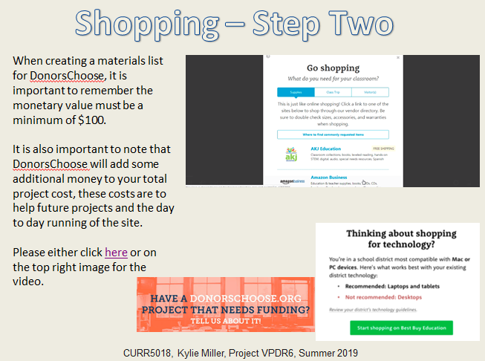](http://warhawks.ulm.edu/~millerky/5018/bin/ProjectVPDR6.pptx)

Once background information is completed on the draft of the proposal, materials must be selected. There are a few different vendor options to choose from including Best Buy and Amazon. Once a vendor is chosen you may click on their link and begin browsing their site for your materials. Once everything is in the cart, the cart is transferred back to DonorsChoose. The video on this slide does work with the text and shows, through modeling, how to complete this step.

[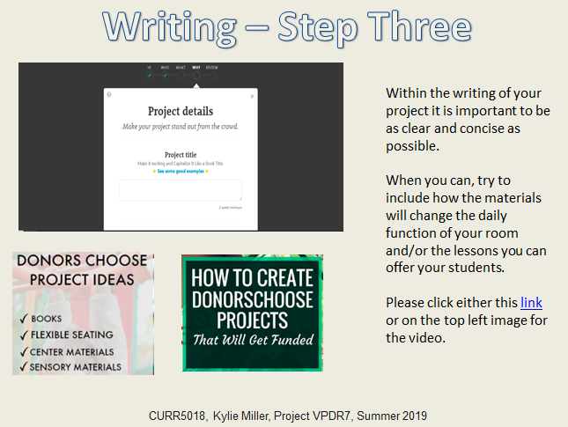](http://warhawks.ulm.edu/~millerky/5018/bin/ProjectVPDR7.pptx)

Perhaps the most important step in the DonorsChoose process is the actual writing itself. Within this VPDR there are suggestions for making the most out of the brief writings that make up your project. The slide includes links and a video to aid in gaining a fuller understanding of how to navigate through the process of submission.

[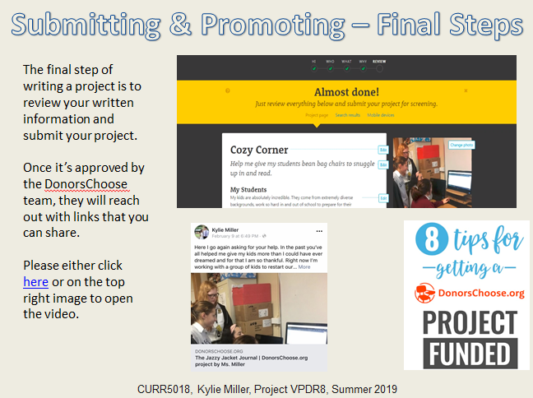](http://warhawks.ulm.edu/~millerky/5018/bin/ProjectVPDR8.pptx)

Finally you’ve made it – this is the point in which your project gets edited and submitted. Within the video included in this VPDR there are reminders of how you can promote your teacher page/donation page as well as reminders for successful writing that could be helpful during the editing stages.

7. **Visually Describe At Least 10 Professional “Visual Professional Diary Reflections”.** Provide captured images that actively link to at least 10 online visual professional diary reflections (VPDRs). (150 pts).

[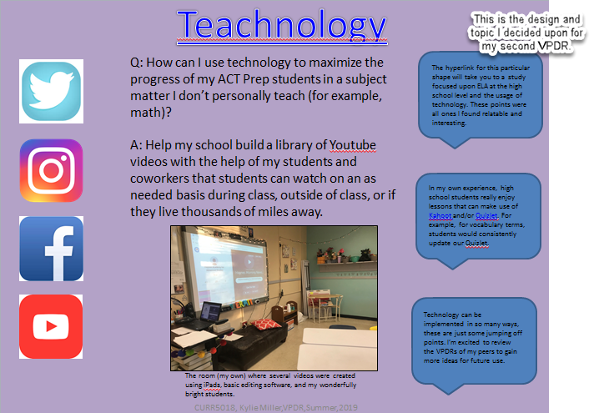](http://warhawks.ulm.edu/~millerky/5018/bin/VPDR2.pptx)

“Teachnology” refers to the ways that technology can be implemented into any and all classes, here I’ve used my ACT Prep course as an example. This VPDR provides insight into how popular apps like Instagram can be used to supplement classroom learning for all teachers.

[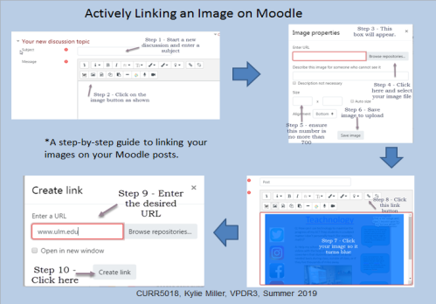](http://warhawks.ulm.edu/~millerky/5018/bin/VPDR3.pptx)

This VPDR was created to assist educators and Moodle users on how they can link an image on their Moodle account. This feature helps to add another level of understanding and detail to one’s online posts, which in turn allows others to have a more in-depth experience within each post.

[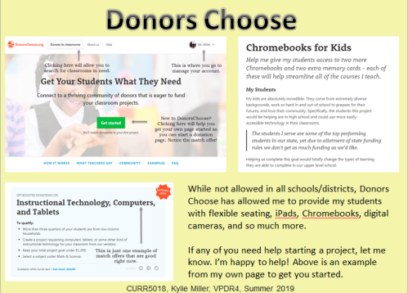](http://warhawks.ulm.edu/~millerky/5018/bin/VPDR4.pptx)

The VPDR above was the inspiration behind my final course project, as they are both focused upon the website [www.donorschoose.org](http://www.donorschoose.org). This website helps educators fund projects to provide their students with a wide variety of materials. The site can also be used to fun professional development opportunities for the teachers themselves. This VPDR acts as an overview to the site, while my final projects goes much more in-depth.

[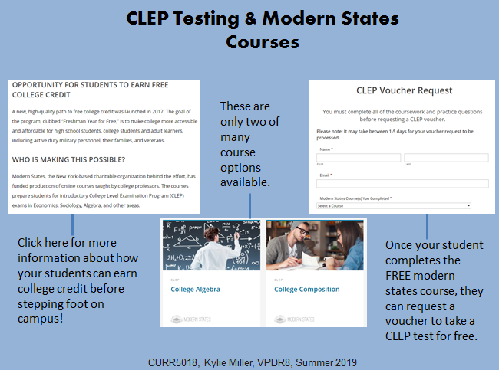](http://warhawks.ulm.edu/~millerky/5018/bin/VPDR8.pptx)

Modern States is an incredibly useful program for high school students, as it can be used to earn college credit for free. Educators can link the Modern States courses to their curriculum and use the CLEP test as a type of final assessment. Once a student completes the Modern States course, they will earn a voucher to take a CLEP test free of charge. It is this test that will convert their time spent on the course into college level credits.

[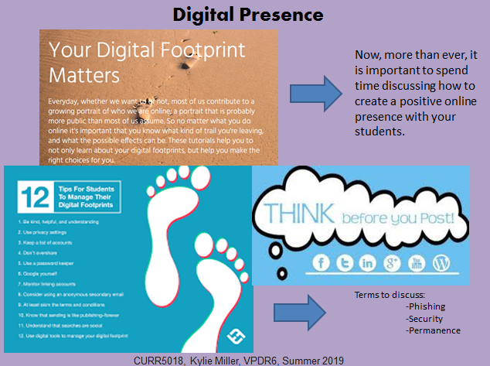](http://warhawks.ulm.edu/~millerky/5018/bin/VPDR6.pptx)

For all 21st century students it is important to be aware of what is being posted online and who has access to it. This VPDR provides resources that can be shared with students of all ages to make them “think before they post.” The purpose of this information is to prevent young people from falling victim to phishing, security breaches, posting something inappropriate, and more.   
  
[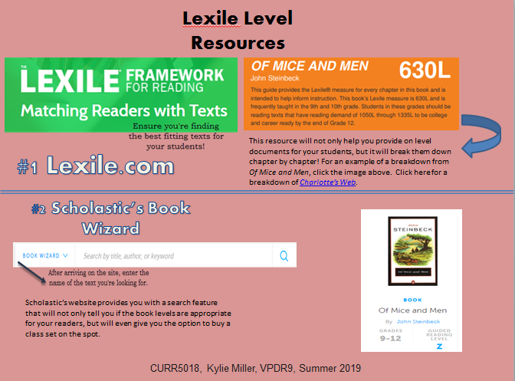](http://warhawks.ulm.edu/~millerky/5018/bin/VPDR9.pptx)

The Lexile focused VPDR linked above serves to help teachers, especially ELA teachers, have more information on choosing the correct texts for their students. To do this, teachers need tools such as [www.lexile.com](http://www.lexile.com) to find Lexile levels and texts appropriate for your students, but some resources will even allow you to then purchase texts for your students, meaning that everything is all in one place.

[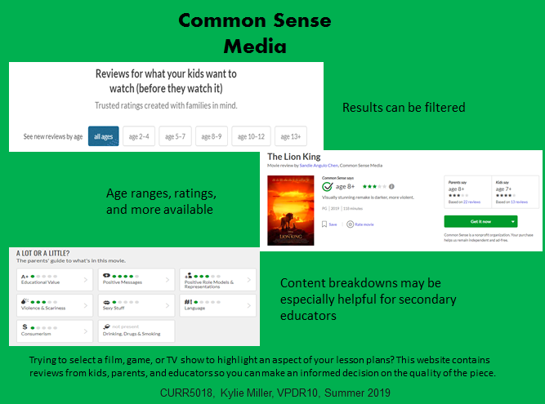](http://warhawks.ulm.edu/~millerky/5018/bin/VPDR10.pptx)

The VPDR above allows educators to find supplemental videos, games, etc. that are age appropriate to their students. Common Sense Media’s website pushes this a step further by including reviews by students, parents, and teachers. It is this level of thoroughness that gives teachers a piece of mind, while still allowing them to make choices students are likely to benefit from and enjoy.

[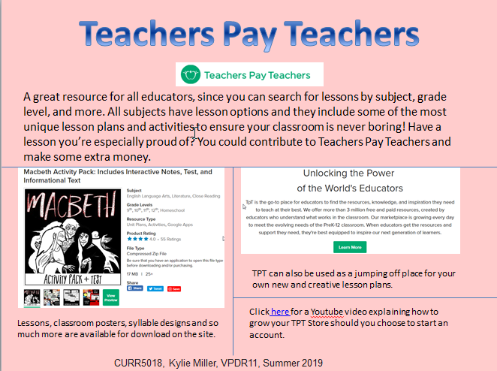](http://warhawks.ulm.edu/~millerky/5018/bin/vpdr11.pptx)

Teachers Pay Teachers allows educators the chance to search for exciting and new classroom lessons, while also giving teachers the opportunity to share (and profit from) lessons and materials they’ve worked especially hard on. The website is used by teachers across disciplines and also provides goods for the classroom, such as posters. Customers on the site are able to pay, download, and print their choices quickly.   
  
[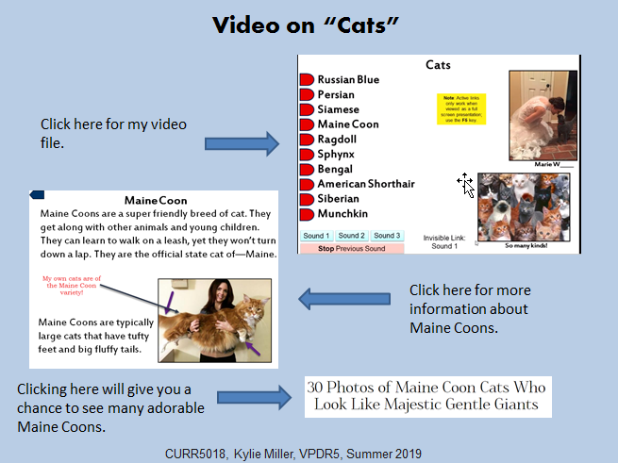](http://warhawks.ulm.edu/~millerky/5018/bin/VPDR5.pptx)

This particular VPDR includes a video discussing the Interactive Powerpoint capabilities. Additionally, it includes bonus links to more information on a particular breed of cat.

[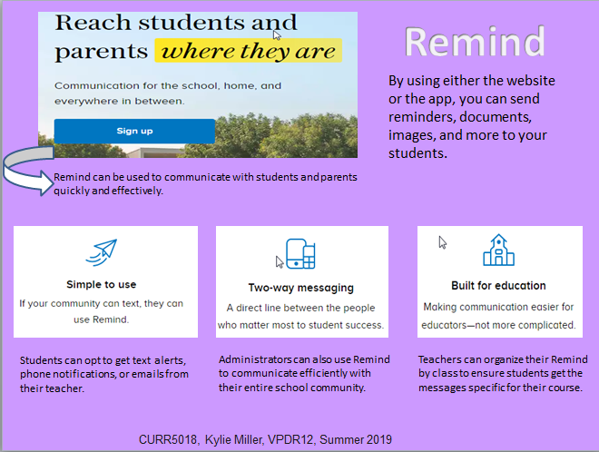](http://warhawks.ulm.edu/~millerky/5018/bin/vpdr12.pptx)

Remind is an excellent tool that provides another means of communication among students, teachers, and parents. This resource can also be used by administrators and coaches to communicate with their community.

8. **Identify An Outstanding Free Online Educational Resource** (25 points)

[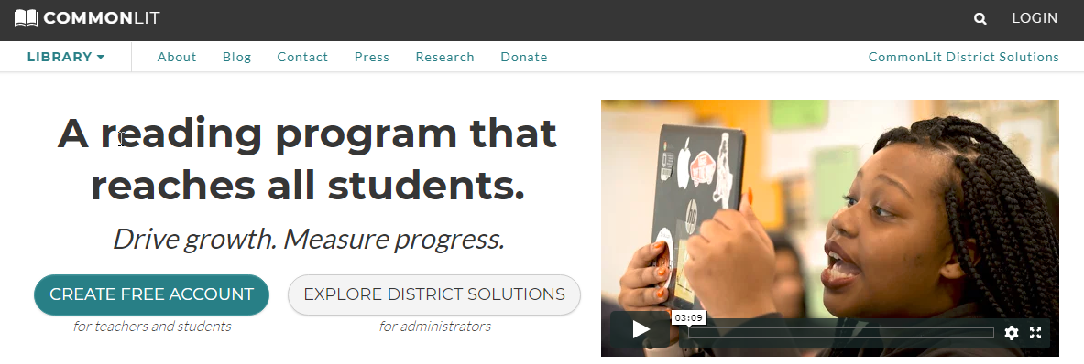](https://www.commonlit.org/)

CommonLit is a resource I’ve used for the entirety of my teaching career to supplement my classroom’s reading materials. One of the biggest things my school values is test preparation and CommonLit has thousands of reading passages with comprehension, A/B, and written response questions included. Once you create a teacher account you have access to download the documents as PDFs and you gain access to the answer keys. The best way I’ve used these passages is as a cold-read at the beginning of the semester and as timed reading exercises to prepare for the ACT. I find that my students love these passages when I’m able to either turn the timed readings into a contest or when I find a passage that is interesting to them, such as one focused on modern technology.