[](https://ulm.edu/webguide/index.html)This document is part of a student’s **academic eFolio (electronic portfolio)** for an online course during the summer of 2019 at the University of Louisiana at Monroe (ULM). The images link to files located on the student’s personal ULM website account.

This student has allowed this *exemplar* to be publicly viewed. **Note: After this student graduates, these links will no longer work because the website will be de-activated. However, the student has the option to COPY and transfer the files to another website account in the future.**

3. **Your Photo.** Insert an “annotated” image of yourself that actively links to your online **about-me.pptx** online file located on your ULM website account. (25 pts)

***[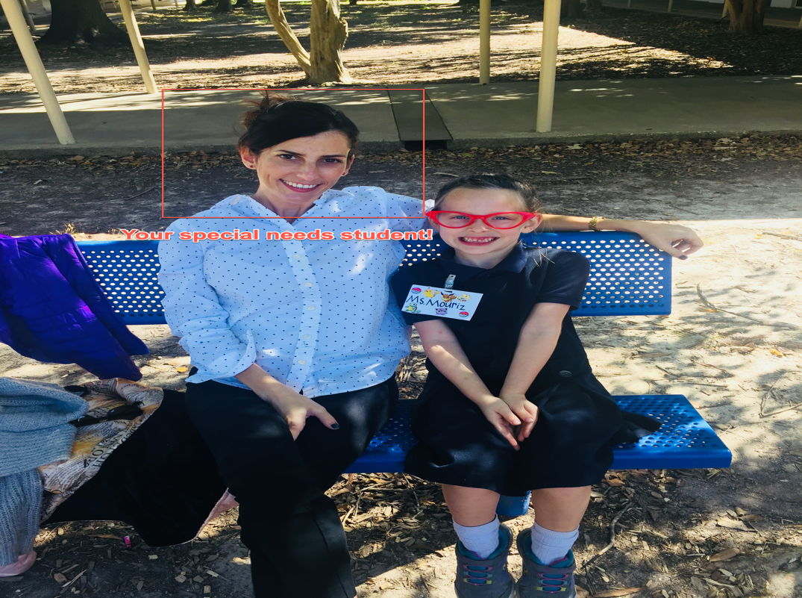](http://warhawks.ulm.edu/~mourizje/5018/bin/project-proposal.pptx)***

4. **Your Project Proposal Cognitive Map**. Include a “cognitive map” describing your course project. (25 points)   
[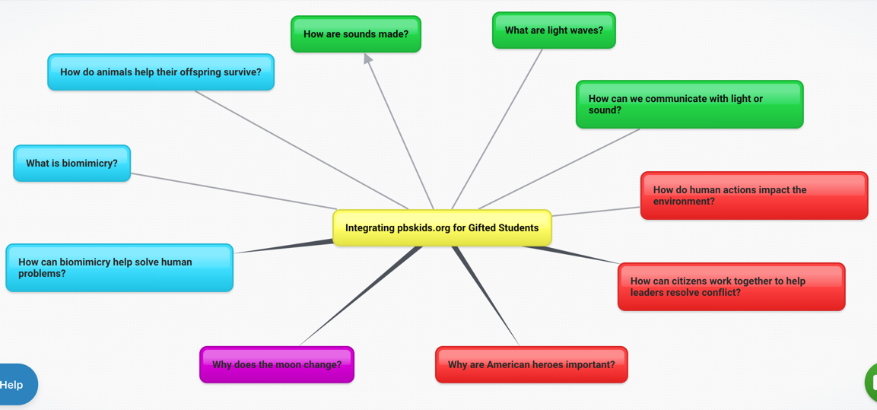](https://bubbl.us)  
Pbskids.org is a vast resource for student learning. These presentations will integrate the website with science and social studies standards. The kiosk slides will make it easier for students to find information relative to content being taught in the classroom. Teachers can use these slides to ensure that students are using technology wisely. This web represents the topics students will explore.

5. **30-Second Video Summary Of Your Completed Online Course Project**. (50 points)

[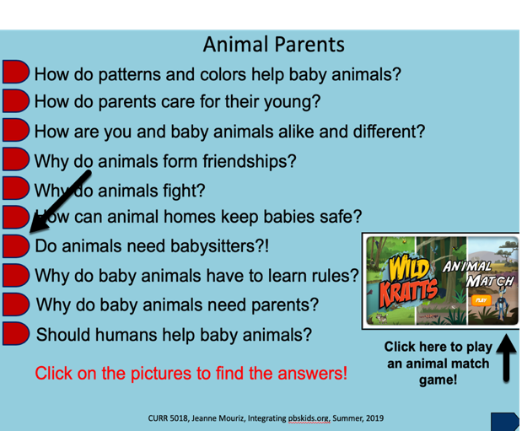](https://www.screencast.com/t/ZEVDK6Ae7)

* 66. **Visually Link Your “Course Project Files” That You Created, Based On Your Project Proposal.**Provide actively linked images of your online course project files and provide text commentary. (200 pts.).

[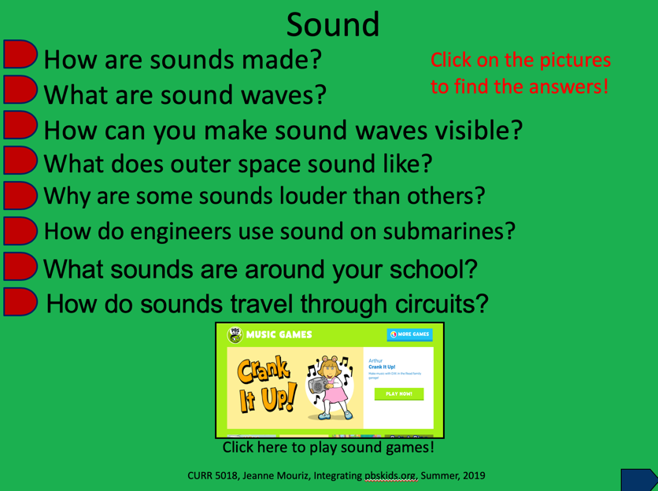](http://warhawks.ulm.edu/~mourizje/5018/bin/project-01.pptx)

This file allows students to explore sound. The questions are aligned with the Next Generation Science Standards. This slide includes interesting video of engineers using sonar on submarines.

[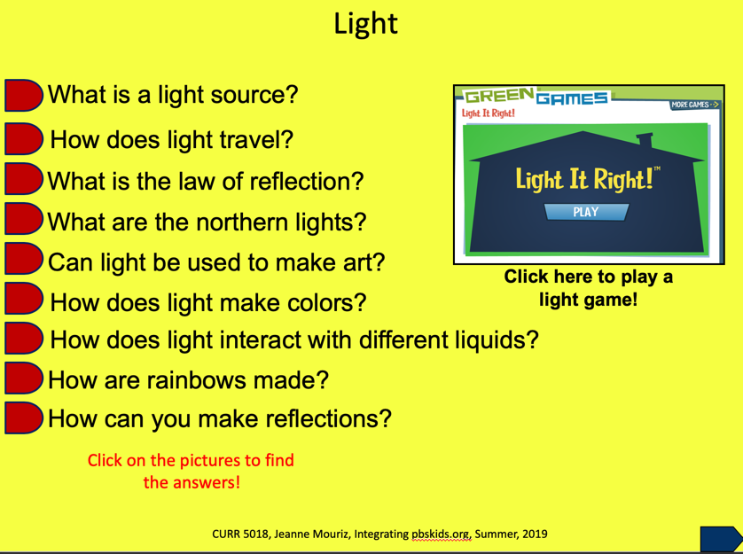](http://warhawks.ulm.edu/~mourizje/5018/bin/project-02.pptx)

This file addresses the standards regarding light. Students explore how light travels, the law of reflection, reflection, and making rainbows.

[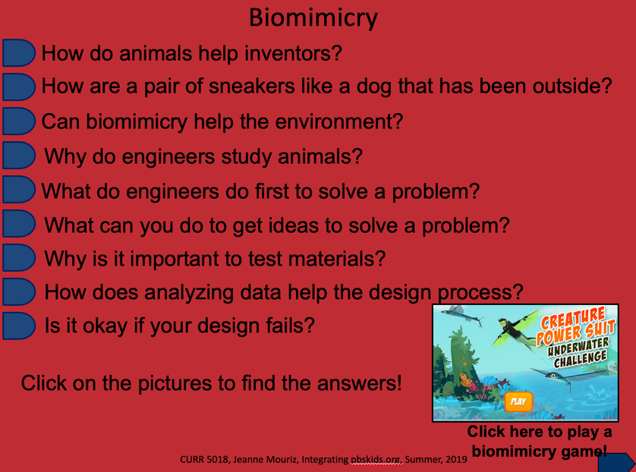](http://warhawks.ulm.edu/~mourizje/5018/bin/projectslide-03.pptx)

This file addresses biomimicry. Students explore how engineers study animals to solve human problems. The design process is also addressed in this file.

[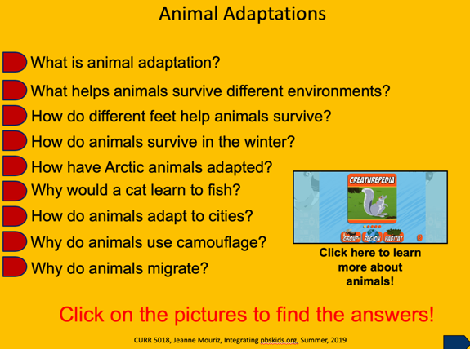](http://warhawks.ulm.edu/~mourizje/5018/bin/project-04.pptx)

Animal adaptations is the focus of this file. Students explore how different animals adapt to climate and habitats.

[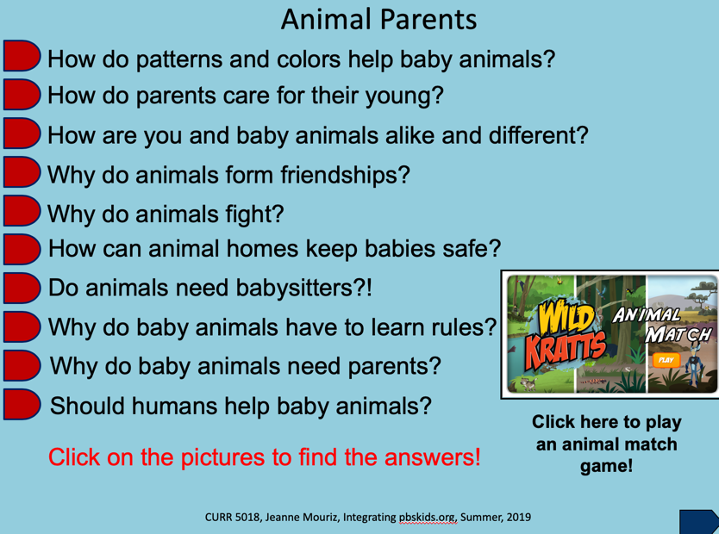](http://warhawks.ulm.edu/~mourizje/5018/bin/project-05.pptx)

This file allows students to explore animal parents and their babies. Interesting topics include animal babysitters and animal friendships.

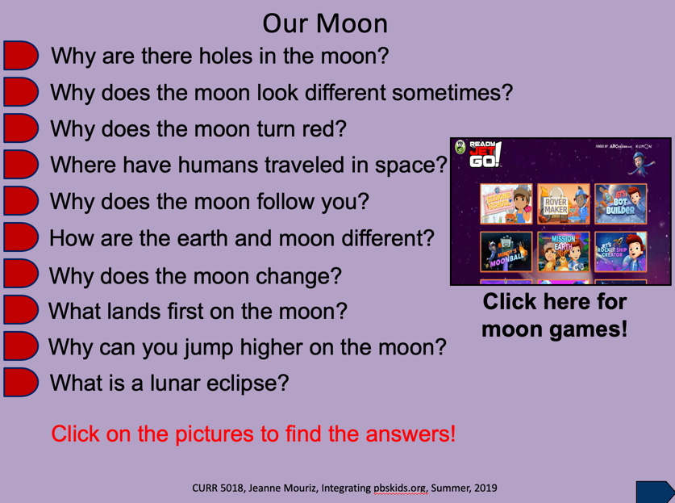

The moon is the topic of this file. Students explore the phases of the moon, space travel, and gravity.

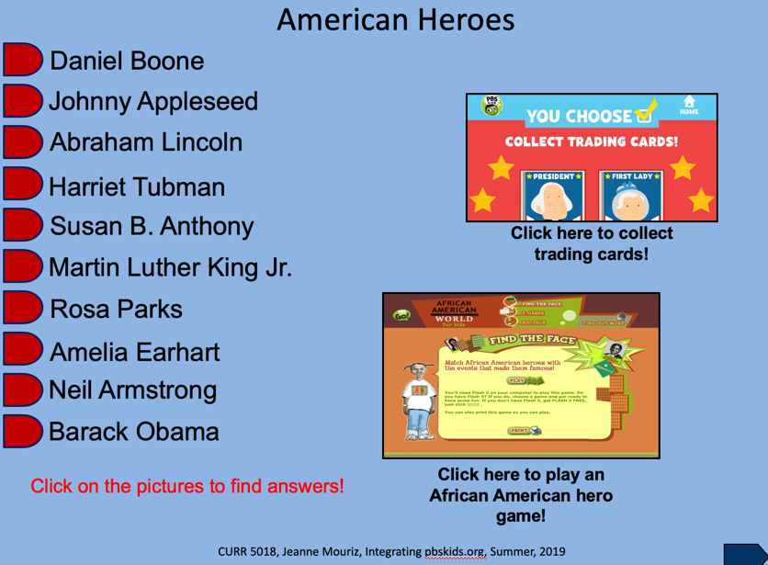

American heroes is the topic for the last file. Students learn about famous Americans and how they showed courage.

7. **Visually Describe At Least 10 Professional “Visual Professional Diary Reflections”.** Provide captured images that actively link to at least 10 online visual professional diary reflections (VPDRs). (150 pts).

[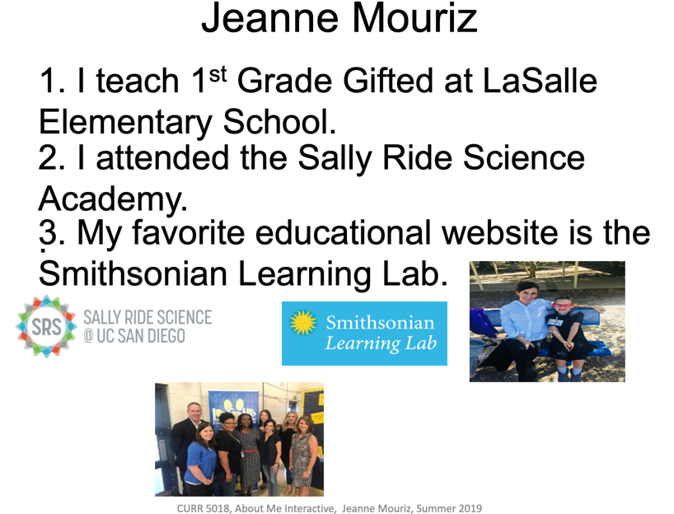](http://warhawks.ulm.edu/~mourizje/5018/bin/abiut-me.pptx)

This was my first vpdr. It took a long time to hyperlink but I finally got the hang of it!

[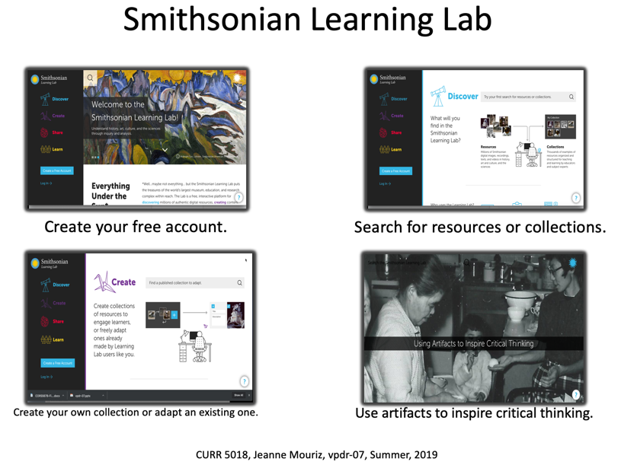](http://warhawks.ulm.edu/~mourizje/5018/bin/vpdr-07.pptx)

Smithsonian learning lab is a great resource for gifted teachers. It allows you to create curated units, which can be assigned to specific students.

[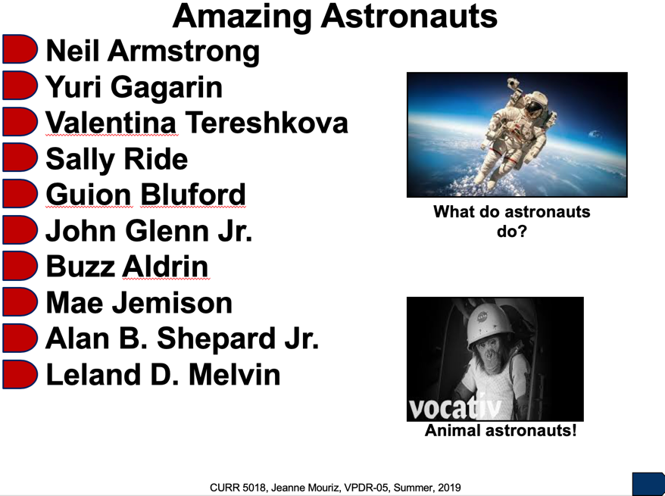](http://warhawks.ulm.edu/~mourizje/5018/bin/vpdr-05.pptx)

This was my first vpdr kiosk presentation. It took me while to complete at first, but now I’m a whiz at it!

[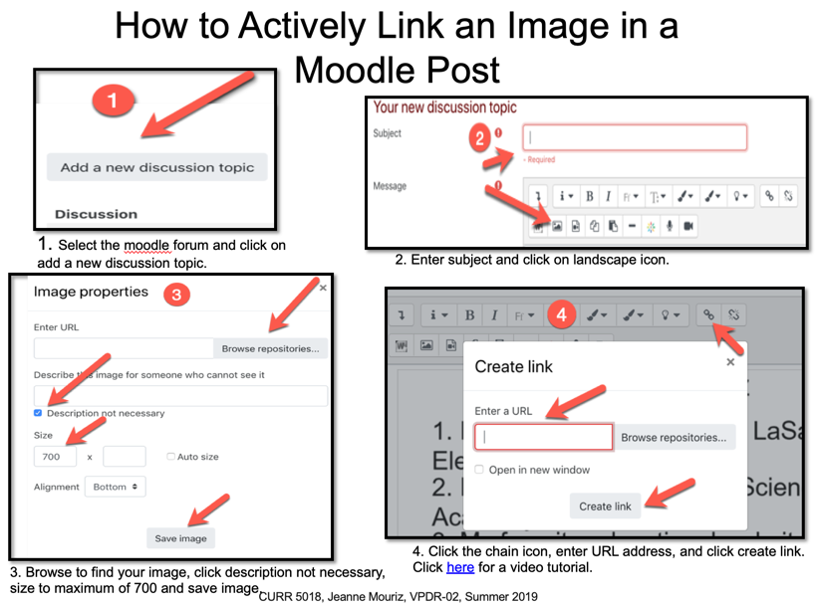](http://warhawks.ulm.edu/~mourizje/5018/bin/vpdr-02.pptx)

This vpdr explains how to actively link an image in a moodle post. I can’t believe it was difficult for me to do this, but it was!

[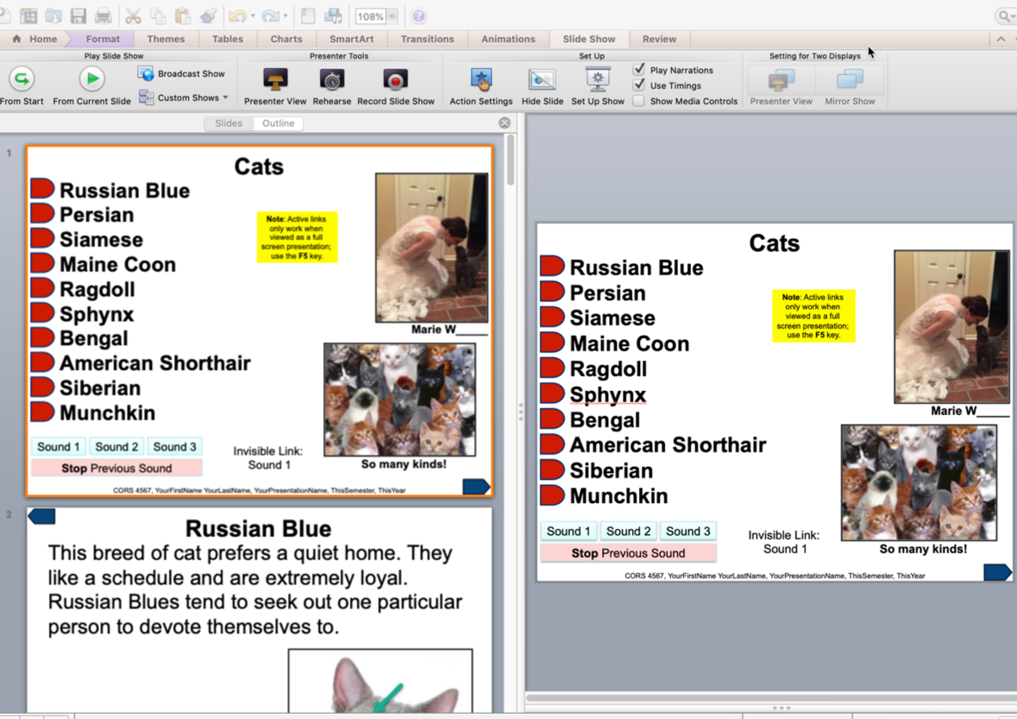](http://warhawks.ulm.edu/~mourizje/5018/bin/vpdr-04.pptx)

This vpdr is a video tutorial. It explains how to get around a kiosk PowerPoint presentation.

[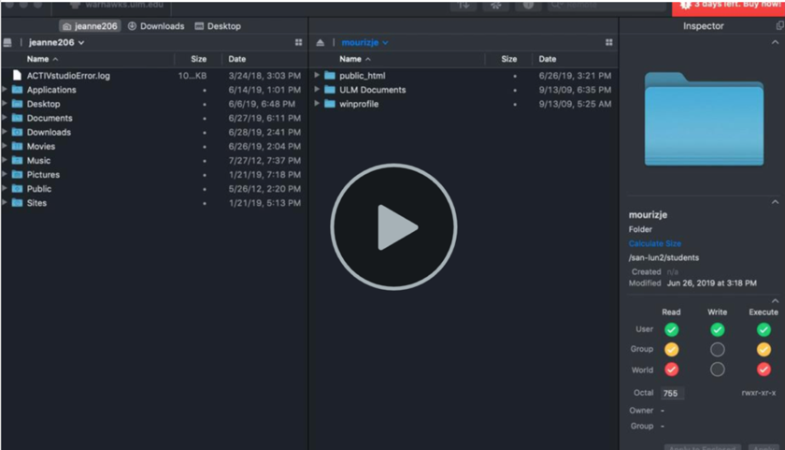](http://warhawks.ulm.edu/~mourizje/5018/bin/vpdr-03.pptx)

In this vprd I explain what not to do when transferring files. This was a huge issue solved!

[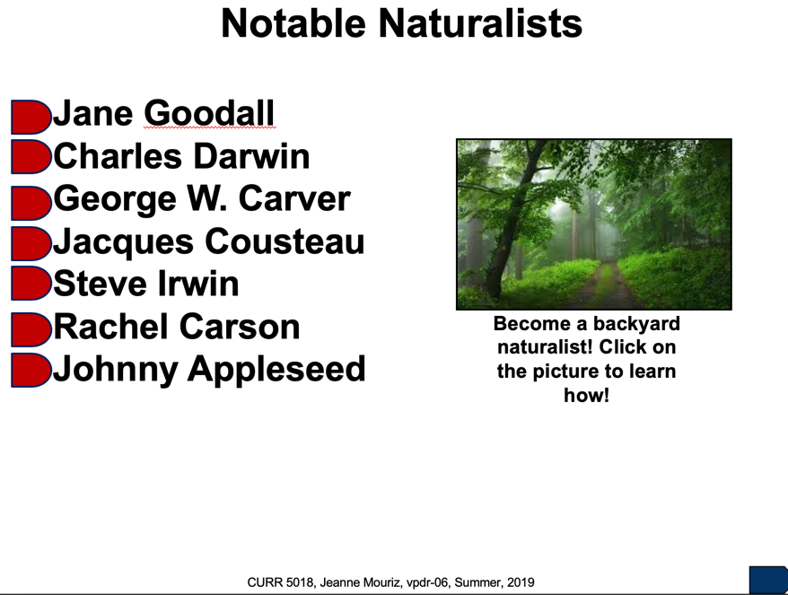](http://warhawks.ulm.edu/~mourizje/5018/bin/vpdr-06.pptx)

This vprd is another kiosk presentation. I think that my students will enjoy these, so I spent a lot of time on these types of presentations.

[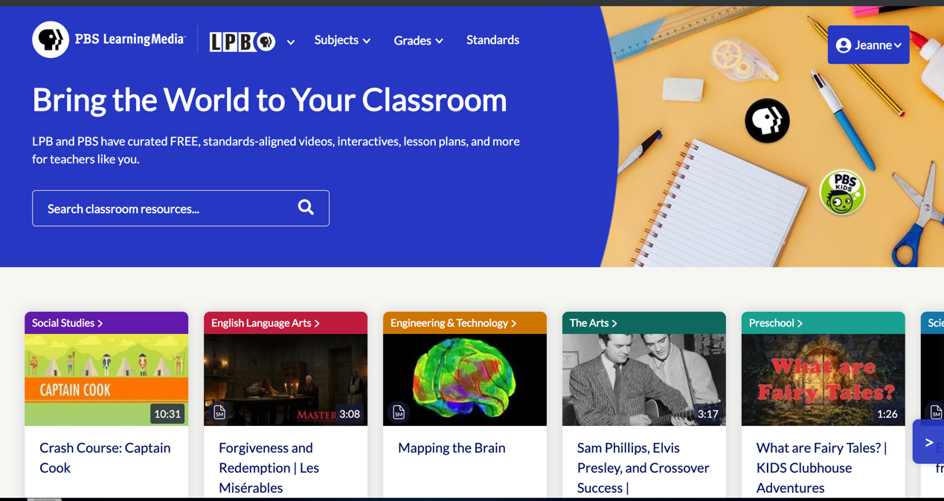](https://lpb.pbslearningmedia.org/)

PBS Learning Media is a free website that contains outstanding educational content. The site features standards-aligned videos, interactives, and lesson plans. All content is curated, so content is easy to find in one place.

8. **Identify An Outstanding Free Online Educational Resource** (25 points)

[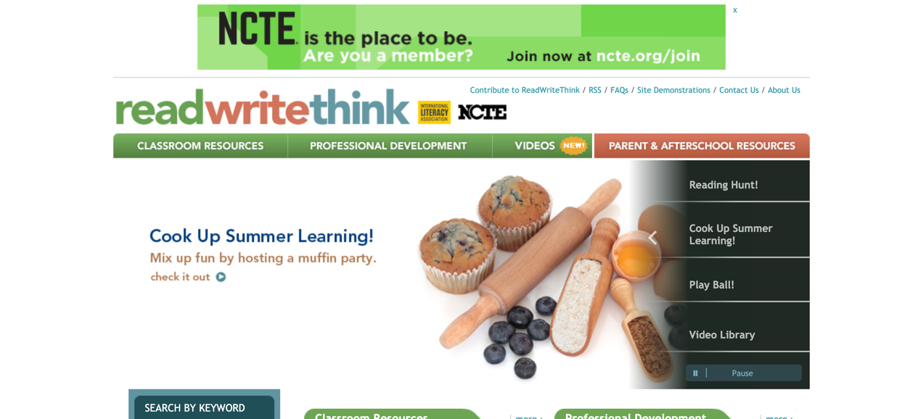](http://www.readwritethink.org/)

ReadWriteThink.is a great resource for ELA teachers. The site provides lesson plans, resources, and professional development. It is very well organized and provides standards that are met with each lesson.