[](https://ulm.edu/webguide/index.html)This document is part of a student’s **academic eFolio (electronic portfolio)** for an online course during the summer of 2019 at the University of Louisiana at Monroe (ULM). The images link to files located on the student’s personal ULM website account.

This student has allowed this *exemplar* to be publicly viewed. **Note: After this student graduates, these links will no longer work because the website will be de-activated. However, the student has the option to COPY and transfer the files to another website account in the future.**

3. **Your Photo.** Insert an “annotated” image of yourself that actively links to your online **about-me.pptx** online file located on your ULM website account. (25 pts)

***[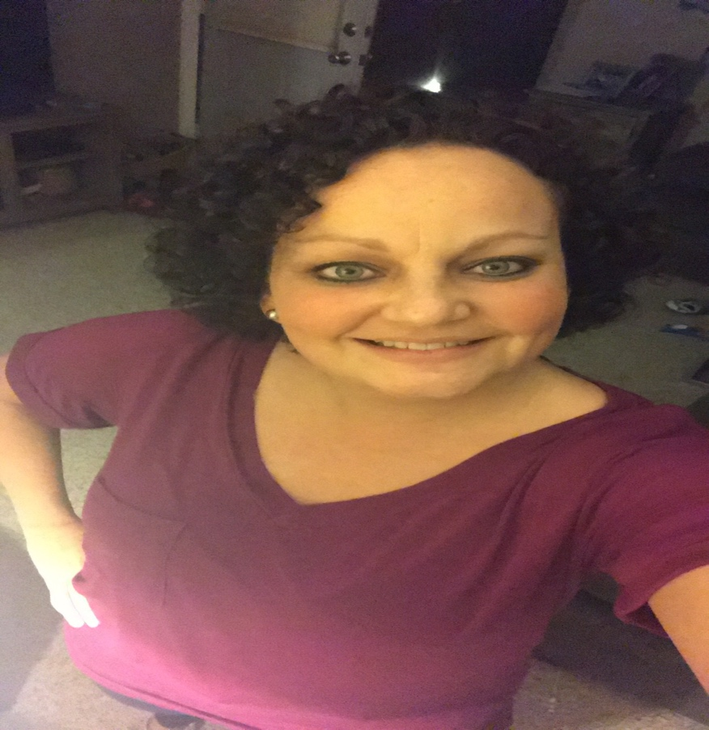](http://warhawks.ulm.edu/~lockwoodm/5018/bin/about%20me.pptx)***

4. **Your Project Proposal Cognitive Map**. Include a “cognitive map” describing your course project. (25 points)   
[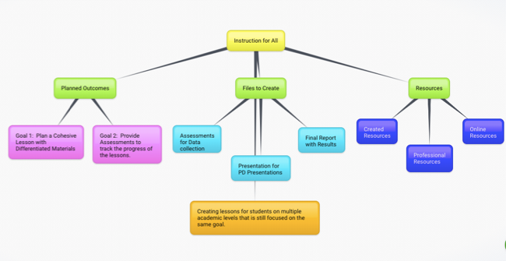](http://warhawks.ulm.edu/~lockwoodm/5018/bin/Project-proposal.docx)  
This map demonstrates the goals and guidelines for my project. The goal is to assist other teachers in creating lessons that are modified for students attending grade level classes but function at several grade levels below. There are many components in each lesson. With a combination of all the components, a successful lesson is not difficult5. **30-Second Video Summary of Your Completed Online Course Project**. (50 points)

[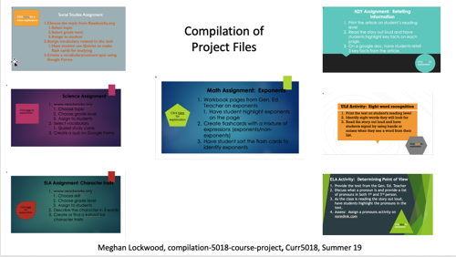](https://www.screencast.com/t/icjC3hllQN9c)

* 66. **Visually Link Your “Course Project Files” That You Created, Based on Your Project Proposal.**Provide actively linked images of your online course project files and provide text commentary. (200 pts.).

[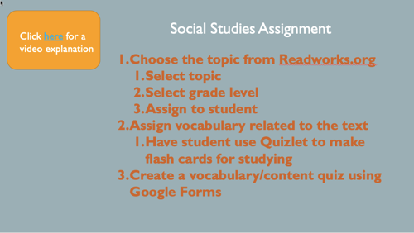](http://warhawks.ulm.edu/~lockwoodm/5018/bin/file1.pptx)

This is a modified version of a social studies lesson that could be done in a general education setting. The student with disabilities would receive information on the same content area but it would be presented on their learning level and in a different format than the other students. .

[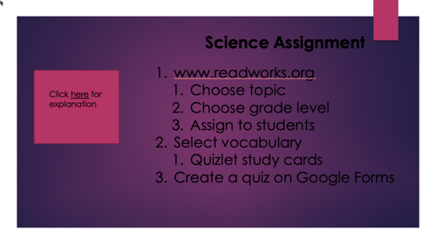](http://warhawks.ulm.edu/~lockwoodm/5018/bin/file2.pptx)

This student would use the same vocabulary that the other students are using from the text read in class. The student would use a website to create flashcards. Then, he or she would take a teacher-made test on those vocabulary words.

[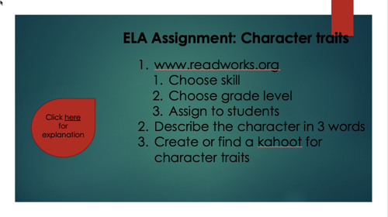](http://warhawks.ulm.edu/~lockwoodm/5018/bin/file3.pptx)

An ELA lesson is modified to fit the needs of a lower functioning student. The student would be asked to identify character traits from a text read aloud in class rather than writing a response like the other students.

[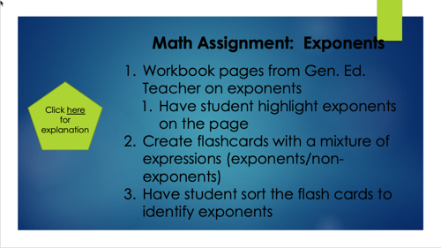](http://warhawks.ulm.edu/~lockwoodm/5018/bin/file4.pptx)

Here is an example of how a math lesson could be modified from typical lesson in a general education classroom. The student is still working on content, but focusing on the basic of the material.

[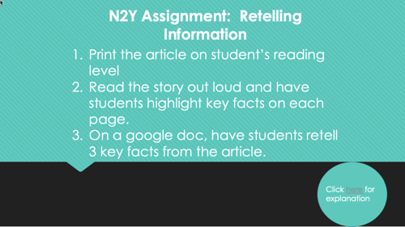](http://warhawks.ulm.edu/~lockwoodm/5018/bin/file5.pptx)

N2Y is a special education curriculum that still addresses the standards. This lesson uses N2Y to address ELA standards for recalling important information.

[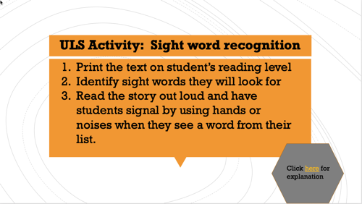](http://warhawks.ulm.edu/~lockwoodm/5018/bin/file6.pptx)

Unique Learning System (ULS) is another resource for special education students. Taking a unit from this program is a great way to have students with disabilities meet standards being addressed in the regular classrooms

[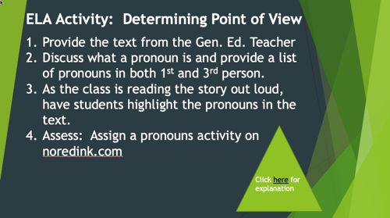](http://warhawks.ulm.edu/~lockwoodm/5018/bin/file7.pptx)

I took a lesson that is done in regular education classrooms and showed how you could modify it to meet the needs of your significant students. This lesson is great because it is simple yet effective.

7. **Visually Describe At Least 10 Professional “Visual Professional Diary Reflections”.** Provide captured images that actively link to at least 10 online visual professional diary reflections (VPDRs). (150 pts).

[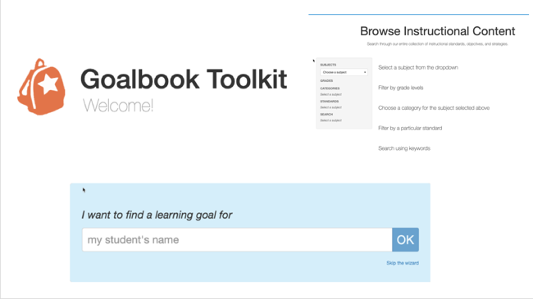](http://warhawks.ulm.edu/~lockwoodm/5018/bin/vpdr1.pptx)

Goalbook is a great resource for finding IEP goals for your students. This site has a ton of goals in every area all at your fingertips!

[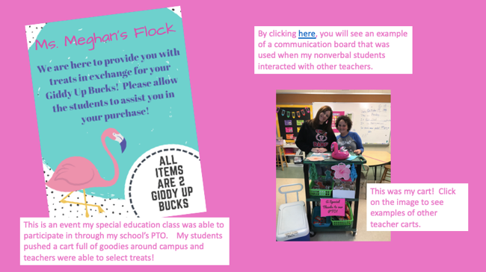](http://warhawks.ulm.edu/~lockwoodm/5018/bin/vdpr2.pptx)

This was a project that I did on campus. My students went around to teachers and offered them snacks and drinks ☺

[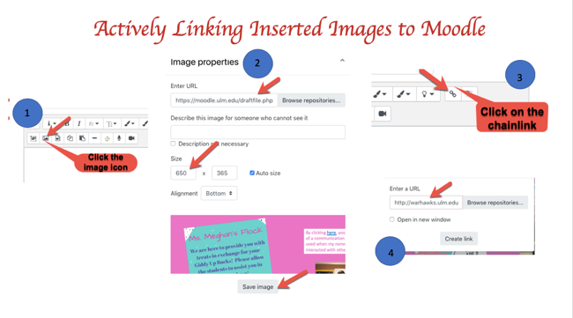](http://warhawks.ulm.edu/~lockwoodm/5018/bin/vdpr3.pptx)

These files give visual directions for actively linking images. The steps are labeled according to make the instructions simple and easy to follow.

[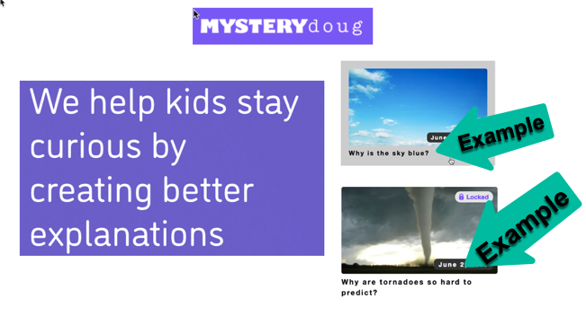](http://warhawks.ulm.edu/~lockwoodm/5018/bin/vdpr4.pptx)

This is a resource to use with students as a quick warmup or time filler. There is an interesting question presented each week and students can guess the outcome.

[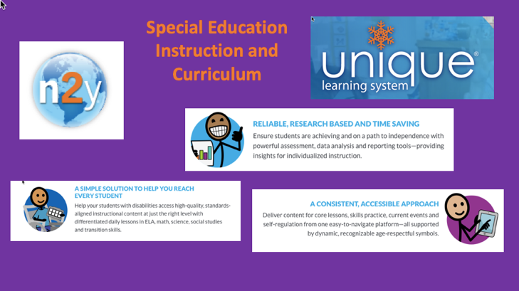](http://warhawks.ulm.edu/~lockwoodm/5018/bin/vpdr5.pptx)

My favorite special education curriculum! This is a fabulous resource and should be available to all special ed teachers.

[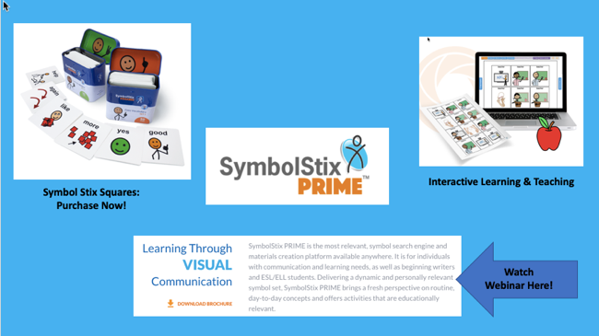](http://warhawks.ulm.edu/~lockwoodm/5018/bin/vpdr6.pptx)

This provides a link to a company that sells cue cards for non-verbal learners. It has been a great resource for my classroom.

[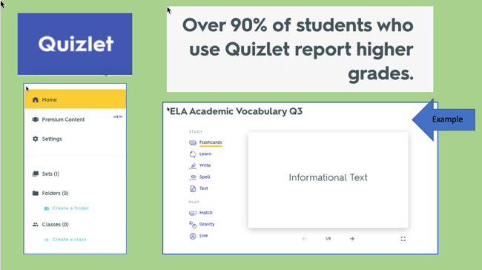](http://warhawks.ulm.edu/~lockwoodm/5018/bin/vpdr7.pptx)

Quizlet is fabulous for study skills. This site is beneficial to both students and adults.

[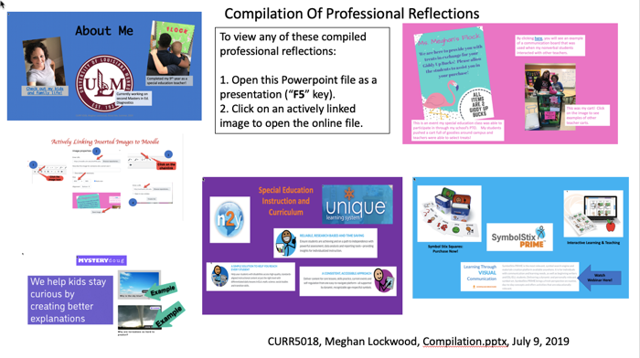](http://warhawks.ulm.edu/~lockwoodm/5018/bin/vpdr8.pptx)

This file provides easy access to 5 of the resources at once. A great one-stop location for finding resources.

[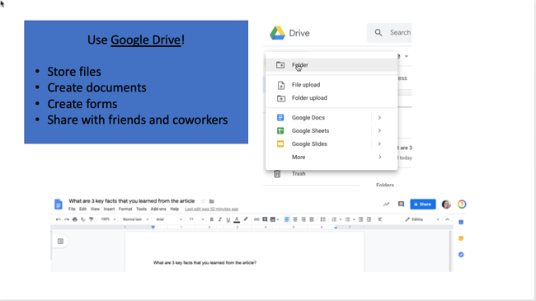](http://warhawks.ulm.edu/~lockwoodm/5018/bin/vpdr9.pptx)

By using Google Drive, you can access all of your files in one location. You can share them with others as well. This is my go to resource for everything.

[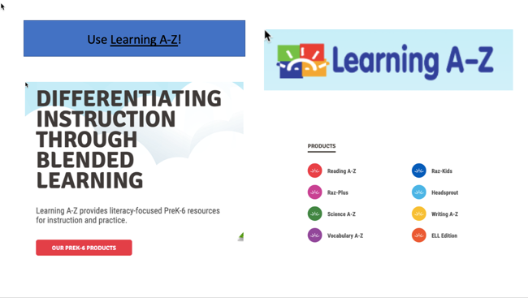](http://warhawks.ulm.edu/~lockwoodm/5018/bin/vpdr10.pptx)

Great spot to get differentiated content materials. Quizzes, activities, and projects can be found as well.

8. **Identify an Outstanding Free Online Educational Resource** (25 points)

[](http://readworks.org/)

This site offers so many options for the same topic of information. I use this resource to assign materials to students that are on different levels. I can choose “solar system” as a topic and assign it on 4 different reading levels. Just an all-around useful resource.