[](https://ulm.edu/webguide/index.html)This document is part of a student’s **academic eFolio (electronic portfolio)** for an online course during the summer of 2019 at the University of Louisiana at Monroe (ULM). The images link to files located on the student’s personal ULM website account.

This student has allowed this *exemplar* to be publicly viewed. **Note: After this student graduates, these links will no longer work because the website will be de-activated. However, the student has the option to COPY and transfer the files to another website account in the future.**

3. **Your Photo.** Insert an “annotated” image of yourself that actively links to your online **about-me.pptx** online file located on your ULM website account. (25 pts)

***[](http://warhawks.ulm.edu/~marcelledoironaa/5018/bin/about-me.pptx)***4. **Your Project Proposal Cognitive Map**. Include a “cognitive map” describing your course project. (25 points)   
[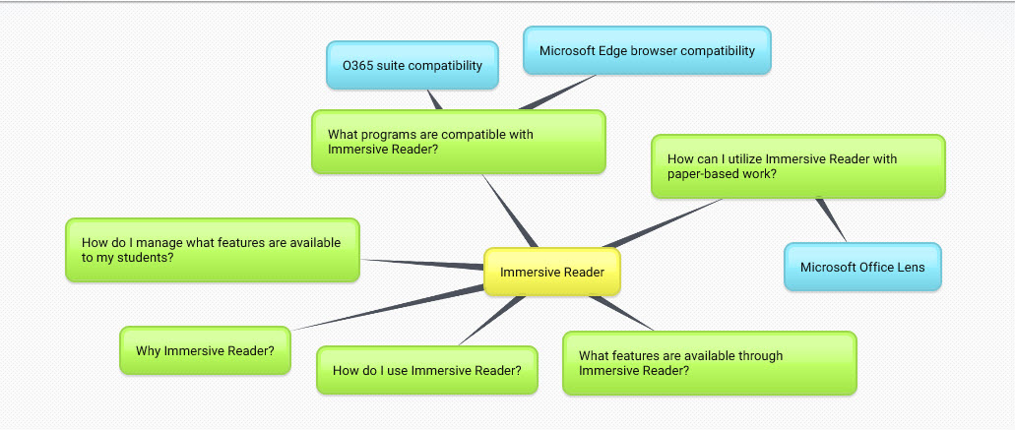](http://warhawks.ulm.edu/~marcelledoironaa/5018/bin/CURR5018-Ashley%20Marcelle%20Doiron-Immersive%20Reader.docx)  
I tried to present the most frequently asked questions about Immersive Reader in the cognitive map. The questions are the major points that are covered through vpdrs for this project. In covering each question, I included articles, videos, downloads, and narrated instructional videos. 5. **30-Second Video Summary Of Your Completed Online Course Project**. (50 points)

[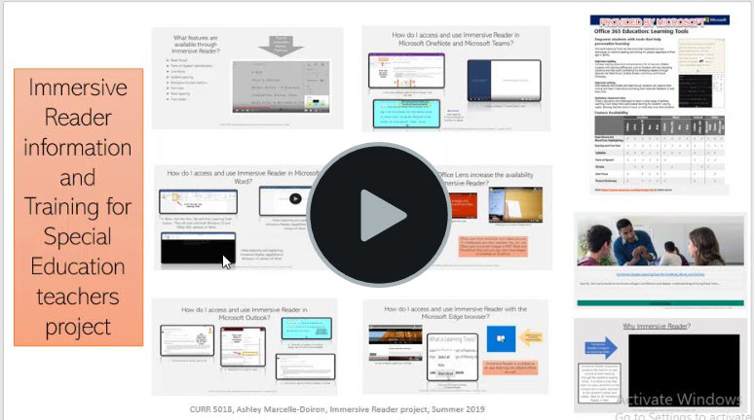](https://www.screencast.com/t/Y4v4KRehPx)

* 66. **Visually Link Your “Course Project Files” That You Created, Based On Your Project Proposal.**Provide actively linked images of your online course project files and provide text commentary. (200 pts.).

[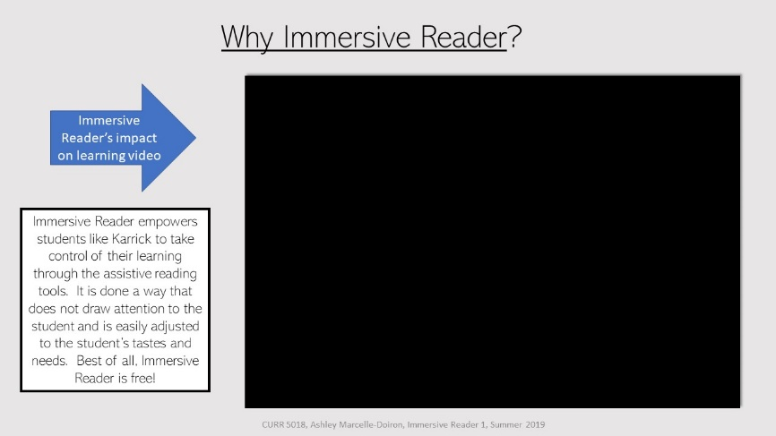](http://warhawks.ulm.edu/~marcelledoironaa/5018/bin/immersive%20reader%201.pptx)

This is a great video showing the impact Immersive Reader can have on struggling readers’ lives. This is just one child’s journey. The number of students we can impact with this in the Special Ed department is huge.

[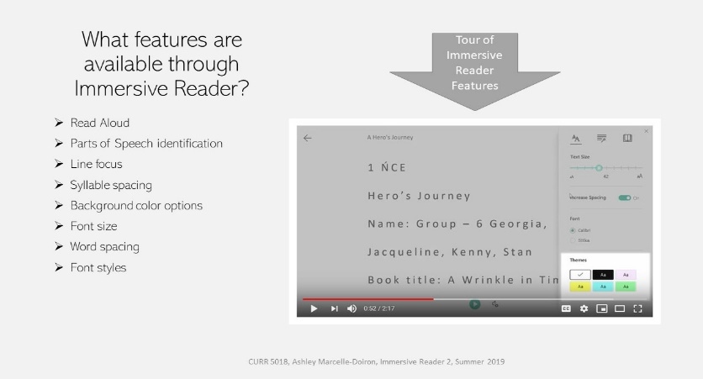](http://warhawks.ulm.edu/~marcelledoironaa/5018/bin/Immersive%20Reader%202.pptx)

This vpdr concentrates on the features that are available with Immersive Reader. There is also a great video that demonstrates the features as well as the ease of use.

[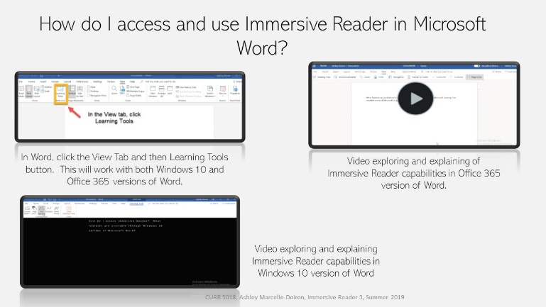](http://warhawks.ulm.edu/~marcelledoironaa/5018/bin/Immersive%20Reader%203.pptx)

This vpdr demonstrates how to access Immersive Reader in both Windows 10 and Office 365 versions of Microsoft Word. There is also a video demonstrating both methods.

[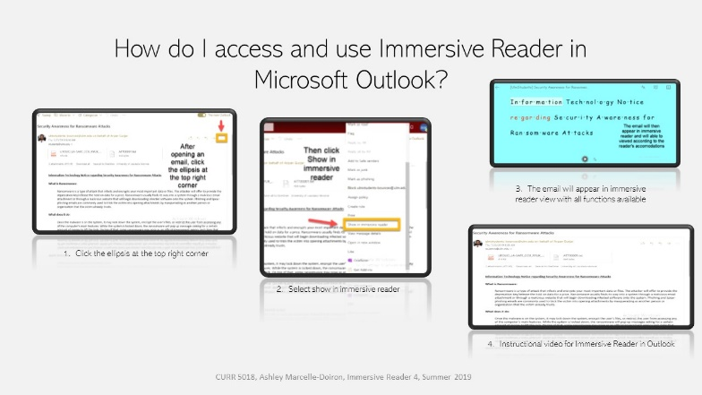](http://warhawks.ulm.edu/~marcelledoironaa/5018/bin/Immersive%20Reader%204.pptx)

This vpdr exhibits how to access Immersive Reader in Outlook. Outlook can be set up so that all emails appear in Immersive Reader view first. There is a short video demonstrating this feature.

[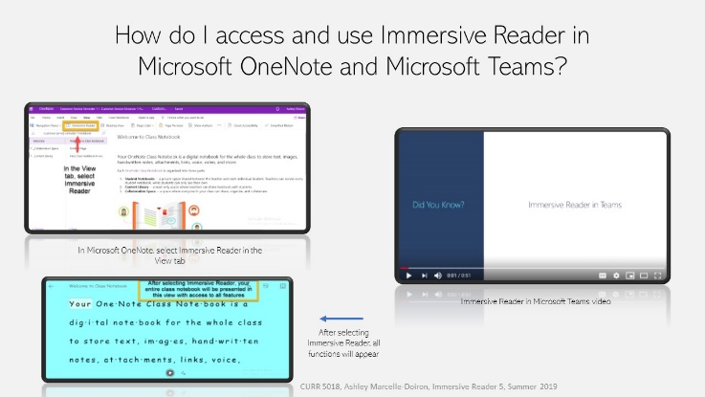](http://warhawks.ulm.edu/~marcelledoironaa/5018/bin/Immersive%20Reader%205.pptx)

This vpdr shows how to access Immersive Reader while in Microsoft OneNote and Teams. The functions are available in both programs and makes learning and participating easier than ever.

[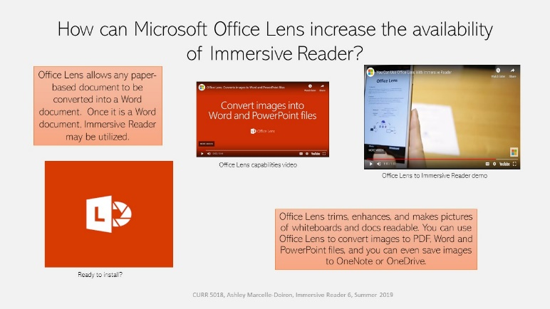](http://warhawks.ulm.edu/~marcelledoironaa/5018/bin/Immersive%20Reader%206.pptx)

Microsoft Office Lens means that Immersive Reader can be used to assist a student when they are presented with an assignment of any medium or program. With a cell phone or tablet, students are able to transform text into a Microsoft compatible program and have access to all of Immersive Reader’s features.

[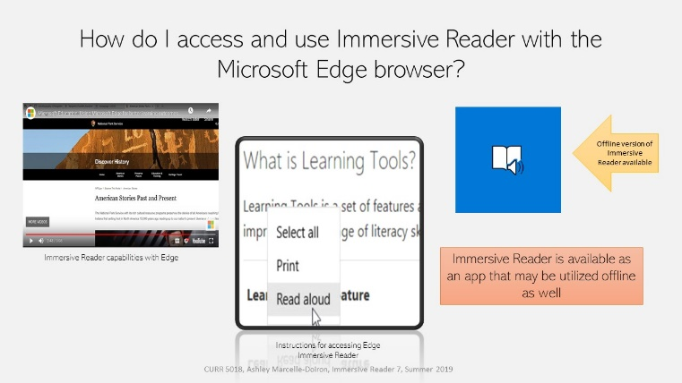](http://warhawks.ulm.edu/~marcelledoironaa/5018/bin/Immersive%20Reader%207.pptx)

This vpdr demonstrates how Immersive Reader is available in the Microsoft Edge browser. This means it is available for all online content for our students.

[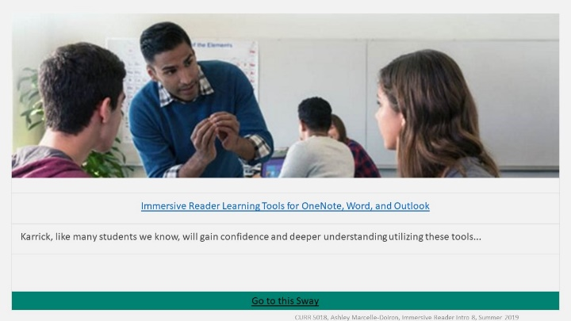](https://sway.office.com/kakYzY6Yj4OdTFEk?ref=Link&loc=play)

This Sway I created gives a great overview of Immersive Reader. There is also a resource list at the bottom of the presentation.

7. **Visually Describe At Least 10 Professional “Visual Professional Diary Reflections”.** Provide captured images that actively link to at least 10 online visual professional diary reflections (VPDRs). (150 pts).

[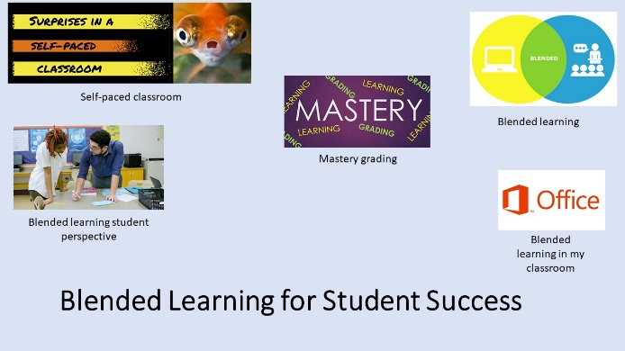](http://warhawks.ulm.edu/~marcelledoironaa/5018/bin/vpdr-02-5018.pptx)

This vpdr covers blended learning and the different ways this type of learning can lead to student success. The vpdr contains both articles and videos.

[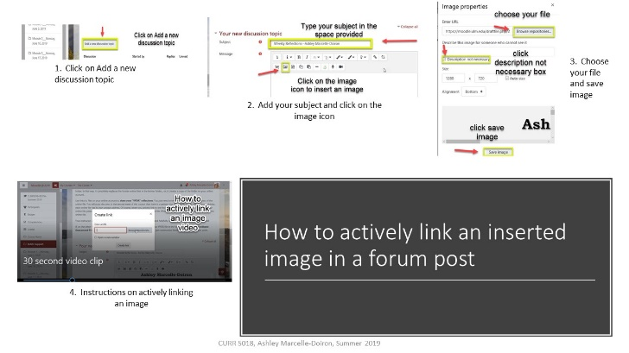](http://warhawks.ulm.edu/~marcelledoironaa/5018/bin/vpdr-03-5018.pptx)

This vpdr was very helpful to create. Through creating the step by step instructions and video, I was able to become more competent at actively linking an image in a forum post.

[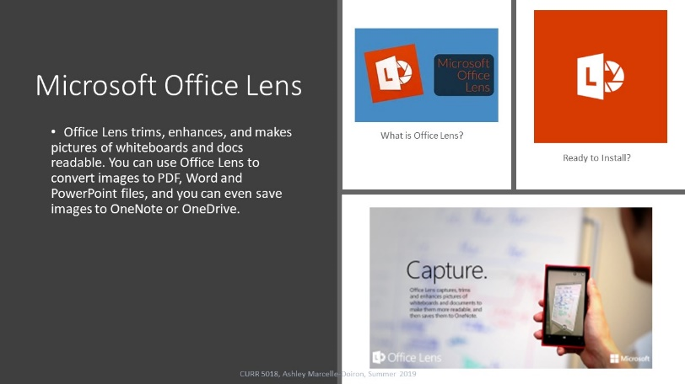](http://warhawks.ulm.edu/~marcelledoironaa/5018/bin/vpdr-04-5018.pptx)

This vpdr details the capabilities of the Microsoft Office Lens app and how it connects to Immersive Reader. The app makes all forms of print accessible to Immersive Reader.

[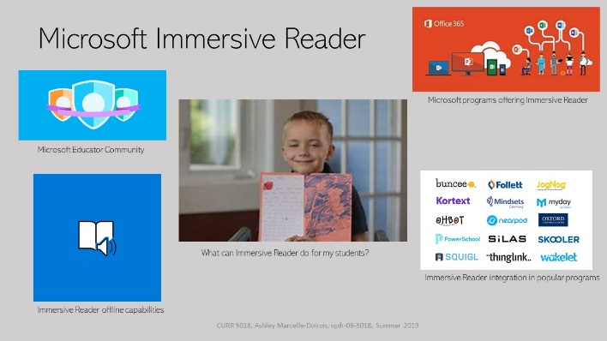](http://warhawks.ulm.edu/~marcelledoironaa/5018/bin/vpdr-06-5018.pptx)

This vpdr is a great basic overview of Immersive Reader. This vpdr led me to choose it for the basis of my project.

[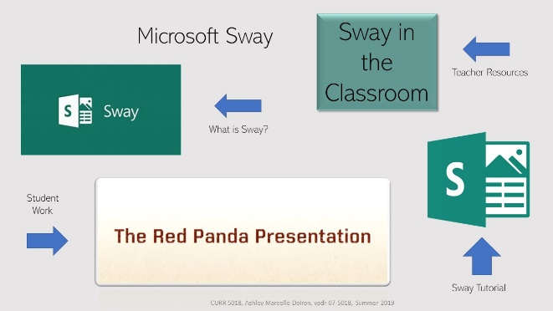](http://warhawks.ulm.edu/~marcelledoironaa/5018/bin/vpdr-07-5018.pptx)

This vpdr gives more information about the presentation program Microsoft Sway. This vpdr includes articles, a sample Sway, and download information.

[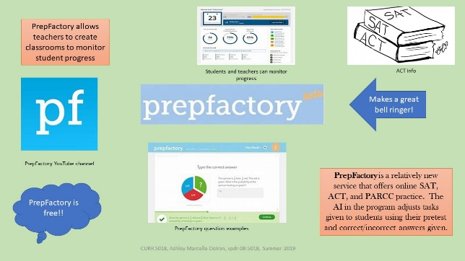](http://warhawks.ulm.edu/~marcelledoironaa/5018/bin/vpdr-08-5018.pptx)

This vpdr introduces PrepFactory. I have used this free program the past few years as a bell ringer for my students. They are able to complete personalized ACT practice online. The questions asked is constantly adapting to the number of correct answers.

[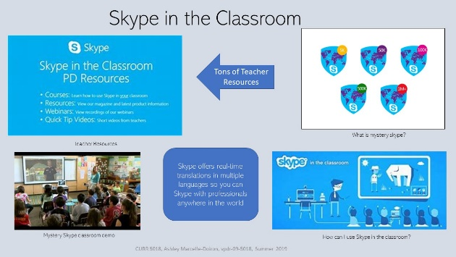](http://warhawks.ulm.edu/~marcelledoironaa/5018/bin/vpdr-09-5018.pptx)

Skype in the classroom is a fantastic resource for all skill and grade levels. You can chat with industry professionals or students the same age from around the globe. This vpdr contains videos, articles, and enrollment information.

[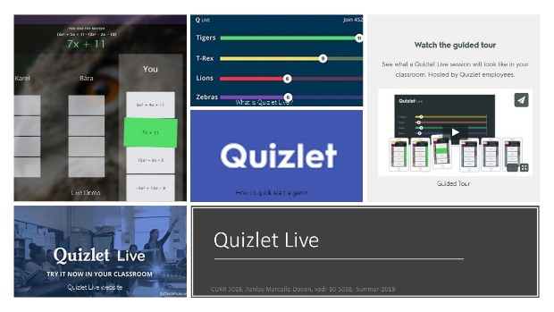](http://warhawks.ulm.edu/~marcelledoironaa/5018/bin/vpdr-10-5018.pptx)

This vpdr provides information about Quizlet Live. It contains articles, download information, and a video demonstration.

[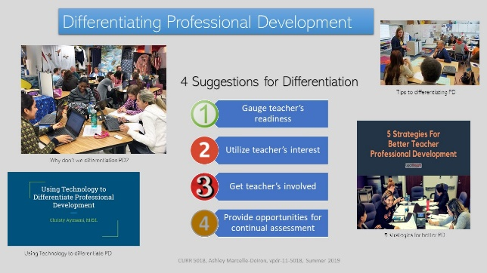](http://warhawks.ulm.edu/~marcelledoironaa/5018/bin/vpdr-11-5018.pptx)

This vpdr makes the case for differentiating professional development. There is a lot of emphasis on differentiating our instruction, but just as students learn differently, so do teachers. This includes articles and a presentation.

[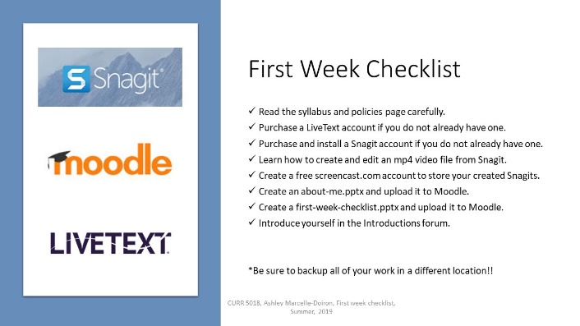](http://warhawks.ulm.edu/%7Emarcelledoironaa/5018/bin/First%20Week%20Checklist.pptx?web=1)

This vpdr worked as a great reference throughout the semester. I was quickly able to link to Moodle from the slide.

8. **Identify An Outstanding Free Online Educational Resource** (25 points)

[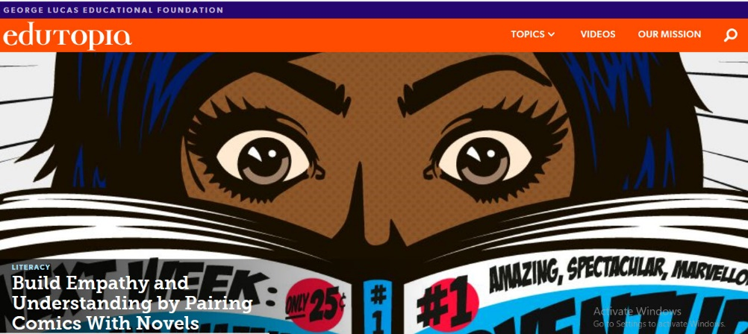](https://www.edutopia.org/)

My favorite online educator’s website is Edutopia.org. I subscribe to their newsletter and I am never disappointed. They offer a great variety of articles and lesson plans. Their articles are always up to date and thorough. I am often inspired to try new techniques, lessons, and technology by their website. There videos are great and offer a better insight into many of the topics or techniques covered.