[](https://ulm.edu/webguide/index.html)This document is part of a student’s **academic eFolio (electronic portfolio)** for an online course during the summer of 2019 at the University of Louisiana at Monroe (ULM). The images link to files located on the student’s personal ULM website account.

This student has allowed this *exemplar* to be publicly viewed. **Note: After this student graduates, these links will no longer work because the website will be de-activated. However, the student has the option to COPY and transfer the files to another website account in the future.**

3. **Your Photo.** Insert an “annotated” image of yourself that actively links to your online **about-me.pptx** online file located on your ULM website account. (25 pts)

***[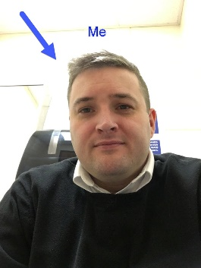](http://warhawks.ulm.edu/~philippedj/5018/bin/AboutMeDJP.pptx)***4. **Your Project Proposal Cognitive Map**. Include a “cognitive map” describing your course project. (25 points)   
[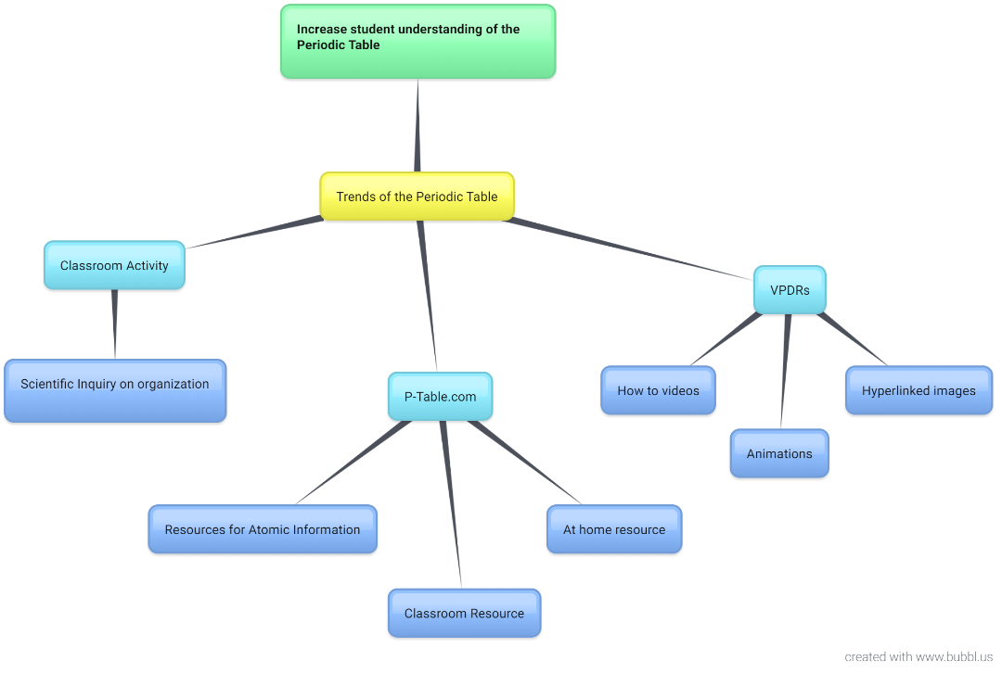](http://warhawks.ulm.edu/~philippedj/5018/bin/project-proposal.docx)  
The image above describes my final course project. Families and trends of the periodic table is the foundation of most science courses. The project serves as a great tool for students to continue learning from home. With this tool, parents can also keep track of student learning and be engaged in their child’s education. It includes instructional videos, graphics, activities, and helpful educational sites for students.

[**http://warhawks.ulm.edu/~philippedj/5018/bin/project-proposal.docx**](http://warhawks.ulm.edu/~philippedj/5018/bin/project-proposal.docx)

Each trend of the periodic table will have a separate VPDR for students to explore. They will include “how to” videos where I show the student what we use that trend for, animations showing the atomic motion, and pictures with hyperlinks of info about each trend. Students will be able to utilize their chromebooks and explore every trend of the periodic table by using it, rather than writing about it.

5. **30-Second Video Summary Of Your Completed Online Course Project**. (50 points)

[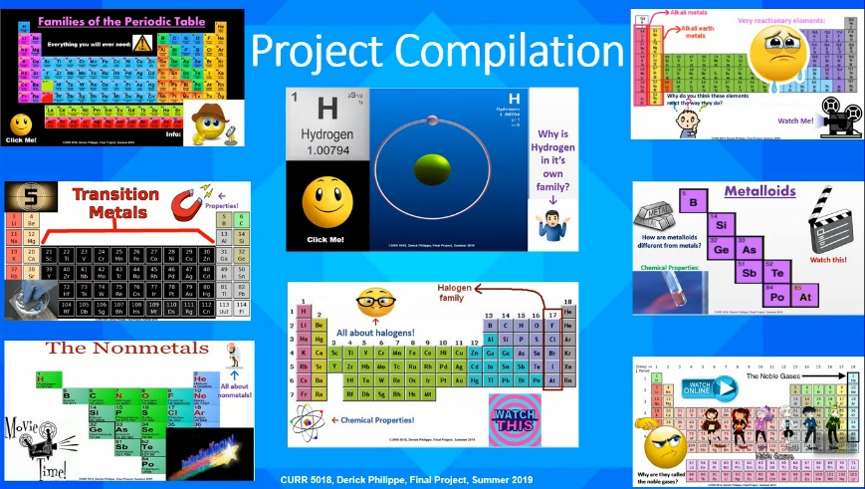](https://www.screencast.com/t/Ni98aXiTVs5)

* 66. **Visually Link Your “Course Project Files” That You Created, Based On Your Project Proposal.**Provide actively linked images of your online course project files and provide text commentary. (200 pts.).

[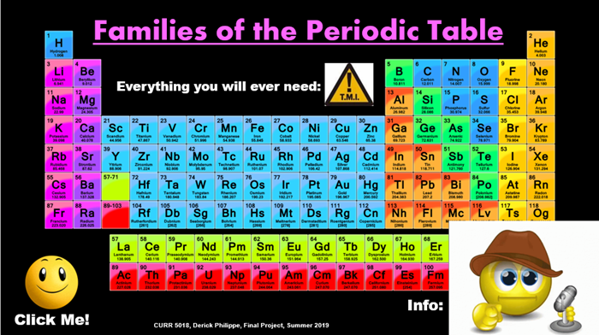](http://warhawks.ulm.edu/~philippedj/5018/bin/project1.pptx)

This VPDR acts as in introduction to the families of the periodic table. It includes a short video on why the table is arranged the way it is. It also includes a link to ptable.com which will be used throughout the lesson.

[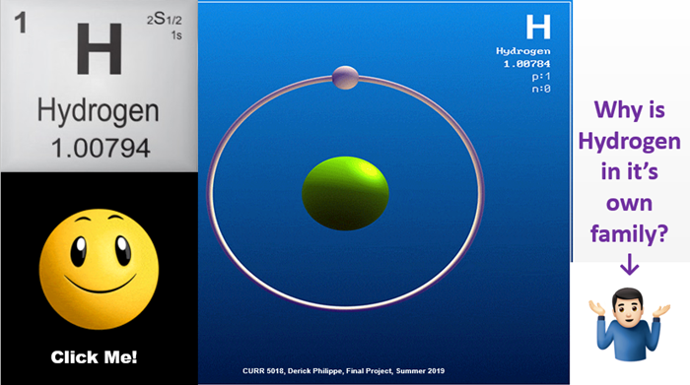](http://warhawks.ulm.edu/~philippedj/5018/bin/project2.pptx)

This VPDR serves as a resource for the first family of the periodic table. I used a leading question to serve as an inquiry activity for the students.

[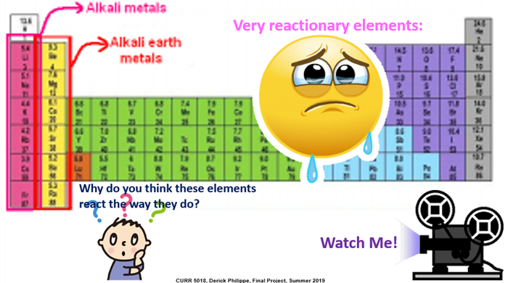](http://warhawks.ulm.edu/~philippedj/5018/bin/project3.pptx)

This VPDR also includes a leading question for students to discover on their own the meaning of the lesson. It also includes links to a video and information pertaining to these families.

[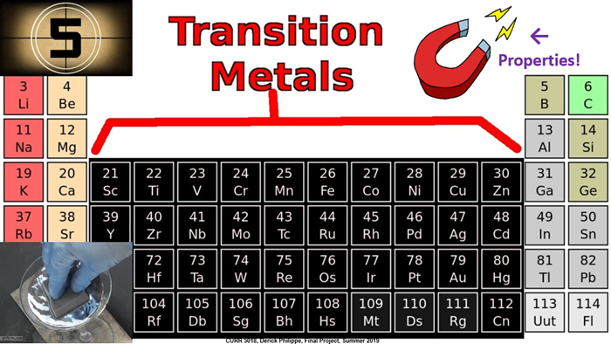](http://warhawks.ulm.edu/~philippedj/5018/bin/project4.pptx)

This VPDR serves as a resource for the transition metal family of the periodic table. It contains three links for students leading them to an activity, video, and visual components of the elements.

[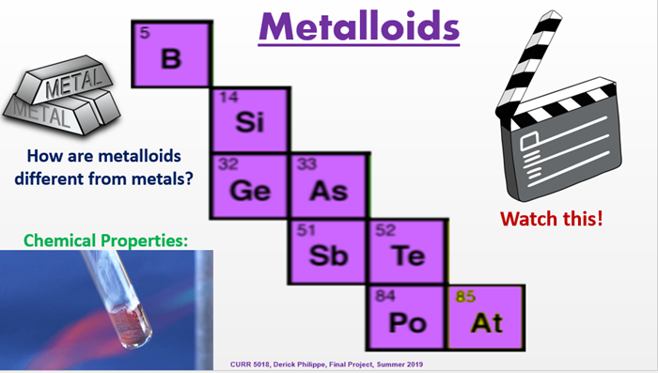](http://warhawks.ulm.edu/~philippedj/5018/bin/project5.pptx)

This VPDR serves as a resource for the Metalloids. I used a leading question so students can discover on their own the properties and behavior of this family.

[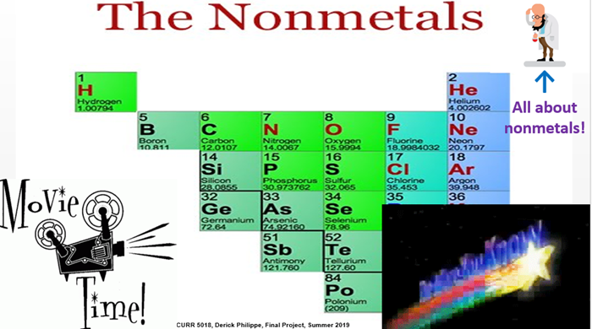](http://warhawks.ulm.edu/~philippedj/5018/bin/project6.pptx)

This VPDR contains the Nonmetals and has a fun video describing what makes a metal and what doesn’t. It also has links that describe the properties of all nonmetals.

[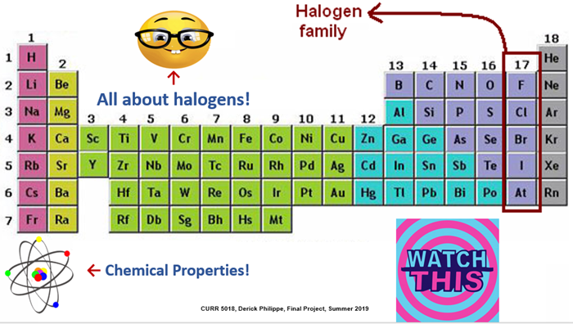](http://warhawks.ulm.edu/~philippedj/5018/bin/project7.pptx)

This VPDR containing the Halogens contains links that describe the reactive properties of the Halogen family. It also contains a video for students to see how something very reactive can become stable by forming bonds.

[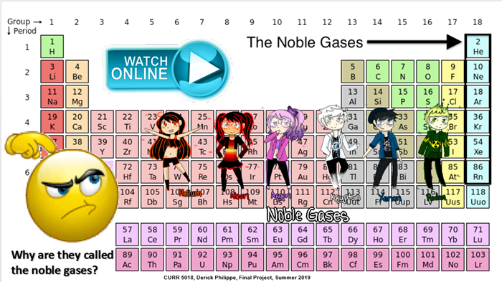](http://warhawks.ulm.edu/~philippedj/5018/bin/project8.pptx)

This final VPDR includes a leading question for students to describe the noble gases without even knowing what they are yet. It includes links to informational texts as well as a video describing the use of the noble gases.

7. **Visually Describe At Least 10 Professional “Visual Professional Diary Reflections”.** Provide captured images that actively link to at least 10 online visual professional diary reflections (VPDRs). (150 pts).   
  
[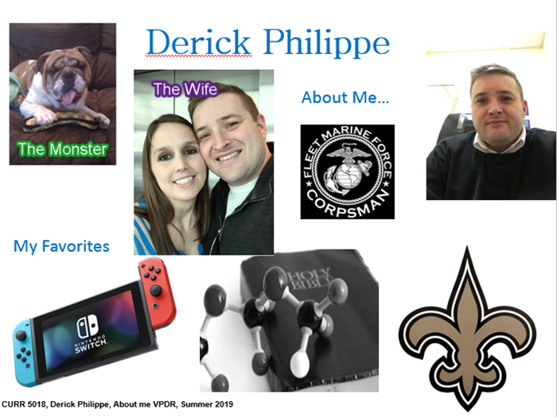](http://warhawks.ulm.edu/~philippedj/5018/bin/vpdr-01.pptx)

The image above is linked to my About Me VPDR. It includes pictures of my wife and puppy dog Oliver. It shows my love for the Saints and Nintendo Switch.

[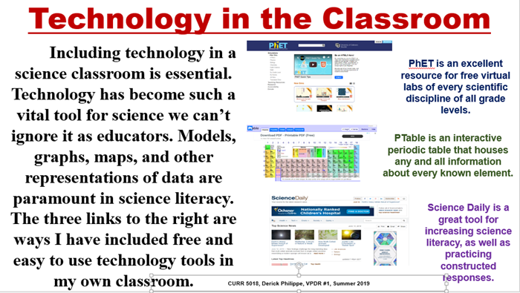](http://warhawks.ulm.edu/~philippedj/5018/bin/vpdr-02.pptx)

The image above contains links to several useful websites for science teachers. Phet is one of the most interesting websites for students to discover scientific labs that they may not be able to do in a classroom setting.

[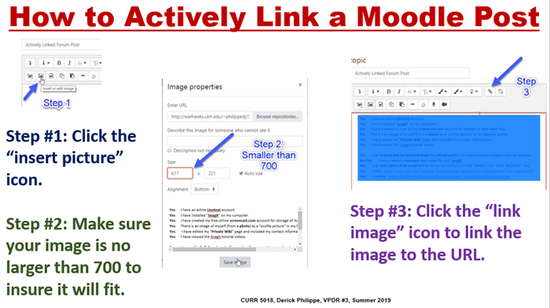](http://warhawks.ulm.edu/~philippedj/5018/bin/vpdr-03.pptx)

The image above contains a link to a video that I created to show how to actively link a Moodle forum post. It was a very useful concept to learn especially for this course.

[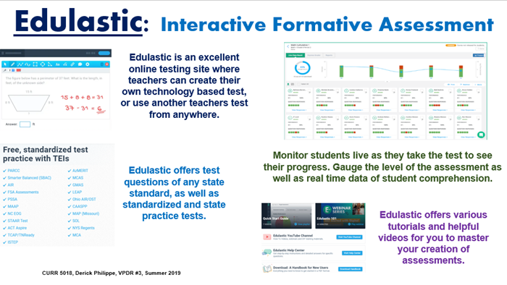](http://warhawks.ulm.edu/~philippedj/5018/bin/vpdr-04.pptx)

Edulastic is an excellent assessment tool. It gives immediate student feedback and you are able to monitor student progress in real time.

[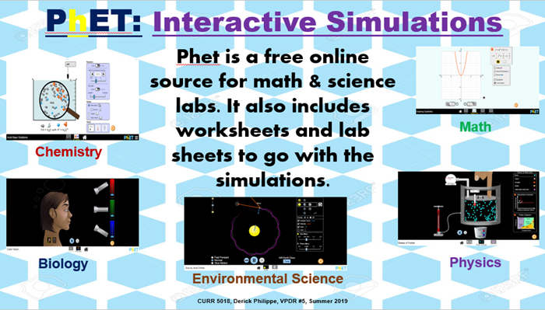](http://warhawks.ulm.edu/~philippedj/5018/bin/vpdr-05.pptx)

Phet provides students with the opportunity to engage in labs that they might otherwise be unable to perform. It contains excellent scientific models of natural phenomenon.

[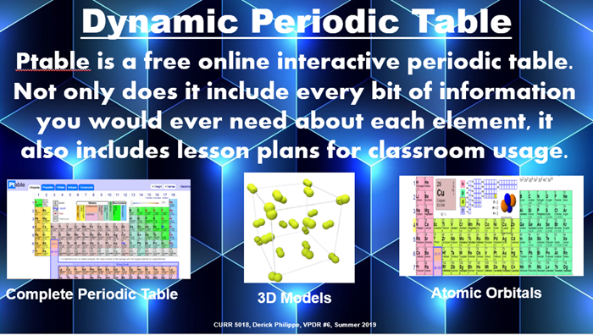](http://warhawks.ulm.edu/~philippedj/5018/bin/vpdr-06.pptx)

This is an online Periodic table that contains everything about every known element. It is a great resource for biology, chemistry, or physical science.

[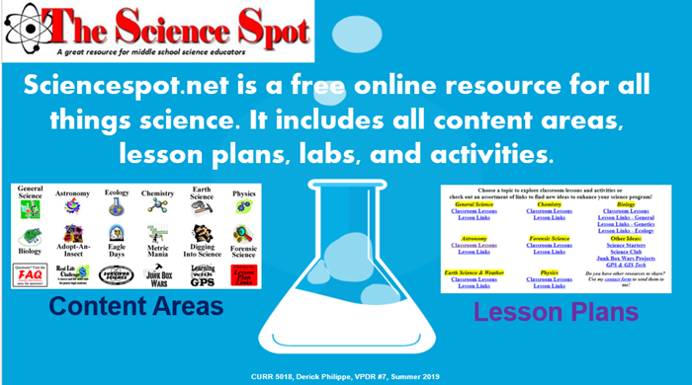](http://warhawks.ulm.edu/~philippedj/5018/bin/vpdr-07.pptx)

This is an online scientific resource for kids. It contains games, animations, models, and project ideas. It also has lesson plans for teachers.

[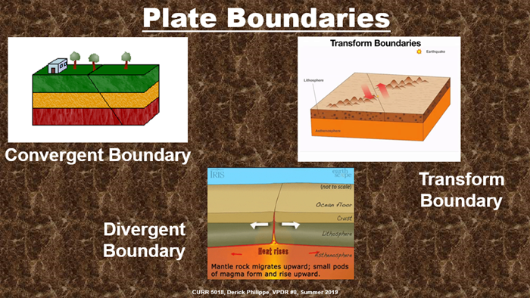](http://warhawks.ulm.edu/~philippedj/5018/bin/vpdr-08.pptx)

This above VPDR is something I made specifically for my classroom. It illustrates the three different types of plate boundaries and has animations for each one.

[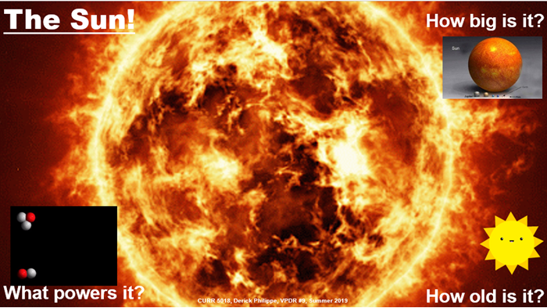](http://warhawks.ulm.edu/~philippedj/5018/bin/vpdr-09.pptx)

The VPDR above was made for my students unit in Astronomy. Students can discover all the relevant information pertaining to our sun. It serves as an excellent model for information assessed by the state.

[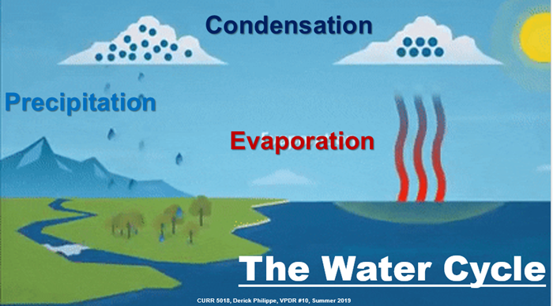](http://warhawks.ulm.edu/~philippedj/5018/bin/vpdr-10.pptx)

This VPDR begins our unit on weather. Students can see how energy and matter is cycled through the atmosphere. It includes a scientific model to show the exact path that water takes through all of its transformations.

[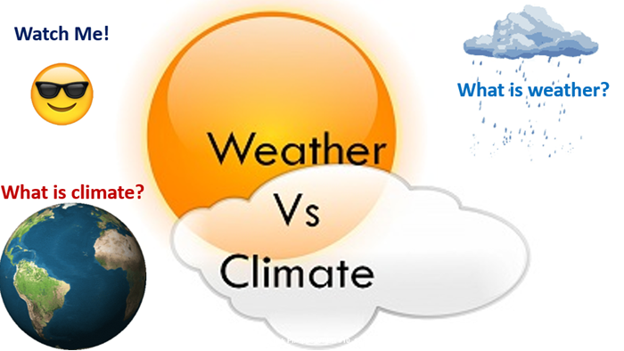](http://warhawks.ulm.edu/~philippedj/5018/bin/vpdr-11.pptx)

The above VPDR starts an inquiry lesson where students discover on their own the difference between weather and climate. Students use online resources to compare and contrast the specific cause and effect of weather and climate.

8. **Identify An Outstanding Free Online Educational Resource** (25 points)

[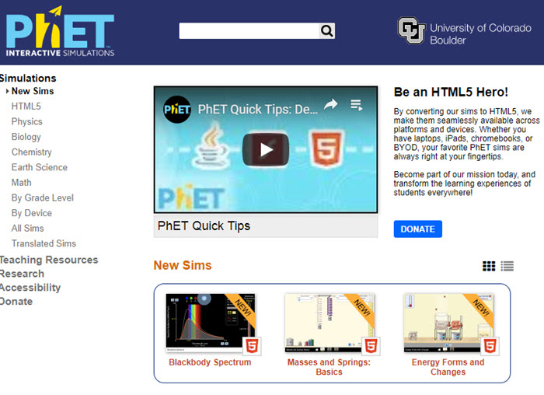](https://phet.colorado.edu/en/simulations/category/new)

This is a must have resource for all science teachers. “Phet” contains virtual labs of every scientific discipline. It also includes lesson plans and worksheets that follow along with the labs. Students are able to actually use the skills they learned in class instead of just reading about them. It can also serve as another means of assessment for students.