[](https://ulm.edu/webguide/index.html)This document is part of a student’s **academic eFolio (electronic portfolio)** for an online course during the summer of 2019 at the University of Louisiana at Monroe (ULM). The images link to files located on the student’s personal ULM website account.

This student has allowed this *exemplar* to be publicly viewed. **Note: After this student graduates, these links will no longer work because the website will be de-activated. However, the student has the option to COPY and transfer the files to another website account in the future.**

3. **Your Photo.** Insert an “annotated” image of yourself that actively links to your online **about-me.pptx** online file located on your ULM website account. (25 pts)

[](http://warhawks.ulm.edu/~adamsrl/5018/bin/about-me.pptx)

About ME

4. **Your Project Proposal Cognitive Map**. Include a “cognitive map” describing your course project. (25 points)

[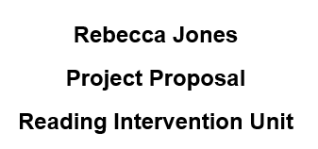](http://warhawks.ulm.edu/~adamsrl/5018/bin/project-proposal.docx)**NOTE:** During our phone conversation about my project, Dr. Beutner said that I did not have to do a cognitive map for my project because it was unnecessary.

**My project proposal is centered around reading intervention in the classroom. I wanted to create something that students can use to better their reading because many students complete school without ever being able to read. This would be very useful in reinforcing and instructing students who are having a hard time reading. The project will eventually be 26 rhyming story Fliplets. Essentially, there will be a short rhyming story will illustrations, HOTS questions, and narration for each letter of the alphabet. For this project, I only had to create the first five. A through E are seen below.** 5. **30-Second Video Summary Of Your Completed Online Course Project**. (50 points)

[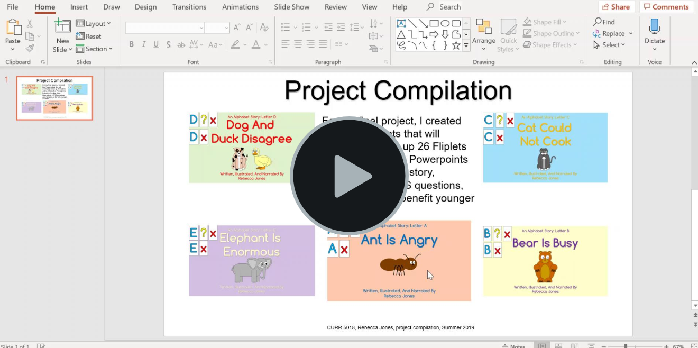](https://www.screencast.com/t/HSmcDSv2UpPP)

* 66. **Visually Link Your “Course Project Files” That You Created, Based On Your Project Proposal.**Provide actively linked images of your online course project files and provide text commentary. (200 pts.).

[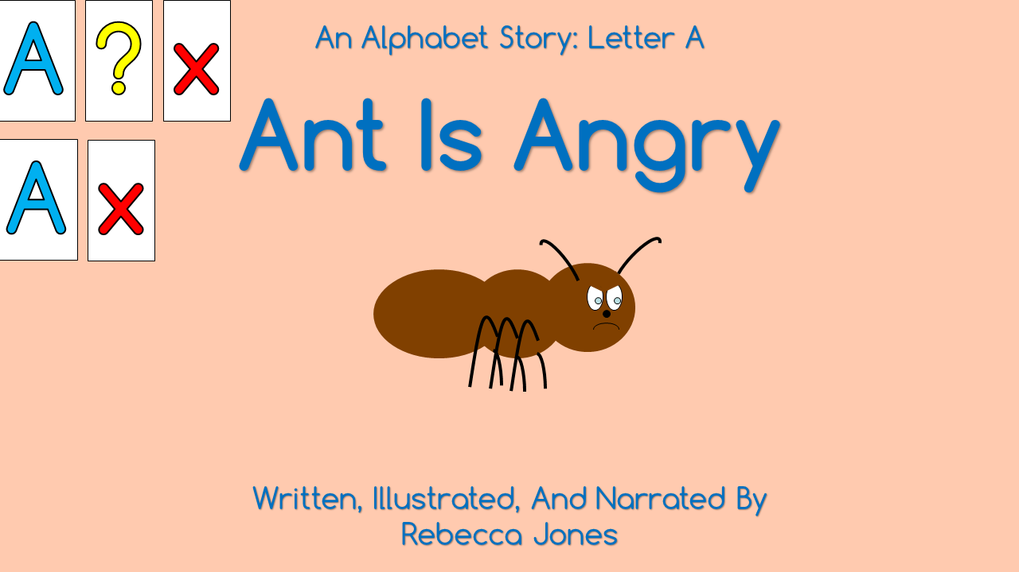](http://warhawks.ulm.edu/~adamsrl/5018/bin/ant-is-angry.pptx)

This is the first file of my project. This rhyming story is called “Ant Is Angry”. It is about an ant who is very angry. His friend Alligator sees that her friend is angry and wants to figure out why so that she can help him. Ant is stubborn, and doesn’t say much at first, but eventually explains that he is angry because he is small, and he has a hard time doing some things. Alligator helps Ant feel better by pointing out what he can do. Students will learn about how to take care of their friends and how to communicate when they are mad. The story features narrations and HOTS questions.

**Note: This is one of my project files that will not upload to WinSCP. The link does not work.**

[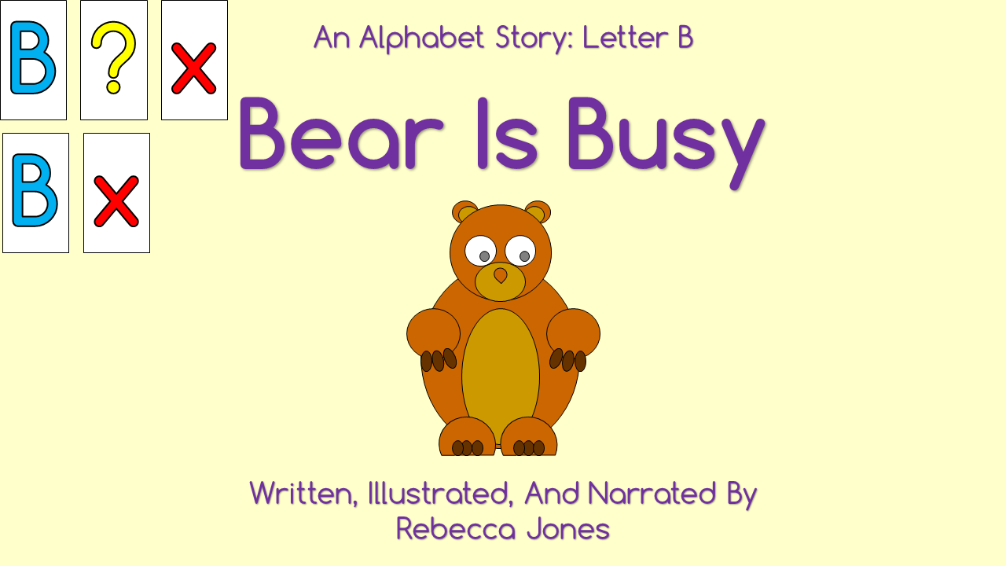](http://warhawks.ulm.edu/~adamsrl/5018/bin/bear-is-busy.pptx)

This second rhyming story is about Bear. Bear has a lot of chores, probably because he normally dirty, and he can’t go play with his friends when they come and ask. Bear feels overwhelmed. Eventually, his friends decide to help him so that he can play. This teaches children about how they can help others. The story features narrations and HOTS questions.

**Note: This is one of my project files that will not upload to WinSCP. The link does not work.**

[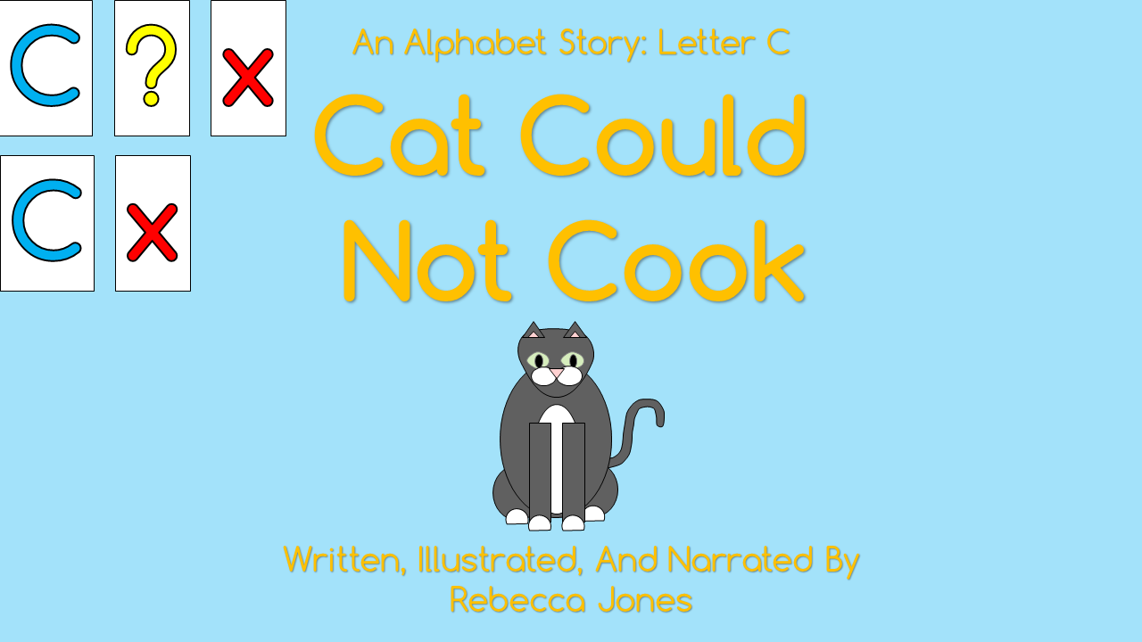](http://warhawks.ulm.edu/~adamsrl/5018/bin/cat-could-not-cook.pptx)

Cat is very hungry, but she can’t cook anything! She eventually decides to try cooking a recipe from her grandmother’s recipe book, chicken pot pie. Because she followed the directions, it turns out great. She decided to cook for all of her friends. This rhyming story teaches children how they should follow directions. The story features narrations and HOTS questions.

[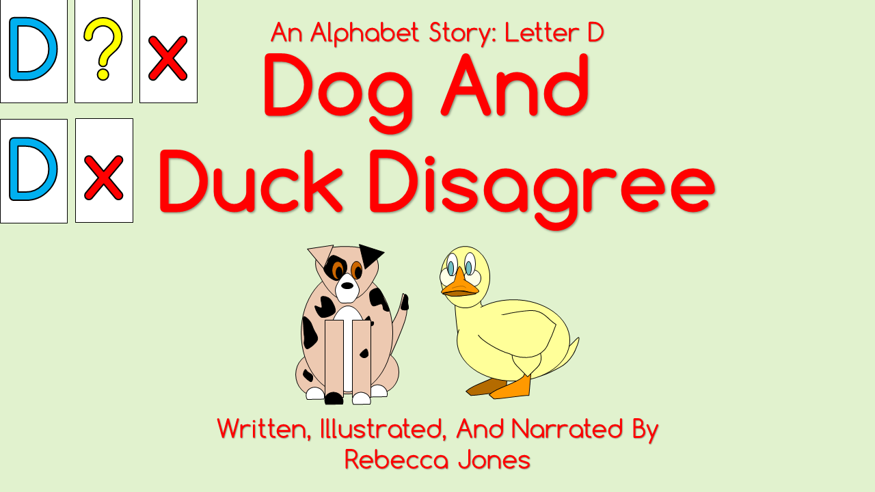](http://warhawks.ulm.edu/~adamsrl/5018/bin/dog-and-duck-disagree.pptx)

In this alphabet story, Dog and Duck are trying to figure out what to do, but they can’t seem to agree. They have to work together to solve their problem. This rhyming story teaches children how they can problem solve in a positive way. The story features narrations and HOTS questions.

[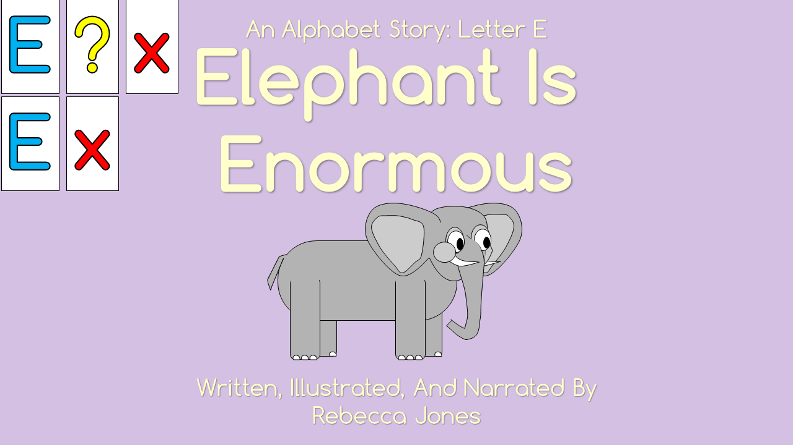](http://warhawks.ulm.edu/~adamsrl/5018/bin/elephant-is-enormous.pptx)

Elephant is trying to play outside with his friends, but he keeps running into a problem. He is too big! He keeps messing up all of the games that his friends want to do. He gets frustrated and quits, but his friends come up with a game that only Elephant can do. This rhyming story teaches children that everyone is unique and should be included. The story features narrations and HOTS questions.

**Note: This is one of my project files that will not upload to WinSCP. The link does not work.**

**Note: Dr. Beutner said during our phone conversation about my course project that I only needed to create the first five by the submission date.**

[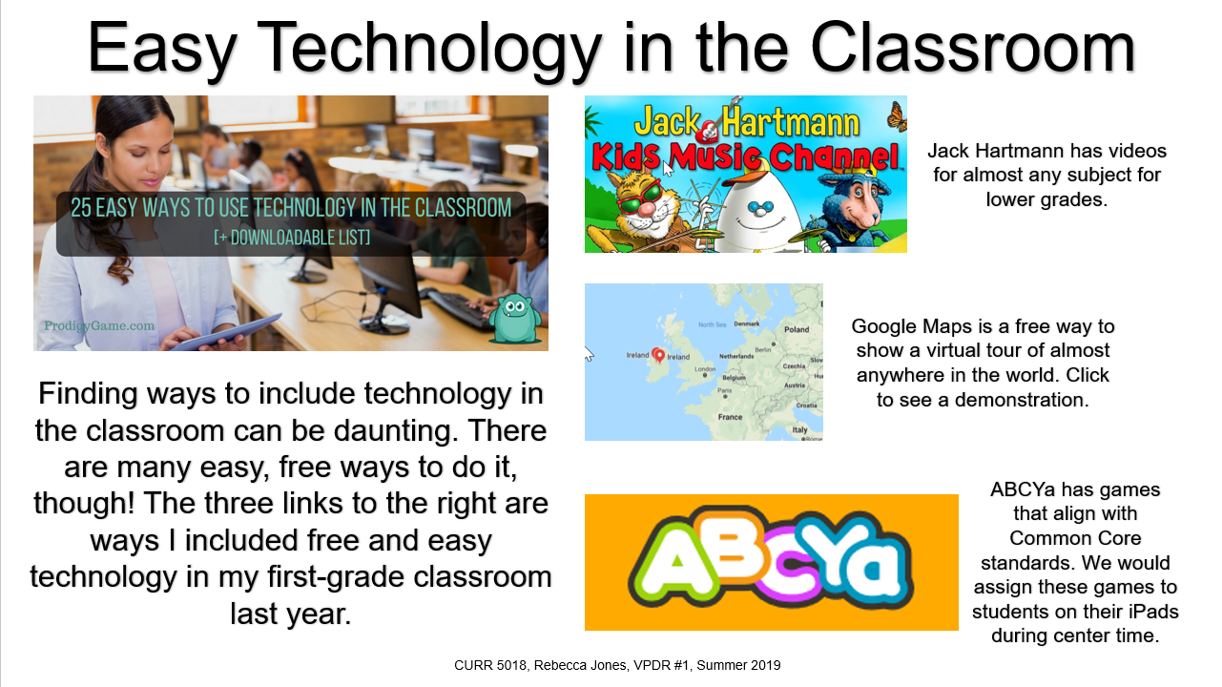](http://warhawks.ulm.edu/~adamsrl/5018/bin/vpdr-01.pptx)7. **Visually Describe At Least 10 Professional “Visual Professional Diary Reflections”.** Provide captured images that actively link to at least 10 online visual professional diary reflections (VPDRs). (150 pts).

This VPDR provides free resources that can be used in the classroom. These in particular are for younger students, but some of them can be adapted to older students as well.

[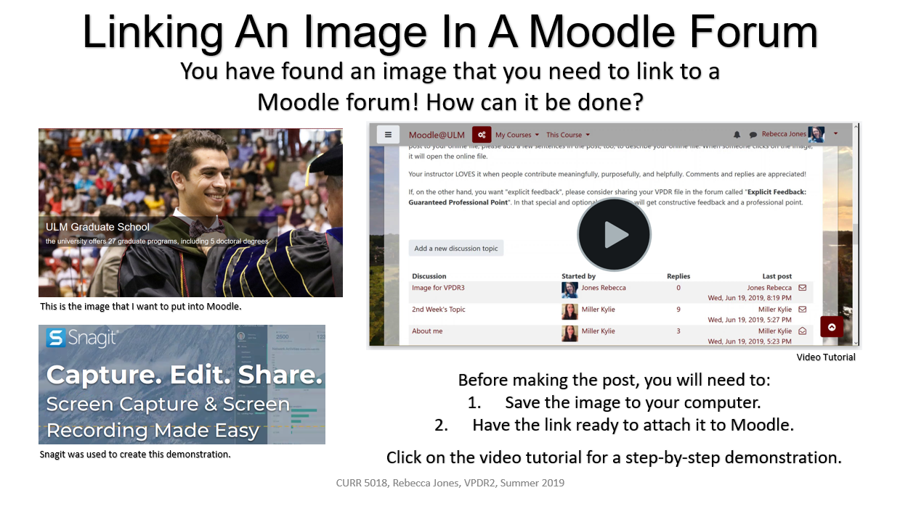](http://warhawks.ulm.edu/~adamsrl/5018/bin/vpdr-02.pptx)

This VPDR offers a tutorial on how to link an image in a Moodle Forum. The very descriptive tutorial takes a reader through all the steps. This is helpful in sharing ideas in forums on Moodle. It also includes a link to Snagit, the tool that is used in this project.

[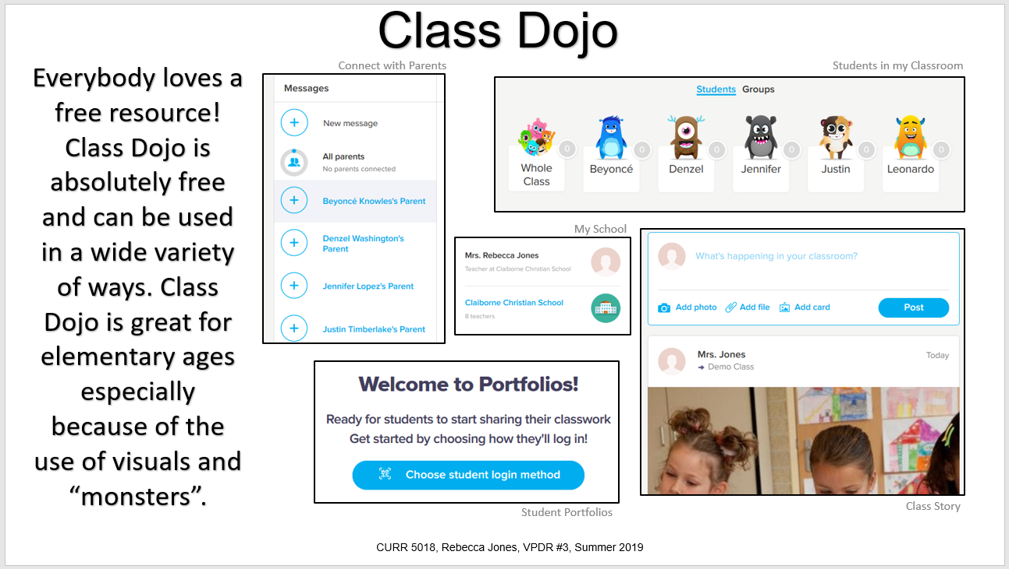](http://warhawks.ulm.edu/~adamsrl/5018/bin/vpdr-03.pptx)

Class Dojo is completely free to teachers. It allow teachers to keep track of student behavior, communicate with parents, and much more. This VPDR has tutorials and links to Class Dojo for others to use.

[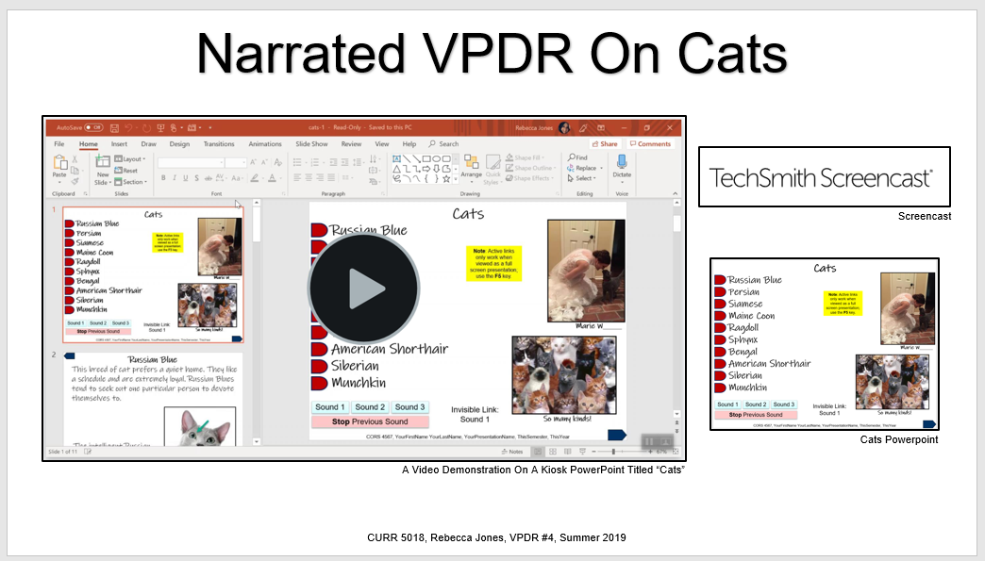](http://warhawks.ulm.edu/~adamsrl/5018/bin/vpdr-04.pptx)

This VPDR features a kiosk Powerpoint on Cats. The VPDR includes a narration on how to use a kiosk Powerpoint.

[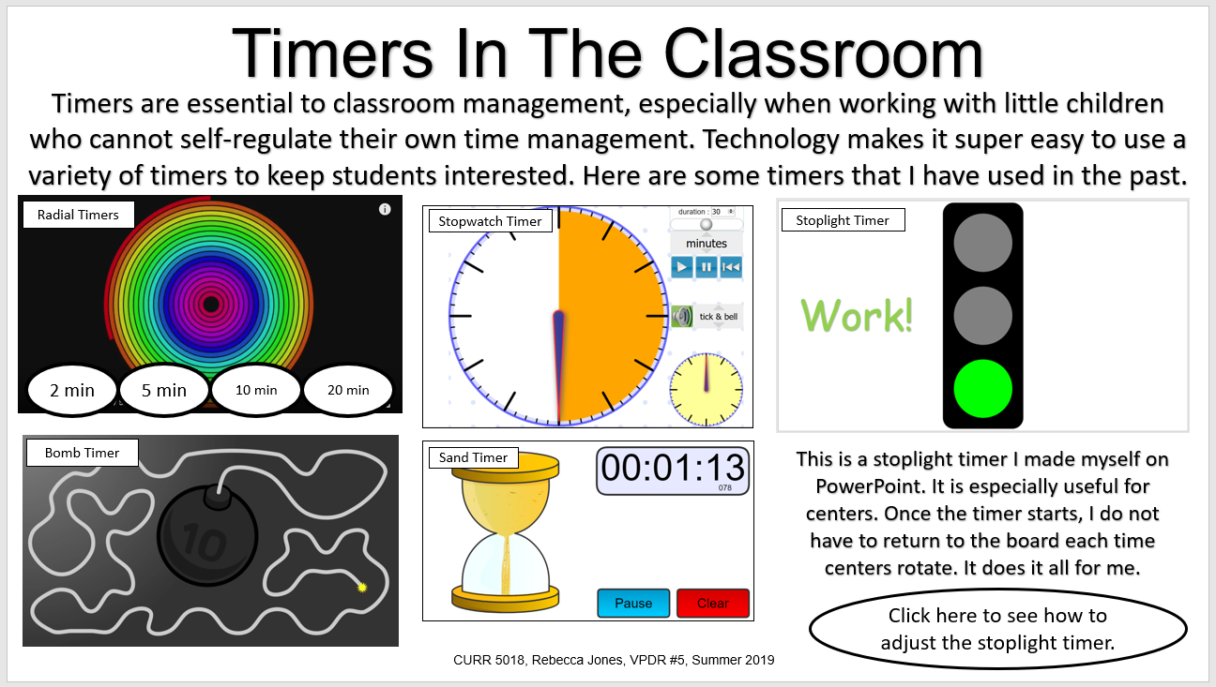](http://warhawks.ulm.edu/~adamsrl/5018/bin/vpdr-05.pptx)

Timers are excellent resources in the classroom. They can be used in many ways. This VPDR shows different timers that teachers can use. Some of them are on YouTube or other websites, but the Stoplight Timer was created by me for using centers in the classroom. It can be adjusted to any time.

[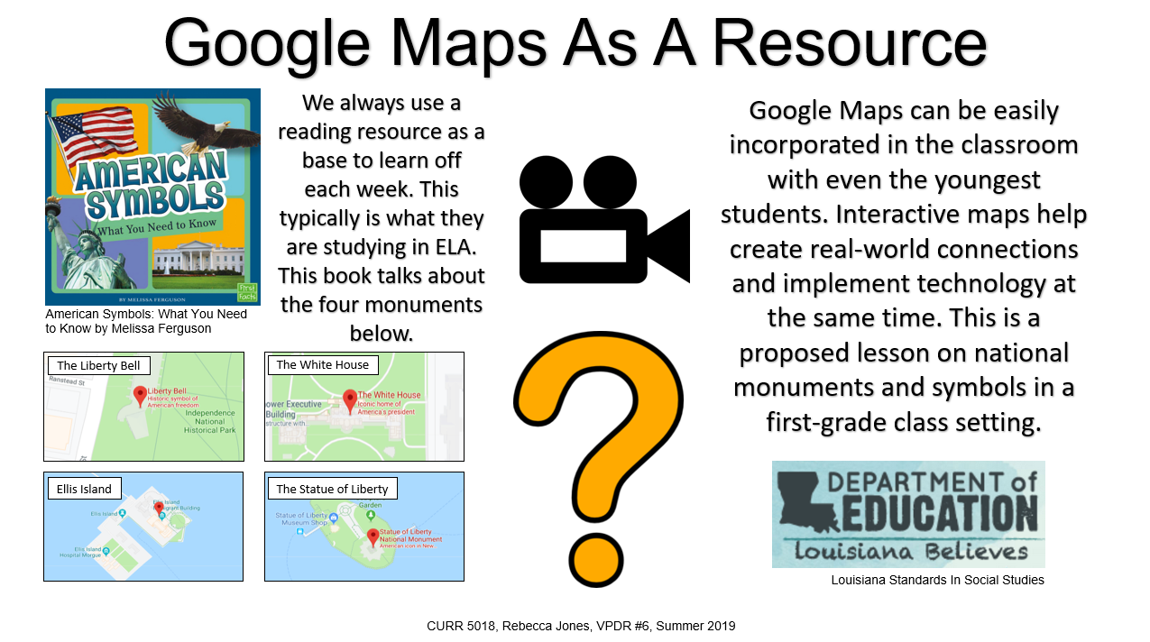](http://warhawks.ulm.edu/~adamsrl/5018/bin/vpdr-06.pptx)

This VPDR shows how Google Maps can be used in the classroom as a resource. Google Maps is a great way to bring real world connections into any classroom. This VPDR has a video tutorial of how to use Google Maps as well as questions that could go along with this proposed lesson.

[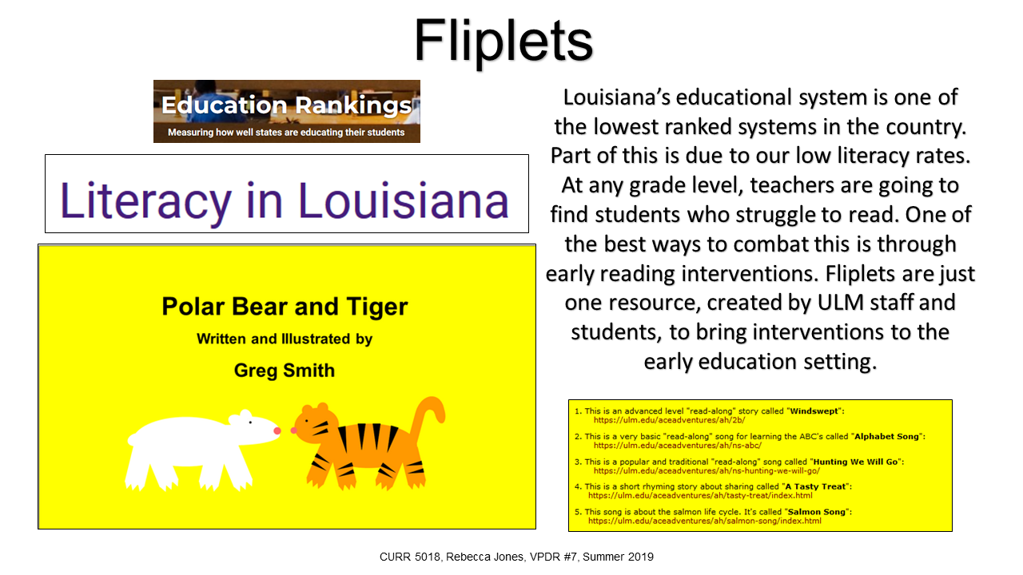](http://warhawks.ulm.edu/~adamsrl/5018/bin/vpdr-07.pptx)

Fliplets are an amazing resource for teachers in the early childhood setting. This VPDR offers links to how Louisiana rates in reading, which proves that reading intervention is essential in the classroom. This VPDR features “Polar Bear and Tiger”, Fliplet that teaches about climate. It also provides links on how ULM students can help make Fliplets.

[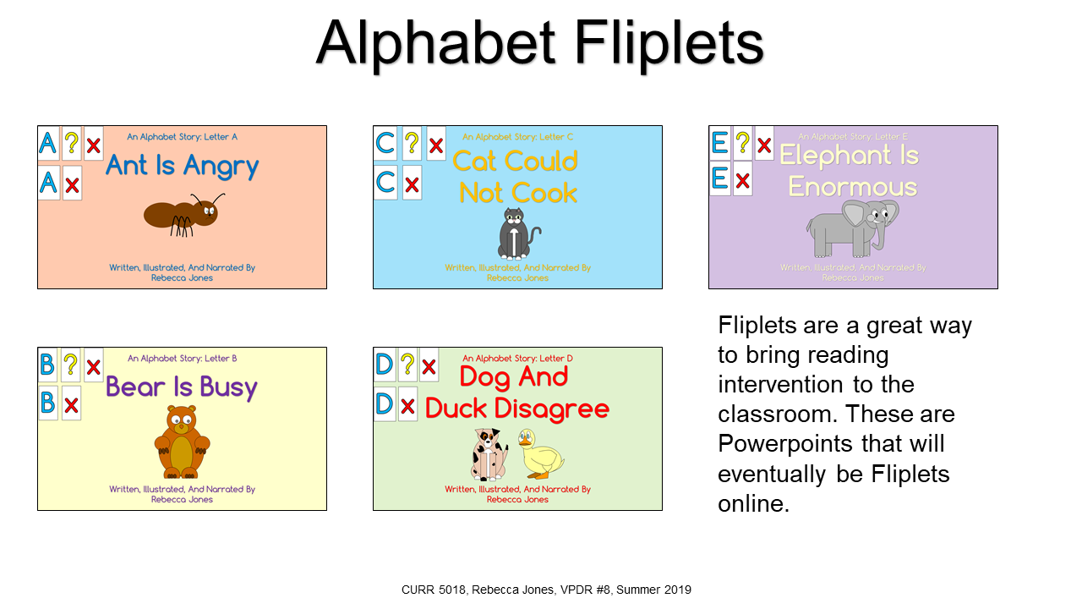](http://warhawks.ulm.edu/~adamsrl/5018/bin/vpdr-08.pptx)

Related to my last VPDR, these are Alphabet Fliplets that will eventually be online. For now, they are in Powerpoint. They feature a rhyming story and HOTS questions to go along with the text, as well as narrations for young students to listen to. Fliplets are a great way to combine student use of technology and reading intervention in the classroom and at home.

**Note: This VPDR has links that do not work. Ant Is Angry, Bear Is Busy, and Elephant is Enormous would not load onto WinSCP. These files can be viewed on LiveText, but the links to these Powerpoints within this VPDR do not work.**

[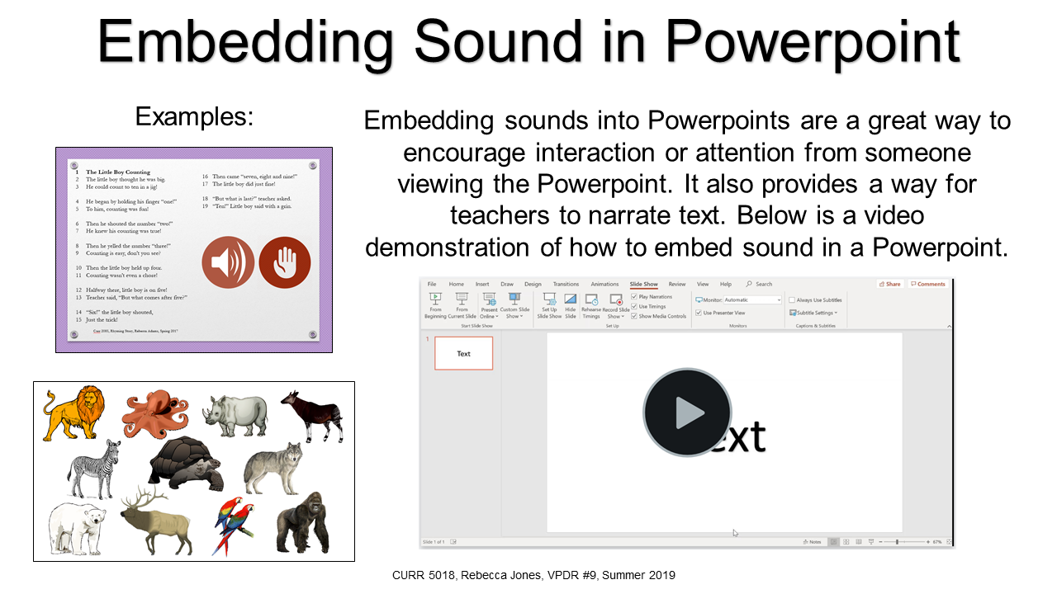](http://warhawks.ulm.edu/~adamsrl/5018/bin/vpdr-09.pptx)

This VPDR shows a tutorial on how sound can be embedded into a Powerpoint. This is a really useful feature to use in narrating text for younger students or just grabbing the attention of a crowd. This VPDR shows two examples of how narration can be used in a Powerpoint. I made these other two examples for another class.

[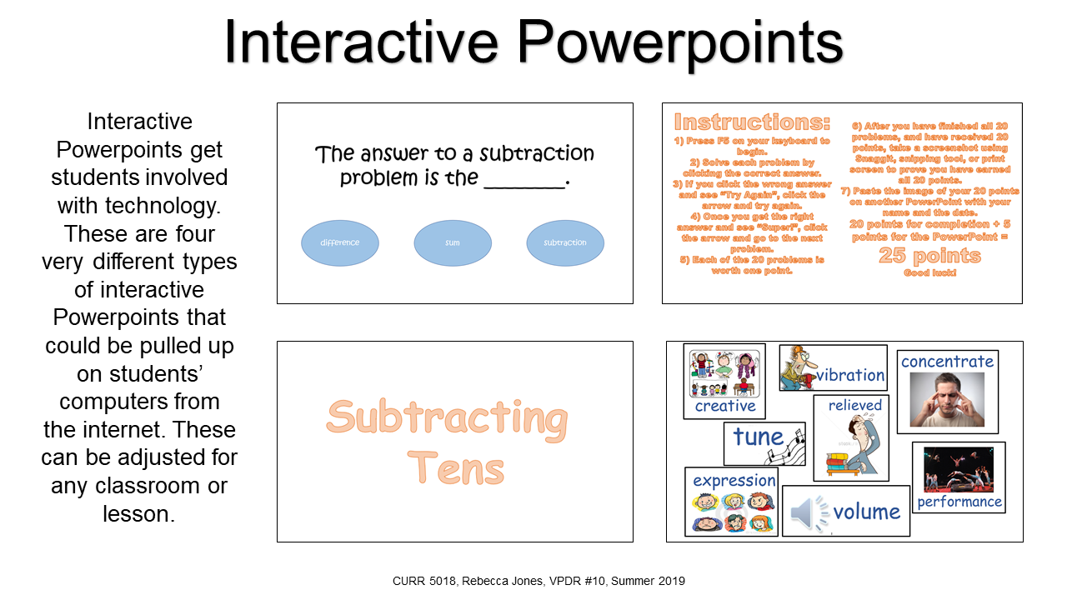](http://warhawks.ulm.edu/~adamsrl/5018/bin/vpdr-10.pptx)

This VPDR is on interactive Powerpoints. Students are highly motivated by technology, and this is a way to put it in their hands in the classroom. The VPDR has five interactive Powerpoints that I have made. These can be modified by teachers for almost any lesson.

8. **Identify An Outstanding Free Online Educational Resource** (25 points)

[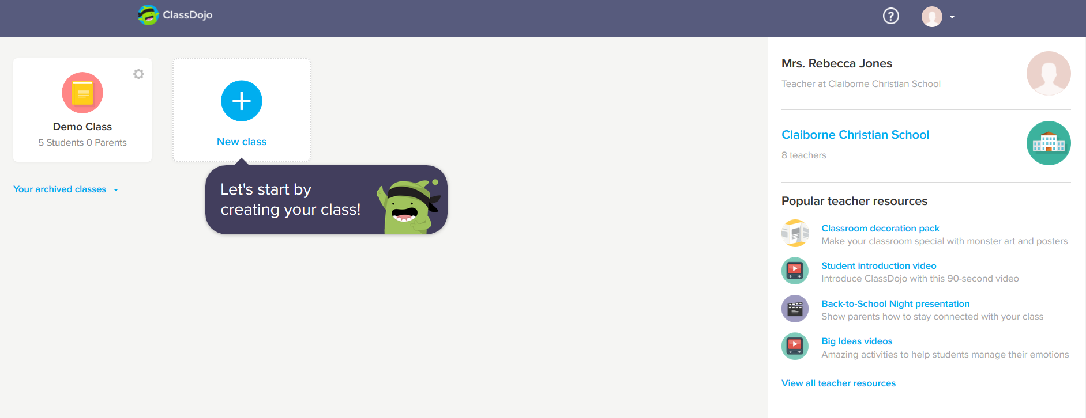](https://teach.classdojo.com/#/launchpad)

This resource is completely free yet offers so much to teachers. Class Dojo is an interactive way to keep up with everything a teacher may need. Teachers can use ClassDojo to take attendance, keep track of rewards and consequences to students, which in turn keeps track of conduct marks, and communicate with parents. ClassDojo has a recently added feature that allows for a “Classroom Webpage” where teachers can post announcements and events that are taking place in the classroom. Parents in the classroom can log on and see what is going on the classroom and comment, just like on social media. This, in a way, allows for “social media” in the classroom without breaking privacy laws. ClassDojo also allows teachers to communicate with others in the school. It is completely free for teachers to use and doesn’t require school-wide use like a lot of similar programs do.