[](https://ulm.edu/webguide/index.html)This document is part of a student’s **academic eFolio (electronic portfolio)** for an online course during the summer of 2019 at the University of Louisiana at Monroe (ULM). The images link to files located on the student’s personal ULM website account.

This student has allowed this *exemplar* to be publicly viewed. **Note: After this student graduates, these links will no longer work because the website will be de-activated. However, the student has the option to COPY and transfer the files to another website account in the future.**

* [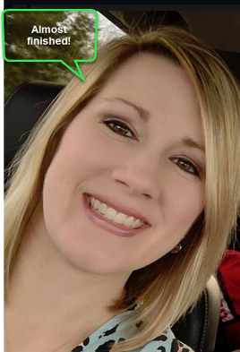](http://warhawks.ulm.edu/~poekl/5018/bin/about-me.pptx)**YYour Photo.** Insert an “annotated” image of yourself that actively links to your online **about-me.pptx** online file located on your ULM website account. (25 pts)

4. **Your Project Proposal Cognitive Map**. Include a “cognitive map” describing your course project. (25 points)   
[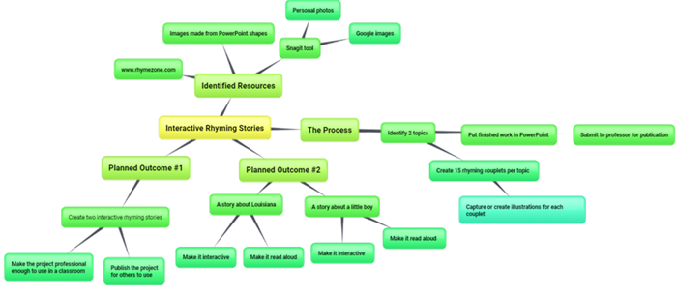](http://warhawks.ulm.edu/~poekl/5018/bin/project-proposal.docx)The cognitive map describes this project. This project is intended for elementary students and teachers. First, a topic had to be determined of each story. The first story involves traveling through Louisiana and the things you would see. The second story is dedicated to my son. After determining the topics, fifteen rhyming couplets had to be created for each story. The website Rhyme Zone was used to help with rhyming words and phrases. After creating the two stories, a PowerPoint was created with illustrations for each couplet. Illustrations are created with using PowerPoint shapes and using SnagIt software to edit personal photos and images from google. This will be submitted to the professor for his students to create a Fliplet. The goal of these two stories is to include narration and for each story to be published into internet stories and hard-copied books.

5. **30-Second Video Summary Of Your Completed Online Course Project**. (50 points)

[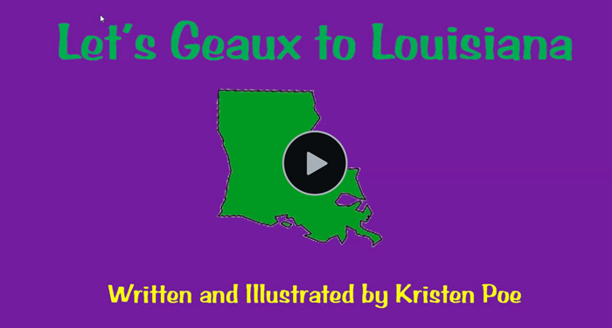](https://www.screencast.com/t/qaYDHsEHvT)

* 66. **Visually Link Your “Course Project Files” That You Created, Based On Your Project Proposal.**Provide actively linked images of your online course project files and provide text commentary. (200 pts.).

[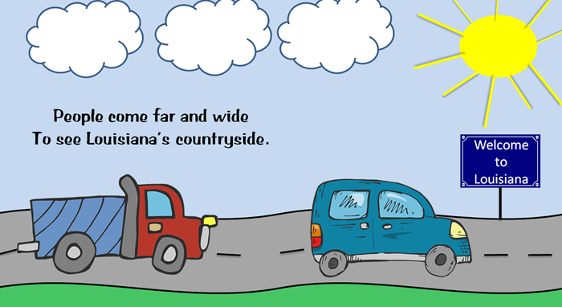](http://warhawks.ulm.edu/~poekl/5018/bin/project-1.pptx)

The clouds, sky, sun, grass, road, and sign were created using PowerPoints shapes. The two cars were downloaded free from the website [www.pixabay.com](http://www.pixabay.com). I used SnagIt to edit and crop the images.

[](http://warhawks.ulm.edu/~poekl/5018/bin/project-02.pptx)

The second story is also illustrated from PowerPoint shapes and free images from the website [www.pixabay.com](http://www.pixabay.com). I used SnagIt to edit and crop the images.

[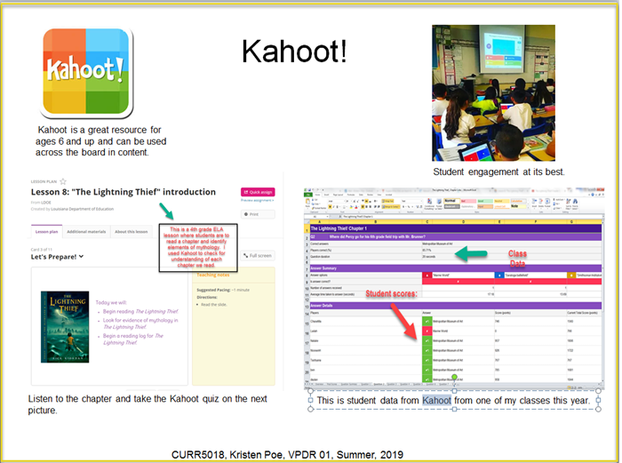](http://warhawks.ulm.edu/~poekl/5018/bin/vpdr-01.pptx)7. **Visually Describe At Least 10 Professional “Visual Professional Diary Reflections”.** Provide captured images that actively link to at least 10 online visual professional diary reflections (VPDRs). (150 pts).

This VPDR describes a great online resource called Kahoot. Kahoot is a free resource where you can check individual students’ comprehension all while having fun. You can create your own questions or use questions that have been created by other educators.

[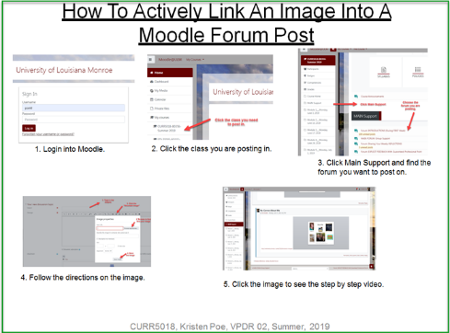](http://warhawks.ulm.edu/~poekl/5018/bin/vpdr-02.pptx)

This VPDR describes how to actively link an image in Moodle. This VPDR was created through creating an mp4 video through SnagIt to visual show how to actively link and image.

[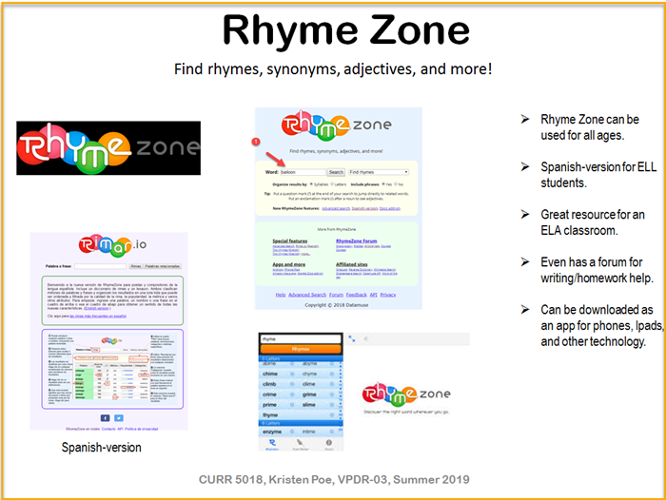](http://warhawks.ulm.edu/~poekl/5018/bin/vpdr-03.pptx)

This VPDR describes a great online resource called Rhyme Zone. This resource is also available in Spanish. Rhyme Zone was a great tool I used when creating my rhyming stories for my project.

[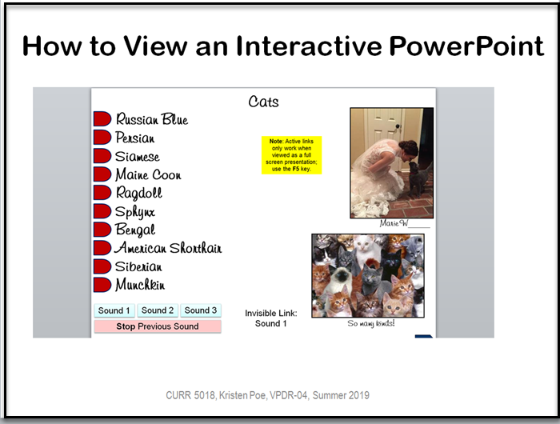](http://warhawks.ulm.edu/~poekl/5018/bin/vpdr-04.pptx)

This VPDR describes how to view and navigate through an interactive PowerPoint. This was another mp4 demonstration video created through SnagIt.

[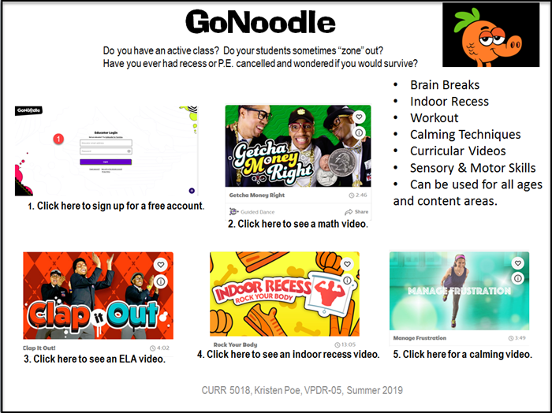](http://warhawks.ulm.edu/~poekl/5018/bin/vpdr-05.pptx)

This VPDR describes a great online resource called GoNoodle. GoNoodle is appropriate for all ages and a great engaging tool to get the wiggles out, calming, or for indoor recess.

[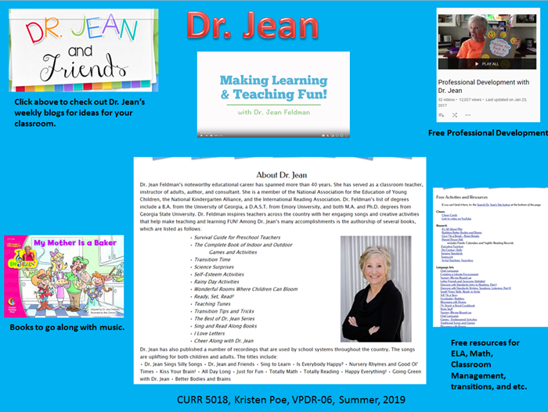](http://warhawks.ulm.edu/~poekl/5018/bin/vpdr-06.pptx)

Dr. Jean is the queen of Early Childhood. She has a website full of resources for the Early Childhood classroom.

[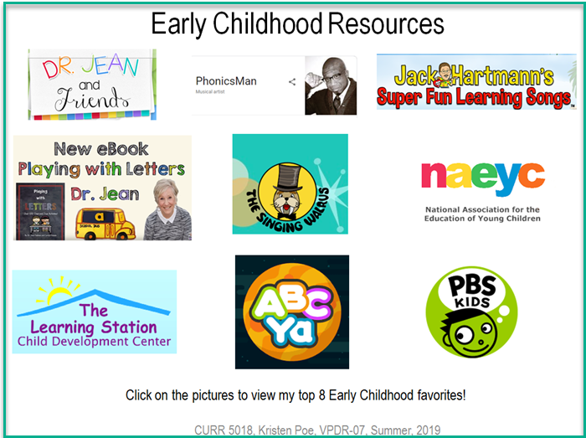](http://warhawks.ulm.edu/~poekl/5018/bin/vpdr-07.pptx)

This VPDR has my top eight Early Childhood resources. These are great resources to use for all subject areas.

[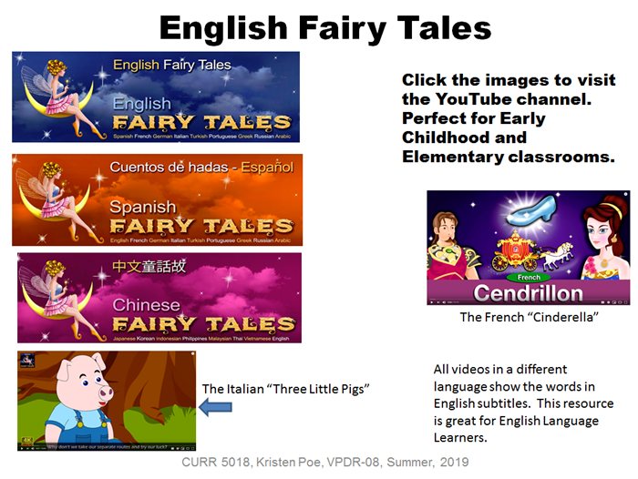](http://warhawks.ulm.edu/~poekl/5018/bin/vpdr-08.pptx)

This VPDR is great for ELL students and elementary students who are learning about fairy tales. This YouTube channel has several different languages to choose from. Each video no matter the language always has the English captions at the bottom of the video.

[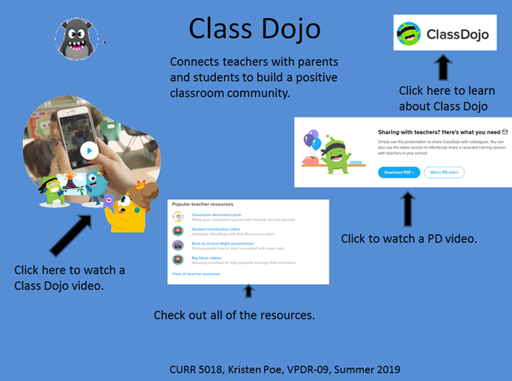](http://warhawks.ulm.edu/~poekl/5018/bin/vpdr-09.pptx)

Class Dojo is a great resource for communicating with parents, tracking behavior in the classroom and school-wide. This resource also has several professional development videos.

[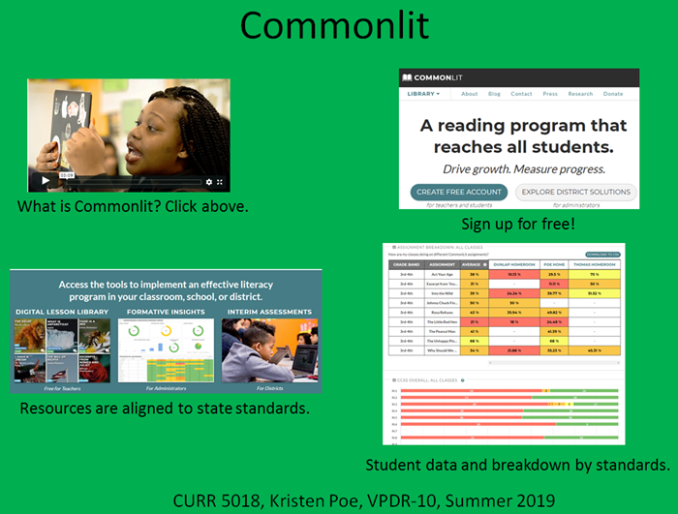](http://warhawks.ulm.edu/~poekl/5018/bin/vpdr-10.pptx)

This VPDR describes a tool I used in my ELA classroom this year. This is a free tool that teachers can assign text for students to read that is aligned to the state standards and take test on. This tracks students’ progress and they can use this at home for practice.

8. **Identify An Outstanding Free Online Educational Resource** (25 points)

[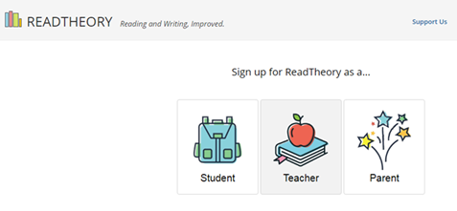](https://www.readtheory.org/welcome/register)

“Read Theory” is a free resource for students, parents, and teachers. This resource will determine a child’s reading level after giving a pre-test and will choose text based on each child’s reading levels. I highly recommend this resource to teachers because it is an easy way to meet each child’s needs and work with that individual child on their own reading level to support literacy and comprehension.